Cycle Balance

Start here …… create three folders on mm-ops-a01

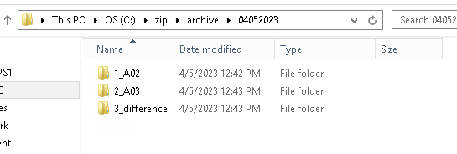

Go to mm-ops-a02

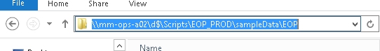

Go to mm-ops-a03

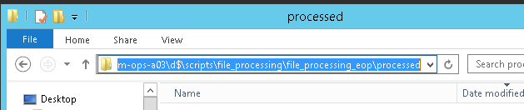

Beyond compare 4

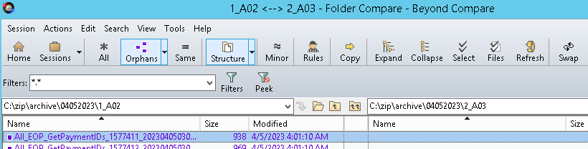

From the diff folder copy the .csv back to Processed foldr…..

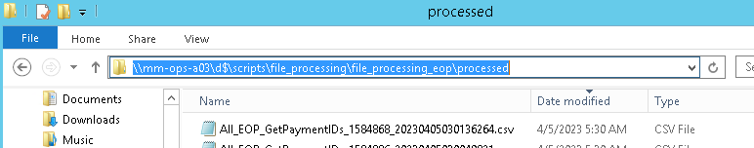

A01

C:\ zip\Archieve

create three folders

A02

A03

Diff

On A02 goto SampleData and copy all the All_EOP files to A02

On A03 goto File_Processing\EOP and copy all the All_EOP files to A03

then used the Beyond Compare A02 and A03 and then copy the diff into the Diff folders

that it.....