HRP Replicate:

Server: MP-HRP-D03

[‎11/‎18/‎2020 7:35 AM] Soza, Gilbert:

http://lp-spl-a09.corp.net.bcbsaz.com:8000/en-US/account/login?return_to=%2Fen-US%2F

Use this:

http://lp-spl-a02.corp.net.bcbsaz.com:8000/en-US/app/splunk_app_db_connect/data_lab#/inputs?_k=vrmi2i

SI5 - http://splunkops.azblue.com/en-US/app/bcbsaz_data_tracking/search?earliest=%40d&latest=now&q=search%20index%3Dmain%20OR%20index%3Dsterling%20sourcetype%3Deop*%20%20linecount!%3D1%20%7C%20stats%20%20count(totalAmount)&display.page.search.mode=verbose&dispatch.sample_ratio=1&display.general.type=statistics&workload_pool=&display.page.search.tab=statistics&sid=1605711731.4006625

Make sure to disable script scheduler.... then enable it again...

index=main OR index=sterling sourcetype=eop* linecount=1 | stats count(totalAmount)

index=main OR index=sterling sourcetype=eop* FileName = All_EOP_GetPaymentIDs_130772_20201118030040360

| delete

Notes: Look for the problem file....

All_EOP_GetPaymentIDs_130772_20201118030040360 $93.35

Should be in DB connect menu....

http://lp-spl-a02.corp.net.bcbsaz.com:8000/en-US/app/splunk_app_db_connect/data_lab#/inputs?_k=c2t9uy

admin

Sp1Unk1tyo!

HRP_Extract - if the count is more then 1,000

Once you click the exec you get a preview

in the where clause

add this code

change the date to -2 ... if need too??

AND payment_dt.Date_Value LIKE '2021-xx-xx%'

AND pf.Payment_Cycle_Key LIKE 'Parent Commerical Payment Cycle'

If not "parent"

AND pf.Payment_Cycle_Key NOT LIKE 'Parent Commerical Payment Cycle'

Might need this just in case for non "parent data"

AND pf.Payment_Cycle_Key NOT LIKE '%Commercia%'

AND payment_dt.Date_Value LIKE '2021-02-10%'

00 03 * * 1,3 - change the min and hour if need.....

00 12 * * 2,4,5 - change the min and hour if need.....

SI5 - EOP zip files (001HRPayor)

Check the sheduler in mm-ops-a01......

Decompress folder should have the zip files....

might reach out to SI5 team......

8917HR...3A4D11.zip ----

RedCard - runs on mm-ops-a02.....

Not able to do this task

index=main OR index=sterling sourcetype=eop* FileName = All_EOP_GetPaymentIDs_(204106_20210217030003342) | delete

Make sure to disable the job in the task scheduler....

Rename the file path :

D:\EOP Or C:\

Search for missing file in SI5...

index=sterling sourcetype=eop* linecount=1 | stats count(totalAmount)

index=sterling sourcetype=eop* linecount=1

look for the host to see what to disable from the scheduler... once done can re-enable the sheduler....

EOP_Read (Tue, Thur)

rename the file path to path= D:\EOP

us this search :

Look for the routed time….. 30-40min





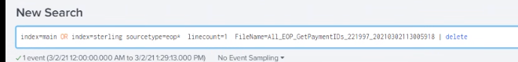

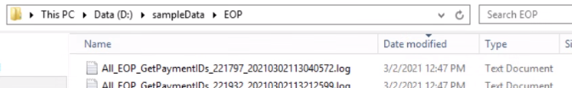

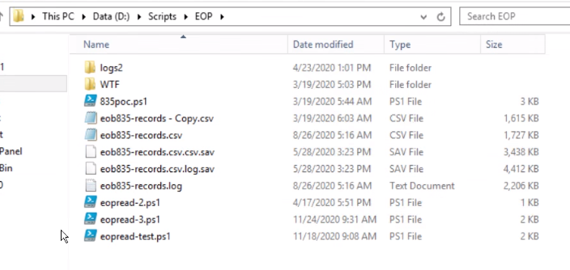



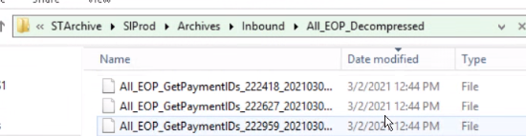

New schedule for 4-7-21

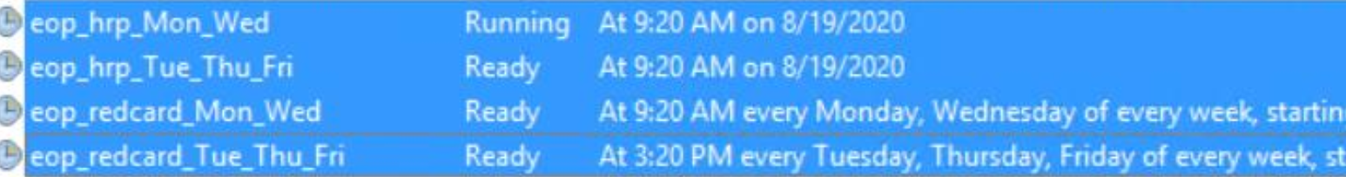

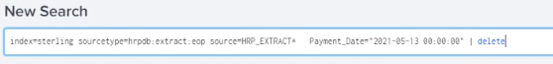s