How to fix HRP panel

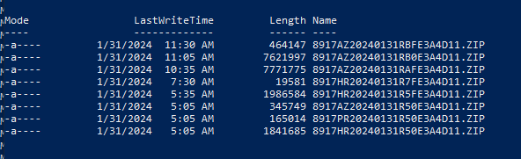

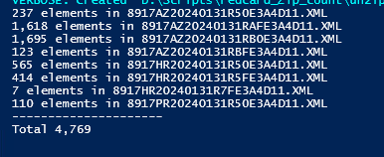

-HRP is 1 higher than SI count

-so you got to delete 1 file

-Sign into SplunkOps with splunk_eop_delete

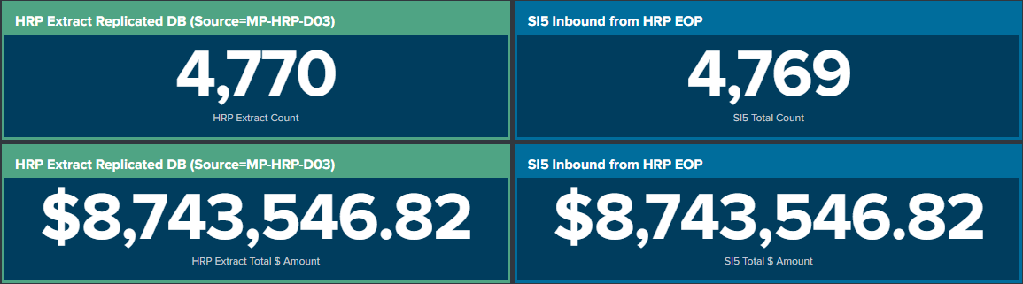

-Batch 199413 has the count off for BCBSAZ commercial Member Payment Cycle.

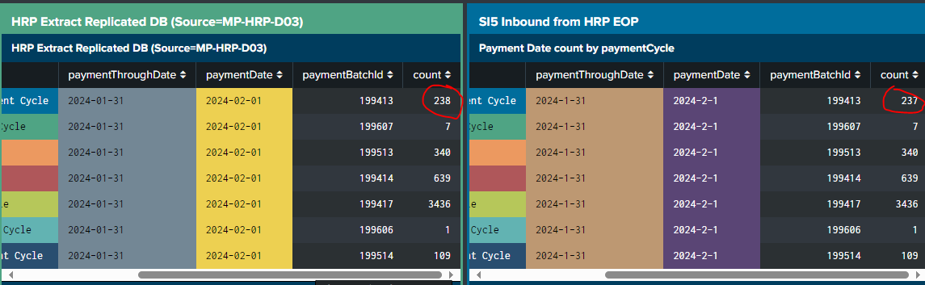

HRP side:

index=sterling sourcetype=hrpdb:extract:eop source=HRP_EXTRACT* payment_cycle_key!="Child BCBSAZ Individual Supplier Payment Cycle" Payment_Batch_Key=199413 | Table paymentId | sort paymentId

SI Side:

index=main OR index=sterling sourcetype="eop:hrp:prod" paymentBatchNumber=199413 | Table paymentId | sort paymentId

-I took batch 199413 and compared paymentId

-and 2817047 was the extra in HRP that did not count in the actual count

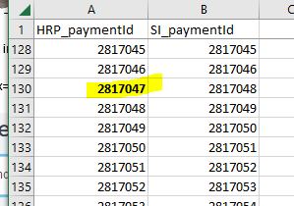

**-for HRP splunk query**

index=sterling sourcetype=hrpdb:extract:eop source=HRP_EXTRACT* payment_cycle_key!="Child BCBSAZ Individual Supplier Payment Cycle" Payment_Batch_Key=199413 paymentId=2817047

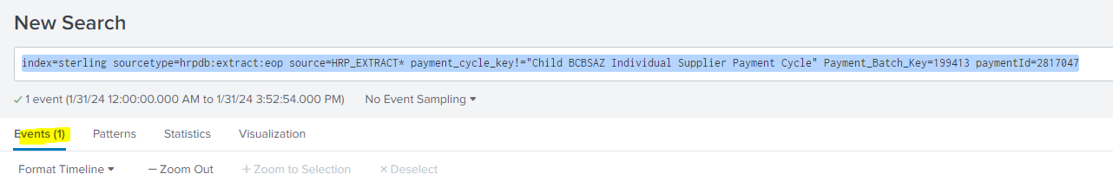

**-Delete command**

index=sterling sourcetype=hrpdb:extract:eop source=HRP_EXTRACT* payment_cycle_key!="Child BCBSAZ Individual Supplier Payment Cycle" Payment_Batch_Key=199413 paymentId=2817047 | delete

-success delete

