PCS_manual

login into si5 gui look for producername FNPScndUndrscr_OUT

search eop file name with today date in si5

Notes -

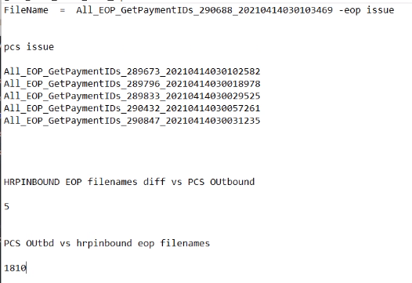

New:

index=sterling sourcetype="eop:hrp:prod" | rex field=source "(EOP\W)(?<file_name>\w+)"  
| fields file_name  
| stats values(file_name) as InboundHRP_FileName  
| appendcols [search index=sterling sourcetype="SI5:Jobs" host="mp-si0-d01`" file_name="All_EOP_GetPaymentIDs*"  
| fields file_name  
| stats values(file_name) as PCSOutbound_FileName]  
| mvexpand InboundHRP_FileName  
| where not match(PCSOutbound_FileName, InboundHRP_FileName)  
| table InboundHRP_FileName

Might need to add something like to not duplicate files:

Put at end of script……

AND FILE_NAME = 'All_EOP_GetPaymentIDs_334729_20210511140512391'  
AND A.STATE = 'Routed'  
OR FILE_NAME = 'All_EOP_GetPaymentIDs_335783_20210511140512406'  
AND A.STATE = 'Routed'

Old

this is eop wip dashboard sourcetype to see hrp inbound count diff using filenames vs pcs outbound panel

​

New

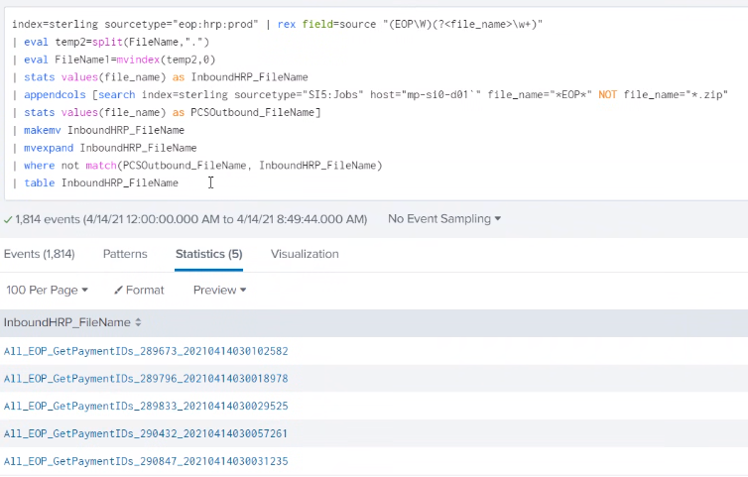

Copy these files names to notepad…

Old source – eop_wip

Edit to make change to the script and enable the job once it been queue….

FYI – **Make sure to disable the job once done….**

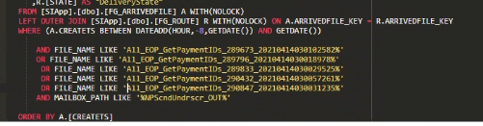

Copy the file name to the script….