On MM-OPS-A02

                CiscoAmp is disabled = good

                Splunk services was running = good

I check log file in MM-OPS-A02\D:\Scripts\Redcard\eop\log

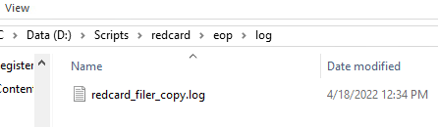

The number changed from 164 to 165

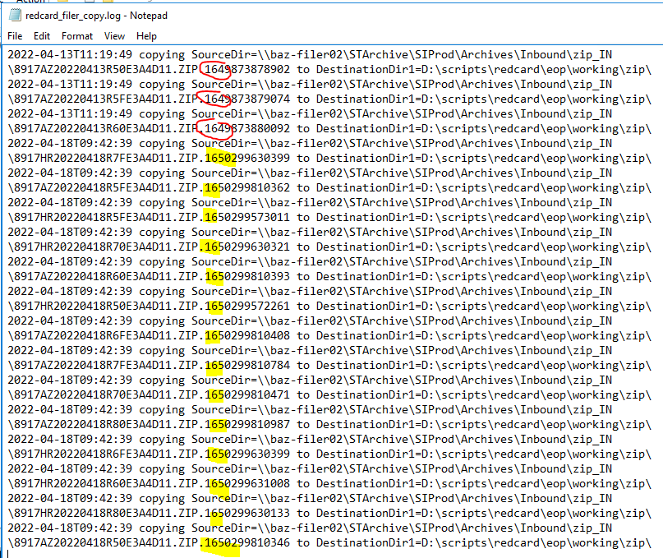

I then check powershell script in MM-OPS-A02\D:\Scripts\Redcard\eop

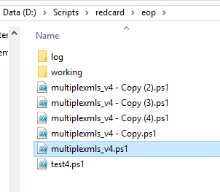

I edited script and it is looking for \***ZIP.164**\*

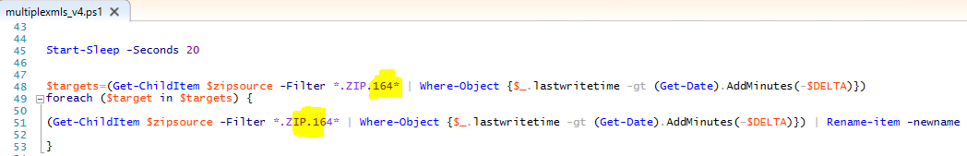

Therefore I **changed from 164 to 165** and then I ran task scheduler



EOP Redcard column updated

