Log into MP-OPS-A02

Goto d:\scripts\Redcard_Cleanup\

Create a new folder month_date_year (101121)

Copy the two scripts and create three folders (see highlight)

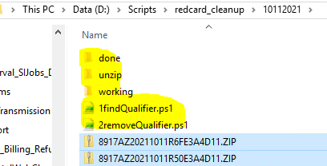

Goto Redcard Outbound folder

EMFT_FTP\Outbound\Redcard\EOP\Prod\ Here are the zip files location

Then unzip the file(s)

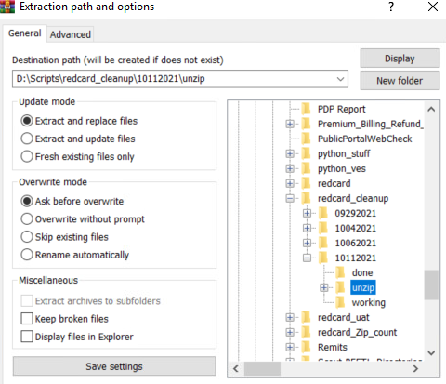

Once files are unzip run the first script to find which one has the extra fields

*** make sure to change the folder date in the scripts..

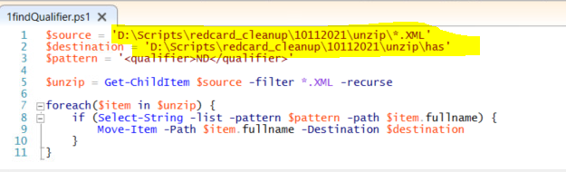

Copy these to the working folder…

After the first script ran the file size should go down a little bit…

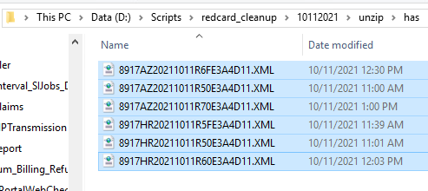

Then run the second script to removed the two fields.

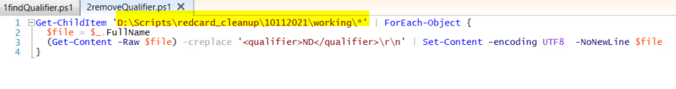

Open the beyond compare

If no red on the right side all is good…..

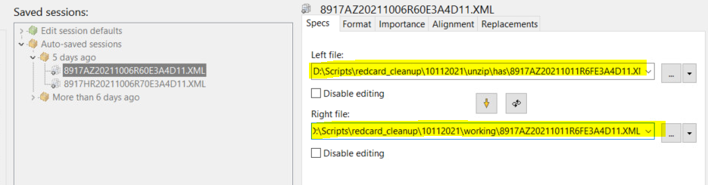

Copy the new clean files to the done folder

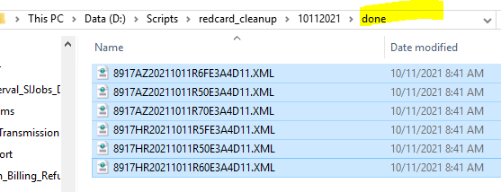

Now zip up these files

Click on on send to – compressed zip folder

Copy zip files and overwrite in redcard\eop\prod folder

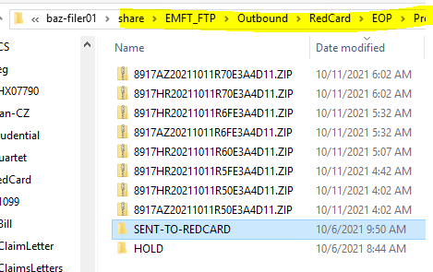

Run the redcard scripts

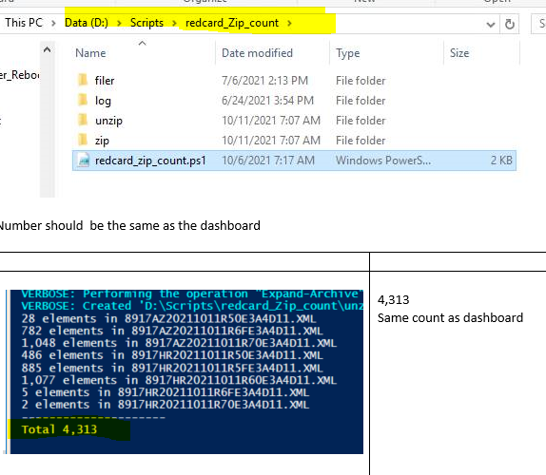

Final steps

Now we can run the 1520 and 1878 job.

Ex: At 0857, ran JobID 1520 (since we confirmed all file is received and file sizes match)

                =confirmed files  are gone from \\baz-filer01\share\EMFT_FTP\Outbound\RedCard\EOP\Prod\  and routed in SI

Ex: At 0859, ran JobId 1878  (since we confirmed all file is received and file sizes match)

                =confirmed files  are gone from \\baz-filer01\share\EMFT_FTP\Outbound\RedCard\EOP\Prod\  and routed in SI

Si5 to outbound to recard



Ex: At 0905, ran JobID 1531 (pcs\outbound folder), nothing to do in A02.

                - \\baz-filer01\share\EMFT_FTP\Outbound\PCS\EOP\Prod