Fix the redcard panel -

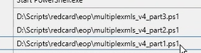



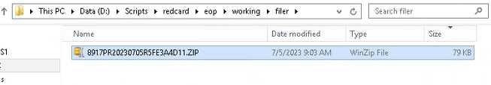

Get redcard zip files : do not do the one that has the “c” in the file name

\\baz-filer01\share\EMFT_FTP\Outbound\RedCard\EOP\Prod\SENT-TO-REDCARD

Copy zip files – make sure folder is empty and the other 4 folders too

D:\Scripts\redcard\eop\working\filer

D:\Scripts\redcard\eop\working\zip

D:\Scripts\redcard\eop\working\unzip

D:\Scripts\redcard\eop\working\sampledata

Run the 3 scripts :

First script – moved to zip folder

Second script – moved to the unzip

Three script – sampledata now a .csv file

Once all the scripts has run.. copy the CSV file to a02 and a03



