6. View

**1.**

CREATE OR REPLACE FORCE VIEW userV

AS

SELECT firstname,lastname, location, dob, age FROM user_p WHERE pid = 2;

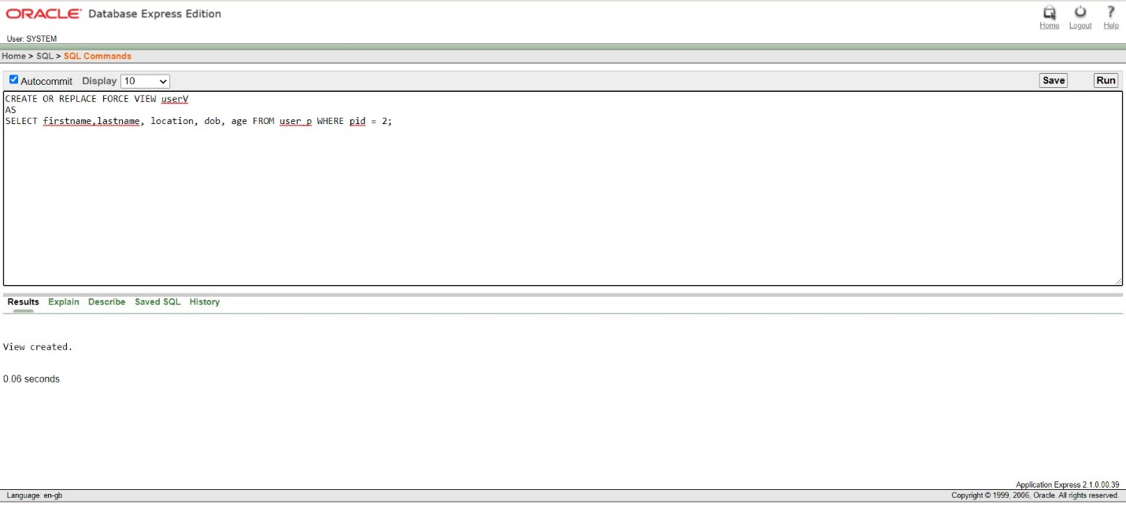

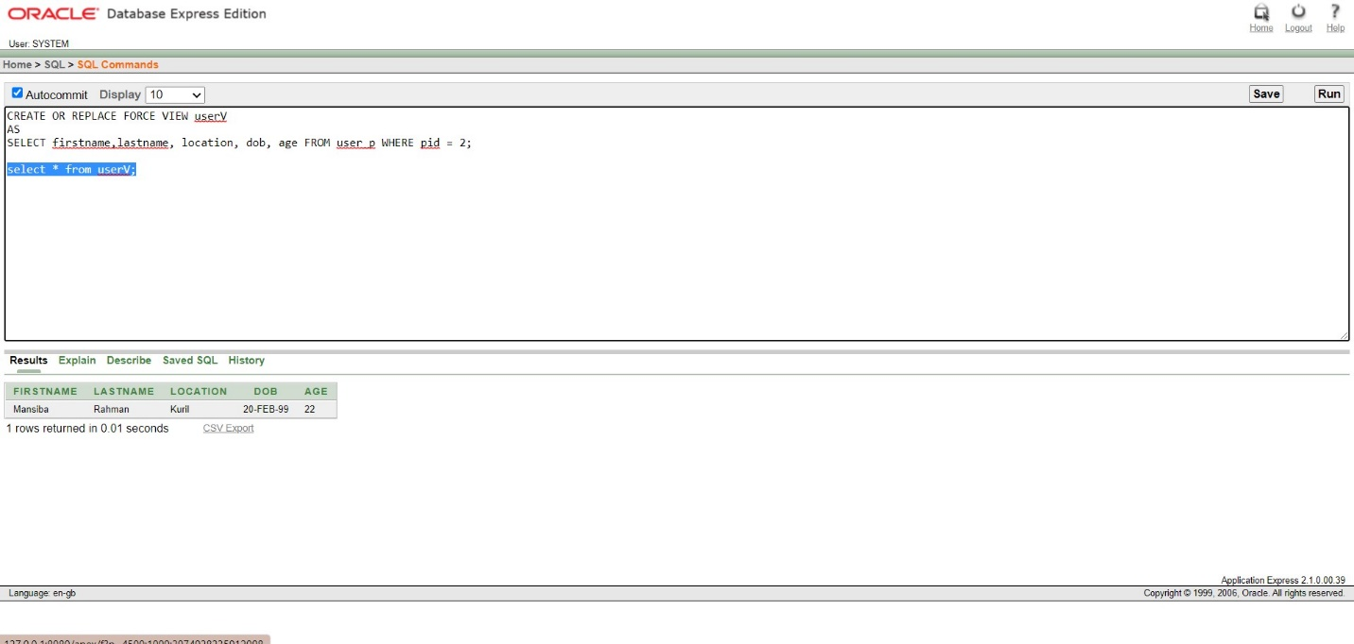

**2.**

CREATE OR REPLACE FORCE VIEW amt_max_min

(roomtype,maxamount,minamount,avgamount)

AS SELECT t.room_type,MIN(e.amount), MAX(e.amount),AVG(e.amount) from roomdetail e,roomtype t

where e.room_type=t.room_type

GROUP BY t.room_type;

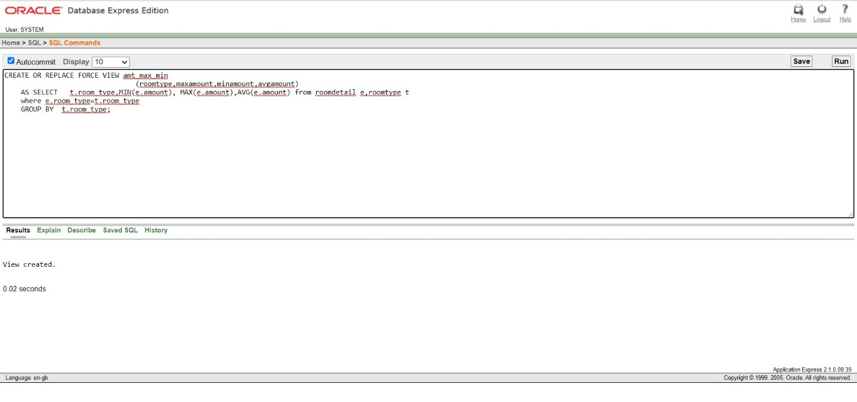

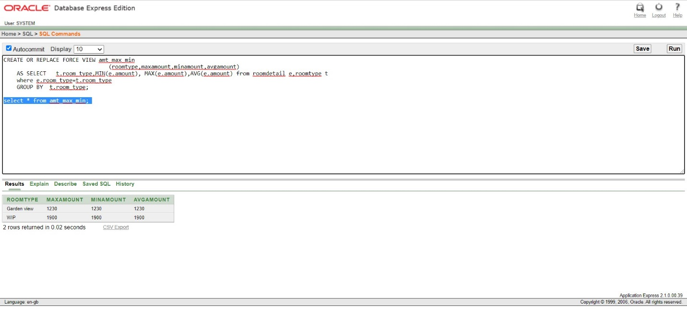

**3.**

CREATE OR REPLACE FORCE VIEW lrange

AS SELECT * from login

where short_time_booking between '1-JAN-20' and '20-MAY-20'

order by l_id

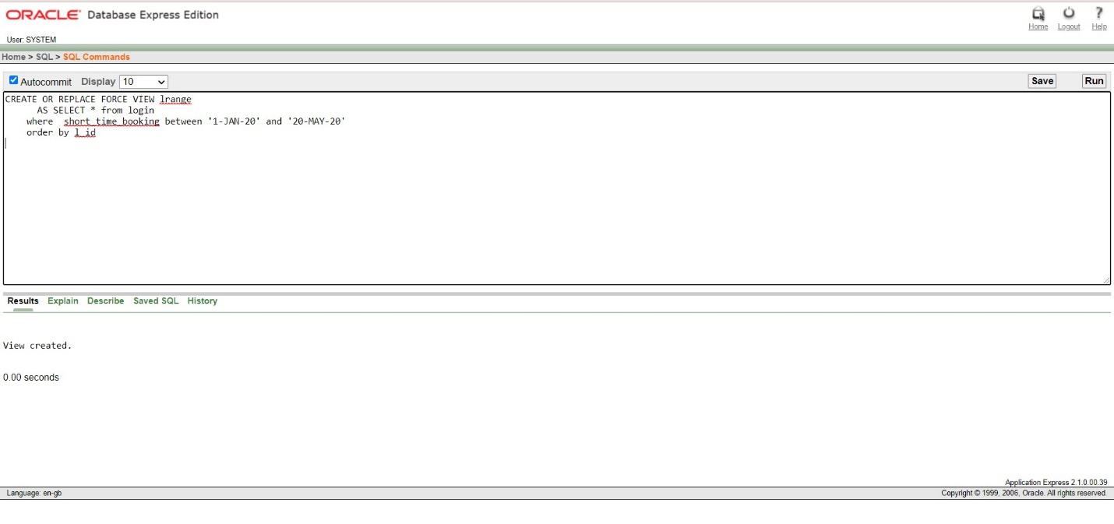

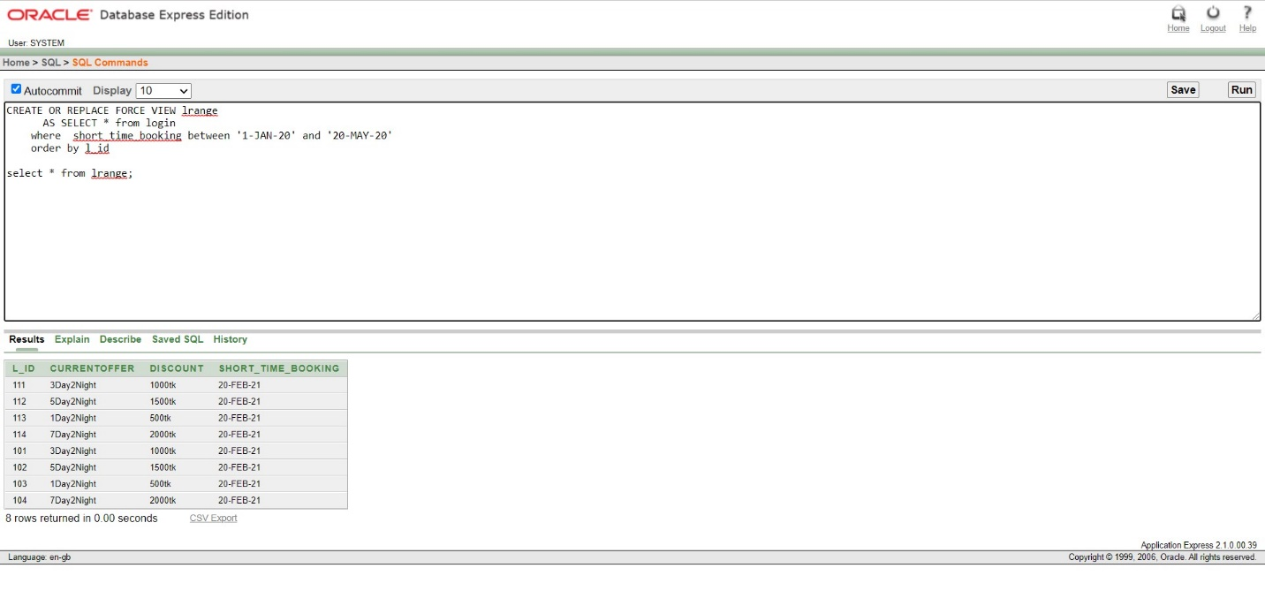

**4.**

CREATE OR REPLACE FORCE VIEW BOOKING

AS

SELECT book.*,((room_price*no_of_room)-(((room_price*no_of_room)*5)/100)) as total_with_discount from BOOK

where ((room_price*no_of_room)-(((room_price*no_of_room)*5)/100))=(select max(((room_price*no_of_room)-(((room_price*no_of_room)*5)/100))) from book);

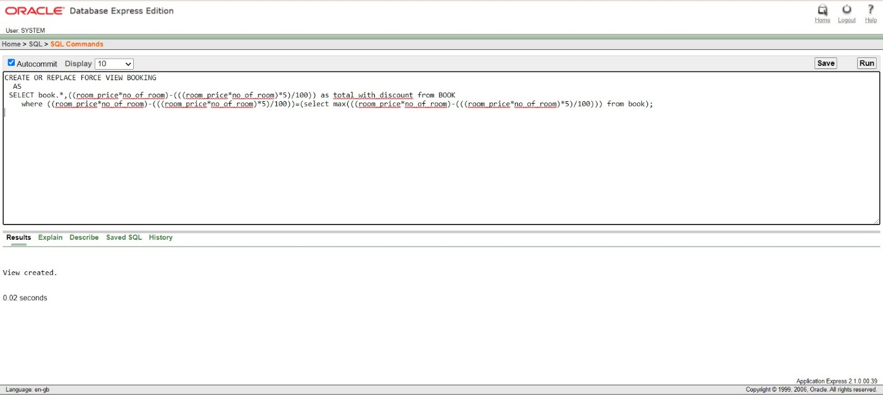

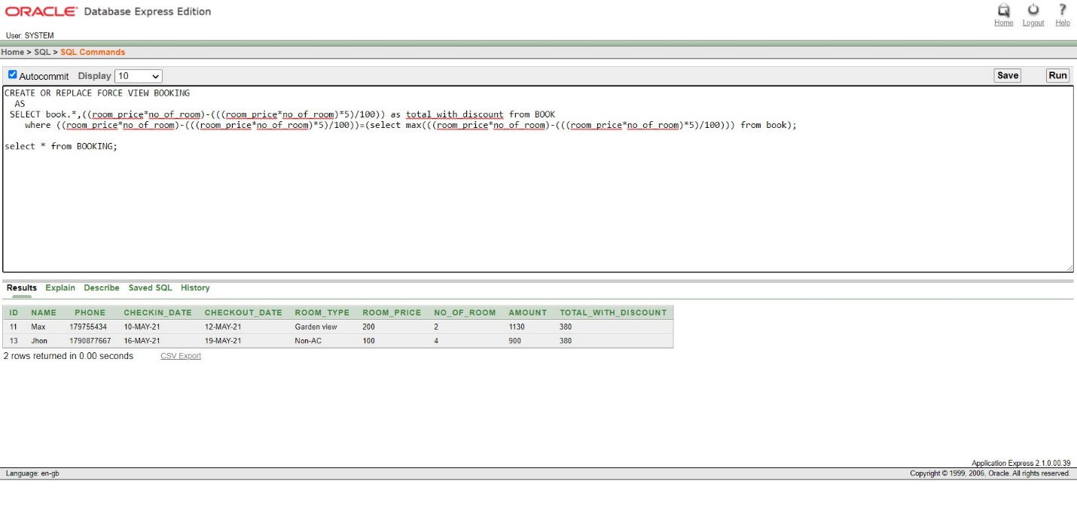

7. **Procedures and Function:**

**1.**

create or replace procedure Users_details(U_no IN user_p.u_id%type,u_fn OUT user_p.firstname%type,u_ln OUT user_p.lastname%type,u_loc OUT user_p.location%type,u_dob OUT user_p.dob%type,u_age OUT user_p.age%type)

is

Begin

select firstname,lastname,location,dob,age into u_fn,u_ln,u_loc,u_dob,u_age from user_p where u_id=U_no;

END;

Declare

Uno user_p.u_id%type:=:User_number;

Ufn user_p.firstname%type;

Uln user_p.lastname%type;

Uloc user_p.location%type;

Udob user_p.dob%type;

Uage user_p.age%type;

Begin

Users_details(Uno,Ufn,Uln,Uloc,Udob,Uage);

dbms_output.put_Line('FirstName:'||Ufn);

dbms_output.put_Line('LastName:'||Uln);

dbms_output.put_Line('Location:'||Uloc);

dbms_output.put_Line('Date Of Birth:'||Udob);

dbms_output.put_Line('Age:'||Uage);

END;

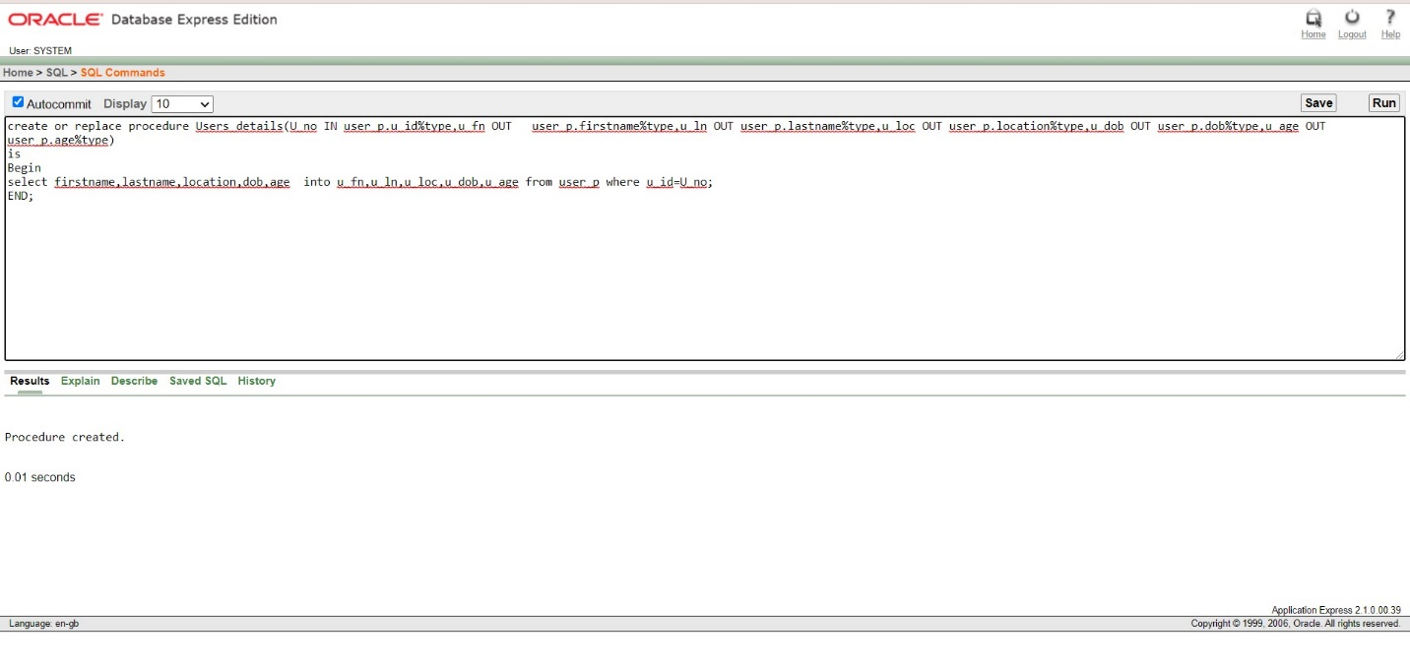

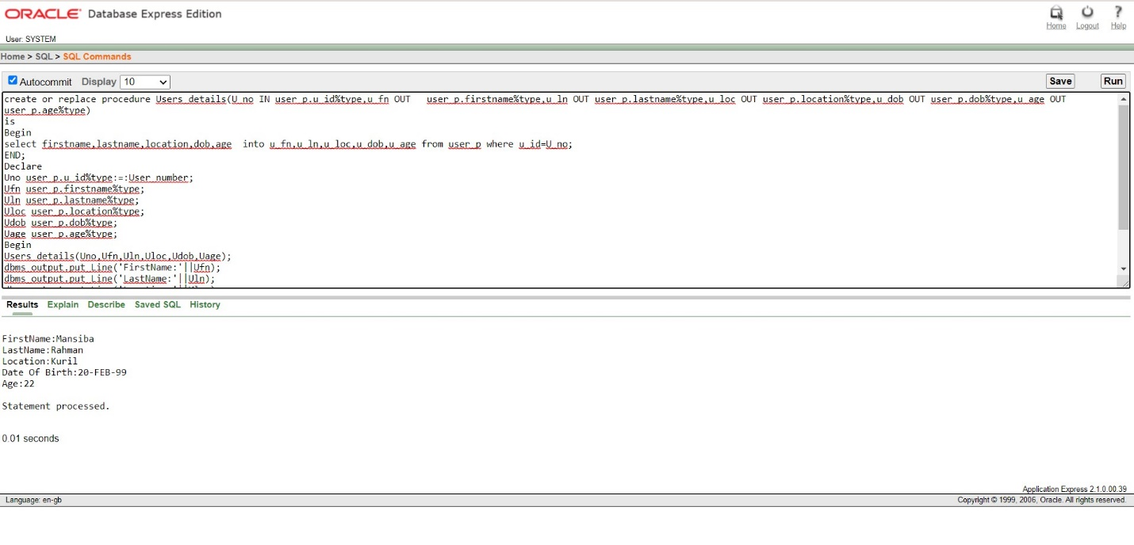

**2.**

create or replace procedure customer_count

is

u_id project.id%type;

Begin

select count(id) into u_id from project;

dbms_output.put_line('Total: '||u_id||'USER');

END;

DECLARE

BEGIN

customer_count;

END;

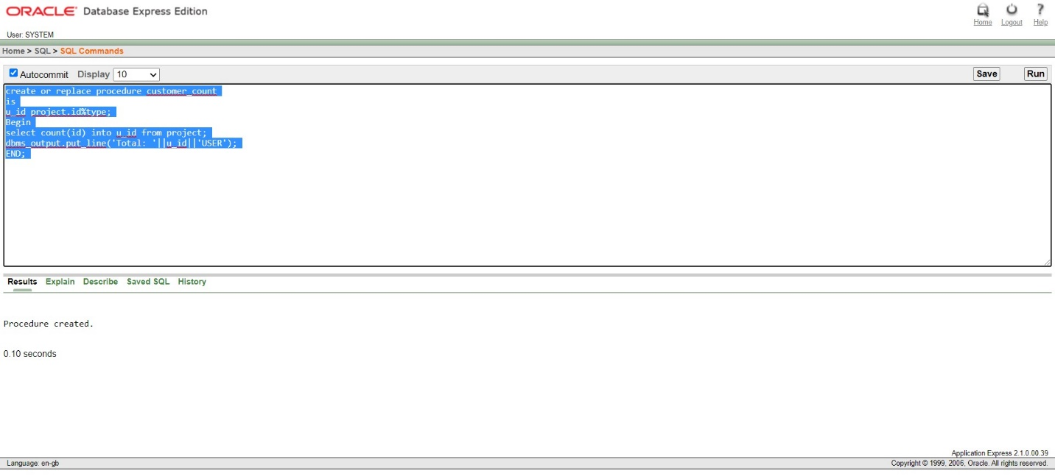

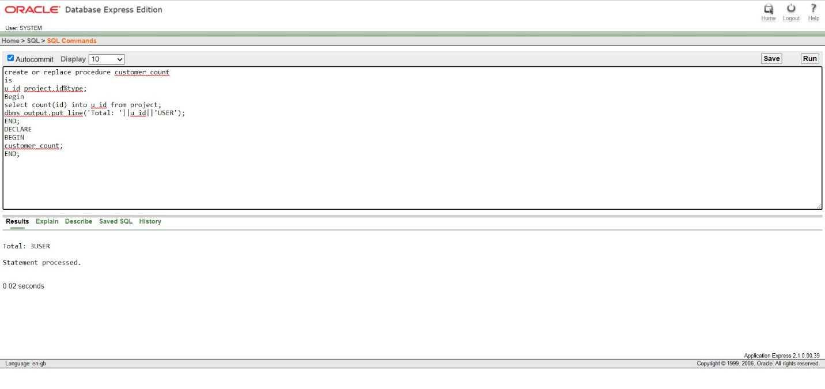

**3.**

CREATE OR REPLACE PROCEDURE Booking_list

IS

v_id NUMBER(4);

v_name VARCHAR2(10);

v_phone NUMBER(15);

v_checkin_date date;

v_checkout_date date;

v_room_type varchar2(50);

v_room_price varchar2(10);

CURSOR book_cur IS

SELECT id, name,phone,checkin_date, checkout_date ,room_type,room_price FROM book ORDER BY id;

BEGIN

OPEN book_cur;

DBMS_OUTPUT.PUT_LINE('Booking ID NAME Phone no CHECKIN DATE CHECKOUT DATE ROOM TYPE ROOM PRICE');

DBMS_OUTPUT.PUT_LINE('---------- ------ ------- ------------- ------------- --------- ----------');

LOOP

FETCH book_cur INTO v_id, v_name,v_phone,v_checkin_date,v_checkout_date,v_room_type, v_room_price;

EXIT WHEN book_cur%NOTFOUND;

DBMS_OUTPUT.PUT_LINE(v_id ||' '|| v_name ||' '||v_phone||' '||v_checkin_date||' '||v_checkout_date||' '||v_room_type||' '|| v_room_price);

END LOOP;

CLOSE book_cur;

END;

DECLARE

BEGIN

Booking_list;

END;

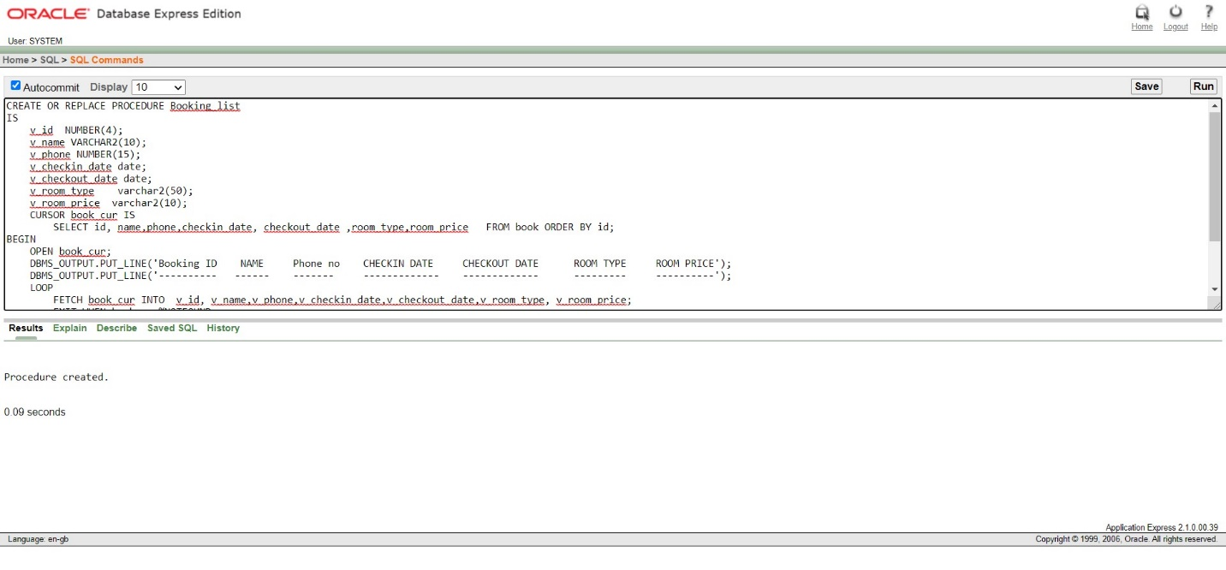

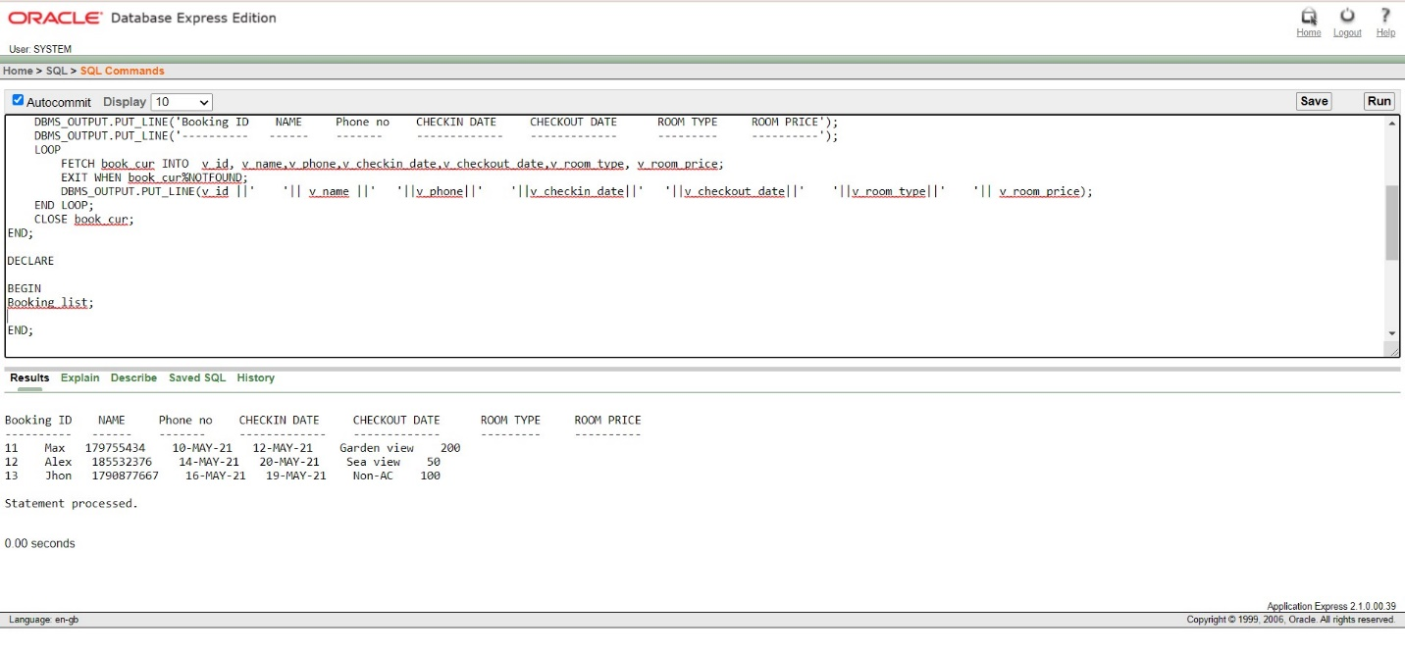

**4.**

CREATE OR REPLACE PROCEDURE update_roomtype(up_roomtype IN roomtype.room_type%TYPE)

IS

BEGIN

UPDATE roomtype

SET room_type ='Vip'

WHERE room_type= up_roomtype;

END;

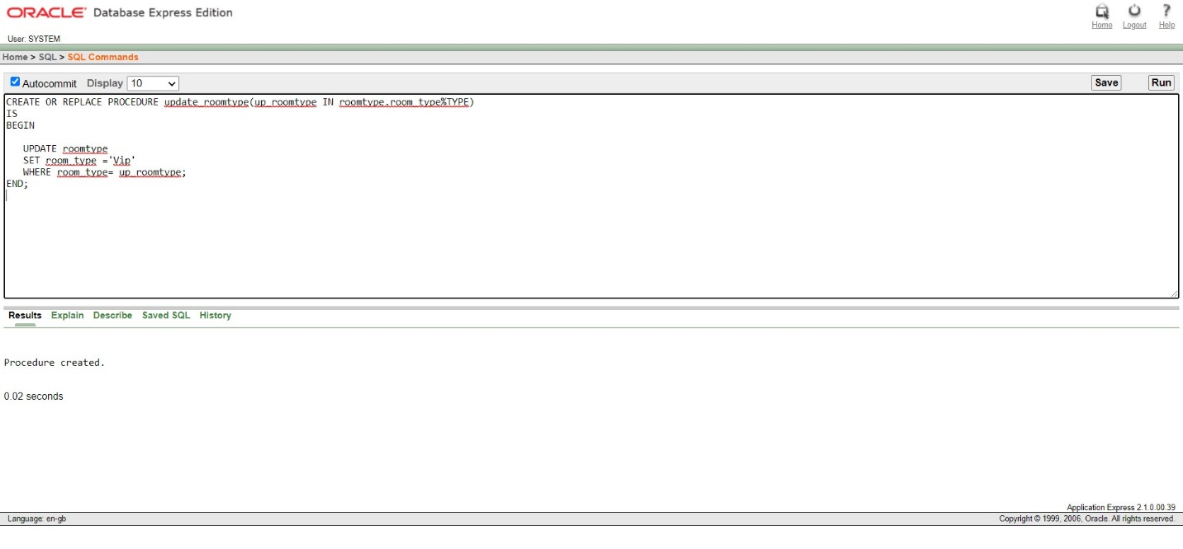

**5.**

create or replace function r_percentage(uno roomdetail.id%type)

return roomdetail.amount%type

is

ramount roomdetail.amount%type;

Begin

select (amount-((amount*10)/100)) into ramount from roomdetail where id=uno;

return ramount;

END;

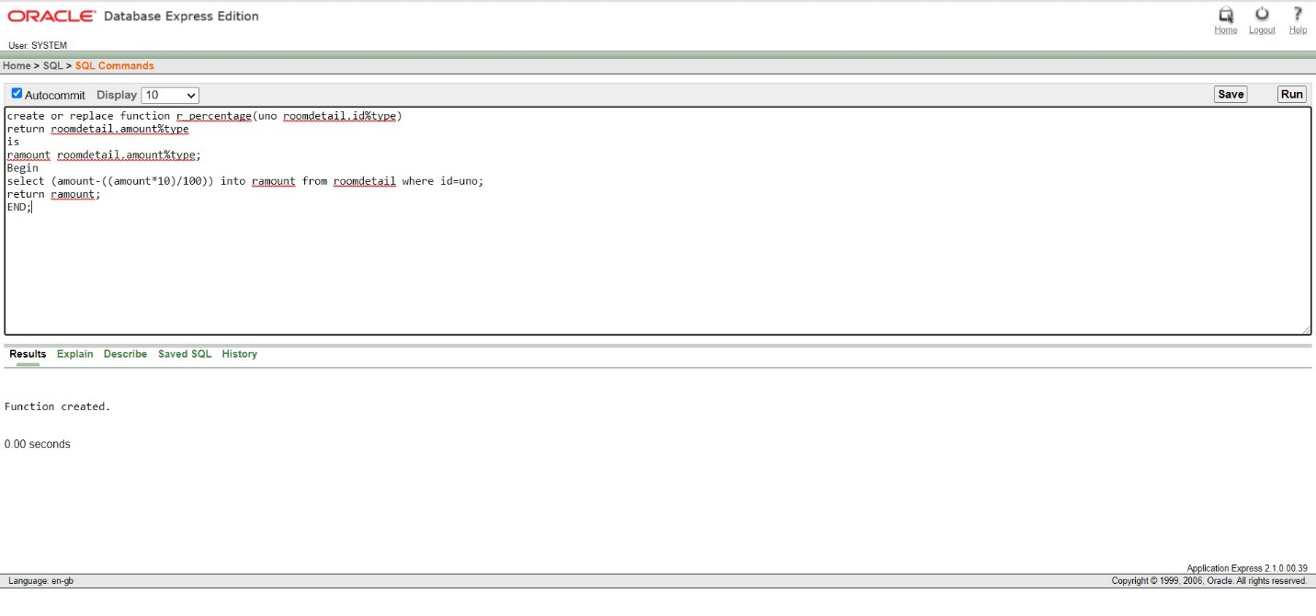

**6.**

create or replace function transportdetails(t_no transport.b_id%type)

return transport.b_name%type

is

tname transport.b_name%type;

Begin

select b_name into tname from transport where b_id=t_no;

return tname;

END;

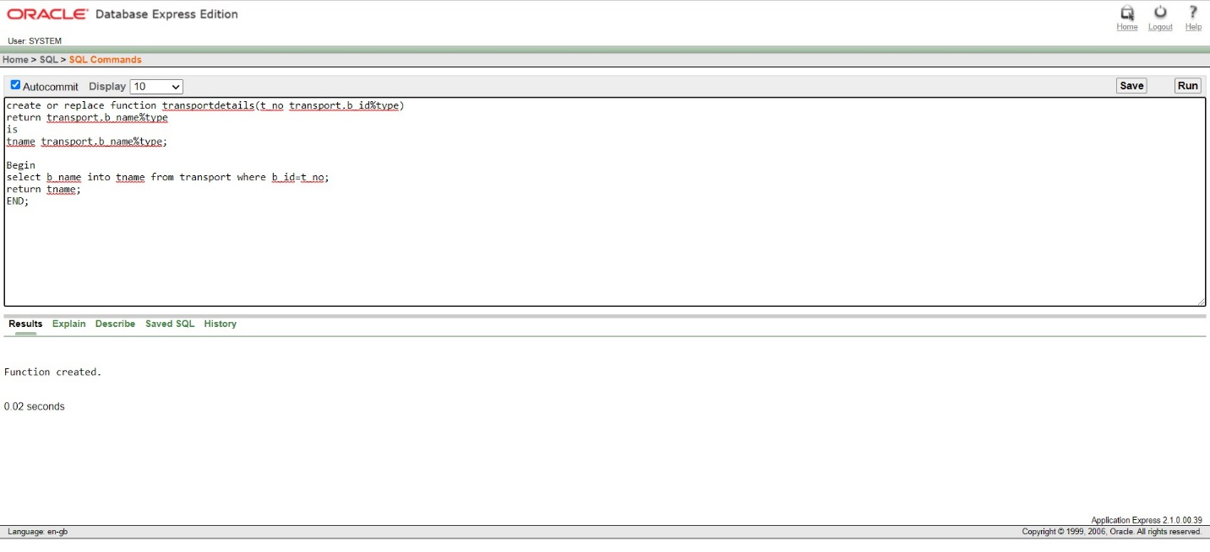

8. **Trigger:**

**1.**

Table:

CREATE TABLE sys_evnt_audit

(

event_type VARCHAR2(30),

logon_date DATE,

logon_time VARCHAR2(15),

logof_date DATE,

logof_time VARCHAR2(15)

);

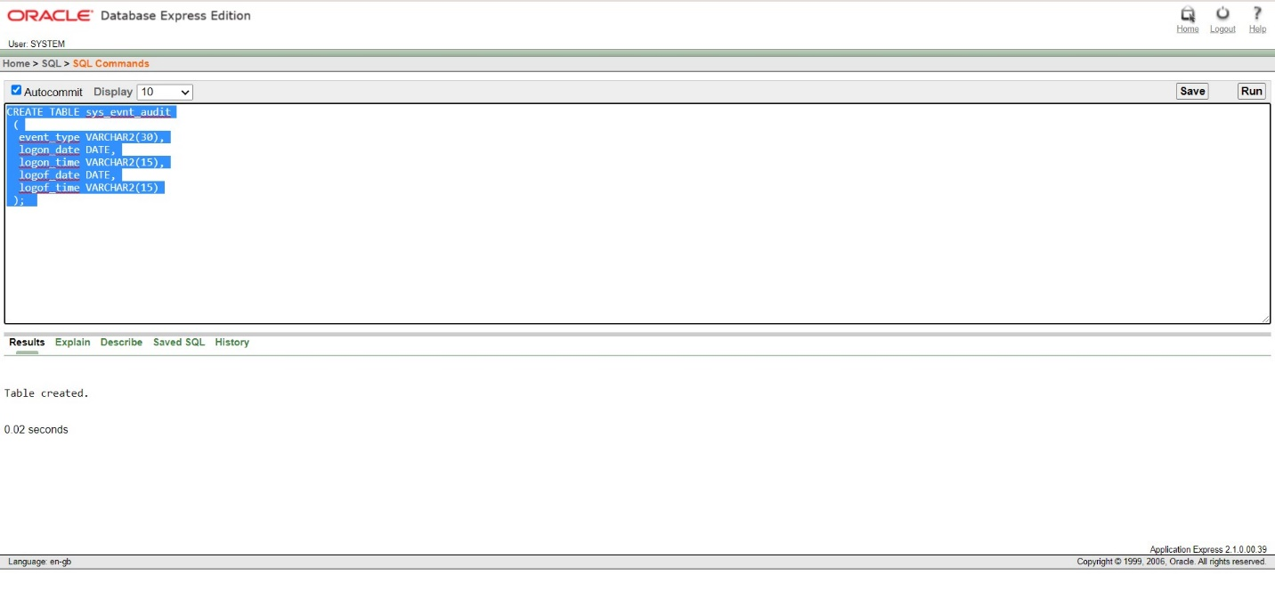

-----------------------------------------trigger--------------------

CREATE OR REPLACE TRIGGER sys_lgon_audit

AFTER LOGON ON SCHEMA

BEGIN

INSERT INTO sys_evnt_audit VALUES(

ora_sysevent,

sysdate,

TO_CHAR(sysdate, 'hh24:mi:ss'),

NULL,

NULL

);

COMMIT;

END;

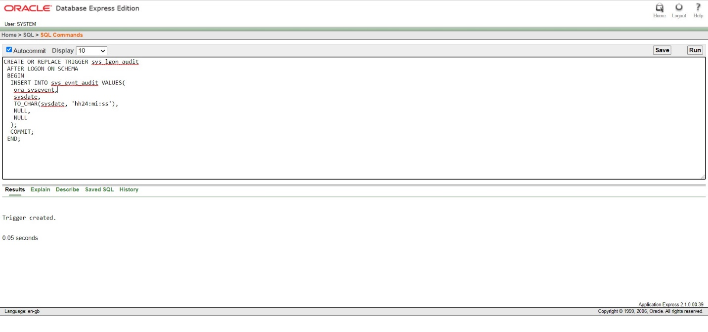

**2.**

Table:

CREATE TABLE sys_evnt_logof

(

event_type VARCHAR2(30),

logon_date DATE,

logon_time VARCHAR2(15),

logof_date DATE,

logof_time VARCHAR2(15)

);

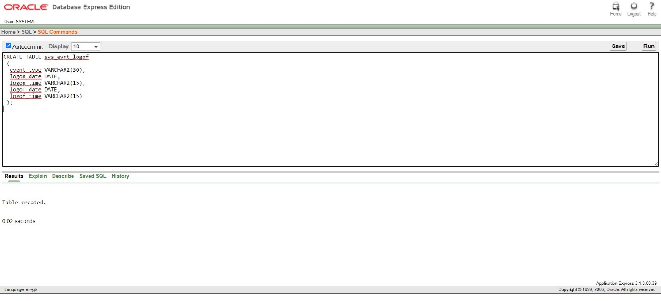

-------------------Trigger----------------------

CREATE OR REPLACE TRIGGER log_off_audit

BEFORE LOGOFF ON SCHEMA

BEGIN

INSERT INTO sys_evnt_logof VALUES

(

ora_sysevent,

NULL,

NULL,

SYSDATE,

TO_CHAR(sysdate, 'hh24:mi:ss')

);

COMMIT;

END;

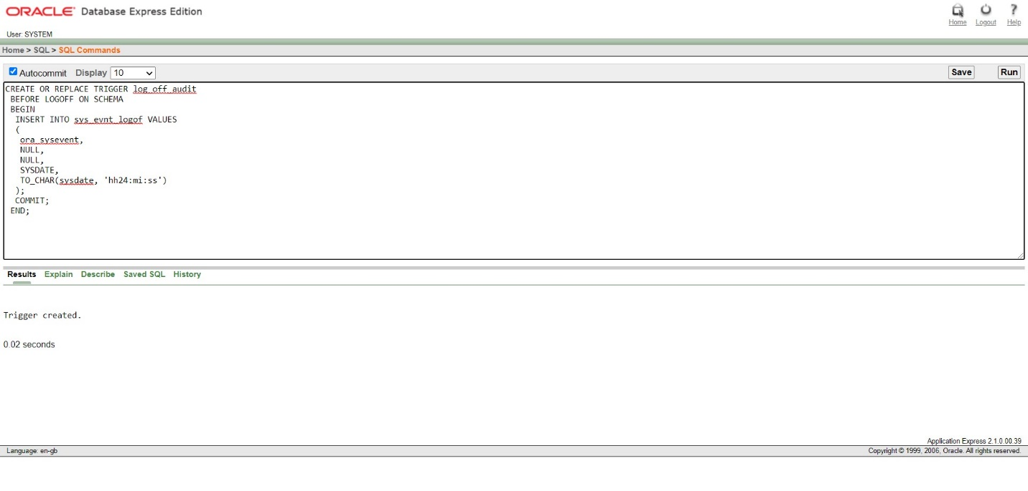

3.

CREATE TABLE project_audit (

new_name varchar2(30),

old_name varchar2(30),

user_name varchar2(30),

entry_date varchar2(30),

operation varchar2(30)

);

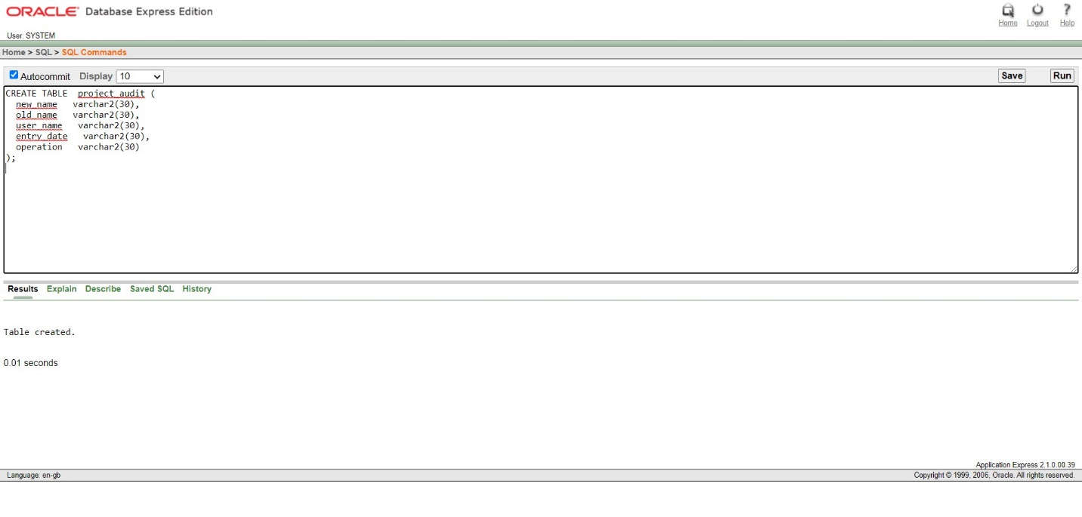

--------------------------trigger-----------------------

CREATE OR REPLACE TRIGGER reg_audit

BEFORE INSERT ON project

FOR EACH ROW

DECLARE

v_user varchar2 (30);

v_date varchar2(30);

BEGIN

SELECT user, TO_CHAR(sysdate, 'MON/DD/YYYY HH24:MI:SS') INTO v_user, v_date FROM dual;

INSERT INTO project_audit VALUES(:NEW.NAME, Null , v_user, v_date, 'Insert');

END;

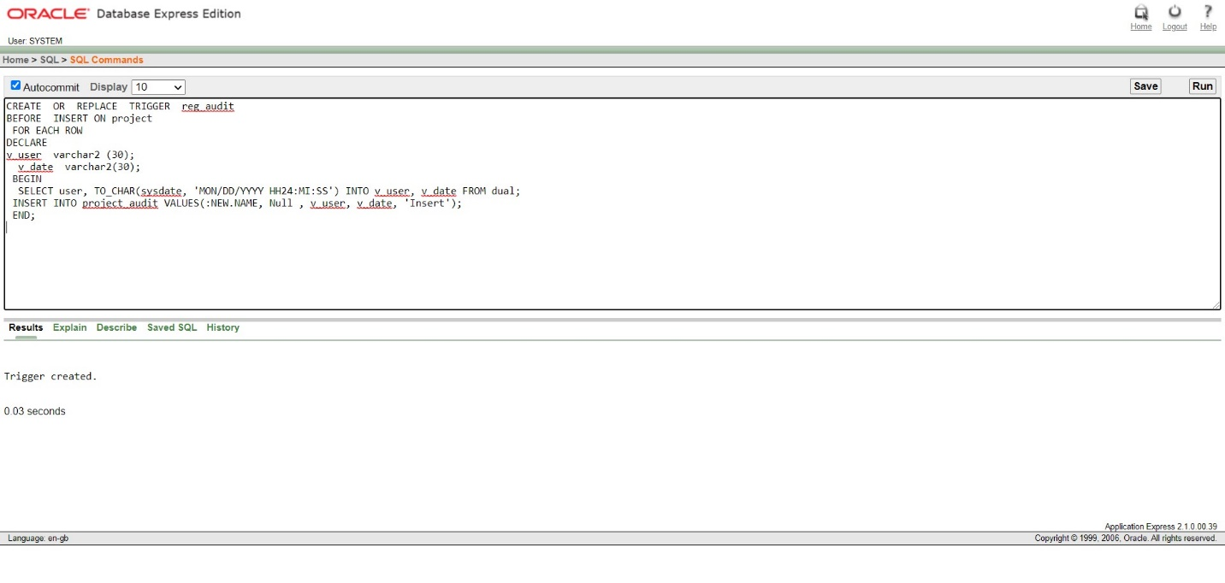

4.

--------------------trigger------------

CREATE SEQUENCE project_seq;

CREATE OR REPLACE TRIGGER project_id

BEFORE INSERT ON project

FOR EACH ROW

WHEN (new.id IS NULL)

BEGIN

SELECT project_seq.NEXTVAL

INTO :new.id

FROM dual;

END;

