**Data Engineer In Medical Industry Report  
Zihan Ma**

**Northeastern University College of Professional Studies - ALY 6000**

**Professor: Dr. Dee Chiluiza Reyes**

**02/14/2023**

**INTRODUCTION**



As big data continues to transform industries, the medical industry has not been left behind. As data becomes an increasingly essential resource in today’s economy, the role of data engineers in the medical industry has significantly changed due to the influx of big data. Because the medical industry generates much more amounts and data types daily, data engineering has become more critical than ever before. The vast amount of data generated by electronic health records, clinical trials, and research studies requires a robust data management infrastructure to ensure that the data is collected, stored, and processed efficiently and accurately. (Dash et al., 2019) In this report, we will examine how the advent of big data has transformed the role of data engineers in the medical industry. We’ll look at the new skills and expertise that data engineers need to succeed, their challenges in this rapidly evolving field, and how their work contributes to better health outcomes for patients worldwide.



**HOW BIG DATA INFANLANCE DATA ENGINEER IN MEDICAL INDUSTRY ANALYSIS**

**How has data analytics evolved in the medical industry?**

Data analytics has significantly evolved in the medical industry with the influx of big data. In the project from IBM, Watson Health’s main page states under the Healthcare data analytics overview section. In the past, medical data was mainly used for research purposes, and it was challenging to get insights from it. Today, data analytics has become essential for clinical decision-making, drug development, and patient care. Here are some ways that data analytics has evolved in the medical industry:

1. Machine learning: Machine learning has become an essential tool for data engineers in the medical industry after the existence of big data. When analyzing large amounts of data, machine learning algorithms can identify patterns and predict outcomes, even if we don’t know what do we looking for, which is impossible for human analytics. And this will help medical professionals develop personalized treatment plans, identify potential drug targets, and more. (Johnson et al., 2021)
2. Predictive analytics: Through machine learning, we can gather data from electronic health records and wearable devices and predict the patient’s health stats, which is very helpful for locating the patient who might need medical treatment soon, which Foreseemed explained on their website in detail for how predictive analytics works.
3. Real-time data analysis: Real-time data analysis utilizes the data from wearable devices, but it’s more focused on short-term predictions related to emergencies.
4. Precision medicine: Data analytics has been instrumental in developing precision medicine. Which helps avoid the possible sequela and minimize the drug cost.  
   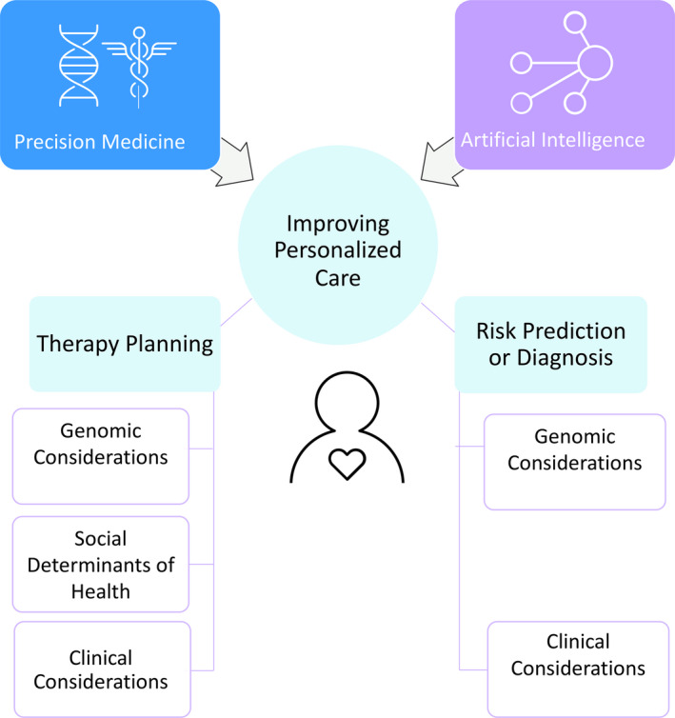



Figure Precision Medicine, AI, and the Future of Personalized Health Care

**Are there any ways in which big data has disrupted the medical industry?**

Big data has disrupted the medical industry in several ways. It has caused significant improvements in medical research and patient care. But it also created new challenges in data privacy and security area.

1. Medical research: By the ability of machine learning to create a pattern on the existing data, the researchers are way more efficient in making new medicine and researching unknown disease treatments.
2. Big data improved patient care by predicting disease outbreaks, reducing wait times, and improving hospital efficiencies.
3. Data privacy and security have been threatened because the new law for preventing patient private leaking is still improving. During the analysis process, more and more people other than the doctor and patient have a chance to access their health records, which has caused a severe crisis of confidence in the past few years.

**What are the organizational roles associated with data analytics in the medical industry?**

There are several organizational roles associated with data analytics in the medical industry. Here are some of the most common positions:

1. Data Analyst: The data analyst uses tools like SQL, Python, and R to extract data from various sources, manipulate the data, and create visualizations that help medical professionals make informed decisions.



1. Data Scientist: The data scientist works with large datasets to identify patterns and develop models that predict outcomes.



1. Data Engineer: The data engineer is responsible for designing and maintaining the data architecture that underpins the organization’s data analytics initiatives.
2. Healthcare IT Manager: The healthcare IT manager manages the organization’s IT infrastructure, including the hardware and software used for data analytics.

**Are there any that are unique to the industry?**  
Although some jobs in the medical industry are very unique, I still don’t think they have much difference when it comes to actual daily task.

Figure Healthcare Data Analyst: Skills Employers Request

**What is the current demand for data analytics talent in the Medical industry?**The demand for data analytics talent in the medical industry is expected to continue to grow in the coming years. As the medical industry is producing more data than ever in the big data era, more and more data analytics will be needed through the growth of the medical industry. It will be one-sided if we only list the changes in a few related jobs, but the development of the entire medical industry should be able to prove the demand for analytics talent in the medical industry.

In a report from Grand View Research, the global healthcare analytics market size was valued at USD 10.18 billion in 2020. And It’s expected to grow at a compound annual growth rate (CAGR) of 20% from 2022 to 2030.  
  
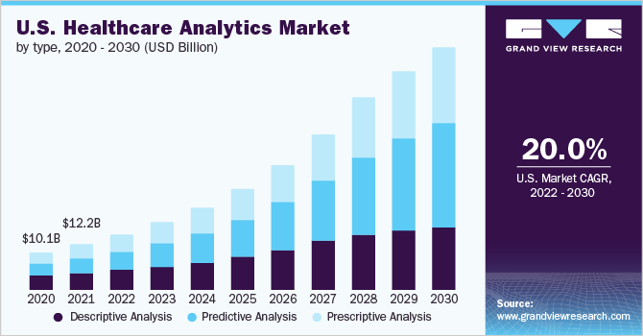



Figure : Healthcare Analytics Market Size (US)

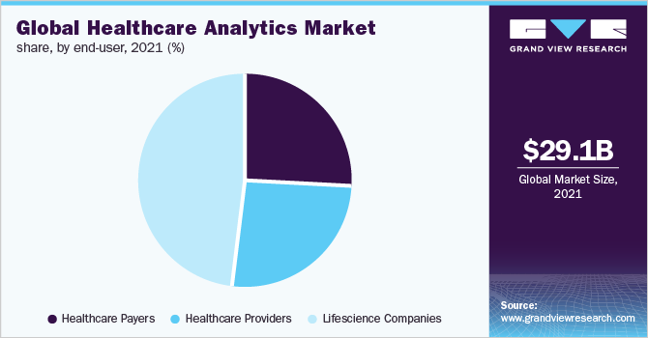



Figure Healthcare Analytics Market Size (Global)

From another report written by the burning glass, from 2012 to 2016, Health care industries hired 68% more data analysts during five years gap, and since the recent covid outburst, I believe there only will be more medical companies notice the importance of a professional data worker in their companies.

Figure Data Analyst in Health Care

Figure 3 is a plot from the report which writes after covid-19 happened and globally wise, which shows the CAGR increased compared to Figure 1 even in a shorter period.

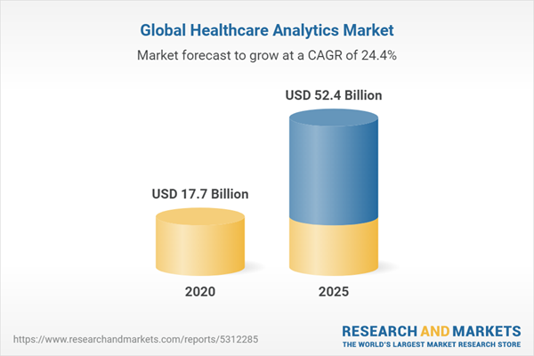

Figure Global Healthcare Analytics Market (2020-2025) by Type, Components, Application, Delivery Model, End-User, Geography, Competitive Analysis and the Impact of Covid-19 with Ansoff Analysis

**What makes working as a data engineer in the medical industry your ideal career?**



Firstly, the medical industry is more data-sensitive than all others. As a data engineer, I can utilize the knowledge I have or will learn in my major (Computer science/Analytics), which I have an advantage over people in other majors.  
Secondly, working in the medical industry is very rewarding mentally. As a person who likes to help people around, I could walk further if I enjoy the effort that brings out by my work.   
Last, I was born into a medical family. Both of my patients are working in the hospital, and they will be happy to see their child can also walk along their path.



**What specific role would you like to play?**

I prefer a job related to health application development since it does not need that much medical background compared to a research position.

**CONCLUSIONS**

**Conclusions:**

As the medical industry continues to embrace digital health technologies and generate even more data, the demand for data analytics talent is expected to grow, according to the report above. Also, on health analytics, the author Jennifer Bresnick said that “96 percent of business leaders believe that a big data analytics strategy is vital for the future success of their enterprises.” and “just 38 percent of healthcare organizations are fully staffed for their health IT needs.” Which directly proved the future of a data engineer in the healthcare industry.

**Bibliography**

Dash, S., Shakyawar, S. K., Sharma, M., & Kaushik, S. (2019, June 19). *Big Data in Healthcare: Management, analysis and future Prospects - Journal of Big Data*. SpringerOpen. Retrieved February 14, 2023, from https://journalofbigdata.springeropen.com/articles/10.1186/s40537-019-0217-0

Healthcare Analytics Market Size & Share Report, 2030. (n.d.). Retrieved February 14, 2023, from https://www.grandviewresearch.com/industry-analysis/healthcare-analytics-market

HealthITAnalytics. (2017, May 8). *48% of businesses, including healthcare, face Big Data Skills Gap*. HealthITAnalytics. Retrieved February 14, 2023, from https://healthitanalytics.com/news/48-of-businesses-including-healthcare-face-big-data-skills-gap

Hillier, W., Will Hillier Contributor to the CareerFoundry blogA British-born writer based in Berlin, Will Hillier Contributor to the CareerFoundry blog, Hillier, W., blog, C. to the C. F., & A British-born writer based in Berlin. (2023, January 30). *A step-by-step guide to the data analysis process [2023]*. CareerFoundry. Retrieved February 13, 2023, from https://careerfoundry.com/en/blog/data-analytics/the-data-analysis-process-step-by-step/

ltd, R. and M. (n.d.). *Global Healthcare Analytics Market (2020-2025) by type, components, application, delivery model, end-user, geography, competitive analysis and the impact of covid-19 with Ansoff analysis*. Research and Markets - Market Research Reports - Welcome. Retrieved February 14, 2023, from https://www.researchandmarkets.com/reports/5312285/global-healthcare-analytics-market-2020-2025-by

Johnson, K. B., Wei, W.-Q., Weeraratne, D., Frisse, M. E., Misulis, K., Rhee, K., Zhao, J., & Snowdon, J. L. (2021, January). *Precision Medicine, AI, and the Future of Personalized Health Care*. Clinical and translational science. Retrieved February 14, 2023, from https://www.ncbi.nlm.nih.gov/pmc/articles/PMC7877825/

*Predictive analytics in healthcare - benefits & regulation*. ForeSee Medical. (n.d.). Retrieved February 14, 2023, from https://www.foreseemed.com/predictive-analytics-in-healthcare

*Report: Data Analyst in health care - burning glass technologies*. (n.d.). Retrieved February 14, 2023, from http://www.burning-glass.com/wp-content/uploads/HCM-Report-Data-Analyst-in-Health-Care-091217-v017.pdf