Week 3

R Output.R

Student Name: Zihan Ma

Class NameALY6010: Probability Theory and Introductory Statistics

Instructor: Tom Breur

03/12/2023

First, in table 1 below, we can see that the three Southern states' incomes are higher than the average US median income. But most of the Southern has a lower income median. This information can tell us that there is variability in median household incomes across the Southern states. It can also suggest that there may be factors that contribute to higher or lower incomes in certain states. Further analysis and research would be needed to understand these differences' underlying factors and causes.

In the book "The geography of opportunity: Race and housing choice in metropolitan America," the authors said that numerous studies have shown that Southern states have lower median household incomes compared to the national average, which may reflect the lasting impact of historical and cultural differences between the North and the South (Wilson & Talbert, 2019). That could show us the reason why the average income is lower in Southern states.

A t-test is used to compare means of samples when the population variance is unknown, while a z-test is used for large samples when the population variance is known. A paired t-test is used for dependent samples, and for independent samples, an independent t-test is used. An F-test is used to test the ratio of two population variances, and a z-test is used for the difference of two population proportions. In comparing the median income of Southern states to the US as a whole, a two-sided one-sample t-test is appropriate, with the null hypothesis that the median incomes are equal and the alternative hypothesis that they are different. The p-value (0.05637) is greater than the significance level (0.05), indicating that we fail to reject the null hypothesis, and the 95% confidence interval (46210.22, 55661.28) includes the null value of 55520, suggesting that there is not enough evidence to conclude that the median income of Southern states is significantly different from the median income of the US as a whole.

Here is the code and result:

# Running a one-sample t-test

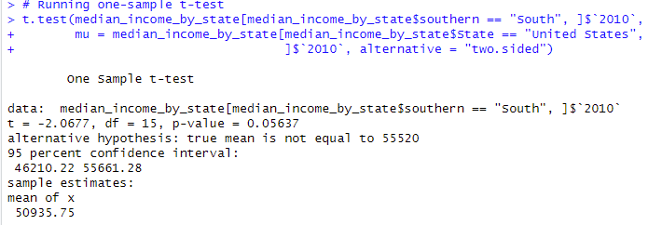

References:

Wilson, C., & Talbert, R. (2019). The geography of opportunity: Race and housing choice in metropolitan America. Routledge.