Module4ROutput_ZihanMa_03.19.2023

Student Name: Zihan Ma

Class Name: ALY6010: Probability Theory and Introductory Statistics

Instructor: Tom Breur

03/19/2023

**Introduction:**

In this report, we examine the World Happiness dataset to determine whether wealthy individuals experience greater happiness than those with less financial means. To address this query, we employ a two-sample t-test with unequal variance and a significance level of α = 0.05.

**Dataset:**

The dataset used in this report came with the homework, which name is "world_happiness_report  
_20230314.csv". This dataset ranks countries based on their happiness levels, considering factors such as GDP per capita, social support, healthy life expectancy, freedom, generosity, and perceptions of corruption, which offers valuable insights into the well-being and happiness of people worldwide.

The dataset has already been cleaned, and this report will only focus on the factors related to the hypothesis.

**Hypotheses:**

The null hypothesis (H₀) posits that there is no significant disparity in happiness levels between affluent and impoverished individuals. Conversely, the alternative hypothesis (H₁) contends that a considerable distinction in contentment exists between these two groups.

H₀: μ₁ = μ₂  
H₁: μ₁ ≠ μ₂

Where μ₁ is the mean happiness score of rich people and μ₂ is the mean happiness score of poor people.

**R Output:**

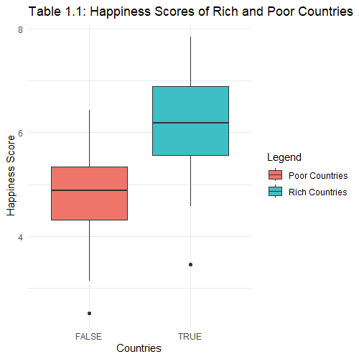

**Observation:**

This boxplot shows a clear difference in happiness scores between rich and developing countries. Rich countries have higher happiness scores, with the median score being noticeably higher than developing countries. The interquartile range (IQR), represented by the height of the boxes, is smaller for rich countries, indicating a more consistent level of happiness among them. In contrast, developing countries exhibit a more comprehensive range of happiness scores. Additionally, there are a few outliers in the developing countries group with relatively high happiness scores compared to the rest. The boxplot suggests that rich countries generally have higher happiness scores than developing countries.

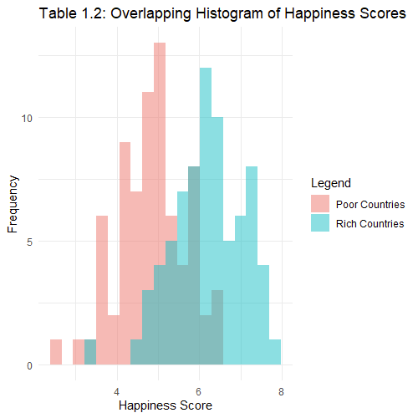

**Observation:**

This histogram shows that rich countries have a more concentrated distribution of happiness scores, peaking around 6.5 to 7.0. On the other hand, developing countries exhibit a wider distribution of happiness scores, with a peak of around 4.5 to 5.0. The overlap between the two histograms is minimal, indicating a clear distinction in happiness scores between rich and developing countries. This graph supports the finding from the boxplot that happiness scores are generally higher for rich countries than for developing countries.

Overall, by combining the result of the two graphs, we can confirm possible relationships between happiness score and wealth level, which means our hypothesis is worth examining.

**Interpretation:**

We dismiss the null hypothesis with a p-value below 0.05, concluding that a notable difference in happiness between wealthy and less fortunate individuals is present. The average happiness score for developed nations is 6.20, while for developing countries, it stands at 4.85.

**Significance Level Change:**

Altering the significance level from 0.05 to 0.1 would not impact our conclusion, as the p-value remains substantially smaller than 0.05 and 0.1.

**Justification of the Test:**

We opted for the two-sample t-test with unequal variance to compare the mean values of two independent groups: developed and developing countries. We don't assume equal variances because the variance in happiness scores might differ between the two groups. Other tests, such as a paired t-test, are not appropriate here because the data points in the two groups are not paired or dependent.

**Summary:**

In conclusion, our analysis shows that happiness scores are generally higher in rich countries compared to developing countries. This finding is supported by the study conducted by Stutzer (2003), which states that higher income aspirations lead to reduced satisfaction with life, ceteris paribus. This implies that the absolute level of income and consumption is essential for individual well-being, but people's aspirations also play a critical role in determining their overall happiness. The importance of relative income is further emphasized by Boyce, Brown, and Moore (2010), who propose that an individual's utility is influenced not by their total income but by their ranked position within a comparison group. Thus, being among people richer than oneself can harm one's well-being.

Our analysis reveals a clear distinction in happiness scores between rich and developing countries, which can be attributed to differences in income and relative positions within their respective societies. Further research may be needed to explore other factors contributing to happiness and well-being and potential policy implications for promoting greater happiness and reducing income inequality.

References:

world_happiness_report_20230314.csv. https://northeastern.instructure.com/courses/131412/files/20477276?wrap=1. (n.d.). Retrieved March 19, 2023.

Boyce, C. J., Brown, G. D. A., &amp; Moore, S. C. (2010). Money and happiness. Psychological Science, 21(4), 471–475. https://doi.org/10.1177/0956797610362671

Stutzer, A. (2003). The role of income aspirations in individual happiness. Journal of Economic Behavior & Organization, 54(1), 89-109. https://doi.org/10.1016/j.jebo.2003.04.003