**ALY6050 80478 Intro to Enterprise Analytics SEC 09 Spring 2023 CPS**

**Module 6 Assignment — Transshipment & Risk Minimizing Problem REPORT**

**NORTHEASTERN UNIVERSITY**

**College of Professional Studies, Boston, MA, 02215.**

**Submitted by**

Zihan Ma

ma.zihan1@northeastern.edu

**Instructor**

 Prof. Richard He

**Date**

06/26/2023

**Transshipment & Risk Minimizing Problem**

**Part I: Rockhill Shipping & Transport Company**

**Assignment Introduction:**

This project involves devising optimal waste shipment strategies for Rockhill Shipping & Transport Company, taking into consideration the various constraints such as weekly waste production at each plant, shipping costs, and maximum disposal capacities at the waste disposal sites. We will explore different shipment scenarios including direct shipping and shipping with transshipment. The analysis will be carried out with the help of Excel Solver, a powerful tool for performing complex optimization tasks. We will also examine the effects of increased disposal capacities on the shipping plans, aiming to extract insights that would help minimize costs and enhance efficiency.

**Shipping Plan Without Transport:**

**Constructed the Table:**

1. First, I copied the structure of the table, which includes the names of the plants and the waste disposal sites, but I left the cells where the shipping amounts would go empty. This created a space for the Solver to work with.
2. Next, I set up a "Sent" column to the right of my main table. This column is calculated by taking the sum of the barrels sent from each plant to all disposal sites. For instance, for Denver, I add up the barrels sent to Orangeburg, Florence, and Macon to get a total of 65 barrels, which matches Denver's weekly waste production. This step ensures that all waste produced at a plant is accounted for in my shipping plan.
3. Similarly, I set up a "Received" row below my main table. This row is calculated by taking the sum of the barrels received at each disposal site from all plants. For example, for Orangeburg, I add up the barrels received from Denver, Morganton, Morrisville, Pineville, Rockhill, and Statesville to get a total of 90 barrels. This number does not exceed Orangeburg's maximum capacity of 90 barrels, ensuring the disposal site is not overloaded.

**Constraints Explanation:**

Break down the constraints applied in Solver:

1. The values in the light blue area (the number of barrels shipped from each plant to each waste disposal site) must be integers greater than 0: This constraint ensures that the solution makes sense in a real-world context. You can't ship a fraction of a barrel, so all shipping quantities must be integers. Additionally, since you can't ship a negative number of barrels, all shipping quantities must be greater than or equal to 0.
2. All sent out shipment for each place must equal to the weekly waste amount: This constraint ensures that all waste produced at a plant is shipped out to a disposal site. Essentially, it makes sure that no waste is left behind at the plants.
3. Every waste site's final received must be less than or equal to each's maximum capacity: This constraint ensures that the waste received at each disposal site does not exceed the maximum capacity of the site. Essentially, it makes sure that the disposal sites are not overloaded with waste.

These constraints are vital for the model to accurately reflect the real-world conditions of this shipping problem. Without them, the model might suggest unrealistic or unfeasible solutions. For instance, it might suggest shipping fractions of barrels, leaving waste behind at the plants, or overloading the disposal sites, all of which are not acceptable in practice.

**Result Interpretation:**

Here's the breakdown of the shipping plan:

1. Denver: All 65 barrels of waste from Denver are shipped directly to Orangeburg.
2. Morganton: All 35 barrels of waste from Morganton are shipped directly to Florence.
3. Morrisville: All 60 barrels of waste from Morrisville are shipped directly to Macon.
4. Pineville: The 50 barrels of waste from Pineville are split between Orangeburg and Macon, with 25 barrels going to each disposal site.
5. Rockhill: All 40 barrels of waste from Rockhill are shipped directly to Florence.
6. Statesville: The 50 barrels of waste from Statesville are split between Florence and Macon, with 25 barrels going to each disposal site.

The total cost of this direct shipping strategy is $3,165.

**Shipping Plan With Transport:**

**Constructed the Table:**

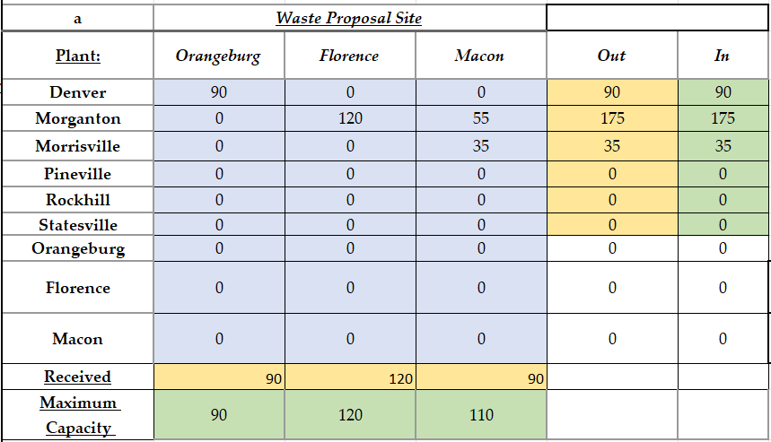

1. To start, I copied over the structure of the Plant x (Plant & Waste Site) table. I removed the shipping amount data to create a 6x9 matrix. This allowed room for Solver to find the optimal shipping amounts. This table is a representation of the first stage of transshipment where the waste can go from any plant to any place.
2. Next, I calculated the sent and received amounts for each location by summing the respective rows and columns.
3. For the second stage of transshipment, I created a new table to track the flow of waste from the intermediate points (which could be either plants or waste disposal sites) to the waste disposal sites. This was done by copying the (Plant & Waste Site) x Waste Sites table and again removing the data to allow Solver to work.
4. I then added up the total waste going in and out of each location and compared that to the total waste that needed to be disposed of. For waste sites, I added an additional constraint that accounted for the maximum capacity of each site.
5. Finally, I calculated the total cost by applying the shipping prices to the shipping amounts. This was done for both stages of transshipment and the results were summed to give the total cost.

**Constraints Explanation:**

I created the following constraints for the Solver to work within:

1. Each value in the areas containing the transit amount (colored light blue) must be an integer greater than or equal to zero. This reflects the fact that we can't ship a negative amount of waste or a fraction of a waste barrel.
2. The total waste sent out from each plant must be equal to the weekly waste amount for that plant. This ensures that all waste is accounted for and no waste is left behind at the plants. This constraint only applies to the plant-to-site part of the second step because the waste disposal sites don't have to dispose of their entire stock.
3. The total amount of waste received by each waste site must be less than or equal to the site's maximum capacity. This ensures that we don't overfill the waste sites.
4. The total amount of waste received must remain the same across both steps, which is 300 barrels per week.

**Result Interpretation:**

After running the Solver, I found the optimal solution which minimized the total cost while adhering to all constraints. In the first step of the transshipment, waste was shipped from one plant to another, with Denver sending all of its waste to Morganton, and so forth. In the second step of transshipment, the waste was shipped from these intermediate points to the final waste disposal sites.

The costs for the first and second steps were $860 and $2525, respectively, yielding a total cost of $3385.

By considering transshipment options, we could reduce costs and maximize efficiency. This in-depth analysis not only helped to determine the optimal routes and their respective costs, but it also provided insight into how much waste will be transported each week from a source to a destination.

**Shipping Plan With Incerase Of Capacity:**

**Construction of the Table:**

To investigate how an increase in capacity at each waste disposal site impacts the optimal waste shipping plan, I copied the previous tables and added 10 barrels to the capacity of each waste disposal site.

**Constraints Explanation:**

All the constraints for the Solver remain the same as before. The waste amount sent out from each plant still needs to equal the plant's weekly waste production. The total amount of waste received by each waste site still needs to be less than or equal to the site's capacity, but this time the capacities have been increased by 10 barrels each. And, the total amount of waste received in both steps must still equal 300 barrels per week.

**Result Interpretation:**

With increased capacities, the optimal waste shipping plans for both direct shipping and shipping with transshipment changed slightly.  
  
For direct shipping:

* The waste from Pineville is now divided between Orangeburg and Macon, as opposed to previously when it was divided between Orangeburg and Florence.
* Statesville now sends its waste to Florence and Macon, whereas before it was divided between Orangeburg and Macon.

The total cost of direct shipping with increased capacities is $3125, which is a $40 reduction compared to the original direct shipping plan.  
  
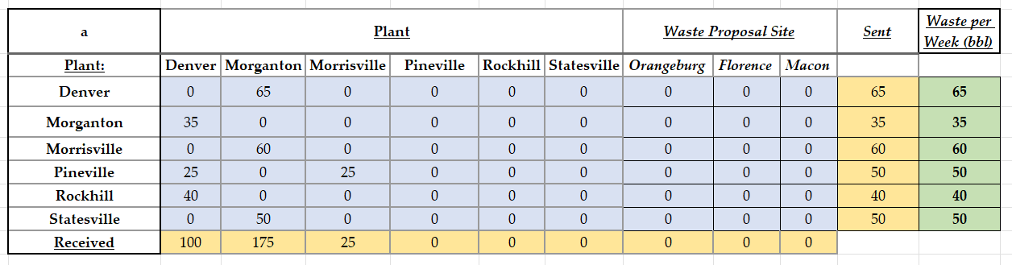  
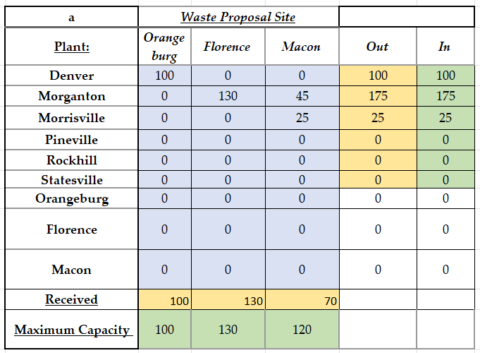

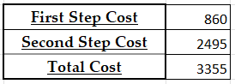

For shipping with transshipment:

* The first step of transshipment remains unchanged.
* In the second step, Morganton now sends more waste to Florence and less to Macon, and Morrisville now sends all its waste to Macon.

The total cost of shipping with transshipment and increased capacities is $3355, a $30 reduction compared to the original transshipment plan.

**Analysis of Differences:**

The increase in capacities at the waste disposal sites allows for more flexibility in the waste shipping plans. This results in a cost reduction in both the direct shipping and transshipment plans, although the reduction is slightly greater for the direct shipping plan.

This suggests that the capacity constraints at the waste disposal sites were limiting factors in the original plans. Relaxing these constraints allowed for better utilization of the plants and disposal sites, leading to a more cost-efficient distribution of waste.

It's worth noting that the transshipment plan still costs more than the direct shipping plan, even with the increased capacities. This suggests that, while transshipment allows for more flexibility in how the waste is transported, it may not always be the most cost-efficient solution. Depending on the specifics of the transportation costs and the capacities at the plants and waste disposal sites, direct shipping might still be the preferred option.

In conclusion, while increasing the capacities at the waste disposal sites leads to cost savings in both scenarios, the choice between direct shipping and transshipment depends on the specific costs and constraints of the situation.

**Conclusion:**

In conclusion, we successfully formulated optimal shipping strategies for Rockhill Shipping & Transport Company for a variety of scenarios using Excel Solver. Both direct shipping and transshipment plans were developed, each demonstrating unique benefits and constraints. While direct shipping offered a lower cost solution, transshipment provided additional flexibility. An increase in waste site capacity led to modest cost reductions for both shipping plans. In essence, this project showcased the value of optimization tools and strategic planning in logistic operations, providing critical insights for efficient and cost-effective waste shipment.

**Part II: Investment Allocations:**

**Assignment Introduction:**

In this section, we will delve into an optimal investment allocation problem involving six asset types: bonds, high-tech stocks, foreign stocks, call options, put options, and gold. Using Excel Solver, we aim to find the optimal allocation to minimize risk while achieving a baseline return of at least 15%. This part also includes constructing a risk-return relation to visually demonstrate the classic financial trade-off between expected return and risk.

**(i) Minimum Risk:**

**Construction of the Table:**

In this problem, we aimed to find an optimal allocation of investments across six asset types - bonds, high tech stocks, foreign stocks, call options, put options, and gold - to minimize risk while maintaining a minimum baseline return of 15%.

1. **Allocation Table**: This table contains the allocation percentages for each asset type that result from the optimization process. The 'Total' row shows the sum of these percentages, which should be 1, indicating that 100% of the investment is distributed across the assets.
2. **Return Calculation Cell**: This cell calculates the expected return of the portfolio, based on the current allocations and the expected returns of each asset type. It uses Excel's SUMPRODUCT function to multiply each asset's allocation by its expected return and sum these products.
3. **Risk Calculation Cell**: This cell calculates the portfolio's risk (variance), based on the current allocations and the covariances between each pair of assets. It uses the matrix multiplication function MMULT and the transpose function TRANSPOSE in Excel. This formula essentially calculates the portfolio variance formula: Variance = w^T * Σ * w, where w is the vector of asset weights (allocation) and Σ is the covariance matrix.

**Constraints Explanation:**

The optimization problem had the following constraints:

1. Each allocation must be greater than or equal to 0. This means that we are not considering short selling in this scenario.
2. The sum of all allocations must be 1, implying all available funds are invested.
3. The expected return of the portfolio, given the current allocations, must be greater than or equal to the baseline return of 15%.

**Result Interpretation:**

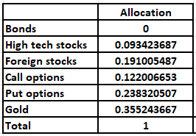



The optimal allocation that minimizes risk while achieving a baseline return of 15% is as follows:

* Bonds: 0% * $250,000 = $0
* High tech stocks: 9.34% * $250,000 = $23,350
* Foreign stocks: 19.10% * $250,000 = $47,750
* Call options: 12.20% * $250,000 = $ 30,500
* Put options: 23.83% * $250,000 = $ 59,575
* Gold: 35.52% * $250,000 = $ 88,800

The total allocation sums to 1, confirming that 100% of the investment funds are allocated.

With this allocation, the portfolio achieves the minimum return of 15% and has a risk measure (portfolio variance) of approximately 0.061. This is the lowest risk that can be achieved for a portfolio with a return of at least 15%, given the expected returns and covariances of these asset types.

**(ii) Return/Risk Relation:**

**Construction of the Table:**

In this exercise, we revisited the optimization process with different baseline returns: 8%, 11%, 14%, 15%, 17%, 20%, and 23%. The table created listed these seven baseline returns.

**Constraints Explanation:**

The constraints remain the same as the previous exercise, but the expected return constraint is adjusted for each of the seven baseline returns. This means for each baseline return, the optimization process is repeated to find the allocations that would minimize the portfolio's risk while achieving at least the given return.

**Result Interpretation:**

After repeating the optimization for each new baseline return, we have a series of minimized risks associated with each return:

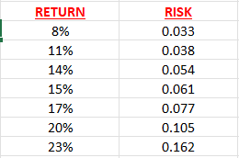

* For an 8% return, the minimum risk is 0.033.
* For an 11% return, the minimum risk is 0.038.
* For a 14% return, the minimum risk is 0.054.
* For a 15% return, the minimum risk is 0.061.
* For a 17% return, the minimum risk is 0.077.
* For a 20% return, the minimum risk is 0.105.
* For a 23% return, the minimum risk is 0.162.

These pairs of return and risk values were plotted on a line graph, with risk on the x-axis and returns on the y-axis.

The line graph showcases the fundamental principle of finance – the trade-off between risk and return. As the required return increases, the risk associated with the portfolio also increases. This makes sense, as to achieve a higher return, we often need to invest in riskier assets, which increases the overall risk of the portfolio.

The graph reveals a positively sloped, presumably convex curve that represents the efficient frontier in modern portfolio theory. It means for each level of return, the risk is minimized, and for each level of risk, the return is maximized. The shape of the graph, especially if it's convex, signifies the concept of diminishing marginal returns, indicating that each additional unit of risk taken on brings a smaller increase in return. This relationship between risk and return is a key consideration for investors when they make investment decisions. They must determine their risk tolerance and find the point on the efficient frontier that provides the highest return for that level of risk.

**Conclusion:**

In summary, this part of the project successfully highlights how Excel Solver can be utilized for portfolio optimization to achieve desired investment outcomes. In the minimum risk scenario, we calculated the optimal allocations to each asset type that minimize risk while ensuring a return of at least 15%. We then extended the problem to explore the relationship between return and risk, showcasing the financial principle of higher returns requiring higher risk tolerance. Through a series of seven baseline returns, we constructed an efficient frontier on a risk-return graph. This graphical representation demonstrates the diminishing marginal returns, a key concept in investment decision-making. The insights derived from this analysis can aid investors in making informed decisions about their investment allocations, aligning them with their financial goals and risk tolerance.