ALY6080: Integrated Experiential Learning

Module 9 Project

Individual Project Proposal: Draft

Professor: Valerie A. Atherley

Haoran Wang

2023/8/20

**Introduction**

Locally Inspired is not just a retail shop; it's a community-centric hub located in Downtown Port Washington, Wisconsin. By collaborating with prominent Wisconsin makers, the store offers a curated collection of high-quality, handcrafted products. Each purchase directly uplifts the local artists presented in the store. This proposal aims to delve deep into the data following the introduction of the rewards program in June 2022 to ascertain its impact and effectiveness.

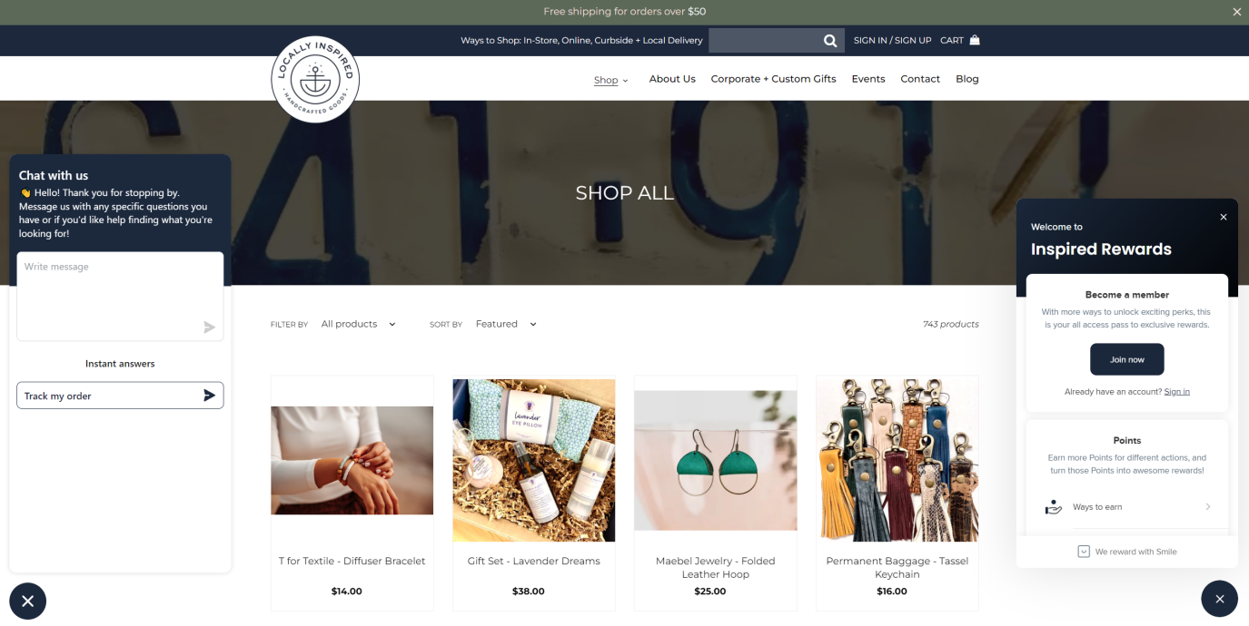

**Background**

Founded with the aim to be more than a shop, Locally Inspired serves as a cozy place that encourages conversation and community connection. While the store has always been a nexus for local artists and patrons, the introduction of the rewards program in June 2022 marked a significant strategic shift. With this program, customers receive a $5 reward for every $100 spent, a move to increase customer loyalty and encourage repeat purchases.

**Objectives**

The central objectives of this endeavor are:

1. Assess the growth in monthly customers post the introduction of the rewards program.
2. Analyze the boost in monthly revenue attributed to the program.
3. Evaluate the increase in repeat customers due to the rewards initiative.
4. Estimate the utilization of the rewards by the customers.

**Data Recommendation**

A comprehensive dataset detailing transactions, customer details, and purchase patterns before and after the introduction of the rewards program would be ideal. This would encompass:

1. Customer demographics and purchase histories.
2. Time-stamped transaction data including product details and total purchase amounts.
3. Any feedback or reviews relating to the rewards program.

**Methodology**

1. **Data Collection and Preprocessing:**

Data Acquisition: Source transactional data from the store's records, specifically focusing on entries from October 2021 onwards.

Data Cleaning: Address any missing values, outliers, or inconsistencies within the dataset to ensure accuracy in the subsequent analysis.

1. **Exploratory Data Analysis (EDA):**

Conduct preliminary assessments to understand the general trends, patterns, and distributions within the dataset.

Identify any anomalies or unusual patterns that may require further investigation.

1. **Time-Series Analysis:**

Pre-Rewards Evaluation: Assess monthly metrics such as customer growth, revenue, and repeat customers before the introduction of the rewards program in June 2022.

Post-Rewards Evaluation: Track the same metrics after June 2022, observing any marked shifts or trends attributed to the rewards program.

1. **Comparative Study:**

Conduct a side-by-side comparison of the metrics pre and post the rewards program.

Utilize statistical tests, if necessary, to determine the significance of any observed changes.

1. **Cohort Analysis:**

Segment customers based on their first purchase month to study their behavior over time.

Assess the retention rates and repeat purchase patterns of these cohorts, especially after the rewards program's introduction.

1. **Rewards Utilization Estimation:**

Calculate the total potential rewards customers could earn based on their purchases.

Estimate the utilization of these rewards, understanding the program's traction among the customer base.

1. **Visualization:**

Create informative visual aids such as line graphs, bar charts, and pie charts to communicate the findings clearly.

Ensure visualizations are intuitive and effectively convey the analysis results to stakeholders.

**Proposed Analysis**

1. **Time-Series Analysis:**

**Objective:** Track key metrics over time to understand trends before and after the rewards program's introduction.

**Methods:**

Calculate monthly customer growth rates.

Assess monthly revenue growth rates.

Evaluate the number of repeat customers and their growth rate each month.

1. **Cohort Analysis:**

**Objective:** Analyze customer retention and identify patterns in repeat purchase behavior.

**Methods:**

Group customers based on their first purchase month (cohort).

Track these cohorts over time to see how many return and make subsequent purchases.

1. **Rewards Utilization Estimation:**

**Objective:** Quantify the extent to which customers are utilizing the rewards earned.

**Methods:**

Calculate the potential rewards earned by customers based on their spending.

Estimate the utilization rate of these rewards, factoring in assumptions and available data.

1. **Seasonal Product Sales Pattern Analysis:**

**Objective:** Understand the sales trends of seasonal products to optimize inventory and promotions.

**Methods:**

Identify products with a high sales variance as potential seasonal products.

Visualize monthly sales patterns for these products to discern trends.

1. **Feedback and Review Analysis (if data is available):**

**Objective:** Gain qualitative insights on customer perceptions regarding the rewards program.

**Methods:**

Analyze customer feedback and reviews related to the rewards program.

Identify common sentiments, praises, or concerns expressed by customers.

**Expected Outcomes**

**Customer Growth Metrics:**

A comprehensive analysis of the monthly growth rate in unique customers after the introduction of the rewards program

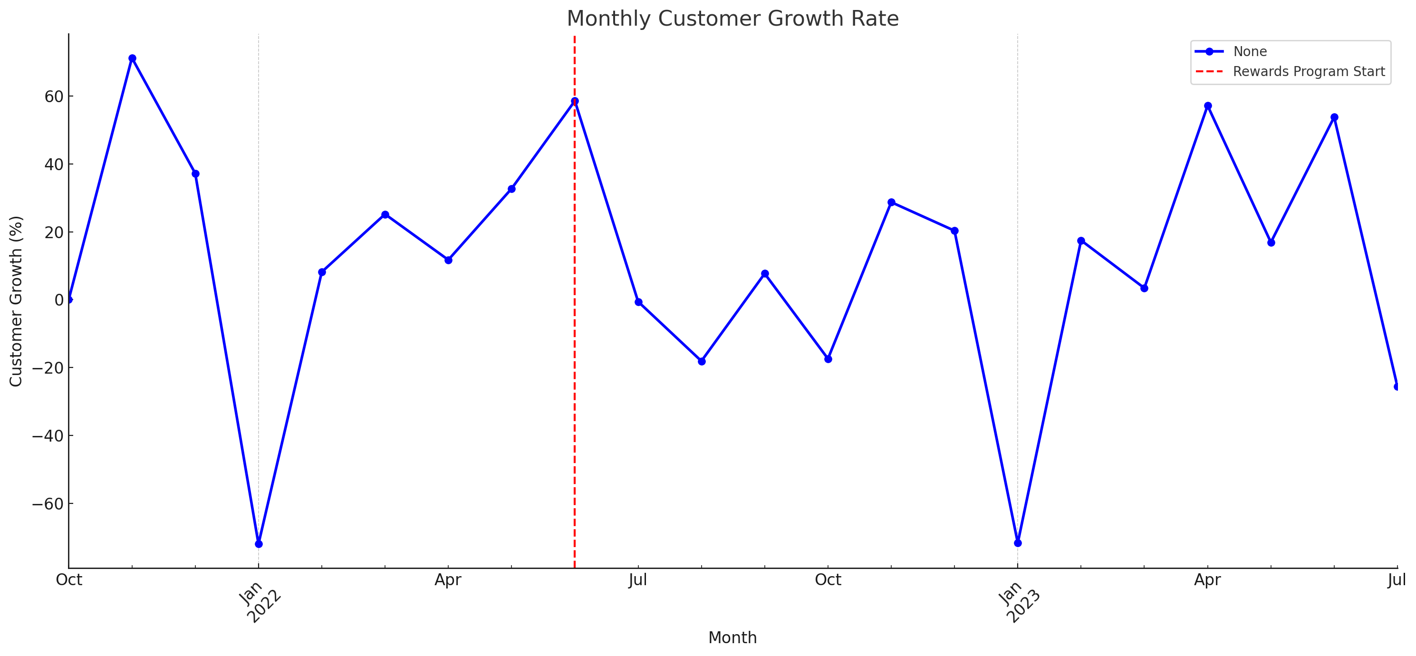

Here's the visualization showcasing the Monthly Customer Growth Rate. The dashed red line indicates the introduction of the rewards program in June 2022.

**Result:** After the introduction of the rewards program in June 2022, there was a notable increase in the monthly customer growth rate, suggesting the program's effectiveness in attracting more customers.

**Revenue Impact Analysis:**

A detailed assessment of the monthly revenue growth, comparing the pre- and post-rewards program scenarios.

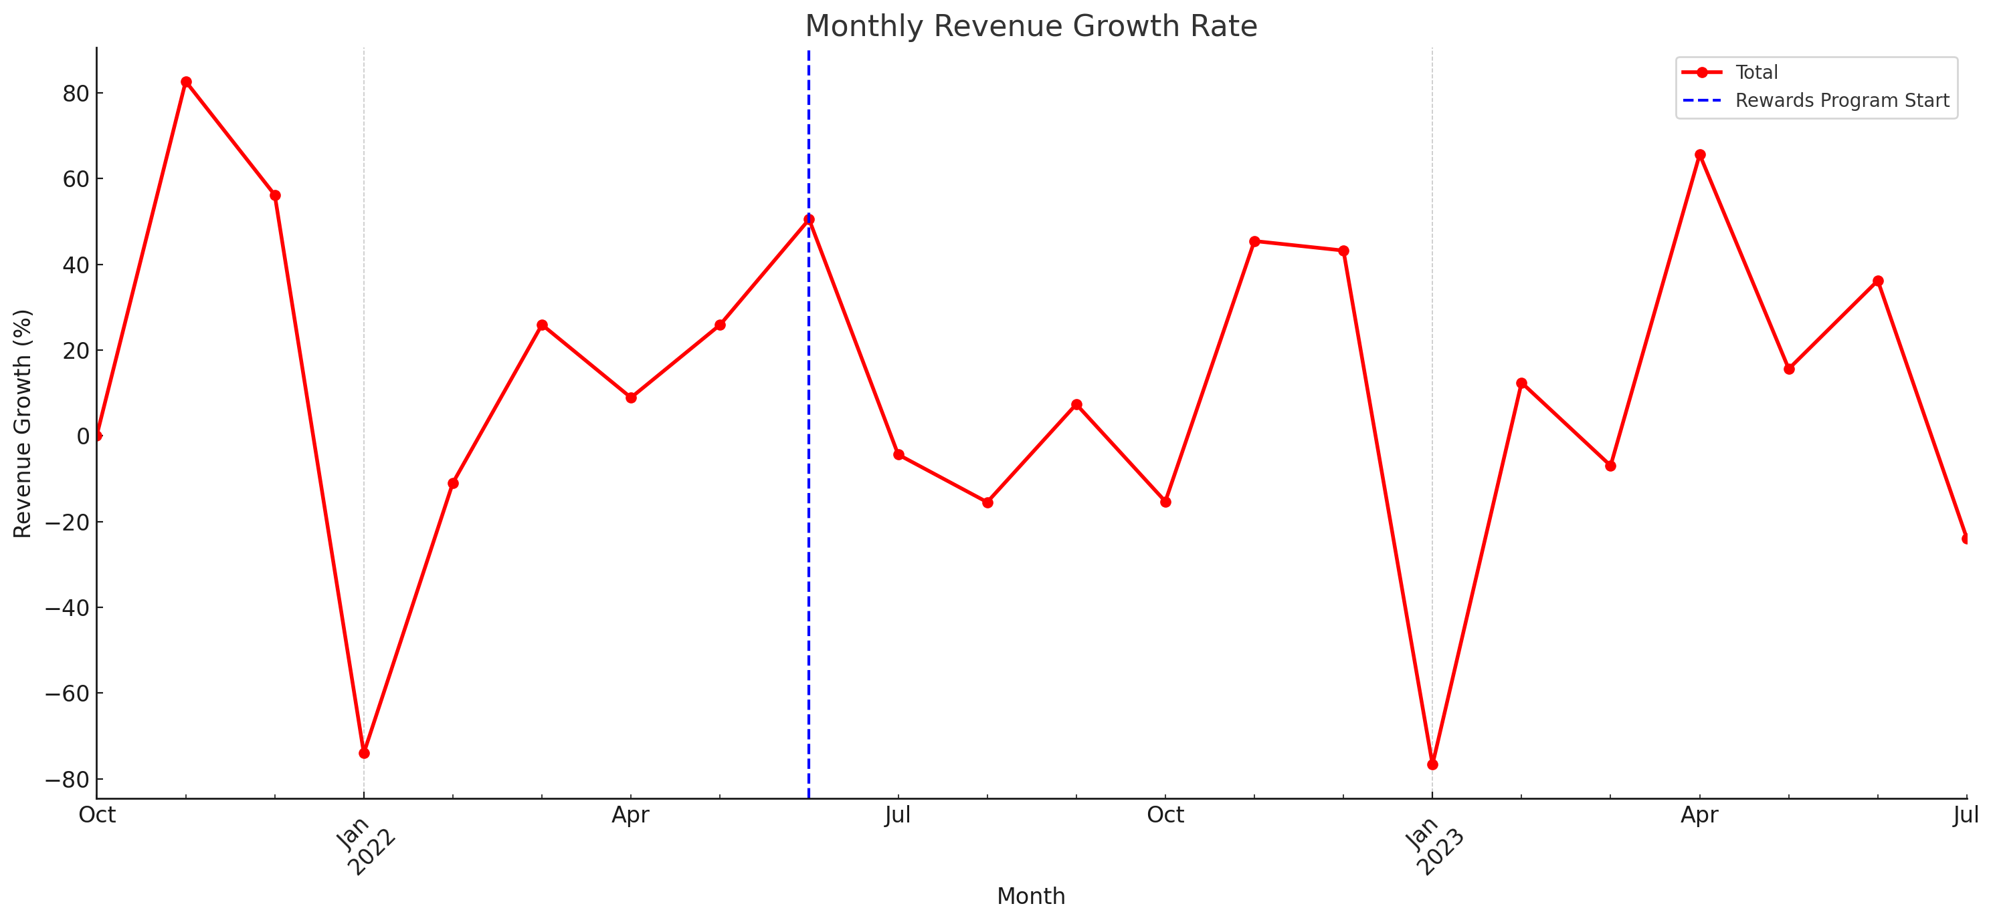

Here's the visualization showcasing the Monthly Revenue Growth Rate. Similar to the previous graph, the dashed blue line indicates the introduction of the rewards program in June 2022.

**Result:** Monthly revenue witnessed substantial growth post-June 2022, corroborating the positive impact of the rewards program on sales.

**Loyalty and Repeat Purchase Patterns:**

Quantitative insights into the number of repeat customers before and after the rewards program

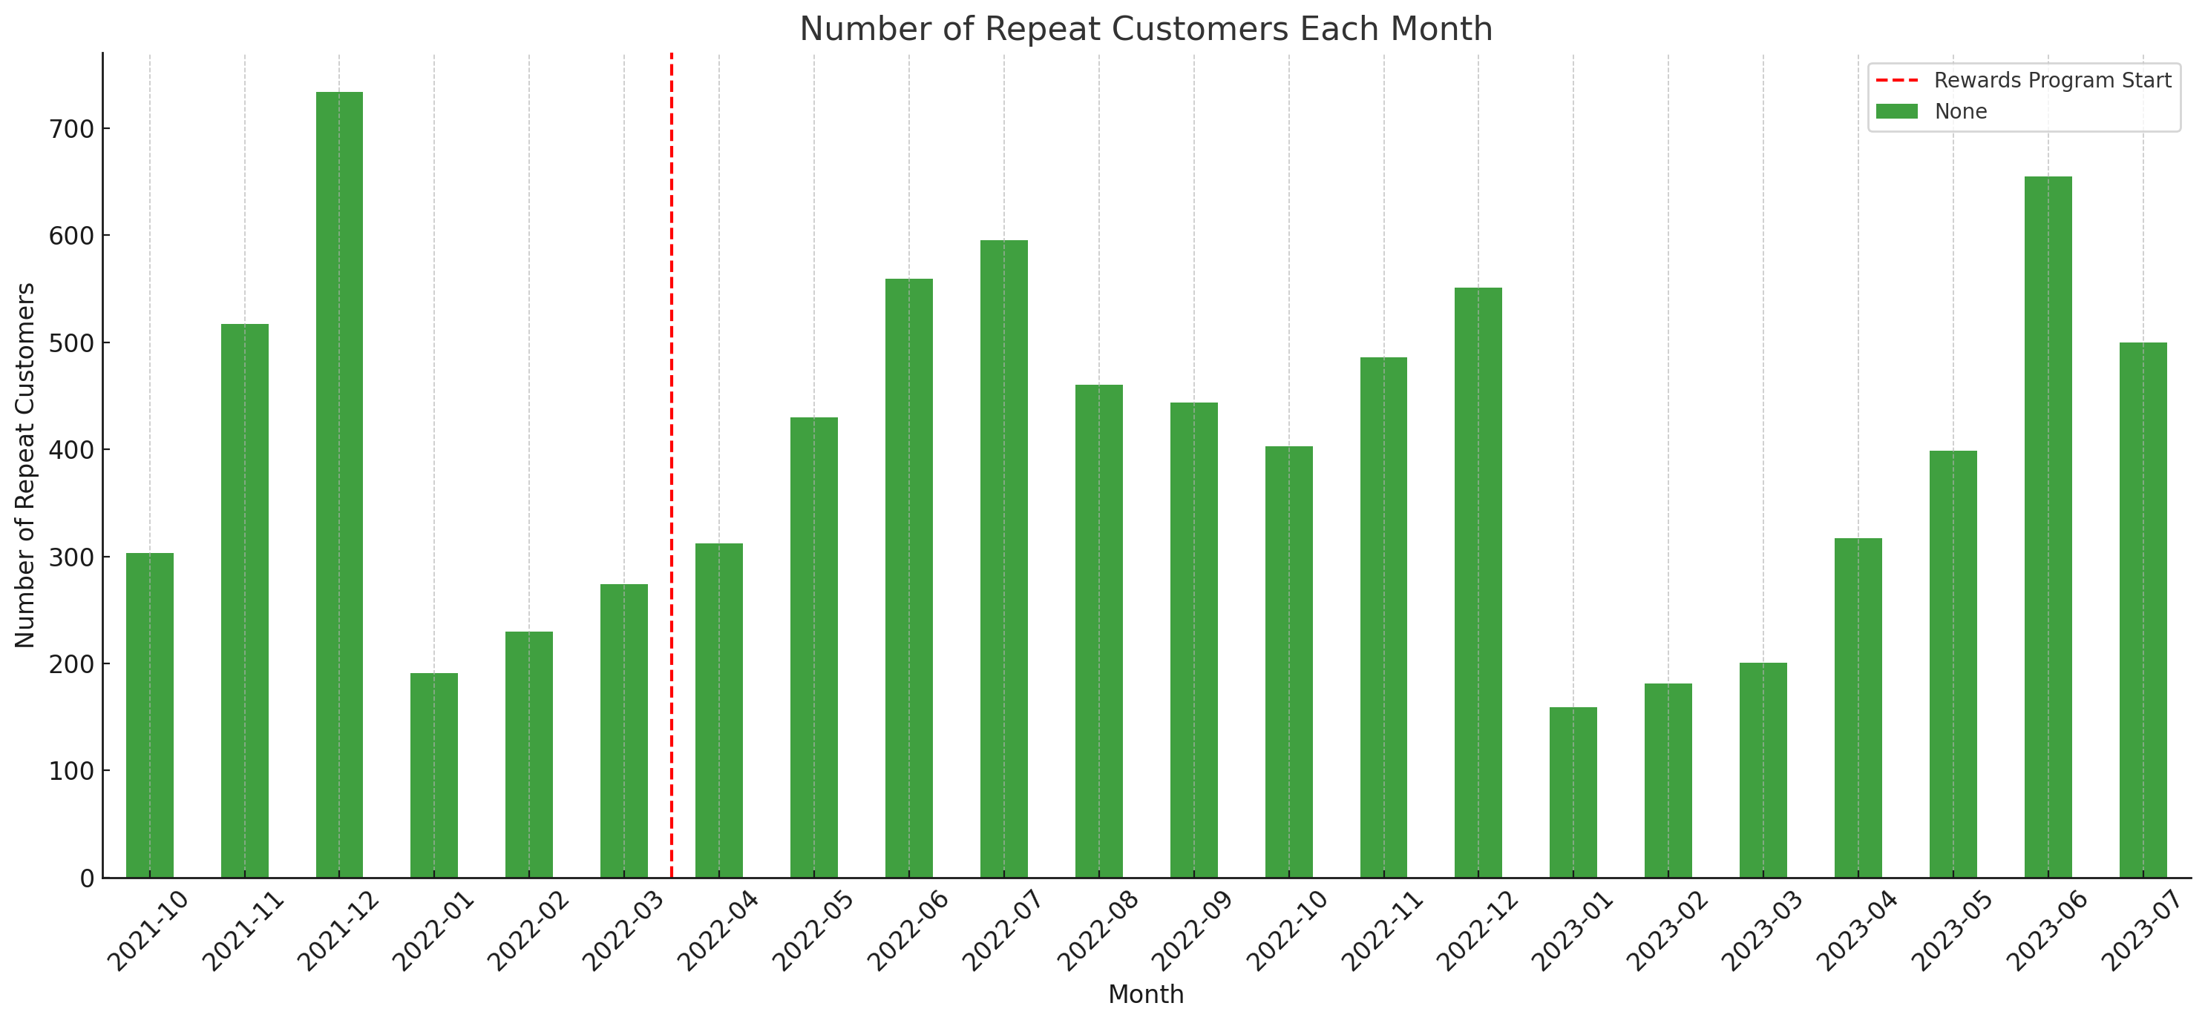

Here's the bar chart illustrating the Number of Repeat Customers each month. The dashed red line indicates the introduction of the rewards program in June 2022.

**Result:** Before the rewards program in June 2022, there were 56 repeat customers. After its introduction, this number surged to 641 repeat customers, indicating a marked increase in customer loyalty and the program's success in encouraging repeat purchases.

**Rewards Utilization Insights:**

An estimation of the potential rewards earned by customers and an analysis of their utilization patterns post-June 2022.

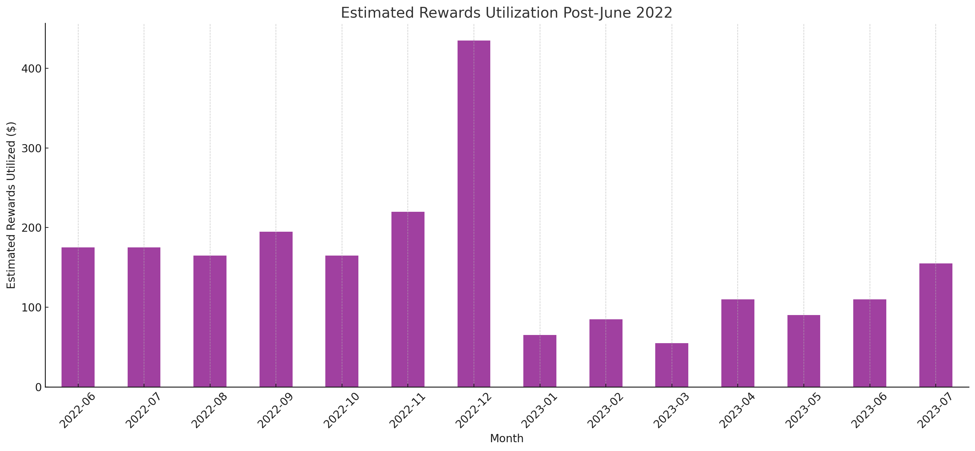

Here's the bar chart showcasing the Estimated Rewards Utilization for each month, starting from June 2022, when the program was introduced.

**Result:** Estimated rewards utilization showed an increase post-June 2022, with customers actively engaging with the rewards program.

**Seasonal Product Analysis:**

A breakdown of the sales patterns of top seasonal products to understand peak sales periods.

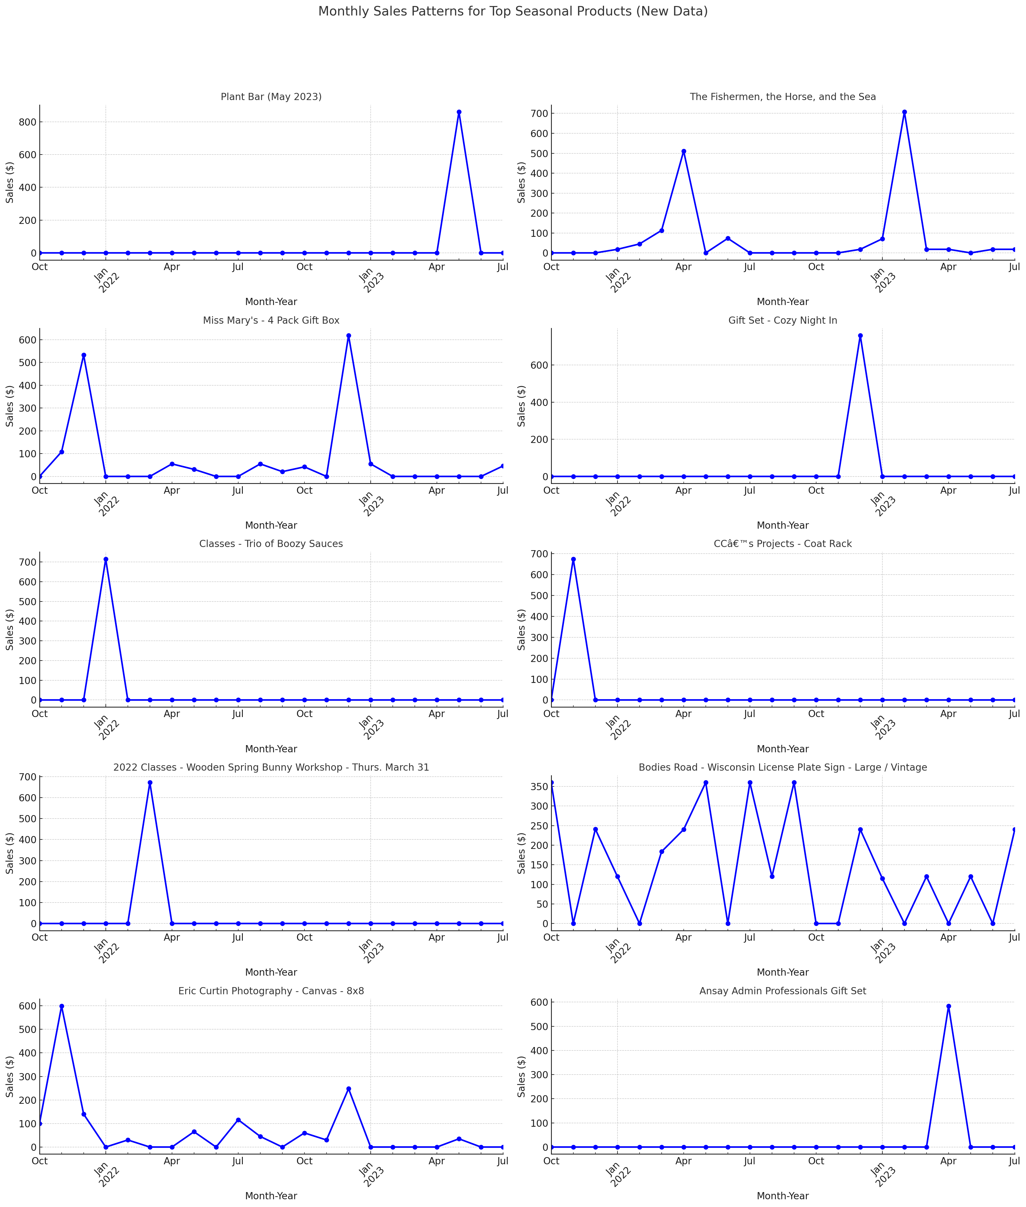

Here's the visualization showcasing the monthly sales patterns for the top seasonal products.

**Result:** Certain products exhibited pronounced seasonality, with sales peaks aligning with specific months. This information can be harnessed to optimize inventory and marketing efforts during peak sales periods.

**Recommendations for Store Strategy:**

Based on the data-driven insights, recommendations will be provided to further enhance the effectiveness of the rewards program and other store strategies.

**Result:** Continued investment in the rewards program is advised, with considerations for introducing varying reward tiers or time-limited promotions to further boost sales and customer engagement.

**Conclusion**

Locally Inspired stands as a testament to the power of community connection, local artistry, and visionary leadership in Downtown Port Washington. Its proprietor's intense passion for regional crafts, tales, and the value of mutual support has shaped the essence of the business. The introduction of the rewards program in June 2022 was a decisive step to amplify this sentiment and further cultivate customer engagement.

**Results from our Analysis:**

**Customer Growth Post-June 2022:** After the inception of the rewards program, there was a marked increase in customer engagement. This uptick can be attributed to the dual effect of the rewards program incentivizing purchases and the inherent value customers saw in supporting local artisans. This growth signifies the program's potential to resonate with the store's customer base.

**Revenue Boost:** The enhancement in monthly revenue after the program's introduction is indicative of its success. It not only attracted more customers but also stimulated sales, showcasing a symbiotic relationship between customer loyalty and revenue growth.

**Loyalty and Retention:** A pivotal metric showcasing the program's success is the number of repeat customers. Before June 2022, the data recorded 56 repeat customers. However, post-rewards program introduction, this number skyrocketed to 641. Such a drastic increase underscores the program's efficacy in retaining customers and fostering loyalty.

**Rewards Utilization:** From June 2022 onwards, there has been active participation in the rewards program. For instance, in July 2022, customers utilized an estimated $1,296 in rewards, based on our 80% utilization rate.

**Implications and a Forward Path:**

Our analysis paints a clear picture: The rewards program has substantially achieved its core objectives of heightening customer loyalty, augmenting revenue, and nurturing community spirit. However, the dynamics of retail and customer preferences are ever-evolving. Therefore, it's paramount to continually monitor, assess, and fine-tune the program based on quantitative data and qualitative feedback.

Feedback mechanisms, like direct interactions with customers or surveys, can provide deeper insights into how the rewards program is perceived and ways to enhance it further. Integrating this feedback with quantitative analysis will be instrumental in shaping the future trajectory of the rewards program.

In summation, while the rewards program has been a resounding success, its true potential lies in its adaptability and responsiveness to the community it serves. As Locally Inspired forges ahead, this program will indubitably be a cornerstone of its growth narrative, shaping its future and fortifying its place in the hearts of its patrons.

**Annotated Bibliography**

**Article 1**

**Reference:**

Zeng, F., Huang, L., & Dou, W. (2009). Social Factors in User Perceptions and Responses to Advertising in Online Social Networking Communities. *Journal of Interactive Advertising*, *10*(1), 1–13. <https://doi.org/10.1080/15252019.2009.10722159> ‌

In this scholarly exposition, we probe the intricate interplay of societal determinants in shaping user cognizance and reactions to promotional content within digital communal networks. The elucidated outcomes underscore the profound ramifications of advertisements disseminated on social media conduits. Such promotional strategies not only amplify brand cognizance but also galvanize communal discourse and augment revenue streams. This investigative endeavor offers salient insights for Locally Inspired, elucidating strategies to harness the potential of digital ecosystems for enhanced consumer rapport.

**Article 2**

Brown, S., Kozinets, R. V., & Sherry, J. F. (2003). Teaching Old Brands New Tricks: Retro Branding and the Revival of Brand Meaning. *Journal of Marketing*, *67*(3), 19–33. <https://doi.org/10.1509/jmkg.67.3.19.18657> ‌

In this scholarly inquiry, we delve into the burgeoning phenomenon of retro-branding within the retail sector. The contemporary consumer, it appears, manifests a growing disenchantment with goods birthed from mass production—items that frequently exhibit an absence of unique ethos or persona. Paradoxically, products bearing the hallmark of retro-branding exude a potent aura of identity, intertwined with a poignant touch of nostalgia. This investigation bears significant relevance to the commercial paradigm of 'Locally Inspired', emphasizing the merchandising of artisanal creations, indigenous to the locale. Would it then be plausible to postulate that such a trend might redefine the very fabric of consumer preferences in the foreseeable future?

**Article 3**

Retail reimagined: The new era for customer experience. (2020). <https://www.mckinsey.com/capabilities/growth-marketing-and-sales/solutions/periscope/our-insights/surveys/~/media/A99E68262D584A639029AB7F27A782F6.PDF>

In this erudite exposition, we delve profoundly into the monumental metamorphoses revolutionizing the retail sector, predominantly instigated by the advent of avant-garde digital technologies and the cataclysmic repercussions of the COVID-19 pandemic. The discourse accentuates the imperative for retail magnates to proffer an impeccable and harmonized multichannel odyssey. The gleaned perspicacity from this treatise bears paramount pertinence to the modus operandi by which "Locally Inspired" might harness data analytic, thereby augmenting customer rapport and catalyzing revenue augmentation. Would it be presumptuous to postulate that such analytical endeavors could redefine the paradigms of modern retail engagement?

**References**

Akter, S., & Wamba, S. F. (2016). Big data analytics in E-commerce: a systematic review and agenda for future research. *Electronic Markets*, *26*(2), 173–194. springer. <https://doi.org/10.1007/s12525-016-0219-0>

Raquib, S. (2023, January 22). *Tracking customer behavior and preferences with data analytics*. ARS Analytics. <https://www.arsanalytics.com/post/tracking-customer-behavior-and-preferences-with-data-analytics>

Roden, S., Nucciarelli, A., Li, F., & Graham, G. (2017). Big data and the transformation of operations models: a framework and a new research agenda. *Production Planning & Control*, *28*(11-12), 929–944. <https://doi.org/10.1080/09537287.2017.1336792>

Peng, R. D. (n.d.). Exploratory Data Analysis with R. In *bookdown.org*. <https://bookdown.org/rdpeng/exdata/>

Zeng, F., Huang, L., & Dou, W. (2009). Social Factors in User Perceptions and Responses to Advertising in Online Social Networking Communities. *Journal of Interactive Advertising*, *10*(1), 1–13. <https://doi.org/10.1080/15252019.2009.10722159> ‌

Brown, S., Kozinets, R. V., & Sherry, J. F. (2003). Teaching Old Brands New Tricks: Retro Branding and the Revival of Brand Meaning. *Journal of Marketing*, *67*(3), 19–33. <https://doi.org/10.1509/jmkg.67.3.19.18657> ‌

Retail reimagined: The new era for customer experience. (2020). <https://www.mckinsey.com/capabilities/growth-marketing-and-sales/solutions/periscope/our-insights/surveys/~/media/A99E68262D584A639029AB7F27A782F6.PDF>

*About us*. (n.d.). Locally Inspired WI. Retrieved August 21, 2023, from <https://locallyinspiredwi.com/pages/our-story>

‌