**Assignments: ALY6080 90325 Integrated Experiential Learn SEC 03 Summer 2023 CPS [BOS-1-HY]**

**Module 10 Assignment — Individual Project Proposal Draft**

**NORTHEASTERN UNIVERSITY**

**College of Professional Studies, Boston, MA, 02215.**

**Submitted by**

Zihan Ma

ma.zihan1@northeastern.edu

**Instructor**

 Prof. Valerie A. Atherley

**Date**

08/23/2023

**Advanced Analytics Approach to Customer Lifetime Value Optimization for Locally Inspired**

1. **Statement of Purpose**

Locally Inspired, rooted in the heart of Wisconsin, serves as more than just a retail store; it's a hub that fosters community collaboration by showcasing top-tier, artisan-crafted items from talented local creators. As we navigate through the dynamics of the modern retail environment, characterized by rapid technological advances and evolving consumer preferences, a critical business challenge emerges: "How can Locally Inspired leverage data to predict and optimize Customer Lifetime Value (CLTV)?" To address this, our project embarks on a mission to design a state-of-the-art predictive model to delve deeper into CLTV intricacies. By doing so, we anticipate not only enhancing customer relationships but also steering the store towards heightened revenue avenues.

1. **Scope of the Project**

At the heart of this initiative lies our ambition to architect a cutting-edge analytical model tailored to capture the nuances of Locally Inspired's customer CLTV, drawing from their rich purchase trajectories. Anchoring our approach on pivotal metrics—Recency, Frequency, and Monetary Value—we aspire to transcend traditional analyses, unlocking transformative insights that can shape future business strategies. Recognizing the importance of agility in today's retail ecosystem, our solution is designed with adaptability in mind, ensuring it complements and elevates Locally Inspired's existing operational frameworks without disruptive overhauls.

1. **Background Research and Literature**

The art of optimizing CLTV is not novel, yet its significance has never been more pronounced, especially when one considers the intertwined relationship between customer loyalty and a company's fiscal health. Drawing parallels, there's a compelling case study of an online retail giant that, upon embracing a CLTV-centric strategy, witnessed a resurgence in customer loyalty, culminating in a substantial uptick in profit margins. Such success stories illuminate a path of potential for establishments like Locally Inspired. Delving deeper into the academic realm, the meticulous research undertaken by Peinkofer et al. (2023) offers a fresh perspective. It accentuates how strategic price discounts, when deployed judiciously, can act as a cushion during periods of product shortages, preventing potential customer churn. Such insights could be the cornerstone for Locally Inspired as it contemplates its future promotional endeavors, ensuring it remains attuned to customer sentiments even in challenging times.

1. **Design and Data Collection Methods**

For effective CLTV prediction, the following approach is recommended:

1. **Data Identification**: Use the 'Email', 'Total', and 'Created at' columns from the dataset. 'Email' will distinguish individual customers; 'Total' signifies expenditure, while 'Created at' denotes the purchase date.
2. **Customer Metrics Calculation**: Determine the Recency (duration since last purchase), Frequency (purchase count), and Monetary Value (average spending) for every customer.
3. **CLTV Calculation**: Apply a straightforward CLTV formula emphasizing Recency, Frequency, and Monetary Value.
4. **Visualization**: Employ tools like Excel to depict data visually, ensuring user-friendly interpretation.
5. **Implementation Methodology and Strategies**

The project will employ a precise method, using a hierarchical Bayes regression model to analyze and forecast the Recency, Frequency, and Monetary Value of Locally Inspired's clientele. This approach is based on the research of Hiroki Yamada and Tadahiko Sato, underscoring its efficacy in discerning customer behaviors and producing accurate forecasts. By exclusively focusing on this model, we strive to deliver a robust yet succinct tool for Locally Inspired's deeper customer comprehension.

Post model development and dashboard creation, a validation phase will be initiated. Here, the model will be tested against new data to evaluate its predictive accuracy, with necessary refinements made to enhance its efficiency.

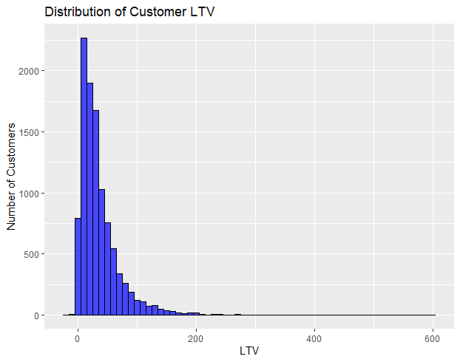

Here is an example graph for CLTV analysis. The Customer LTV histogram reveals crucial insights about our clientele. Most of our customers offer a moderate Lifetime Value, indicating consistent purchasing patterns. However, there's a notable segment of patrons with significantly higher LTVs, suggesting loyal or bulk purchasing behaviors. These high LTV customers represent a valuable asset, and understanding their preferences could pave the way for targeted marketing and sales campaigns. Simultaneously, the presence of unusual negative LTV values warrants further investigation to ensure data accuracy and understand any underlying business scenarios.

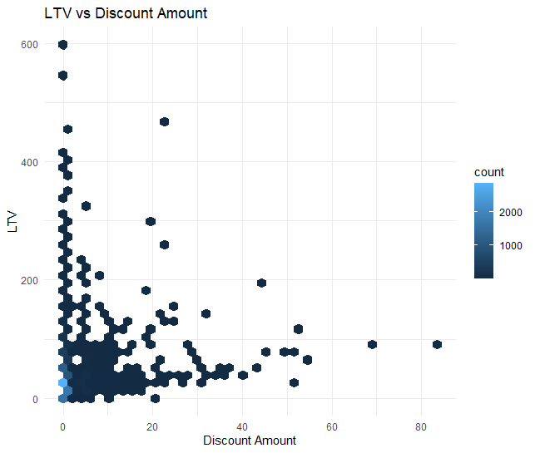

Also this "LTV vs Discount Amount" hexbin visualization provides a rich overview of our customer spending patterns in relation to the discounts they receive. Denser regions, indicated by deeper-colored hexagons, signify areas where most transactions cluster. By examining these clusters, we can discern that a majority of our customers fall within specific LTV and discount brackets. This suggests that certain discount amounts are particularly effective in driving sales. Strategic adjustments to our discounting approach, based on this data, could optimize revenue and enhance customer engagement.

1. **Conclusion**

Optimizing CLTV is essential for Locally Inspired's continued growth. With this project's focused methodology, the store can acquire crucial insights into its customers' behaviors and inclinations. By zeroing in on essential metrics and a validated predictive model, Locally Inspired stands to boost customer interaction, allegiance, and overall profitability.

**Annotated Bibliography**

Peinkofer, S. T., Esper, T. L., Smith, R. J., & Williams, B. D. (2015). Assessing the impact of price promotions on consumer response to online stockouts. *Journal of Business Logistics*, *36*(3), 260–272. <https://doi.org/10.1111/jbl.12095>

This practical research delves into consumer responses to unavailable items, especially those with price promotions, within the online shopping environment. Using the expectation-disconfirmation theory (EDT), the authors investigate how price promotions shape consumers' expectations about product availability and their subsequent responses to online product unavailability. They discovered that in low involvement shopping scenarios, consumers demonstrate less dissatisfaction and a lower likelihood of switching to a competitor's online platform when they encounter a stockout of a discounted item. The research introduces a potential limitation of EDT in high involvement scenarios, suggesting the need for additional theoretical refinement in such contexts.

Peinkofer et al.'s research is noteworthy for its exploration of an under-researched area in e-commerce, providing valuable insights into consumer behavior and inventory management in the online retail context. Their experimental approach and robust theoretical framework elucidate significant implications for both academic study and practical applications in supply chain management. The authors convincingly argue that price promotions, despite potentially leading to stockouts, could also play a vital role in customer retention in the online retail sphere. Nonetheless, they acknowledge the constraints of their study and propose avenues for future research. This includes exploring the effects of varied promotional strategies and different product categories on how consumers react to unavailable items, as well as understanding the prolonged consequences of recurrent stockouts.

Turkmen, B. (2022). Customer segmentation with machine learning for online retail industry. *The European Journal of Social and Behavioural Sciences*, *31*(2), 111–136. <https://doi.org/10.15405/ejsbs.316>

In Turkmen's (2022) influential study, the author investigates and contrasts various customer categorization approaches, utilizing machine learning tools on e-retail datasets. The study emphasizes the importance of dividing customers into groups to better understand buying tendencies and the subsequent implications for setting prices and predicting demand in commerce. Various unsupervised machine learning clustering techniques, including K-means, hierarchical approaches, DBSCAN, and the conventional model centered on recency, frequency, and monetary (RFM) values, are investigated.

The author offers an extensive review of literature tracing the progression and utilization of artificial intelligence, clustering methodologies, and challenges related to customer segmentation across various sectors. The work further discusses the adoption of artificial intelligence as a tool for learning in information systems, forecasting, prediction, and optimization across various industries, and future research directions. Finally, it provides a financial impact analysis of AI, asserting that revenues from the AI market worldwide could surpass $3,060 billion by 2024.

Parikh, Y., &amp; Abdelfattah, E. (2020). Clustering algorithms and RFM analysis performed on retail transactions. 2020 11th IEEE Annual Ubiquitous Computing, Electronics &amp;amp; Mobile Communication Conference (UEMCON). <https://doi.org/10.1109/uemcon51285.2020.9298123>

The study delves into employing multiple clustering techniques like Mean-shift, DBSCAN, Agglomerative Clustering, and K-Means. These methods are combined with the RFM (Recency, Frequency, and Monetary value) analysis to assess online retail transactions. The purpose of this multidimensional analysis is to identify distinct customer groups and understand their purchasing behaviors. The researchers found that these clustering algorithms, when combined with RFM analysis, can reveal valuable insights into customer segmentation based on their RFM scores, thus informing business strategies for customer retention and profit maximization.

The findings of this research are particularly relevant to our current project that involves applying K-means clustering to an online retail store. The paper demonstrates how these algorithms can identify high-value customer segments and potentially drive strategic decisions. The authors recommend subsequent studies to explore alternative clustering methods and employ classification techniques to anticipate the buying patterns of emerging clientele.

**References**

*Data analyst interview question guide: Linkedin talent solutions*. Business Solutions on LinkedIn. (n.d.). <https://business.linkedin.com/talent-solutions/resources/how-to-hire-guides/data-analyst/interview-questions>

Yamada, H., & Sato, T. (2021a, January 31). *An analysis of mechanism for customers’ purchase amount and number of visits in Department Store*. Journal of the Operations Research Society of Japan. <https://www.jstage.jst.go.jp/article/jorsj/64/1/64_12/_article/-char/ja/>

Peinkofer, S. T., Esper, T. L., Smith, R. J., & Williams, B. D. (2015). Assessing the impact of price promotions on consumer response to online stockouts. *Journal of Business Logistics*, *36*(3), 260–272. <https://doi.org/10.1111/jbl.12095>

Turkmen, B. (2022). Customer segmentation with machine learning for online retail industry. *The European Journal of Social and Behavioural Sciences*, *31*(2), 111–136. <https://doi.org/10.15405/ejsbs.316>

Parikh, Y., & Abdelfattah, E. (2020). Clustering algorithms and RFM analysis performed on retail transactions. *2020 11th IEEE Annual Ubiquitous Computing, Electronics &amp; Mobile Communication Conference (UEMCON)*. <https://doi.org/10.1109/uemcon51285.2020.9298123>