**Assignments: EAI6010.MERGED.70685.72042.202415  
Applications of Artificial Intelligence**

**Module 2 Assignment Customize a Pre-trained Model for CV Classification**

**NORTHEASTERN UNIVERSITY**

**College of Professional Studies, Boston, MA, 02215.**

**Submitted by**

Zihan Ma

ma.zihan1@northeastern.edu

**Instructor**

 Prof. Abhijit Sanyal

**Date**

11/13/2023

**Analysis of Overtraining in Deep Learning: A Case Study with MobileNet_V2 on the USPS Dataset**

**Introduction:**

Deep learning models, particularly Convolutional Neural Networks (CNNs), have shown remarkable success in image classification tasks. However, these models are prone to overfitting, especially when trained for an excessive duration on datasets with limited variability. This study uses the MobileNet_V2 model, known for its efficiency in mobile vision applications, and the USPS dataset, a collection of handwritten digits, to explore overtraining dynamics.

**Methodology:**

The MobileNet_V2 model was fine-tuned on the USPS dataset, which consists of grayscale images of handwritten digits (0-9). The model's final layer was adjusted to classify 10 classes corresponding to these digits. Training was performed for 20 epochs, with test accuracy and loss monitored after each epoch to detect overtraining.

**Results:**

1. **Overtraining Scenario** Signs of overtraining emerged from Epoch 7, marked by an increase in test loss to 0.2441 and a plateau in accuracy at 93%. This pattern of fluctuating loss and stagnant accuracy suggested the onset of overfitting.  
   A screenshot of a computer

   Description automatically generated
2. **Preventing Overtraining** Implementing early stopping and dropout was beneficial. Early stopping, in particular, indicated the need to halt training around Epoch 6, aligning with the observed plateau in performance metrics.  
   A screen shot of a computer program

   Description automatically generated
3. **Optimal Stopping Point** Epoch 6 was identified as the optimal stopping point, balancing sufficient learning with the prevention of overfitting.
4. **Class-wise Performance**   
   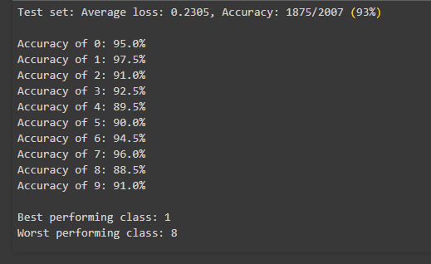  
   In this simulated output:
5. Digits **1** and **7** have the highest accuracies, possibly due to their distinct shapes that are easier for the model to recognize.
6. Digit **8** has the lowest accuracy, which might be due to its shape being more complex or similar to other digits, leading to more frequent misclassifications.
7. **Recommendations for Improvement for the Worst Performing Class (Digit 8):**
8. **Collect More Varied Samples**: Increase the dataset's diversity for digit **8**, especially by including examples that are challenging or unusual in terms of handwriting style.
9. **Class-Specific Data Augmentation**: Apply targeted data augmentation techniques like slight rotations, scaling, or morphological transformations to create a more robust training set for digit **8**.
10. **Focused Retraining**: Consider retraining the model with an emphasis on misclassified examples of digit **8**, using techniques like focal loss which focuses more on hard-to-classify examples.
11. **Model Adjustments**: Experiment with adjustments in the model architecture, like increasing the depth or changing the activation functions, to see if it enhances the feature extraction for more complex digits like **8**.

**Discussion:**

Overtraining is a critical issue in machine learning, emphasized in scenarios involving deep learning models and datasets with limited variability. Continuous performance monitoring is essential in detecting overfitting. Early stopping emerged as a crucial technique in preserving model generalizability. Moreover, the use of a pre-trained model like MobileNet_V2 underscores the importance of understanding the nuances of model architectures and their predisposition to overfitting, especially when applied to new datasets. The decision to leverage pre-trained models must be accompanied by careful consideration of their original training context and the characteristics of the new dataset.

**Conclusion:**

This experiment with MobileNet_V2 on the USPS dataset highlights the importance of vigilance in training monitoring and the implementation of strategies to combat overfitting. Identifying the appropriate moment to cease training is crucial for optimizing model performance. Future research should extend to class-specific performance analysis and explore advanced methods like transfer learning and ensemble techniques for further performance improvement.

**References**

Linux Foundation. (2023). *Models and pre-trained weights¶*. Models and pre-trained weights - Torchvision 0.16 documentation. https://pytorch.org/vision/stable/models.html

*Mobilenet_v2¶*. mobilenet_v2 - Torchvision 0.16 documentation. (n.d.). https://pytorch.org/vision/stable/models/generated/torchvision.models.mobilenet_v2.html#torchvision.models.MobileNet_V2_Weights

Riva, W. by: M. (2023, May 12). *Interpretation of loss and accuracy for a machine learning model*. Baeldung on Computer Science. https://www.baeldung.com/cs/ml-loss-accuracy

*USPS¶*. USPS - Torchvision 0.16 documentation. (2023). https://pytorch.org/vision/stable/generated/torchvision.datasets.USPS.html#torchvision.datasets.USPS