ResNet

Deep neural networks have led to a vast number of breakthroughs in the field of image classification, where they excel due their ability to integrate low/medium/high level features and classifiers in an end-to-end multi-layer fashion. The issue however, is that deep neural networks are extremely hard to train, because at each training iteration, all weights receive an update proportional to the partial derivative of the error function respective to the current weight. If the gradient is small enough, then the weights will no longer be changed effectively and it could effectively stop the neural network from being trained further – a phenomenon commonly referred to as vanishing gradients.

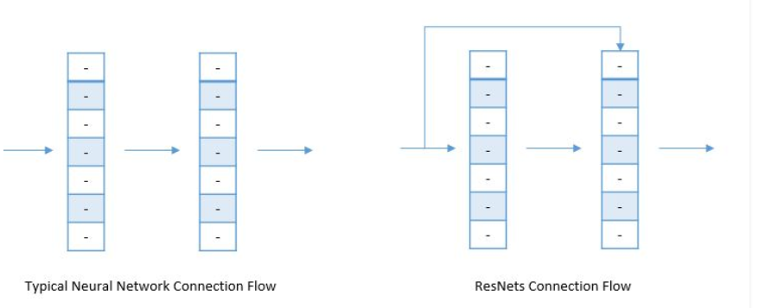Microsoft research discovered that it was possible to split the deep neural network into three layered chunks, passing the input directly into each segment together with the residual output of the previous chunk minus the input that is reintroduced (known as skip-connections). This helps eliminate the vanishing gradient problem common in other deep neural network implementations without any changes to parameters or learning algorithms.

# Architecture

A standard ResNet implementation is generally built using two different types of blocks, the Identity block and the Convolutional block.

## Identity Block

The identity block is used in the standard case where the input activation has the same dimensions as the output activations.

Convolutional Block

On the other hand, whenever the input and output dimensions don’t match, a convolutional layer is added to the shortcut’s path – converting the identity block into a convolutional block.

By repeatedly stacking different blocks together, the ResNet can achieve high accuracies through its deep neural network architecture

[1] He, K., Zhang, X., Ren, S. and Sun, J., 2016. Deep residual learning for image recognition. In *Proceedings of the IEEE conference on computer vision and pattern recognition* (pp. 770-778).

[2] He, K., Zhang, X., Ren, S. and Sun, J., 2016, October. Identity mappings in deep residual networks. In *European conference on computer vision* (pp. 630-645). Springer, Cham.

[3] Xie, S., Girshick, R., Dollár, P., Tu, Z. and He, K., 2017. Aggregated residual transformations for deep neural networks. In *Proceedings of the IEEE Conference on Computer Vision and Pattern Recognition* (pp. 1492-1500).