The Rise of Neural Network Models for Image Classification
CS2IS2 Final Project (2017/2018)
Nicholas Bonello, Zihan Huang
bonellon@tcd.ie, huangzi@tcd.ie
In this research we examined the rise of neural-networks focusing on image classification, and how they raised the bar when compared to previous methods. Starting from one of the very first convolutional neural-networks in the AlexNet, leading up to the significantly improved neural networks in the form of the ResNet and MobileNet, we will be describing their implementations, architectural differences with a focus on how the different layers are designed and why, as well as a comparison to benchmark their performances across different experiments.
This research aimed at one of the popular problems in the domain of AI, image classification and focused on CNNs models including AlexNet, ResNet and MobileNet. There exist many different neural network models and what different implementation done to them and how that made them better is the motivation behind this research. This research focused on how different layers designed and why, as well as comparing the performance on same data set.
1 Introduction
Image Classification is one of the most popular problems in the AI domain. One of the very first approaches to this problem in the journey of Machine Learning was k-NN (k-Nearest Neighbours). Ever since the term of Deep Learning and the idea of structure learning introduced to the machine learning methods, Convolutional Neural Networks(CNNs) became researchers’ most favourable artificial neural network model using to solve image classification problem.
There are number of different CNNs proposed aiming at solving image classification problem, and this research focused on how and why they are designed and implemented in the convolutional layer and pooling layer.
This research investigated into three CNN models in particular, AlexNet, ResNet and MobileNet.
2 Related Work
This section is optional. Either if you are writing a survey or an original report you can find relevant work that has addressed similar problems. This section can briefly introduce them with a specific emphasis on differences and similarities to the proposed approach(es).
3 Problem Definition and Algorithm
The problem of image classification in general is given a set of images being labelled with a single category and a novel set of images comes in, on which the model should be able to identify and labelled the images that belong to the given labelled set.
To solve this, instead of specify each different sets of images into code, researchers find a way to let the computer learn about the visual appearance of each image sets. Therefore, the image classification problem turns into a deep structure learning problem.

3.1 AlexNet
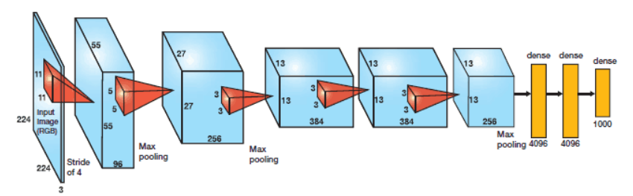
The AlexNet architecture was one of the first deep neural networks that pushed the accuracy of the ImageNet Classification challenge by a significant amount when compared to previously traditional techniques.

The original architecture was composed of 5 convolutional layers followed by 3 fully connected layers as seen below. The main difference to previous neural network implementations was that the AlexNet made use of the ReLu (Rectified Linear Unit) for non-linear parts rather than using the Tanh or Sigmoid functions.

f(x) = max(0,x)

The advantage of this function is that is has the ability to train much faster because the previous methods suffered from the vanishing gradient problem (solved in the ResNet architecture described above). Another significant improvement in the AlexNet architecture, was that after every fully-connected layer, a dropout layer was added to reduce over-fitting. By applying a probability to every node, randomly selected nodes activations would be turned off with the probability assigned in this layer. The idea behind this method is that since neurons are randomly dropped, they tend to avoid developing corresponding adaptations together – instead enabling them to develop important, node-independent features.

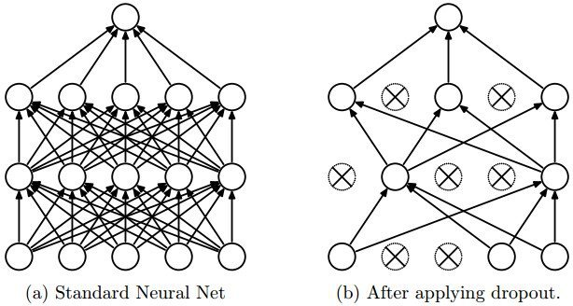
3.2 ResNet
Deep neural networks have led to a vast number of breakthroughs in the field of image classification, where they excel due their ability to integrate low, medium and high-level features and classifiers in an end-to-end multi-layer fashion. The issue, however, is that deep neural networks are extremely hard to train, because at each training iteration, all weights receive an update proportional to the partial derivative of the error function respective to the current weight. If the gradient is small enough, then the weights will no longer be changed effectively, and it could stop the neural network from being accurately trained further – a phenomenon commonly referred to as vanishing gradients.

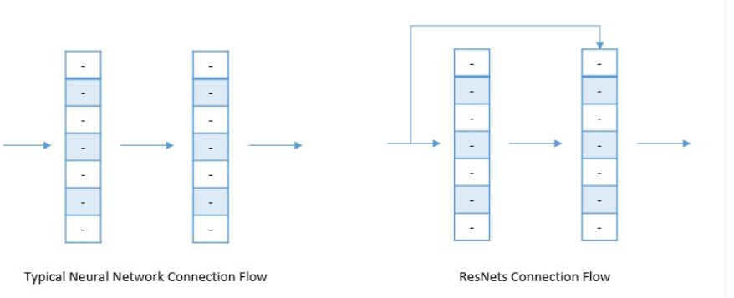
Microsoft research discovered that it was possible to split the deep neural network into three layered chunks, passing the input directly into each segment together with the residual output of the previous chunk minus the input that is reintroduced (known as skip-connections). This helps eliminate the vanishing gradient problem common in other deep neural network implementations without any changes to parameters or learning algorithms.

Architecture
Because of their large depth and the fact that the vanishing gradient problem is solved, ResNet’s with a depth of 152 have achieved an accuracy of 95.51% in top-5 accuracies; all while being more computationally efficient than the VGGNet.

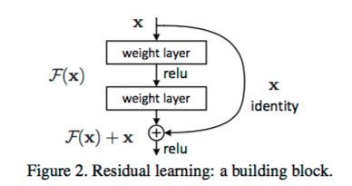

Each block in a standard ResNet architecture follows the same principle, a 3x3 convolution and pooling step followed by 4 layers of similar behaviour. This is then repeated several times depending on the size of the resnet, comparing different map dimensions (64, 128,256, 512) respectively – bypassing the input every second convolution. A standard ResNet implementation is generally built using two different types of blocks, the Identity block and the Convolutional block.

Identity Block

The identity block is used in the standard case where the input activation has the same dimensions as the output activations.

Convolutional Block
On the other hand, whenever the input and output dimensions don’t match, a convolutional layer is added to the shortcut’s path – converting the identity block into a convolutional block.
By repeatedly stacking different blocks together, the ResNet can achieve high accuracies through its deep neural network architecture

3.3 MobileNet

There are two versions of MobileNet, the idea behind those are the same only the version 2 improves the version 1 with better performance.
The idea behind MobileNet version1 is that using depthwise convolution layer to replace the convolution layer in order to reduce the computational cost. The convolution layer is separated into two parts, first a depthwise convolution layer filtering the input, then follows a 1×1 pointwise convolution layer combining filtered values to new features. See architecture Figure 1. Below.
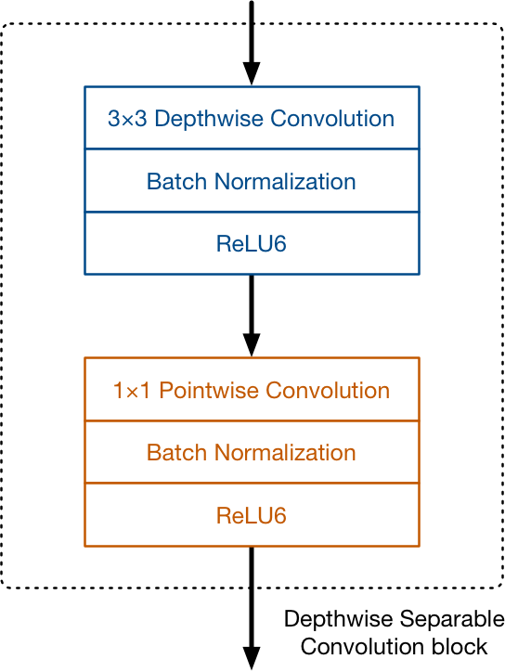
Figure 1. MobileNet Version 1 Convolution Block
The convolution block does the same thing as traditional convolution but much faster. Unlike a regular convolution it performs convolution on each input channel separately instead of combining the them.
The activation function used by MobileNet is ReLU6. The authors of [1] found that ReLU6 is more robust than regular ReLU when using low-precision computation.
And after the convolutional layer, there is a global average pooling layer at the very end, followed by a fully-connected classification layer or an equivalent 1×1 convolution, and a softmax.
The most important of its hyper-parameters is the depth multiplier or width multiplier, which is used to change the number of channels in each layer. Using a depth multiplier of 0.5 will halve the number of channels used in each layer, which cuts down the number of computations by a factor of 4 and the number of learnable parameters by a factor 3. It is therefore much faster than the full model but also less accurate.
The use of depth-wise separable convolutions makes MobileNet has to do about 9 times less work than comparable neural nets with the same accuracy.
MobileNet version2[3] still uses depthwise separable convolutions as its main building block. See figure 2 below.
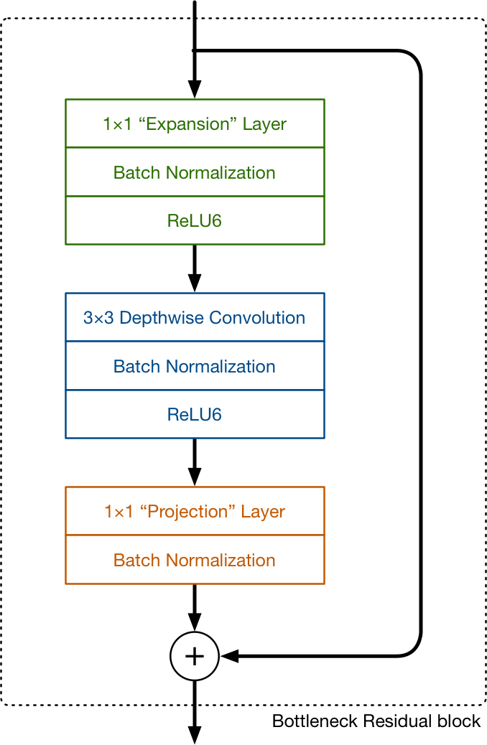
Figure 2. MobileNet Version2 Bottleneck Residual Block
Version 2 has three convolutional layers in the block. The last two are the ones used in version 1, a depth-wise convolution layer that filters the inputs, followed by a pointwise convolution layer. However, instead of keeping or doubling the number of channels in version 1, point-wise layer in version 2 or the ‘projection’ layer reduces the number of channels as in it ‘projects’ data into much smaller dimensions. The first convolutional layer or the ‘expansion’ layer expands the number of channels in the data before going into the depth-wise convolution. And exactly by how much the data gets expanded is given by the one of the hyper parameters, expansion factor.
The idea behind version1 was to replace expensive convolutions with cheaper ones, even if it meant using more layers which works perfectly. The main changes in the version2 architecture are the residual connections and the expand/projection layers.
4 Experimental Results
4.1 MobileNet
MobileNet V2 is mostly an updated version of V1 that makes it even more efficient and powerful in terms of performance.
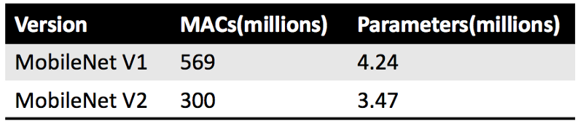
Table 1. MACs of MobileNet
MACs (Multiply-Accumulate Operations) measure how many calculations are needed to perform inference on a single 224×224 RGB image as in the larger the image, the more MACs are needed. From table 1 we can assume that v2 is almost twice as fast as v1 model.
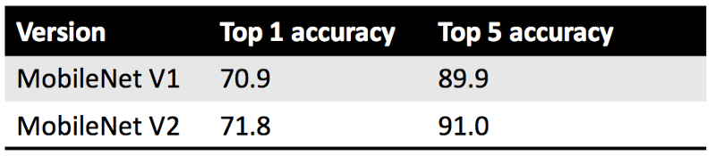
Table 2. Accurarcy of MobileNet
In terms of accuracy, the reported top-1 and top-5 accuracy are on the ImageNet classification dataset [2]. To get the above numbers, the central region of the image was cropped to an area containing 87.5% of the original image, and then that crop was resized to 224×224 pixels. Only a single crop was used per image.
In all of these metrics, here MobileNet V2 is slightly, if not significantly, better than V1.

4.2 Benchmarks - Accuracy Comparison
When calculating benchmarks for convolutional neural networks, it’s important to run tests in identical environments with the same CPU power, memory and even OS. Previous works benchmarking several different neural networks examined the models testing for the following criteria;

- Layers used
- Top-1 Error rate
- Top-5 error rate
- Prediction speed

Model | Parameter Memory | Layers | Top-1 Error | Top-5 Error | Speed (ms)
AlexNet |  | 8 | 42.9 | 19.80 | 14.56
RestNet-18 |  | 18 | 30.43 | 10.76 | 31.54
ResNet-200 |  | 200 | 21.66 | 5.79 | 296.51
MobileNet v1
MobileNet v2

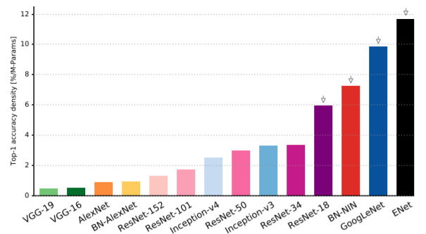

By considering the accuracy as a factor per parameter we can effectively highlight that the capacity of later architectures are more equipped to better utilise their parametric space. In this graph, we can clearly see that the AlexNet implementation is oversized, meaning that it utilises a large number of parameters but does not effectively take advantage of their potential learning enhancement. It is also clear that while accuracy increases together with the number of parameters used by the different ResNet architectures, the increase is far from linear – with larger models having less accuracy per parameter.

Reference: https://openreview.net/pdf?id=Bygq-H9eg
https://github.com/albanie/convnet-burden
https://github.com/albanie/convnet-burden
https://arxiv.org/pdf/1810.00736.pdf
4.3 Benchmarks - Computational Requirements

It is also important to consider the viability of the network in question, considering important factors such as the total memory required, the power consumption, the number of operations and parameters needed and even the inference time.

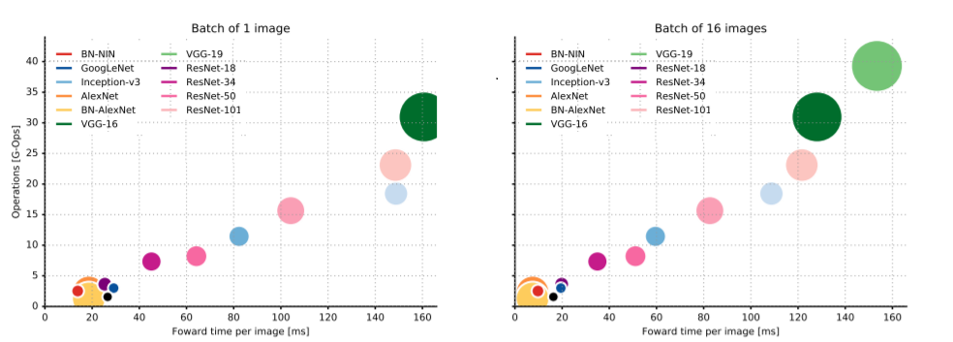
By calculating the total number of operations required before making a prediction, we can then infer the total training time as seen in the below figure. Through the total operations count an estimate of inference time and the size of the hardware circuit in the case of custom-made neural network accelerators can be made.

Even though adding several additional layers to ResNets can significantly improve their accuracies, the tradeoff with operations count and inference time is not negligible and must be factored in when designing models.
5 Conclusions
Provide a final discussion of the main results and conclusions of the report. Comment on the lesson learnt and possible improvements.

A standard and well formatted bibliography of papers cited in the report. For example:
References

1. A. G. Howard, M. Zhu, B. Chen, D. Kalenichenko, W. Wang, T. Weyand, M. Andreetto, and H. Adam. Mobilenets: Efficient convolutional neural networks for mobile vision applications. arXiv preprint arXiv:1704.04861, 2017.
2. Image-net.org. (2019). ImageNet Large Scale Visual Recognition Competition 2012 (ILSVRC2012). [online] Available at: http://www.image-net.org/challenges/LSVRC/2012/ [Accessed 10 Apr. 2019].
3. M. Sandler, A. Howard, M. Zhu, A. Zhmoginov, L. Chen. MobileNetV2: Inverted Residuals and Linear Bottlenecks. arXiv preprint arXiv: 1801.04381, 2019.

