CNNs for Image Classification
CS7IS2 Final Project (2018/2019)
Nicholas Bonello, Zihan Huang
bonellon@tcd.ie, huangzi@tcd.ie
Abstract. In this research, we examined the rise of neural-networks focusing on image classification, and how they raised the bar when compared to previous methods. Starting from one of the very first convolutional neural-networks in the AlexNet, leading up to the significantly improved neural networks in the form of the ResNet and MobileNet; we will be describing their implementations and architectural differences with a special focus on how the different layers are designed and why. We will also be comparing and benchmarking their performances across different experiments, focusing on both their accuracies and their parameter and hardware constraints.
1 Introduction
Image Classification is one of the most popular problems in the AI domain. One of the very first approaches to this problem throughout the Machine Learning journey was the k-NN (k-Nearest Neighbours) implementation. Ever since the term Deep Learning arose and the idea of structured learning was introduced to the machine learning methods, Convolutional Neural Networks (CNNs) quickly became researchers’ most favourable technique used to solve image classification problems [1-3].
There are number of different CNNs implementations proposed aiming at solving the image classification problem, and this research focused on how and why they are designed and implemented using the convolutional and pooling layer.
In this research, we will be analysing different CNN models, with a special focus on understanding the differences in methods used throughout the history of Deep Learning. Starting with one of the earliest and most successful models in 2012 – the AlexNet, all the way to the significantly improved MobileNet architecture in 2017.
2 Problem Definition and Algorithm
The problem of image classification involves giving a set of labelled images with a single category followed by a test-set of similar images which the model is then expected to classify correctly. Rather than having researchers find formal ways of identifying each image manually, convolutional neural networks can learn to recognize the visual appearance of objects given a large enough image set.
2.1 AlexNet

The AlexNet architecture was one of the first deep neural networks that pushed the accuracy of the ImageNet Classification challenge by a significant amount when compared to previously traditional techniques [4].
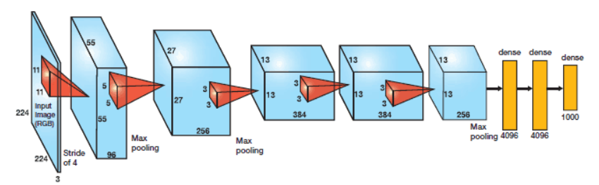
Figure 1. AlexNet architecture

The original architecture was composed of 5 convolutional layers followed by 3 fully connected layers as seen in figure 1 above. The main difference to previous neural network implementations was that the AlexNet made use of the ReLu (Rectified Linear Unit) for non-linear parts rather than using the Tanh or Sigmoid functions.
f(x) = max(0,x)
The advantage of this function is that is has the ability to train much faster because the previous methods suffered from the vanishing gradient problem (solved in the ResNet architecture described below) {6]. Another significant improvement in the AlexNet architecture, was that after every fully-connected layer, a dropout layer was added to reduce over-fitting. By applying a probability to every node, randomly selected nodes activations would be turned off with the probability assigned in this layer. The idea behind this method is that since neurons are randomly dropped, they tend to avoid developing corresponding adaptations together – instead enabling them to develop important, node-independent features [5].

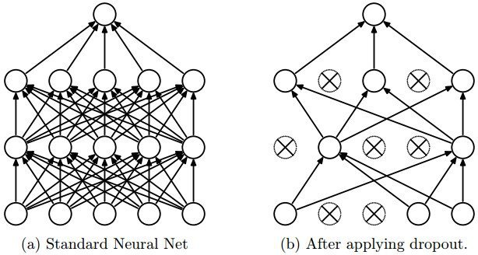
Figure 2. Dropout layer – randomly turning off activation functions for nodes
2.2 Residual Neural Networks (ResNets)
Deep neural networks have led to a vast number of breakthroughs in the field of image classification, where they excel due their ability to integrate low, medium and high-level features and classifiers in an end-to-end multi-layer fashion. The issue, however, is that deep neural networks are extremely hard to train, because at each training iteration, all weights receive an update proportional to the partial derivative of the error function respective to the current weight. If the gradient is small enough, then the weights will no longer be changed effectively, and it could stop the neural network from being accurately trained further – a phenomenon commonly referred to as vanishing gradients [6].
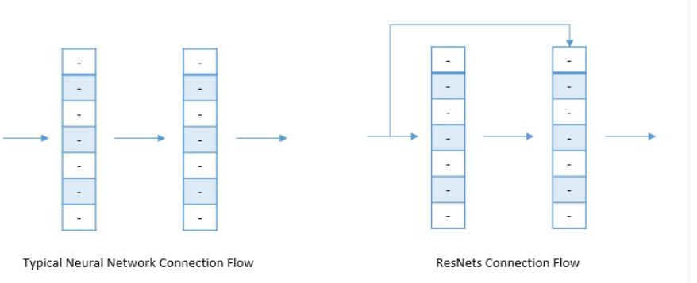
Microsoft research discovered that it was possible to split the deep neural network into three layered chunks, passing the input directly into each segment together with the residual output of the previous chunk minus the input that is reintroduced (known as skip-connections). This helps eliminate the vanishing gradient problem common in other deep neural network implementations without any changes to parameters or learning algorithms [10].
Figure 3. ResNet skip-connections

Because of their large depth and the fact that the vanishing gradient problem is solved, ResNet’s with a depth of 152 have achieved an accuracy of 95.51% in top-5 accuracies; all while being more computationally efficient than the VGGNet [7].
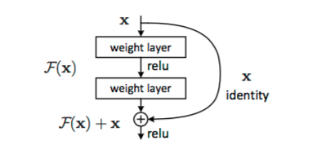
Figure 4. Standard Identity block

Each block in a standard ResNet architecture follows the same principle, a 3x3 convolution and pooling step followed by 4 layers of similar behaviour. This is then repeated several times depending on the size of the resnet, comparing different map dimensions (64, 128,256, 512) respectively – bypassing the input every second convolution. A standard ResNet implementation is generally built using two different types of blocks, the Identity block and the Convolutional block.
The identity block is used in the standard case where the input activation has the same dimensions as the output activations. On the other hand, whenever the input and output dimensions don’t match, a convolutional layer is added to the shortcut’s path – converting the identity block into a convolutional block. By repeatedly stacking different blocks together, the ResNet can achieve high accuracies through its deep neural network architecture [9].
2.3 MobileNet
There are two versions of the MobileNet implementation, both very similar but the second version significantly improves the overall performance.
In the first version, depth-wise convolutional layers are used replacing the standard convolution layers in order to reduce the computational cost. The convolutional layer is separated into two parts, first a depth-wise convolutional layer filters the input, then followed by a 1×1 pointwise convolutional layer combining filtered values with new features as seen in Figure 3 below.
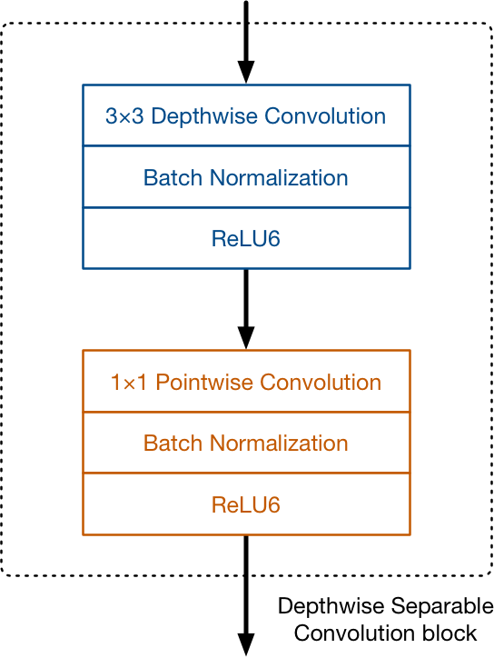
Figure 5. MobileNet Version 1 Convolutional Block

The convolutional block implemented in MobileNet’s perform the same operations as traditional convolution but much faster. Unlike a regular convolution it performs convolution on each input channel separately rather than combining them. The activation function used is ReLU6. The authors of [10] found that ReLU6 is more robust than regular ReLU when using low-precision computations.
The most important of its hyper-parameters is the depth or width multipliers, which are used to change the number of channels in each layer. Using a depth multiplier of 0.5 will halve the number of channels used per layer, which cuts down the number of computations by a factor of 4 and the number of learnable parameters by a factor 3. It is therefore much faster than the full model but also less accurate.
The use of depth-wise separable convolutions ensures that the MobileNet has to perform about 9 times less work than comparable neural networks with the same accuracy.
MobileNet version2[12] still uses depth-wise separable convolutions as its main building block as seen in figure 4 below.
Version 2 has three convolutional layers per block. The last two are the ones used in version 1, a depth-wise convolution layer that filters the inputs, followed by a pointwise convolution layer. However, instead of keeping or doubling the number of channels in version 1, the point-wise layer in version 2 or the ‘projection’ layer reduces the number of channels - it ‘projects’ data into much smaller dimensions. The first convolutional layer or the ‘expansion’ layer expands the number of channels in the data before going into the depth-wise convolution. Exactly by how much the data gets expanded is given by the one of the hyper parameters; the expansion factor.
The idea behind version 1 was to replace expensive convolutions with cheaper ones, even if it meant requiring more layers. The main changes in the architecture of version2 are the residual connections and the expand/projection layers.

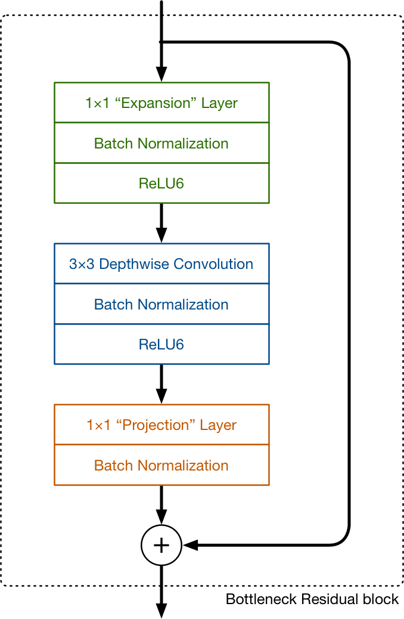
Figure 6. MobileNet Version2 Bottleneck Residual Block
3 Experimental Results
3.1 Benchmarks - Accuracy Comparison
When calculating benchmarks for convolutional neural networks, it’s important to run tests in identical environments with the same CPU power, memory and even OS [15]. Previous works benchmarking several different neural networks examined the models testing for the following criteria;
- Layers used
- Top-1 Error rate
- Top-5 error rate
- Prediction speed

Table 1. Accurarcy of MobileNet
Model | Parameter Memory/ mb | Layers | Top-1 Error | Top-5 Error | Speed (Ms)
AlexNet | 233 | 8 | 42.9 | 19.80 | 14.56
RestNet-18 | 45 | 18 | 30.43 | 10.76 | 31.54
ResNet-152 | 230 | 152 | 22.66 | 6.16 | 217.91
MobileNet v2 | 16 |  | 20.02 | 9 | 200 (on a mobile device CPU)

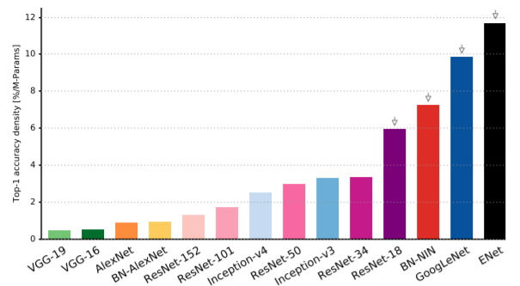
Figure 7. Top-1 Accuracy/parameter comparison

By considering the accuracy as a factor per parameter we can effectively highlight that the capacity of later architectures is more equipped to better utilise their parametric space [13]. In this graph, we can clearly see that the AlexNet implementation is oversized, meaning that it utilises a large number of parameters but does not effectively take advantage of their potential learning enhancement. It is also clear that while accuracy increases together with the number of parameters used by the different ResNet architectures, the increase is far from linear – with larger models having less accuracy per parameter.
3.2 Benchmarks - Computational Requirements
It’s also important to consider the viability of the network in question, considering important factors such as the total memory required, the power consumption, the number of operations and parameters needed and even the inference time [17].
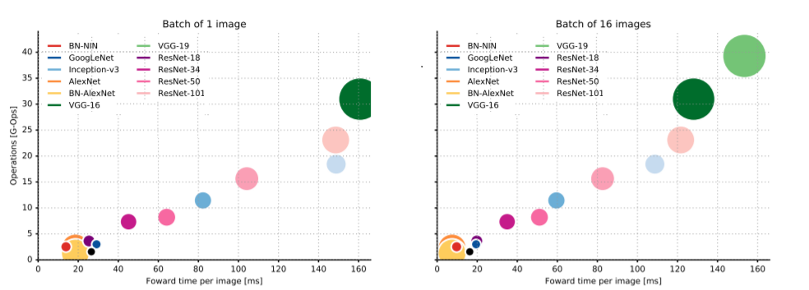
By calculating the total number of operations required before making a prediction, we can then infer the total training time as seen in the below figure [13]. Through the total operations count an estimate of inference time and the size of the hardware circuit in the case of custom-made neural network accelerators can be made.
Figure 8. Operations count comparison for different Neural Networks
Even though adding several additional layers to ResNets can significantly improve their accuracies, the tradeoff with operations count and inference time is not negligible and must be factored in when designing models [14].
3.1 MobileNet Version Comparisons
As discussed above, MobileNet V2 is simply an updated version of V1 focusing on improving efficiency and performance.
Table 2. MACs of MobileNet
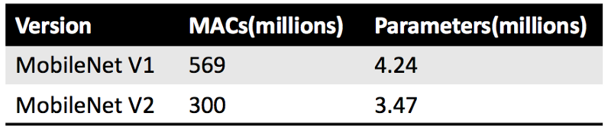
MACs (Multiply-Accumulate Operations) measure how many calculations are needed to perform inference on a single 224×224 RGB image - the larger the image, the more MACs are needed. From table 1 we can clearly see that v2 is almost twice as fast as the v1 model.
In terms of accuracy, the reported top-1 and top-5 accuracy are on the ImageNet classification dataset [14]. To get the above numbers, the central region of the image was cropped to an area containing 87.5% of the original image, and then that crop was resized to 224×224 pixels. Only a single crop was used per image. Through these results it is clear that MobileNet v2 is not only significantly faster but can also achieve higher accuracies than the MobileNet v1 model.
Table 3. Accurarcy of MobileNet
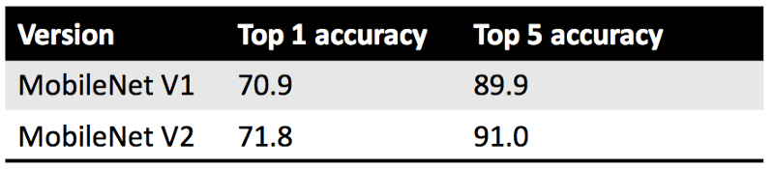
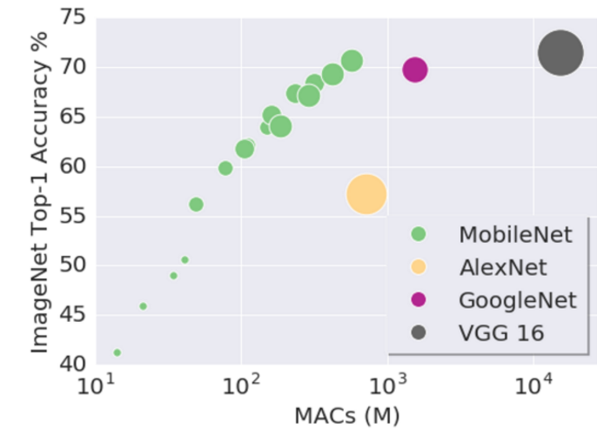
As discussed, MobileNets provide an extremely small, power-efficient models parameterized to suit the highly-restricted resources available across many different use cases [16]. They tradeoff between accuracy, size and latency while still being able to compare favorably with popular state of the art neural network models which work with significantly larger models, higher MAC-counts, and more resource requirements.
Figure 9. Speed Comparison in MACs vs Top-1 Accuracies [16]
4 Conclusions
In this paper, we investigated the differences between the various neural network architectures, both in terms of overall performance and hardware/parameter constraints that each network has. Starting with the then revolutionary AlexNet, building up to the state-of-the-art mobilenet implementations, we discussed common problems such as the vanishing gradient problem and how different neural networks aimed to solve or negate them.
References
1. A. Krizhevsky, I. Sutskever, G.E. Hinton, "Imagenet classification with deep convolutional neural networks", Proc. NIPS, pp. 1-9, 2012.
2. M.D. Zeiler, R. Fergus, "Visualizing and understanding convolutional neural networks", pp. 1311-2901, 2013.
3. Z. Li, X. Zhu, L. Wang and P. Guo, "Image Classification Using Convolutional Neural Networks and Kernel Extreme Learning Machines," 2018 25th IEEE International Conference on Image Processing (ICIP), Athens, 2018, pp. 3009-3013.
4. Krizhevsky, A., Sutskever, I. and Hinton, G.E., 2012. Imagenet classification with deep convolutional neural networks. In Advances in neural information processing systems (pp. 1097-1105).
5. Das, S. (2019). CNN Architectures: LeNet, AlexNet, VGG, GoogLeNet, ResNet and more [online] Medium. Available at: https://medium.com/@sidereal/cnns-architectures-lenet-alexnet-vgg-googlenet-resnet-and-more-666091488df5 [Accessed 14 Apr. 2019].
6. He, K., Zhang, X., Ren, S. and Sun, J., 2016. Deep residual learning for image recognition. In Proceedings of the IEEE conference on computer vision and pattern recognition (pp. 770-778).
7. He, K., Zhang, X., Ren, S. and Sun, J., 2016, October. Identity mappings in deep residual networks. In European conference on computer vision (pp. 630-645). Springer, Cham.
8. Xie, S., Girshick, R., Dollár, P., Tu, Z. and He, K., 2017. Aggregated residual transformations for deep neural networks. In Proceedings of the IEEE Conference on Computer Vision and Pattern Recognition (pp. 1492-1500).
9. Olafenwa, J. (2019). UNDERSTANDING RESIDUAL NETWORKS. [online] Towards Data Science. Available at: https://towardsdatascience.com/understanding-residual-networks-9add4b664b03 [Accessed 14 Apr. 2019].
10. A. G. Howard, M. Zhu, B. Chen, D. Kalenichenko, W. Wang, T. Weyand, M. Andreetto,
and H. Adam. Mobilenets: Efficient convolutional neural networks for mobile vision
applications. arXiv preprint arXiv:1704.04861, 2017.
11. Image-net.org. (2019). ImageNet Large Scale Visual Recognition Competition 2012
(ILSVRC2012). [online] Available at: http://www.image-net.org/challenges/LSVRC/2012/
[Accessed 10 Apr. 2019].
12. M. Sandler, A. Howard, M. Zhu, A. Zhmoginov, L. Chen. MobileNetV2: Inverted
Residuals and Linear Bottlenecks. arXiv preprint arXiv: 1801.04381, 2019.
13. Canziani, A., Paszke, A. and Culurciello, E., 2016. An analysis of deep neural network models for practical applications. arXiv preprint arXiv:1605.07678.
14. Bianco, S., Cadene, R., Celona, L. and Napoletano, P., 2018. Benchmark analysis of representative deep neural network architectures. IEEE Access, 6, pp.64270-64277.
15. GitHub. (2019). albanie/convnet-burden. [online] Available at: https://github.com/albanie/convnet-burden [Accessed 12 Apr. 2019].
16. GitHub. (2019). tensorflow/models. [online] Available at: https://github.com/tensorflow/models/blob/master/research/slim/nets/mobilenet_v1.md [Accessed 12 Apr. 2019].
17. Johnson, J. (2019). jcjohnson/cnn-benchmarks. [online] GitHub. Available at: https://github.com/jcjohnson/cnn-benchmarks#alexnet-paper [Accessed 10 Apr. 2019].

