ML1819 Research Assignment 1

Team 9

Twitter Users Gender Prediction

Team members:

Nicholas Bonello 18307199

Siddharth Tiwari 18300621

Zihan Huang 18300321

Work Contribution:

Nicholas Bonello:

Plot and analyze the tweets count and favorite counts;

Plot and analyze side bar color and link color;

Plot and analyze the color in RGB separately;

Process the tweet content and description and apply logistic regression on.

Write the report.

Siddharth Tiwari:

Process the tweet content and description and apply Naïve-Bayes on it.

Plot and analyze hashtag counts

Plot and analyze emoji counts

Write the report.

Zihan Huang:

Looking for related works;

Plot and analyze the length of tweets and description;

Plot and analyze the bar color hex into decimal and plot;

Write the report.

Word Count: 988 words

Source Code Repository:

https://github.com/zihan0/ML1819-task-107-team-09.git

Source Code Repository Activity:

https://github.com/zihan0/ML1819-task-107-team-09/graphs/contributors

ML1819 Research Assignment 1

Twitter Users Gender Prediction

Nicholas Bonello  
School of Computer Science and Statics  
 Trinity College Dublin, University of Dublin  
 Dublin Ireland  
Bonellon@tcd.ie

Siddharth Tiwari  
 School of Computer Science and Statics  
 Trinity College Dublin, University of Dublin  
 Dublin Ireland  
stiwari@tcd.ie

Zihan Huang  
School of Computer Science and Statics  
 Trinity College Dublin, University of Dublin  
 Dublin Ireland  
 huangzi@tcd.ie

1 INTRODUCTION

Gender prediction is an important tool that can be used to improve existing predictive models. Most existing works focusing on gender prediction through blogs or microblogs such as twitter generally focus on making use of analysing the language used in text – in this case the tweets and user bio.

In this paper we investigate the possibility of predicting twitter users’ gender based on public information. We will be evaluating the potential of using simple statistical measures such as tweet counts, favourite counts per tweet, profile background colours and link colours.

We will also be applying natural language processing and machine learning algorithms to the text in tweets to try and understand the differences between male and female twitter users.

2 RELATED WORK

Predicting gender through social media data is generally considered to be a text classification problem.

According to Chen *et al.* [1], K-Nearest Neighbour (KNN) is an effective and easy to implement machine learning algorithm, but not perfect for text classification purposes. They proposed an algorithm that combines Latent Semantic Indexing (LSI) methods with KNN to compromise the shortages KNN has. From their results, the effectiveness in processing large scale data improved with the new algorithm.

Naïve-Bayes [2] and Support Vector Machine (SVM) [3] also are popular techniques for text classification.

3 METHODOLOGY

1. Data collection

A readily available csv dataset containing a list of tweets and related twitter profile information such as tweet-counts, favourite counts, user biography, tweet contents, etc. was taken from Kaggle [5]. The dataset provides labelled data for twitter users that are either male, female or a brand.

1. Data Processing

First, we manually removed all the extra columns such as user location that clearly don’t have any effect on gender, as well as all the rows that were predicted to be a brand. In order to fine tune our labelled data, we removed all rows where the gender accuracy was less than 80%. Then, we plotted different graphs using two features at a time to determine whether there are any obvious factors that clearly correlate to gender.

1. Machine Learning Algorithm

We attempted to create a classifier that could accurately solve the logistic regression problem of predicting a twitter users gender based on two different features at a time. We used 80% of our dataset to train the model and the remaining 20% as future data to test our model.

The first step was to create graphs that would easily help us visualise the data so that we can determine which of the features can be used to predict the user’s gender.

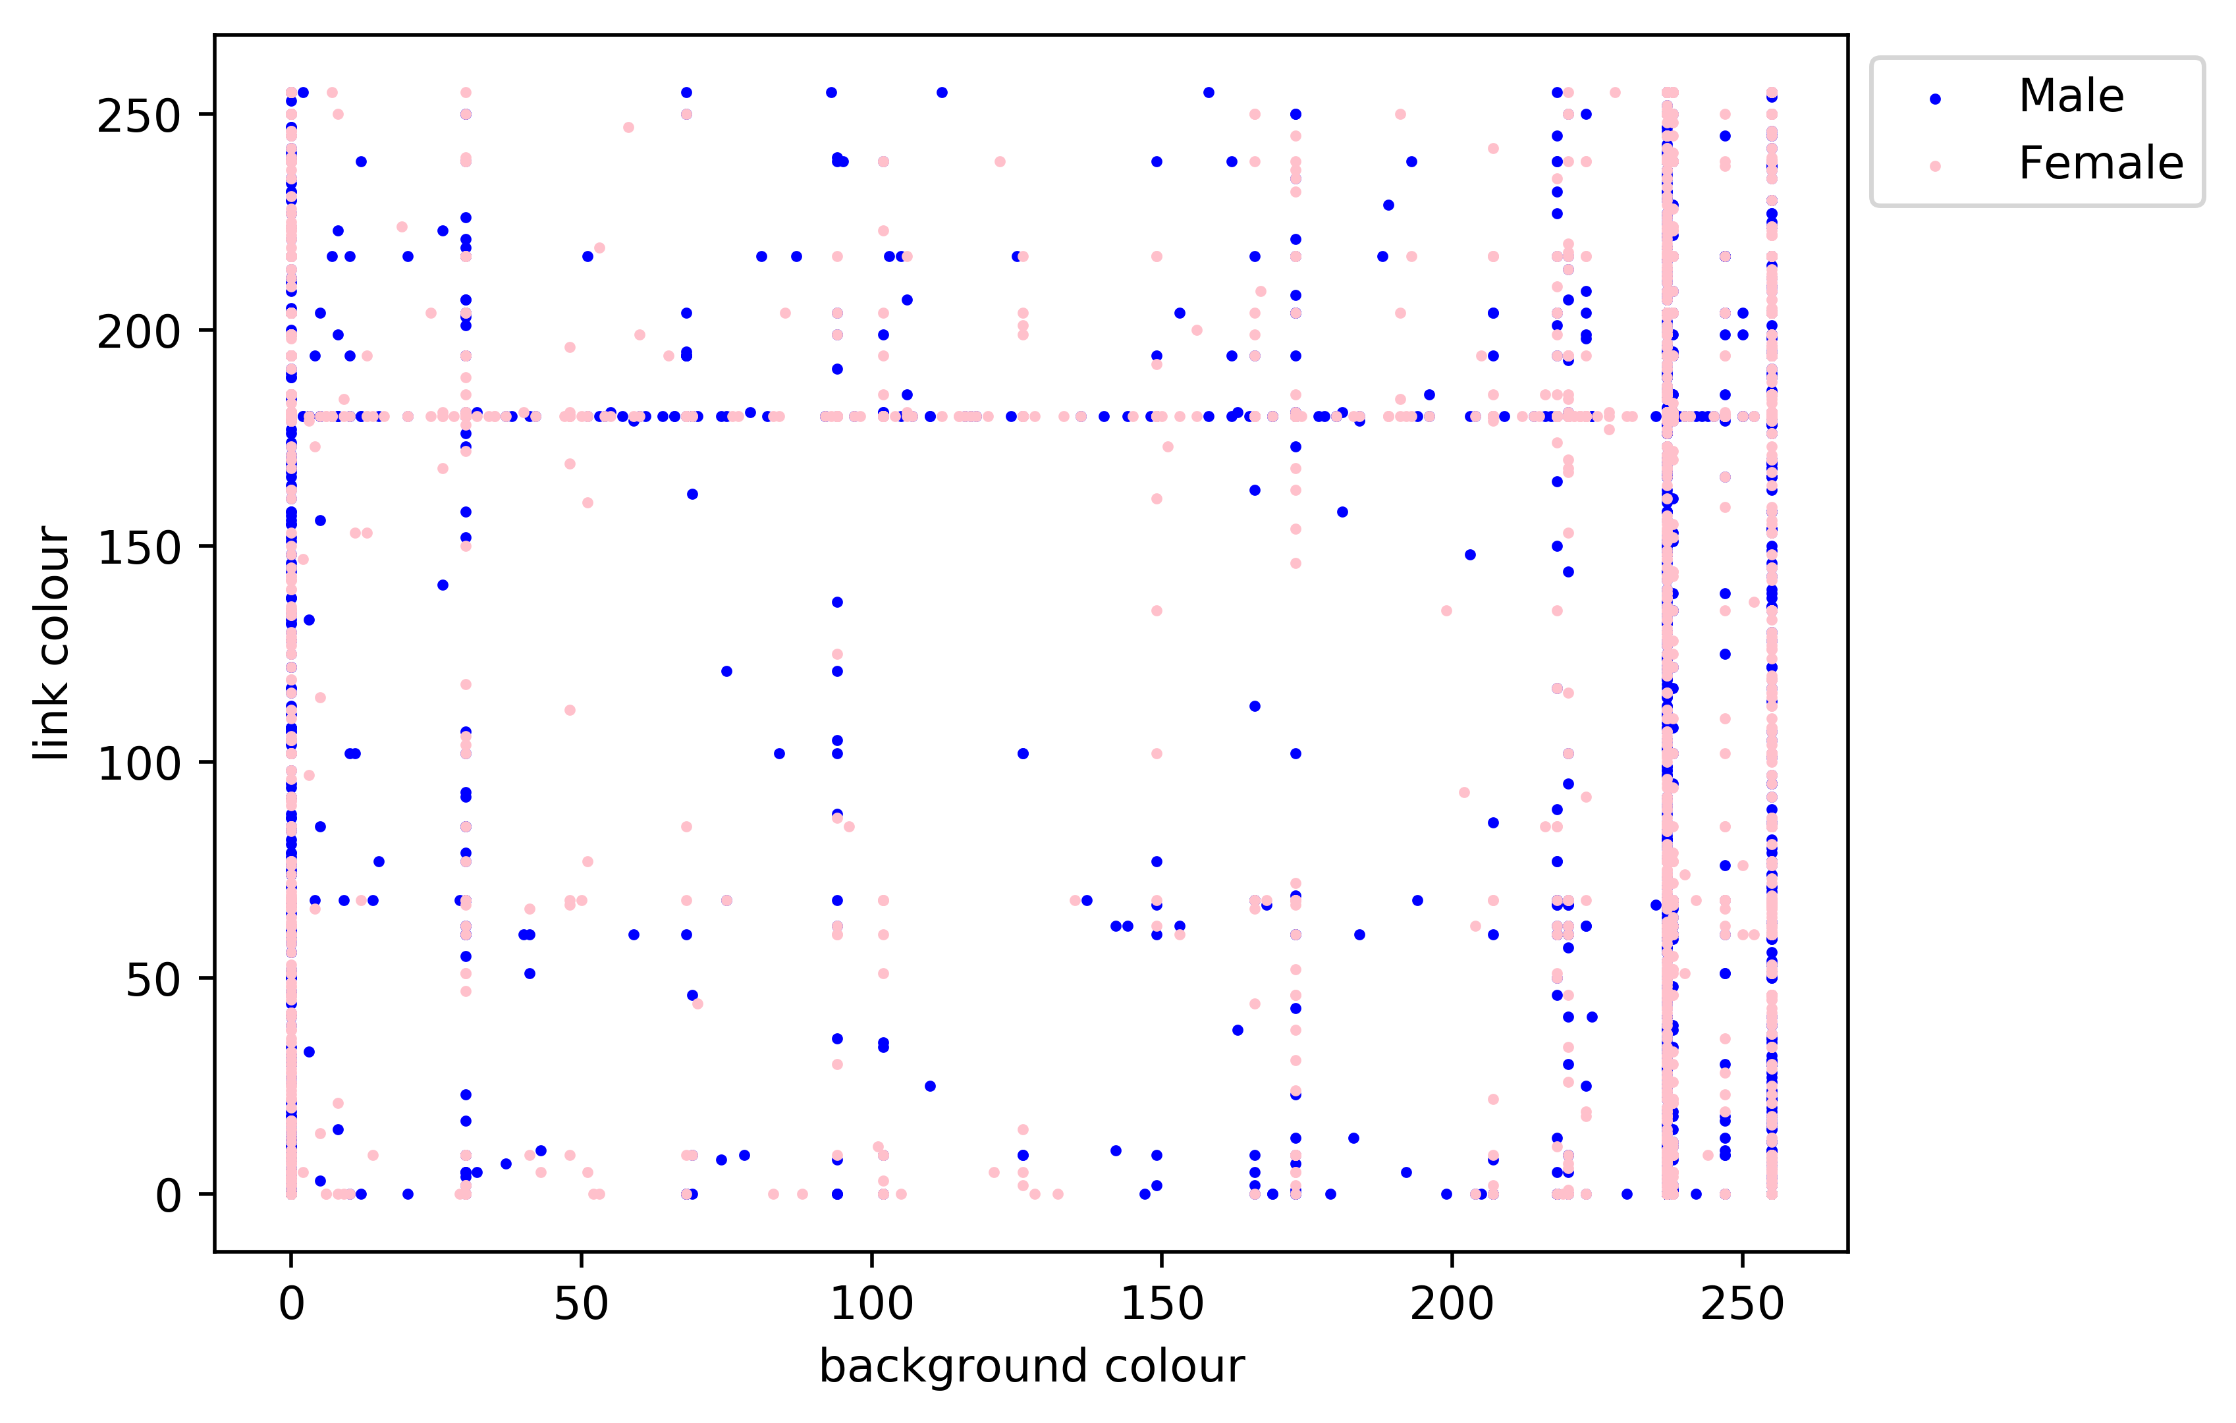

**Figure 1 - Link Colour vs Background colour in Red spectrum**

The graph above shows the link and background colour frequency distribution in the red spectrum. Values such as 0 and 255 are the default values which explain why theres so many users picking them.

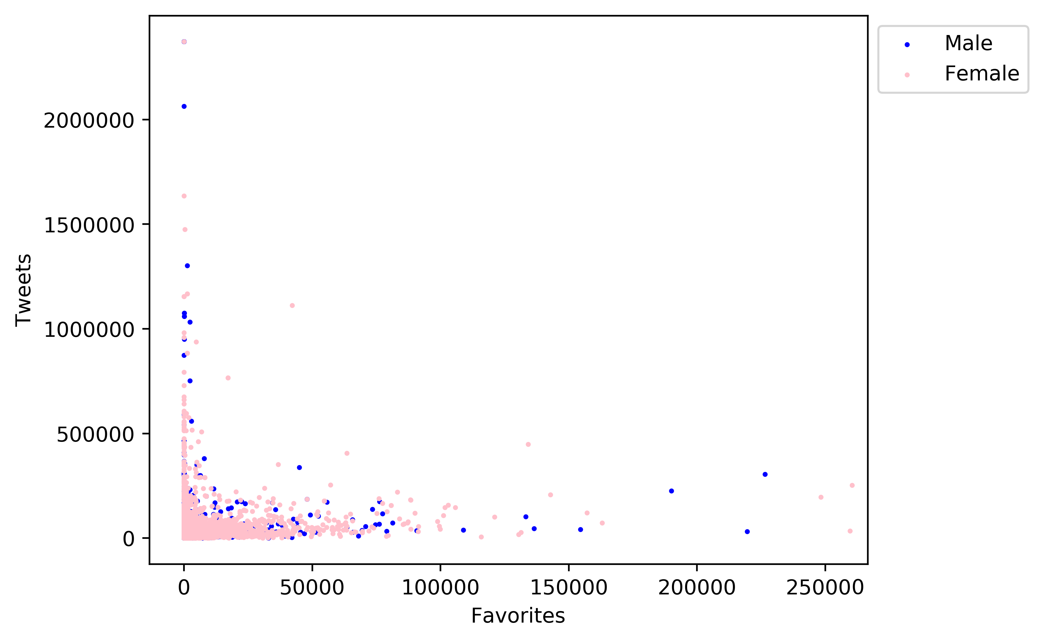

**Figure 2 - Number of tweets vs Number of favorites per user**

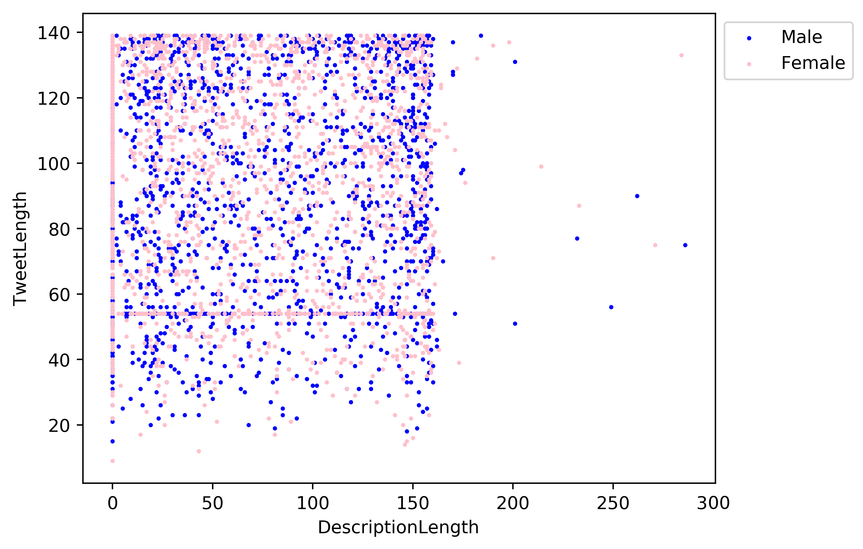

Figure 3 - Tweet Length vs User Description Length

It became instantly clear that none of the provided features could be used to distinguish between a twitter user’s gender. Our next approach was to follow the related works methods and analyse both the tweet and the bio text and apply different machine learning algorithms to determine whether we can predict gender based on text data alone, and to what degree of accuracy.

4 RESULTS & DISCUSSION

Our first attempt was to look at the different features such as favourites counts, tweet counts, tweet content, user description content, background colour, link colour and even the number of hashtags used per tweet – labels that were easily obtained from the dataset. These labels were not a good discriminant for predicting gender.

We created a bag-of-words algorithm that calculates the frequency of word usages per gender. A logistic regression classifier was then used to train our dataset on the top words.

When run against the test data, the logistic regression model had an accuracy of 53.34%. To improve on this result, we attempted to use a Naïve-Bayes algorithm instead of the logistic regression as still relatively weak – 57.27%.

We explored various options to get a better prediction rate; considering different natural language processing techniques including stop-word removal, punctuation removal and stemming. This improved the scores of both above models as seen in the table below.

|  |  |  |
| --- | --- | --- |
|  |  | NLP Techniques |
| Logistic Regression | 53.34% |  |
| Naïve Bayes | 57.27% |  |

All papers that have previously attempted to predict twitter users’ gender based on their profile data have all done so through semantic analysis of tweet text and user biographies. Our results agree with this statement, showing that none of the other provided features that were provided in the dataset have any relevance to the gender of that specific user.

Previous works could successfully predict gender with an accuracy of 67.2% when only considering a randomly obtained tweet using an n-gram model [6].

Burger *et al.* demonstrated that the accuracy of a model improves significantly when more features are considered [5]. As can be seen below, our results match theirs when we only consider the user description and a single tweet.

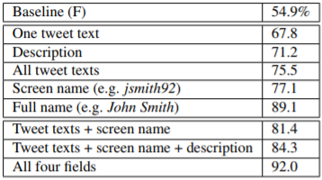

Figure 4 - Burger et al. Results

5 LIMITATIONS & OUTLOOK

Given the limited amount of time available to work on this project, a lot of ideas and proposals have been suggested that we simply were not able to do.

For starters, the provided dataset contained lots of extra useless information while also lacking information that could have been used such as more tweets per user. Creating our own larger dataset with a much higher number of users and tweets per user would have provided us with much more training data and better results.

In terms of implementation techniques, we plan to develop an SVM implementation to compare this result with the already obtained results.

In a dataset as small as the one we used, dedicating 20% of our data to test data is a significant amount that would potentially cause a loss of accuracy in our model. In the second phase we plan to implement cross-validation techniques and experiment with the percentages of training and test data to find the most optimal results.

REFERENCES

[1] Jianle Chen, Tianqi Xiao, Jie Sheng and A. Teredesai, "Gender prediction on a real life blog data set using LSI and KNN," 2017 IEEE 7th Annual Computing and Communication Workshop and Conference (CCWC), Las Vegas, NV, 2017, pp. 1-6.

[2] I. Rish, “An Empirical Study of the Naïve Bayes Classifier”, In Proceedings of the IJCAI-01 Workshop on Empirical Methods in Artificial Intelligence, Vol. 3, Issue 22, pp. 41-46, 2001.

[3] B.E. Boser, I.M. Guyon, and V.N. Vapnik, “A training algorithm for optimal margin classifiers”, COLT '92 Proceedings of the fifth annual workshop on Computational learning theory, pp. 144-152, Pittsburgh, Pennsylvania, USA, July 27 - 29, 1992.

[4] Kaggle.com. (2018). Twitter User Gender Classification. [online] Available at: https://www.kaggle.com/crowdflower/twitter-user-gender-classification [Accessed 9 Oct. 2018].

[5] Delip Rao, David Yarowsky, Abhishek Shreevats, and Manaswi Gupta. 2010. Classifying latent user attributes in Twitter. In 2nd International Workshop on Search and Mining UserGenerated Content. ACM.

[6] Burger, J.D., Henderson, J., Kim, G. and Zarrella, G., 2011, July. Discriminating gender on Twitter. In Proceedings of the conference on empirical methods in natural language processing (pp. 1301-1309). Association for Computational Linguistics.

Conference Name:ACM Woodstock conference

Conference Short Name:WOODSTOCK’18

Conference Location:El Paso, Texas USA

ISBN:978-1-4503-0000-0/18/06

Year:2018

Date:June

Copyright Year:2018

Copyright Statement:rightsretained

DOI:10.1145/1234567890

RRH: F. Surname et al.

Price:$15.00