Neural mechanisms of interaction between episodic memory and working memory
Applicants: Zihan Bai (NYU PhD in C&P, global program) and Sebastian Michelmann (NYU).
Introduction: Working memory (WM) maintains information after it leaves the sensory environment, but its capacity is limited (Luck & Vogel, 1997). Episodic memory (EM) rapidly encodes distinct, high-resolution representations of individual events (Tulving, 1983). How the reinstatement of episodic representations can support WM has been largely untested. This study will localize the site of EM-WM integration and assess the neural mechanisms that endow EM with its ability to support WM.
We previously established that EM can rescue WM mnemonic discrimination, when WM load is high: Thirty-one individuals undergoing eye-tracking encoded items by classifying them as “same” or “similar” relative to their immediate predecessor (one-back task; no response for new items). In a subsequent two-back task, we found a graded and specific benefit of episodic memory on mnemonic discrimination accuracy and response times: performance was best if items had previously been compared to each other, while identification of identical items was not modulated. Successful discrimination of previously compared items was associated with greater pupil dilation, gradually-emerging gaze patterns characteristic of the similar counterpart-item (predictive recall), and higher gaze-similarity between the one-back and two-back viewing of the target item (pattern completion). Diverging gaze patterns during one-back (pattern separation) further predicted discrimination performance during two-back. These results elucidate the mechanisms by which episodic memory supports working memory. What is missing is a direct characterization of the neural underpinnings of this EM-WM interaction.
Experimental design:
The MST-back task: We embed mnemonic discrimination judgements of similar looking everyday objects (Stark et al. 2019) in a continuous N-back task (Kirchner, 1958): Participants will compare objects to their n^{th} predecessor, classifying them as same, similar, or new (no response required). A low WM load (one-back) condition serves as an incidental encoding task. In each of four blocks, participants classify 180 trials (720 trials total). After each one-back block, a high WM load condition requires participants to compare items to the penultimate object (two-back phase), classifying 158 trials (632 trials total).
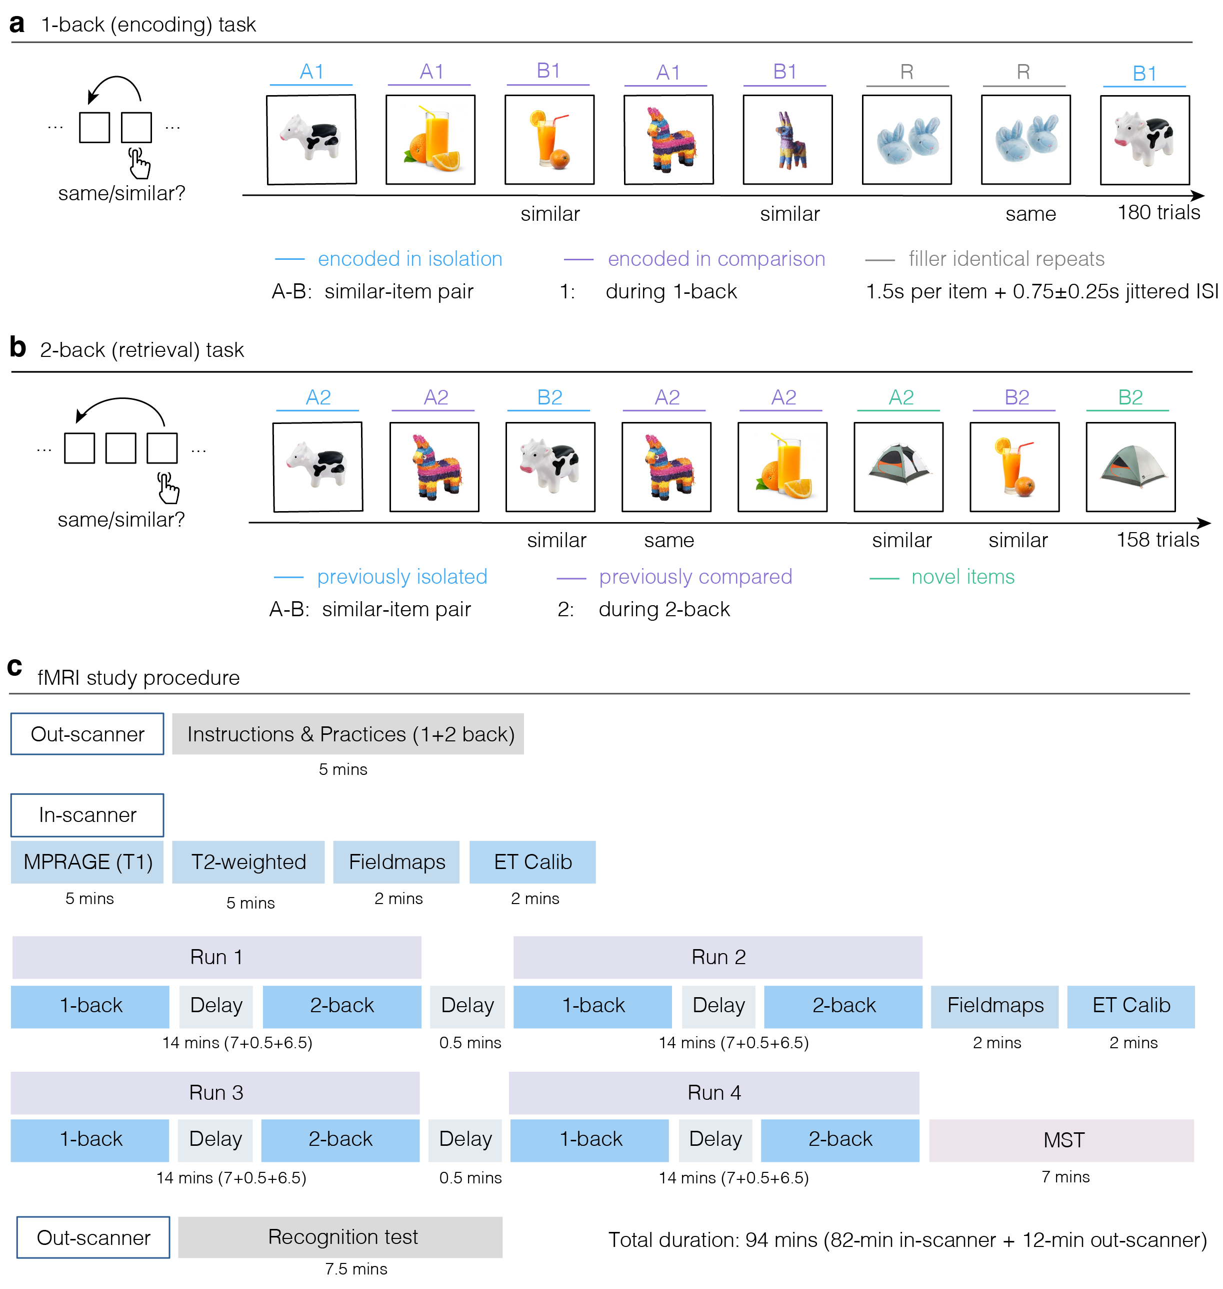 | Figure 1. Task and fMRI study procedure: In two task phases, participants judge objects relative to their n^{th} predecessor as “same”, “similar”, or “new” (no response). Each block contains a one-back phase (used to elicit episodic memory encoding) followed by a two-back phase, in which some items from the one-back phase reappear to test for episodic retrieval effects. Notation: A and B denote the two members of a perceptually similar pair, numbers (1 and 2) denote the task phase in which the item appeared (one-back vs. two-back). (a) One-back encoding task: In the compared condition, A1 and B1 appeared on consecutive trials, allowing direct comparison between similar items. In the isolated condition, A1 and B1 were separated by at least 5 intervening items, limiting direct comparison. Gray items indicate filler identical repeats (R). Each item is presented for 1.5 s followed by a jittered inter-stimulus interval of 0.75 plus or minus 0.25 s. (b) Two-back task: Previously compared, previously isolated, and novel pairs appear as A2 and B2, separated by an intervening item, within a continuous two-back stream. (c) fMRI study procedure: Instructions and practice take place outside of the scanner. The MRI procedure starts with a T1 and T2 scan, fieldmap collection and eye tracker calibration. Four runs of the MST-Back are separated by 30 s rest periods; after 2 runs fieldmaps are collected and the eye tracker is recalibrated. Afterwards, participants perform standard Mnemonic Similarity judgements. An out-of-scanner recognition test is used to confirm memory of the MST-Back items.
We manipulate how pairs of items are experienced during one-back (Figure 1a): In each block, 30 compared pairs appear consecutively, enabling direct detection of distinguishing features; 30 isolated pairs are separated by at least 5 intervening items. In contrast, novel pairs appear for the first time during two-back. Across the four blocks, the two-back phase tests 360 pairs total, consisting of 120 previously compared, 120 previously isolated, and 120 novel pairs (appearing for the first time in the two-back phase; Figure 1b). Additionally, repeated filler items (same detection without episodic memory demand) appear in the one-back. In a final mnemonic similarity task participants discriminate some of these one-back filler items from their unseen “similar” pair-mates. Finally, participants will perform an old/new recognition task outside of the scanner to confirm that they have EM of tested two-back images.
Stimulus timing: Each image is shown for 1.5 s with a jittered 0.5-1 s inter-trial interval (mean SOA ≈ 2.25 s). The session runs for ~82 min as four runs (Figure 1c); each run (14 min) pairs a 1-back encoding phase (7 min), a 0.5-min delay, and a 2-back retrieval phase (6.5 min), with a mid-session fieldmap and eye-tracker recalibration between run-pairs. The final in-scanner mnemonic similarity task will run for 7-min.
Imaging parameters and eye-tracking measurement. Imaging is performed at 3T (Siemens Prisma, 64-channel coil). A whole-brain multiband gradient-echo EPI sequence at 1.5 mm isotropic resolution (TR 1500 ms, multiband factor 6, in-plane GRAPPA 2) provides subfield-scale resolution together with cortical coverage in a single acquisition; reverse-phase-encode spin-echo pairs support distortion correction. A 0.8 mm T1 MPRAGE and a high-resolution oblique-coronal T2 (0.4 × 0.4 × 2 mm, spanning the hippocampal long axis) support automated subfield segmentation (ASHS-T2; DG/CA3, CA1, subiculum, and entorhinal and perirhinal reference regions). Gaze is recorded throughout with an MR-compatible eye tracker (EyeLink 1000 Plus, 1000 Hz), both to reproduce the behavioral reinstatement measures in the scanner and to provide trial-wise gaze regressors.
Analysis procedure and predictions: Single-trial responses are estimated with GLMsingle and submitted to multivariate analyses in native functional space. Pattern similarity is tested as cross-validated Mahalanobis distance between different presentations of the A and B pairs (one-back: A1, B1; two-back A2, B2).
Primary hypothesis (univariate): We expect to find two partially overlapping networks that support the discrimination of novel items in the two-back condition (pure WM demand) and the discrimination of items from similar lures in the final mnemonic similarity task (pure EM demand). Crucially, we expect that a shared subnetwork modulates the successful discrimination of similar pair-mates in the MST-back task when EM is available. This network will be identified by contrasting the difference in BOLD response for successful vs. unsuccessful discrimination in the EM conditions (compared and isolated), with the difference in BOLD response for successful vs. unsuccessful discrimination in the novel condition (no EM available).
Primary hypothesis (multivariate):
Multivariate analyses will directly mirror the analyses of gaze pattern reinstatement in our previous study. We will first localize regions that reliably track image similarity by contrasting the similarity of voxel patterns between different viewings of the same image (A-A, and B-B pairs), different viewings of similar images (A-B pairs), and a null-distribution of different viewings of different images (all other pairs). We will then test three hypotheses about how EM supports WM:
(1) We will compare voxel patterns between the presentations of similar pair-mates in the one-back condition (A1-B1 similarity). We predict that lower pattern similarity (pattern separation) predicts successful discrimination of the pair in the subsequent two-back condition. We expect to find pattern separation in the Dentate Gyrus subfield of the hippocampal formation (Yassa & Stark 2011).
(2) We will compare the voxel pattern during target presentation in the two-back phase with the voxel pattern of target presentation in the one-back task (B2-B1 similarity). We predict that higher similarity between the voxel patterns (pattern completion) predicts successful discrimination performance. We expect to find this phenomenon in known retrieval networks, including the hippocampal CA3 subfield and cortical regions spanning the temporal and parietal lobes (Rugg & Vilberg, 2013).
(3) We will compare the voxel pattern during presentation of the first pair-mate in the two-back phase with the voxel pattern of the first pair-mate in the one-back task (A2-B1 similarity). We predict that higher similarity between the voxel patterns (predictive recall) predicts successful discrimination performance for the target item. We expect pattern completion and predictive recall to be strongest in the cortical region where WM and EM networks overlap (e.g., lateral parietal cortex and precuneus).
Additional information
Number of hours requested. We request ~13.5 hours of scanner time covering nine pilot participants at ~1.5 hours each (structurals, four functional runs, final memory test, and setup), collected after hours per CBI policy. MRI card access will be obtained beforehand by running certification scans with Michael Epstein during standard hours; collaborators Michelmann and Fougnie, provide the MRI expertise required of the team.
Plans for future funding. These pilot data directly support an NIMH R01 on the neural mechanisms of EM–WM coordination (~$4M total costs; planned submission October 5, 2026).
Collaborators. Sebastian Michelmann (NYU) contributes expertise in episodic memory, MEG, and fMRI and will lead fMRI data collection and neuroimaging analysis; Daryl Fougnie (NYU Abu Dhabi) contributes psychophysics and visual-WM fMRI. Zihan Bai already validated the paradigm behaviorally (N = 31) and will run the neuroimaging experiments.
IRB. The current IRB modification request for the fMRI protocol accompanies this proposal (general fMRI consent form, MRI screening form, and recruitment materials prepared); tokens will be used only after human-subjects approval is obtained.

