To the Editors of Nature Human Behaviour,

We are delighted to submit our manuscript, “Episodic memory rescues working memory via pattern separation, pattern completion, and predictive recall,” in which we uncover the mechanisms of integration between episodic memory and working memory.

For decades, the study of working and episodic memory has followed largely independent trajectories, with working memory characterized as a capacity-limited system that operates separately from long-term episodic memory. Accordingly, when episodic memory intrudes on working memory tasks, this is typically treated as a confound to be controlled rather than a mechanism to be understood. In our work we combine a carefully designed behavioral paradigm with human eye tracking to ask how episodic memory interacts with working memory.

Specifically, we developed a paradigm that embeds mnemonic discrimination of perceptually similar object images within a continuous N-back stream: participants judge each object as “same”, “similar”, or “new” relative to its n^{th} predecessor. A one-back phase with low working memory load serves as an incidental encoding phase. In a subsequent two-back phase with high working memory load, some of the pairs from encoding reappear, allowing us to test whether episodic representations of individual object images support their comparison in working memory.

At the behavioral level we found a striking benefit of episodic memory that was confined to the mnemonic discrimination of similar items. Moreover, this episodic benefit for discrimination was modulated by encoding conditions: those items that had previously been compared to each other experienced the strongest episodic performance boost, while similar pairmates that had each been presented in isolation showed a weaker but reliable advantage over novel pairmates.

We unveil the mechanisms that afford this behavioral benefit via eye tracking data. Pupil dilation selectively and reliably tracked the episodic performance boost in the retrieval phase. Tracking the gaze patterns by which participants sampled the images then allowed us to directly pinpoint three hallmark computations of episodic memory that supported working memory at the trial level. At encoding, we found that gaze-pattern separation laid down discriminative memory traces that supported subsequent performance. At retrieval, we found that the recapitulation of gaze patterns from encoding during target viewing (pattern completion) marked an item’s discrimination success. Strikingly, two trials before the target appeared, predictive viewing of the first of two pairmates foreshadowed upcoming discrimination success, indicating predictive recall of diagnostic features.

Our findings suggest that rather than operating as an isolated, capacity-limited system, working memory routinely draws on the same computations long recognized as central to episodic memory. Decades of treating working memory and episodic memory as separate objects of inquiry may consequently have obscured a computational substrate that operates across both. We believe that reuniting the study of working and episodic memory, at both a theoretical and paradigmatic level, is a necessary step forward to understand either system on its own terms, and human memory more broadly. We hope that our work will be of keen interest to the readership of Nature Human Behaviour and that it will be of wide-ranging significance across all fields of memory research.

Sincerely,
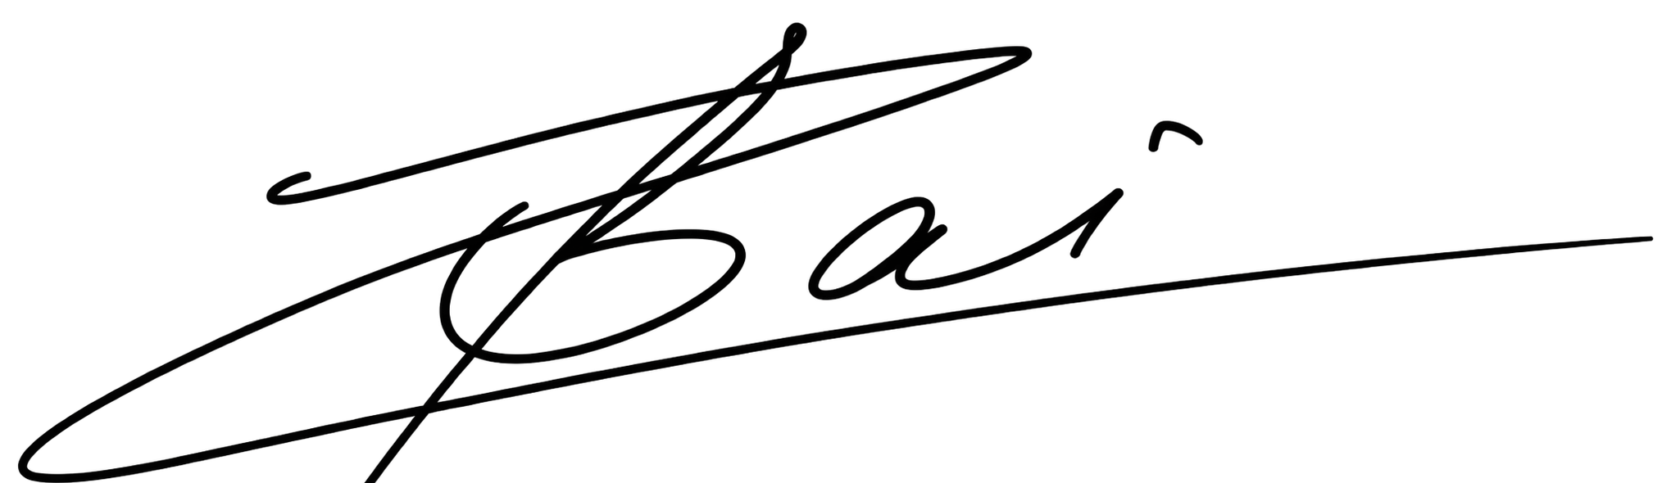
, 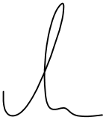
Zihan Bai and Sebastian Michelmann, on behalf of all authors.

