To the Editors of PNAS,

We are delighted to submit our manuscript, “Episodic memory rescues working memory in humans via pattern separation, pattern completion, and predictive recall,” in which we uncover the mechanisms of integration between episodic memory and working memory.

For decades, the study of episodic and working memory has followed largely independent trajectories, and the mechanisms of their interaction have remained uncharacterized. Indeed, when episodic memory intrudes on working memory tasks, this is typically treated as a confound to be controlled rather than a mechanism to be understood. In our work we combine a carefully designed behavioral paradigm with human eye tracking to ask how episodic memory interacts with working memory. Our work provides, to our knowledge, the first characterization of the computational substrate that integrates across the episodic and working memory systems.

Specifically, we developed a paradigm that embeds mnemonic discrimination of perceptually similar object images within a continuous N-back stream: participants judge each object as “same”, “similar”, or “new” relative to its n^{th} predecessor. A one-back phase with low working memory load serves as an incidental encoding phase. In a subsequent two-back phase with high working memory load, some of the pairs from encoding reappear, allowing us to test whether episodic representations of individual object images support their comparison in working memory.

At the behavioral level we found a striking benefit of episodic memory that was confined to the mnemonic discrimination of similar items. Moreover, this episodic benefit for discrimination was modulated by encoding conditions: if items had been compared to each other in the one-back phase, they experienced the strongest episodic performance boost. Similar pairmates that had been presented in isolation during one-back (separated by at least five items) showed a weaker but reliable advantage over novel pairmates in the two-back phase.

We unveil the mechanisms that afford this behavioral benefit via eye tracking data. Pupil dilation selectively and reliably captured the episodic performance boost in the retrieval phase. Tracking the gaze patterns by which participants sampled the images then allowed us to directly pinpoint three hallmark computations of episodic memory that supported working memory at the trial level. At encoding, we found that gaze-pattern separation formed discriminative memory traces that supported subsequent performance. At retrieval, we found that the recapitulation of gaze patterns from encoding during target viewing (pattern completion) marked an item’s discrimination success. Strikingly, two trials before the target appeared, predictive viewing of the first of two pairmates foreshadowed upcoming discrimination success, indicating predictive recall of diagnostic features.

Our findings characterize the mechanisms of integration between episodic and working memory. A key feature of our task is that the novelty of an image is not predictive of the time or type of response. Consequently, episodic memory can neither reduce working memory load, nor can episodic representations replace working memory representations. Instead, object representations stored in episodic memory need to be integrated with the content of working memory in order to improve performance. Our eye tracking analyses then pinpoint when and how this performance benefit emerges — diagnostic memory traces are laid down at encoding, and upcoming content is predicted before and reinstated during discrimination in the retrieval phase. Decades of treating working memory and episodic memory as separate objects of inquiry may consequently have obscured a computational substrate that operates across both. We believe that reuniting the study of episodic and working memory is a necessary step forward to understand either system on its own terms, and human memory more broadly.

We hope that our work will be of keen interest to the readership of PNAS, with implications spanning episodic memory, working memory, and their shared neural basis.

Sincerely,
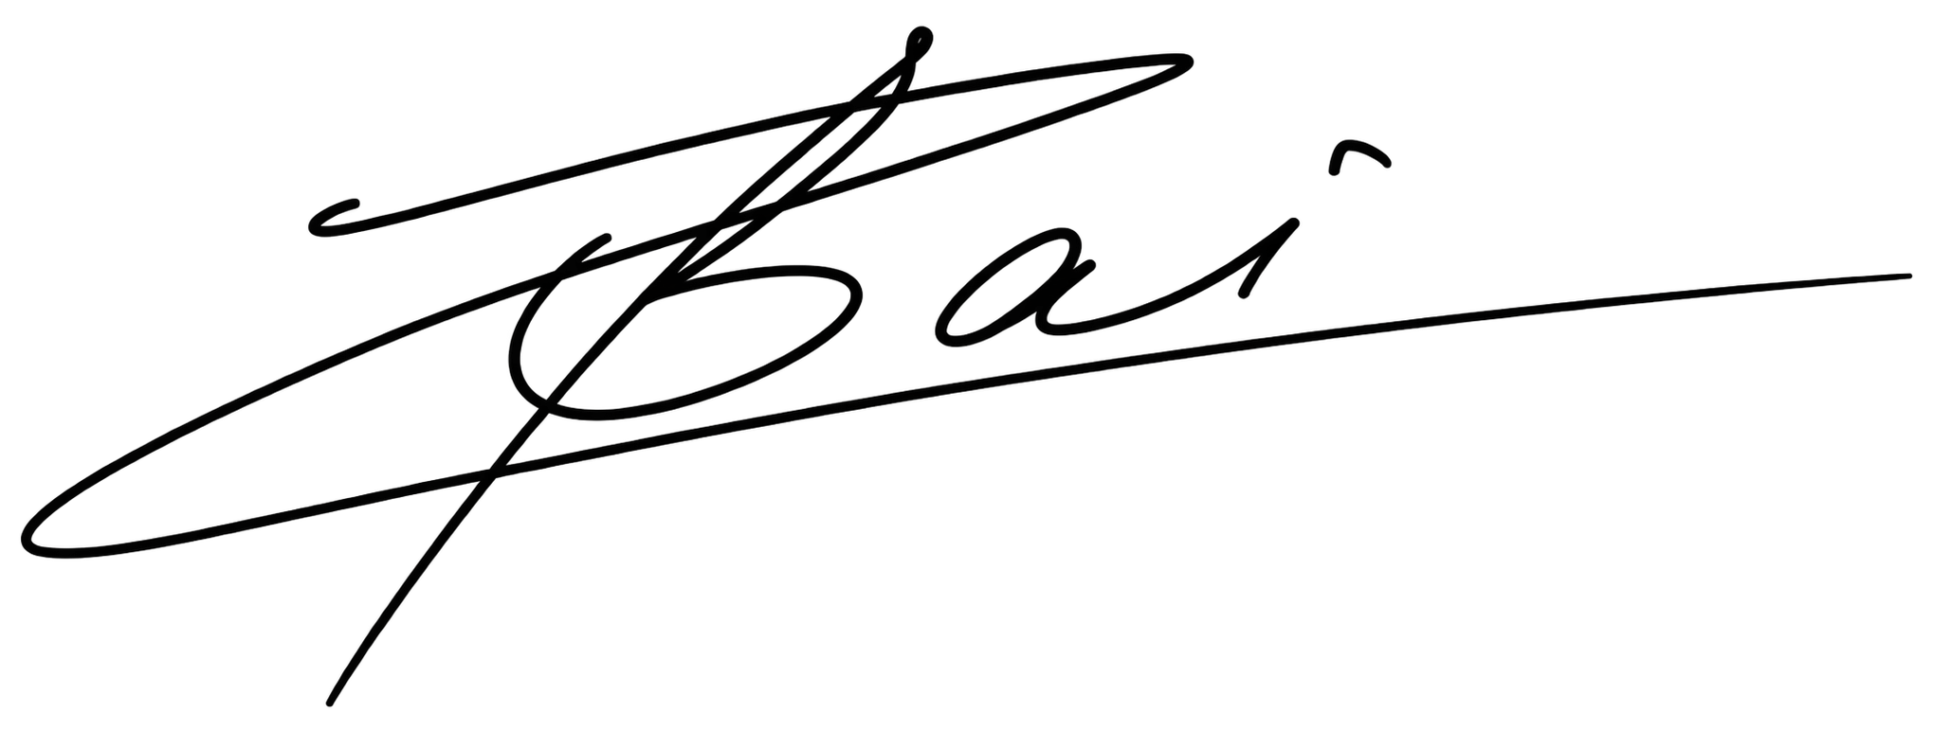
, 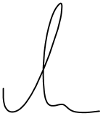

Zihan Bai and Sebastian Michelmann, on behalf of all authors.

