Analysis

Only test the third assignment files does not tell anything about the improvement of the third proejct over the second project. Thus, I intentionally tested two projects at this time to see if any difference. From the results, I regonized that witht the go-back-n mothed, the speed transfering the files is faster than the proejct without go-back-n. If the user looks at the same result from the second project and compare to this one, he might recognize that the time of transfering file is faster. It is because my home Internet speed varies from time to time. In order to make sure the difference between the third proejct and the second proejct, It is better to test them at the same time. The results turn out what we have expected.

HW2 result

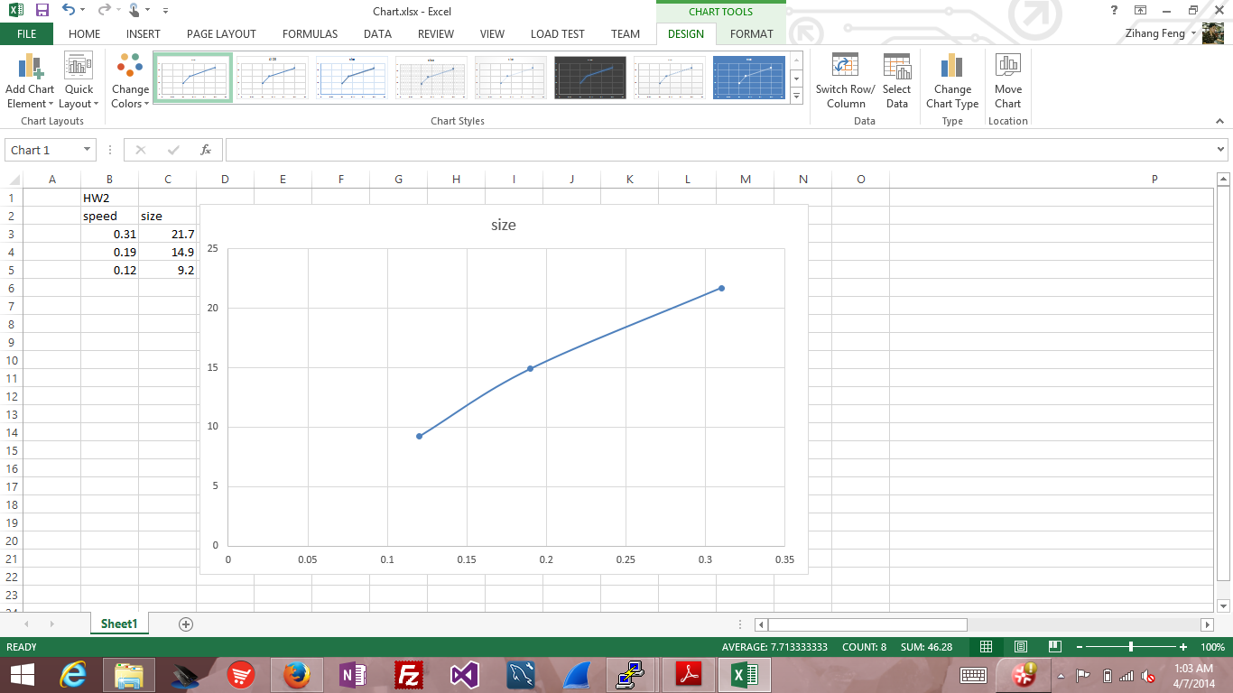

HW3 result

