Report

Selling a used car can make a very big business in the industry. In order to make the business more competitive, the knowledge required to determine the quality of used card is important. Of course, if they know the quality of the used car, they can make a good decision when buying that car. Moreover, some people try to create a platform for the other people to sell and buy the cars, and that makes even more important that both sides need to know the quality of the car to make the deal because most regular people do not have the expertise to determine the quality of a used car. In this report, Weka is used as tool to train the dataset of car evaluation to create a machine learning tool to determine the quality of a used car.

Before using Weka, the raw dataset needs to be converted to the Weka data form. The form of the Weka dataset needs to declare the information about the data in the arff file. In addition, the dataset must match the header information in the same file.

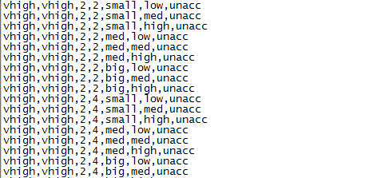

This picture shows the raw dataset

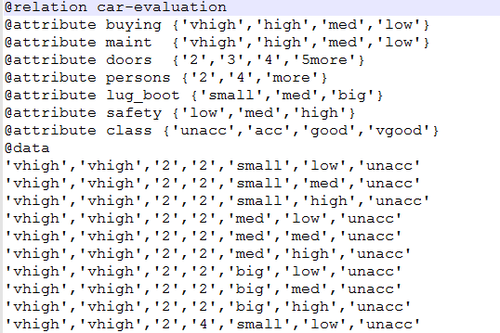

This picture shows the form of Weka dataset

After converting the dataset from raw data to the form of Weka dataset, the Weka can be applied to do the training. There are many different methods that can be used to train the dataset, such as J48, NBTree, and BayesNet. All of these methods have advantages and disadvantages. However, in this case, after using those methods, NBTree shows it has the highest accurate value which is about 95.4%, that is an extremely high accuracy. There could be other methods that can increase the accuracy as well. However, this is a very good one already. All of these results have been saved in names respect to the names of the methods themselves. As the outcome shows, Weka is a good tool to do the training in this scenario.