**Connect 4 - L**

You are to write a program that will allow two people to play the game connect 4. For those of you that do not know how to play Connect 4, the object is to place 4 of your pieces in a row in the game board. The 4 pieces can be either horizontal, vertical, or diagonal. Please see an example of game play below. The player should click on a column of the game board to choose a column and their token slides down the column until it hits the bottom or it lands on another piece. For an example of what the game looks like, refer to the Connect 4 applet at: <http://www.bodo.com/Applets/Connect4/> . A twist in our game is that we will not do the plain vanilla four in a row, but instead be looking for an L shape, 3 down and 1 over. Refer to the pictures below for an example..

This is the Game Connect 4. Each player should place an X or an O   
in the space by entering the column you want to place the piece.   
The piece will fall until it reaches the bottom or the current   
pieces in the board. When X or O gets 4 in an L shape (either   
horizontally or vertically) then that person wins.   
  
Let's get started!!!

At this point a new window opens up with the game board (initially blank).

The window shots below show normal game play.. 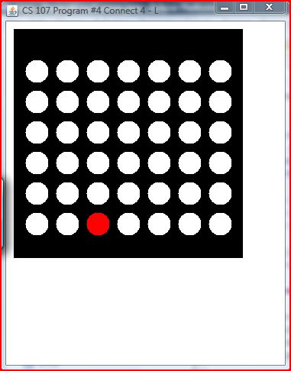

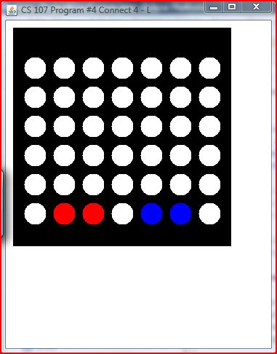

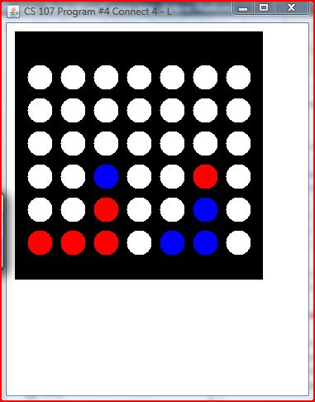  
  
  
  
The last image we see that Red has won, a message should be displayed on the console stating there was a winner and who won. There is the possibility of a draw, in which case an appropriate message should be displayed.

**Hints:**

1. Consider writing the program a step at a time, using the following order.  The number of points for each item are shown, out of the 55 total points for program execution.
   1. (0 points)  Get the instructions to display.
   2. (10 points)  Write code to hold the board information and display the board.
   3. (10 points) Write the loop for normal game play
   4. (15 points)  Write the code that handles the mouse click in a column and places a token (blue or red) in the appropriate column and row if valid (what happens when a column is full?).
   5. (15 points)  Write the code that checks for a winner.
   6. (5 points) Write code that checks for game over and no winner.
2. Turn in your program into Blackboard, into the Program 4 assignment.  You can turn it in multiple times, but only the most recent version turned in will be graded.
3. Looking for up to 10 points of extra credit?   *Be sure* that you have turned in a completed working version of the basic requirements before you try any of the items below.
   1. (4 points)  Instead of using the console window to display information to the users, get all the information to display on the canvas
   2. ( 6 points) Figure out how to have your program play against a "smart" computer opponent.