北京印刷学院

期末大作业报告

课程名称： 专业综合实训
专业： 计算机科学与技术 班级： 计科22-1
姓名： 魏方晓 学号 223010106
合作者姓名： 杨梓涵 合作者学号： 224010506
指导老师： 刘犇
时间： 2025.12.31

- 学校面包房小程序设计的背景、目的、意义​
就餐高峰时段，学校面包房线下点单的长排队等待问题，给赶时间的学生带来了诸多不便，同时也导致门店现场秩序较为拥挤。为切实改善学生的消费体验，提升点单取餐效率，计划采用线上线下结合的点单模式 —— 线上支持随时随地下单，到店即可直接取餐；线下设置免排队点单通道，实现即到即点，以此疏解高峰时段的拥堵压力。

- 技术介绍
- 开发语言和工具
开发语言：WXML、WXSS、JavaScript、JSON。
开发工具：Hbuilder

- 框架
uni-app框架：基于Vue.js的跨端开发框架​
- 需求分析
结合小程序场景与用户/业务诉求，核心需求聚焦于消费闭环+运营闭环：
用户需求：实现“线上/线下便捷点单”“订单全周期记录与操作”“会员权益兑换”，满足个性化消费、消费追溯、福利获取的诉求；
业务需求：通过模块化功能支撑“订单流转（点单→支付→完成）”“会员运营（等级/积分）”，同时借助营销模块触达用户，沉淀消费数据优化运营策略。
首页：承载“线上点单到店取”“线下点单免排队”入口，同时通过轮播展示营销活动；
点单：以“分栏菜单+个性化选购”为核心，实现商品浏览、属性选择、加购等下单操作；
订单：管理“当前订单（空状态引导）”“历史订单（记录+操作）”，支撑订单全生命周期管理；
我的：集中承载“会员中心”“积分商城”“系统设置”，是权益管理与系统信息的入口。

- 系统分析与设计
4.1系统开发流程
在构建学校面包房线上点单程序的设计与开发工程中，首要之举是对用户实际应用需求及特定情境进行深入剖析，细究系统需承载的所有功能要点。随后，依据系统运作流程与功能需求进行周密设计，确保各个模块功能精准对接用户期待。最终，透过严谨测试环节以识别并修正潜在问题，力保系统稳定性及顺畅运行。图1详述了本系统开发之标准流程。
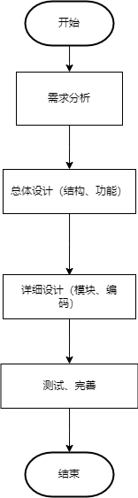
图1
4.1.1用户下单流程

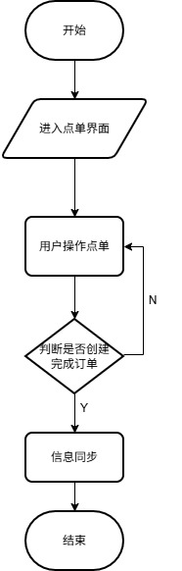
图2
4.1.2系统整体设计
采用“状态-模块-界面”一体化架构，以用户操作路径为核心串联各层：
状态层：定义4个核心状态（首页/下单/订单/个人信息），明确各阶段的功能边界；
模块层：每个状态关联对应的功能模块（如首页状态关联首页模块），提供功能逻辑支撑；
界面层：每个模块对应小程序的物理界面（首页/点单页等），实现用户可视化操作，保障交互流畅性。

%3CmxGraphModel%3E%3Croot%3E%3CmxCell%20id%3D%220%22%2F%3E%3CmxCell%20id%3D%221%22%20parent%3D%220%22%2F%3E%3CmxCell%20id%3D%222%22%20style%3D%22edgeStyle%3DorthogonalEdgeStyle%3Brounded%3D0%3BorthogonalLoop%3D1%3BjettySize%3Dauto%3Bhtml%3D1%3BexitX%3D1%3BexitY%3D0.5%3BexitDx%3D0%3BexitDy%3D0%3BentryX%3D0%3BentryY%3D0.5%3BentryDx%3D0%3BentryDy%3D0%3B%22%20edge%3D%221%22%20source%3D%223%22%20target%3D%225%22%20parent%3D%221%22%3E%3CmxGeometry%20relative%3D%221%22%20as%3D%22geometry%22%2F%3E%3C%2FmxCell%3E%3CmxCell%20id%3D%223%22%20value%3D%22%E5%BF%83%E8%BF%B9%E5%8D%9A%E7%89%A9%E9%A6%86%E7%A8%8B%E5%BA%8F%22%20style%3D%22rounded%3D0%3BwhiteSpace%3Dwrap%3Bhtml%3D1%3B%22%20vertex%3D%221%22%20parent%3D%221%22%3E%3CmxGeometry%20x%3D%2240%22%20y%3D%22280%22%20width%3D%22120%22%20height%3D%2260%22%20as%3D%22geometry%22%2F%3E%3C%2FmxCell%3E%3CmxCell%20id%3D%224%22%20style%3D%22edgeStyle%3DorthogonalEdgeStyle%3Brounded%3D0%3BorthogonalLoop%3D1%3BjettySize%3Dauto%3Bhtml%3D1%3BexitX%3D1%3BexitY%3D0.5%3BexitDx%3D0%3BexitDy%3D0%3BentryX%3D0%3BentryY%3D0.5%3BentryDx%3D0%3BentryDy%3D0%3B%22%20edge%3D%221%22%20source%3D%225%22%20target%3D%2211%22%20parent%3D%221%22%3E%3CmxGeometry%20relative%3D%221%22%20as%3D%22geometry%22%2F%3E%3C%2FmxCell%3E%3CmxCell%20id%3D%225%22%20value%3D%22%E4%B8%BB%E9%A1%B5%22%20style%3D%22rounded%3D0%3BwhiteSpace%3Dwrap%3Bhtml%3D1%3B%22%20vertex%3D%221%22%20parent%3D%221%22%3E%3CmxGeometry%20x%3D%22200%22%20y%3D%22100%22%20width%3D%22120%22%20height%3D%2260%22%20as%3D%22geometry%22%2F%3E%3C%2FmxCell%3E%3CmxCell%20id%3D%226%22%20style%3D%22edgeStyle%3DorthogonalEdgeStyle%3Brounded%3D0%3BorthogonalLoop%3D1%3BjettySize%3Dauto%3Bhtml%3D1%3BexitX%3D1%3BexitY%3D0.5%3BexitDx%3D0%3BexitDy%3D0%3BentryX%3D0%3BentryY%3D0.5%3BentryDx%3D0%3BentryDy%3D0%3B%22%20edge%3D%221%22%20source%3D%227%22%20target%3D%2214%22%20parent%3D%221%22%3E%3CmxGeometry%20relative%3D%221%22%20as%3D%22geometry%22%2F%3E%3C%2FmxCell%3E%3CmxCell%20id%3D%227%22%20value%3D%22%E6%B5%8B%E8%AF%95%22%20style%3D%22rounded%3D0%3BwhiteSpace%3Dwrap%3Bhtml%3D1%3B%22%20vertex%3D%221%22%20parent%3D%221%22%3E%3CmxGeometry%20x%3D%22200%22%20y%3D%22220%22%20width%3D%22120%22%20height%3D%2260%22%20as%3D%22geometry%22%2F%3E%3C%2FmxCell%3E%3CmxCell%20id%3D%228%22%20value%3D%22%E5%B7%A5%E5%85%B7%22%20style%3D%22rounded%3D0%3BwhiteSpace%3Dwrap%3Bhtml%3D1%3B%22%20vertex%3D%221%22%20parent%3D%221%22%3E%3CmxGeometry%20x%3D%22200%22%20y%3D%22340%22%20width%3D%22120%22%20height%3D%2260%22%20as%3D%22geometry%22%2F%3E%3C%2FmxCell%3E%3CmxCell%20id%3D%229%22%20style%3D%22edgeStyle%3DorthogonalEdgeStyle%3Brounded%3D0%3BorthogonalLoop%3D1%3BjettySize%3Dauto%3Bhtml%3D1%3BentryX%3D0%3BentryY%3D0.5%3BentryDx%3D0%3BentryDy%3D0%3B%22%20edge%3D%221%22%20source%3D%2210%22%20target%3D%2218%22%20parent%3D%221%22%3E%3CmxGeometry%20relative%3D%221%22%20as%3D%22geometry%22%2F%3E%3C%2FmxCell%3E%3CmxCell%20id%3D%2210%22%20value%3D%22%E4%B8%AA%E4%BA%BA%E4%BF%A1%E6%81%AF%22%20style%3D%22rounded%3D0%3BwhiteSpace%3Dwrap%3Bhtml%3D1%3B%22%20vertex%3D%221%22%20parent%3D%221%22%3E%3CmxGeometry%20x%3D%22200%22%20y%3D%22500%22%20width%3D%22120%22%20height%3D%2260%22%20as%3D%22geometry%22%2F%3E%3C%2FmxCell%3E%3CmxCell%20id%3D%2211%22%20value%3D%22%E8%BD%AE%E6%92%AD%E7%94%BB%E9%9D%A2%22%20style%3D%22rounded%3D0%3BwhiteSpace%3Dwrap%3Bhtml%3D1%3B%22%20vertex%3D%221%22%20parent%3D%221%22%3E%3CmxGeometry%20x%3D%22360%22%20y%3D%2260%22%20width%3D%22120%22%20height%3D%2240%22%20as%3D%22geometry%22%2F%3E%3C%2FmxCell%3E%3CmxCell%20id%3D%2212%22%20value%3D%22%E8%B6%A3%E5%91%B3%E6%B5%8B%E8%AF%95%22%20style%3D%22rounded%3D0%3BwhiteSpace%3Dwrap%3Bhtml%3D1%3B%22%20vertex%3D%221%22%20parent%3D%221%22%3E%3CmxGeometry%20x%3D%22360%22%20y%3D%22110%22%20width%3D%22120%22%20height%3D%2240%22%20as%3D%22geometry%22%2F%3E%3C%2FmxCell%3E%3CmxCell%20id%3D%2213%22%20value%3D%22%E8%BD%BB%E8%AF%AD%E7%9B%B2%E7%9B%92%22%20style%3D%22rounded%3D0%3BwhiteSpace%3Dwrap%3Bhtml%3D1%3B%22%20vertex%3D%221%22%20parent%3D%221%22%3E%3CmxGeometry%20x%3D%22360%22%20y%3D%22160%22%20width%3D%22120%22%20height%3D%2240%22%20as%3D%22geometry%22%2F%3E%3C%2FmxCell%3E%3CmxCell%20id%3D%2214%22%20value%3D%22%E5%88%86%E7%B1%BB%E6%B5%8B%E8%AF%95%E7%95%8C%E9%9D%A2%22%20style%3D%22rounded%3D0%3BwhiteSpace%3Dwrap%3Bhtml%3D1%3B%22%20vertex%3D%221%22%20parent%3D%221%22%3E%3CmxGeometry%20x%3D%22360%22%20y%3D%22230%22%20width%3D%22120%22%20height%3D%2240%22%20as%3D%22geometry%22%2F%3E%3C%2FmxCell%3E%3CmxCell%20id%3D%2215%22%20value%3D%22%E6%83%85%E7%BB%AA%E8%B0%83%E8%8A%82%E6%96%B9%E6%B3%95%22%20style%3D%22rounded%3D0%3BwhiteSpace%3Dwrap%3Bhtml%3D1%3B%22%20vertex%3D%221%22%20parent%3D%221%22%3E%3CmxGeometry%20x%3D%22360%22%20y%3D%22300%22%20width%3D%22120%22%20height%3D%2240%22%20as%3D%22geometry%22%2F%3E%3C%2FmxCell%3E%3CmxCell%20id%3D%2216%22%20value%3D%22%E5%BF%83%E7%90%86%E5%92%A8%E8%AF%A2%22%20style%3D%22rounded%3D0%3BwhiteSpace%3Dwrap%3Bhtml%3D1%3B%22%20vertex%3D%221%22%20parent%3D%221%22%3E%3CmxGeometry%20x%3D%22360%22%20y%3D%22350%22%20width%3D%22120%22%20height%3D%2240%22%20as%3D%22geometry%22%2F%3E%3C%2FmxCell%3E%3CmxCell%20id%3D%2217%22%20value%3D%22%E8%BD%BB%E9%9F%B3%E4%B9%90%E6%92%AD%E6%94%BE%22%20style%3D%22rounded%3D0%3BwhiteSpace%3Dwrap%3Bhtml%3D1%3B%22%20vertex%3D%221%22%20parent%3D%221%22%3E%3CmxGeometry%20x%3D%22360%22%20y%3D%22394%22%20width%3D%22120%22%20height%3D%2240%22%20as%3D%22geometry%22%2F%3E%3C%2FmxCell%3E%3CmxCell%20id%3D%2218%22%20value%3D%22%E6%84%8F%E8%A7%81%E5%8F%8D%E9%A6%88%22%20style%3D%22rounded%3D0%3BwhiteSpace%3Dwrap%3Bhtml%3D1%3B%22%20vertex%3D%221%22%20parent%3D%221%22%3E%3CmxGeometry%20x%3D%22360%22%20y%3D%22460%22%20width%3D%22120%22%20height%3D%2240%22%20as%3D%22geometry%22%2F%3E%3C%2FmxCell%3E%3CmxCell%20id%3D%2219%22%20value%3D%22%E6%9B%B4%E5%A4%9A%E8%AE%BE%E7%BD%AE%22%20style%3D%22rounded%3D0%3BwhiteSpace%3Dwrap%3Bhtml%3D1%3B%22%20vertex%3D%221%22%20parent%3D%221%22%3E%3CmxGeometry%20x%3D%22360%22%20y%3D%22510%22%20width%3D%22120%22%20height%3D%2240%22%20as%3D%22geometry%22%2F%3E%3C%2FmxCell%3E%3CmxCell%20id%3D%2220%22%20value%3D%22%E5%85%B3%E4%BA%8E%E6%88%91%E4%BB%AC%22%20style%3D%22rounded%3D0%3BwhiteSpace%3Dwrap%3Bhtml%3D1%3B%22%20vertex%3D%221%22%20parent%3D%221%22%3E%3CmxGeometry%20x%3D%22360%22%20y%3D%22560%22%20width%3D%22120%22%20height%3D%2240%22%20as%3D%22geometry%22%2F%3E%3C%2FmxCell%3E%3CmxCell%20id%3D%2221%22%20value%3D%22%22%20style%3D%22endArrow%3Dnone%3Bhtml%3D1%3Brounded%3D0%3B%22%20edge%3D%221%22%20parent%3D%221%22%3E%3CmxGeometry%20width%3D%2250%22%20height%3D%2250%22%20relative%3D%221%22%20as%3D%22geometry%22%3E%3CmxPoint%20x%3D%22180%22%20y%3D%22520%22%20as%3D%22sourcePoint%22%2F%3E%3CmxPoint%20x%3D%22180%22%20y%3D%22310%22%20as%3D%22targetPoint%22%2F%3E%3C%2FmxGeometry%3E%3C%2FmxCell%3E%3CmxCell%20id%3D%2222%22%20value%3D%22%22%20style%3D%22endArrow%3Dclassic%3Bhtml%3D1%3Brounded%3D0%3B%22%20edge%3D%221%22%20parent%3D%221%22%3E%3CmxGeometry%20width%3D%2250%22%20height%3D%2250%22%20relative%3D%221%22%20as%3D%22geometry%22%3E%3CmxPoint%20x%3D%22180%22%20y%3D%22250%22%20as%3D%22sourcePoint%22%2F%3E%3CmxPoint%20x%3D%22200%22%20y%3D%22250%22%20as%3D%22targetPoint%22%2F%3E%3C%2FmxGeometry%3E%3C%2FmxCell%3E%3CmxCell%20id%3D%2223%22%20value%3D%22%22%20style%3D%22endArrow%3Dclassic%3Bhtml%3D1%3Brounded%3D0%3B%22%20edge%3D%221%22%20parent%3D%221%22%3E%3CmxGeometry%20width%3D%2250%22%20height%3D%2250%22%20relative%3D%221%22%20as%3D%22geometry%22%3E%3CmxPoint%20x%3D%22180%22%20y%3D%22369.88%22%20as%3D%22sourcePoint%22%2F%3E%3CmxPoint%20x%3D%22200%22%20y%3D%22369.88%22%20as%3D%22targetPoint%22%2F%3E%3C%2FmxGeometry%3E%3C%2FmxCell%3E%3CmxCell%20id%3D%2224%22%20value%3D%22%22%20style%3D%22endArrow%3Dclassic%3Bhtml%3D1%3Brounded%3D0%3B%22%20edge%3D%221%22%20parent%3D%221%22%3E%3CmxGeometry%20width%3D%2250%22%20height%3D%2250%22%20relative%3D%221%22%20as%3D%22geometry%22%3E%3CmxPoint%20x%3D%22180%22%20y%3D%22519.88%22%20as%3D%22sourcePoint%22%2F%3E%3CmxPoint%20x%3D%22200%22%20y%3D%22519.88%22%20as%3D%22targetPoint%22%2F%3E%3C%2FmxGeometry%3E%3C%2FmxCell%3E%3CmxCell%20id%3D%2225%22%20value%3D%22%22%20style%3D%22endArrow%3Dnone%3Bhtml%3D1%3Brounded%3D0%3B%22%20edge%3D%221%22%20parent%3D%221%22%3E%3CmxGeometry%20width%3D%2250%22%20height%3D%2250%22%20relative%3D%221%22%20as%3D%22geometry%22%3E%3CmxPoint%20x%3D%22340%22%20y%3D%22180%22%20as%3D%22sourcePoint%22%2F%3E%3CmxPoint%20x%3D%22340%22%20y%3D%22130%22%20as%3D%22targetPoint%22%2F%3E%3C%2FmxGeometry%3E%3C%2FmxCell%3E%3CmxCell%20id%3D%2226%22%20value%3D%22%22%20style%3D%22endArrow%3Dclassic%3Bhtml%3D1%3Brounded%3D0%3B%22%20edge%3D%221%22%20parent%3D%221%22%3E%3CmxGeometry%20width%3D%2250%22%20height%3D%2250%22%20relative%3D%221%22%20as%3D%22geometry%22%3E%3CmxPoint%20x%3D%22340%22%20y%3D%22129.86%22%20as%3D%22sourcePoint%22%2F%3E%3CmxPoint%20x%3D%22360%22%20y%3D%22129.86%22%20as%3D%22targetPoint%22%2F%3E%3C%2FmxGeometry%3E%3C%2FmxCell%3E%3CmxCell%20id%3D%2227%22%20value%3D%22%22%20style%3D%22endArrow%3Dclassic%3Bhtml%3D1%3Brounded%3D0%3B%22%20edge%3D%221%22%20parent%3D%221%22%3E%3CmxGeometry%20width%3D%2250%22%20height%3D%2250%22%20relative%3D%221%22%20as%3D%22geometry%22%3E%3CmxPoint%20x%3D%22340%22%20y%3D%22180%22%20as%3D%22sourcePoint%22%2F%3E%3CmxPoint%20x%3D%22360%22%20y%3D%22180%22%20as%3D%22targetPoint%22%2F%3E%3C%2FmxGeometry%3E%3C%2FmxCell%3E%3CmxCell%20id%3D%2228%22%20style%3D%22edgeStyle%3DorthogonalEdgeStyle%3Brounded%3D0%3BorthogonalLoop%3D1%3BjettySize%3Dauto%3Bhtml%3D1%3BexitX%3D1%3BexitY%3D0.5%3BexitDx%3D0%3BexitDy%3D0%3BentryX%3D-0.001%3BentryY%3D0.438%3BentryDx%3D0%3BentryDy%3D0%3BentryPerimeter%3D0%3B%22%20edge%3D%221%22%20source%3D%228%22%20target%3D%2215%22%20parent%3D%221%22%3E%3CmxGeometry%20relative%3D%221%22%20as%3D%22geometry%22%2F%3E%3C%2FmxCell%3E%3CmxCell%20id%3D%2229%22%20value%3D%22%22%20style%3D%22endArrow%3Dclassic%3Bhtml%3D1%3Brounded%3D0%3B%22%20edge%3D%221%22%20parent%3D%221%22%3E%3CmxGeometry%20width%3D%2250%22%20height%3D%2250%22%20relative%3D%221%22%20as%3D%22geometry%22%3E%3CmxPoint%20x%3D%22340%22%20y%3D%22369.86%22%20as%3D%22sourcePoint%22%2F%3E%3CmxPoint%20x%3D%22360%22%20y%3D%22369.86%22%20as%3D%22targetPoint%22%2F%3E%3C%2FmxGeometry%3E%3C%2FmxCell%3E%3CmxCell%20id%3D%2230%22%20value%3D%22%22%20style%3D%22endArrow%3Dnone%3Bhtml%3D1%3Brounded%3D0%3B%22%20edge%3D%221%22%20parent%3D%221%22%3E%3CmxGeometry%20width%3D%2250%22%20height%3D%2250%22%20relative%3D%221%22%20as%3D%22geometry%22%3E%3CmxPoint%20x%3D%22340%22%20y%3D%22420%22%20as%3D%22sourcePoint%22%2F%3E%3CmxPoint%20x%3D%22340%22%20y%3D%22370%22%20as%3D%22targetPoint%22%2F%3E%3C%2FmxGeometry%3E%3C%2FmxCell%3E%3CmxCell%20id%3D%2231%22%20value%3D%22%22%20style%3D%22endArrow%3Dclassic%3Bhtml%3D1%3Brounded%3D0%3B%22%20edge%3D%221%22%20parent%3D%221%22%3E%3CmxGeometry%20width%3D%2250%22%20height%3D%2250%22%20relative%3D%221%22%20as%3D%22geometry%22%3E%3CmxPoint%20x%3D%22340%22%20y%3D%22420%22%20as%3D%22sourcePoint%22%2F%3E%3CmxPoint%20x%3D%22360%22%20y%3D%22420%22%20as%3D%22targetPoint%22%2F%3E%3C%2FmxGeometry%3E%3C%2FmxCell%3E%3CmxCell%20id%3D%2232%22%20value%3D%22%22%20style%3D%22endArrow%3Dnone%3Bhtml%3D1%3Brounded%3D0%3B%22%20edge%3D%221%22%20parent%3D%221%22%3E%3CmxGeometry%20width%3D%2250%22%20height%3D%2250%22%20relative%3D%221%22%20as%3D%22geometry%22%3E%3CmxPoint%20x%3D%22340%22%20y%3D%22580%22%20as%3D%22sourcePoint%22%2F%3E%3CmxPoint%20x%3D%22340%22%20y%3D%22520%22%20as%3D%22targetPoint%22%2F%3E%3C%2FmxGeometry%3E%3C%2FmxCell%3E%3CmxCell%20id%3D%2233%22%20value%3D%22%22%20style%3D%22endArrow%3Dclassic%3Bhtml%3D1%3Brounded%3D0%3B%22%20edge%3D%221%22%20parent%3D%221%22%3E%3CmxGeometry%20width%3D%2250%22%20height%3D%2250%22%20relative%3D%221%22%20as%3D%22geometry%22%3E%3CmxPoint%20x%3D%22340%22%20y%3D%22529.8000000000001%22%20as%3D%22sourcePoint%22%2F%3E%3CmxPoint%20x%3D%22360%22%20y%3D%22529.8000000000001%22%20as%3D%22targetPoint%22%2F%3E%3C%2FmxGeometry%3E%3C%2FmxCell%3E%3CmxCell%20id%3D%2234%22%20value%3D%22%22%20style%3D%22endArrow%3Dclassic%3Bhtml%3D1%3Brounded%3D0%3B%22%20edge%3D%221%22%20parent%3D%221%22%3E%3CmxGeometry%20width%3D%2250%22%20height%3D%2250%22%20relative%3D%221%22%20as%3D%22geometry%22%3E%3CmxPoint%20x%3D%22340%22%20y%3D%22580%22%20as%3D%22sourcePoint%22%2F%3E%3CmxPoint%20x%3D%22360%22%20y%3D%22580%22%20as%3D%22targetPoint%22%2F%3E%3C%2FmxGeometry%3E%3C%2FmxCell%3E%3CmxCell%20id%3D%2235%22%20value%3D%22%E7%94%A8%E6%88%B7%22%20style%3D%22shape%3DumlActor%3BverticalLabelPosition%3Dbottom%3BverticalAlign%3Dtop%3Bhtml%3D1%3BoutlineConnect%3D0%3B%22%20vertex%3D%221%22%20parent%3D%221%22%3E%3CmxGeometry%20x%3D%22630%22%20y%3D%22250%22%20width%3D%2240%22%20height%3D%2270%22%20as%3D%22geometry%22%2F%3E%3C%2FmxCell%3E%3CmxCell%20id%3D%2236%22%20value%3D%22%E5%BF%83%E7%90%86%E6%B5%8B%E8%AF%95%22%20style%3D%22ellipse%3BwhiteSpace%3Dwrap%3Bhtml%3D1%3B%22%20vertex%3D%221%22%20parent%3D%221%22%3E%3CmxGeometry%20x%3D%22760%22%20y%3D%22120%22%20width%3D%22120%22%20height%3D%2260%22%20as%3D%22geometry%22%2F%3E%3C%2FmxCell%3E%3CmxCell%20id%3D%2237%22%20value%3D%22%E8%B0%83%E8%8A%82%E6%96%B9%E6%B3%95%22%20style%3D%22ellipse%3BwhiteSpace%3Dwrap%3Bhtml%3D1%3B%22%20vertex%3D%221%22%20parent%3D%221%22%3E%3CmxGeometry%20x%3D%22760%22%20y%3D%22190%22%20width%3D%22120%22%20height%3D%2260%22%20as%3D%22geometry%22%2F%3E%3C%2FmxCell%3E%3CmxCell%20id%3D%2238%22%20value%3D%22%E8%BD%BB%E9%9F%B3%E4%B9%90%E6%94%BE%E6%9D%BE%22%20style%3D%22ellipse%3BwhiteSpace%3Dwrap%3Bhtml%3D1%3B%22%20vertex%3D%221%22%20parent%3D%221%22%3E%3CmxGeometry%20x%3D%22760%22%20y%3D%22260%22%20width%3D%22120%22%20height%3D%2260%22%20as%3D%22geometry%22%2F%3E%3C%2FmxCell%3E%3CmxCell%20id%3D%2239%22%20value%3D%22%E6%84%8F%E8%A7%81%E5%8F%8D%E9%A6%88%22%20style%3D%22ellipse%3BwhiteSpace%3Dwrap%3Bhtml%3D1%3B%22%20vertex%3D%221%22%20parent%3D%221%22%3E%3CmxGeometry%20x%3D%22760%22%20y%3D%22330%22%20width%3D%22120%22%20height%3D%2260%22%20as%3D%22geometry%22%2F%3E%3C%2FmxCell%3E%3CmxCell%20id%3D%2240%22%20value%3D%22%E5%BF%83%E7%90%86%E5%92%A8%E8%AF%A2%22%20style%3D%22ellipse%3BwhiteSpace%3Dwrap%3Bhtml%3D1%3B%22%20vertex%3D%221%22%20parent%3D%221%22%3E%3CmxGeometry%20x%3D%22760%22%20y%3D%22400%22%20width%3D%22120%22%20height%3D%2260%22%20as%3D%22geometry%22%2F%3E%3C%2FmxCell%3E%3CmxCell%20id%3D%2241%22%20value%3D%22%22%20style%3D%22endArrow%3Dclassic%3Bhtml%3D1%3Brounded%3D0%3BentryX%3D0%3BentryY%3D0.667%3BentryDx%3D0%3BentryDy%3D0%3BentryPerimeter%3D0%3B%22%20edge%3D%221%22%20target%3D%2236%22%20parent%3D%221%22%3E%3CmxGeometry%20width%3D%2250%22%20height%3D%2250%22%20relative%3D%221%22%20as%3D%22geometry%22%3E%3CmxPoint%20x%3D%22670%22%20y%3D%22280%22%20as%3D%22sourcePoint%22%2F%3E%3CmxPoint%20x%3D%22720%22%20y%3D%22230%22%20as%3D%22targetPoint%22%2F%3E%3C%2FmxGeometry%3E%3C%2FmxCell%3E%3CmxCell%20id%3D%2242%22%20value%3D%22%22%20style%3D%22endArrow%3Dclassic%3Bhtml%3D1%3Brounded%3D0%3B%22%20edge%3D%221%22%20parent%3D%221%22%3E%3CmxGeometry%20width%3D%2250%22%20height%3D%2250%22%20relative%3D%221%22%20as%3D%22geometry%22%3E%3CmxPoint%20x%3D%22670%22%20y%3D%22280%22%20as%3D%22sourcePoint%22%2F%3E%3CmxPoint%20x%3D%22760%22%20y%3D%22220%22%20as%3D%22targetPoint%22%2F%3E%3C%2FmxGeometry%3E%3C%2FmxCell%3E%3CmxCell%20id%3D%2243%22%20value%3D%22%22%20style%3D%22endArrow%3Dclassic%3Bhtml%3D1%3Brounded%3D0%3B%22%20edge%3D%221%22%20parent%3D%221%22%3E%3CmxGeometry%20width%3D%2250%22%20height%3D%2250%22%20relative%3D%221%22%20as%3D%22geometry%22%3E%3CmxPoint%20x%3D%22670%22%20y%3D%22280%22%20as%3D%22sourcePoint%22%2F%3E%3CmxPoint%20x%3D%22760%22%20y%3D%22290%22%20as%3D%22targetPoint%22%2F%3E%3C%2FmxGeometry%3E%3C%2FmxCell%3E%3CmxCell%20id%3D%2244%22%20value%3D%22%22%20style%3D%22endArrow%3Dclassic%3Bhtml%3D1%3Brounded%3D0%3B%22%20edge%3D%221%22%20parent%3D%221%22%3E%3CmxGeometry%20width%3D%2250%22%20height%3D%2250%22%20relative%3D%221%22%20as%3D%22geometry%22%3E%3CmxPoint%20x%3D%22670%22%20y%3D%22280%22%20as%3D%22sourcePoint%22%2F%3E%3CmxPoint%20x%3D%22760%22%20y%3D%22360%22%20as%3D%22targetPoint%22%2F%3E%3C%2FmxGeometry%3E%3C%2FmxCell%3E%3CmxCell%20id%3D%2245%22%20value%3D%22%22%20style%3D%22endArrow%3Dclassic%3Bhtml%3D1%3Brounded%3D0%3B%22%20edge%3D%221%22%20parent%3D%221%22%3E%3CmxGeometry%20width%3D%2250%22%20height%3D%2250%22%20relative%3D%221%22%20as%3D%22geometry%22%3E%3CmxPoint%20x%3D%22670%22%20y%3D%22280%22%20as%3D%22sourcePoint%22%2F%3E%3CmxPoint%20x%3D%22760%22%20y%3D%22430%22%20as%3D%22targetPoint%22%2F%3E%3C%2FmxGeometry%3E%3C%2FmxCell%3E%3C%2Froot%3E%3C%2FmxGraphModel%3E
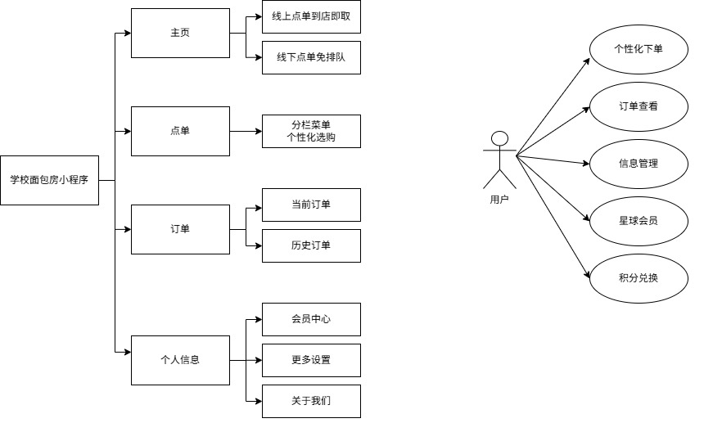
图3 整体功能图

基于类图，以“用户类”为核心交互入口，关联4个功能类，明确各模块的属性与方法：
用户类：包含“用户名”属性，提供“首页()、下单()、查看历史订单()、会员中心()”等操作方法，是用户与系统交互的核心载体；
首页类：包含“线上点单列表、线下点单列表”属性，提供“展示轮播画面()、启动趣味测试()”等方法，支撑首页的展示与互动；
下单类：包含“商品属性列表、搜索列表”属性，提供“匹配搜索结果()、展示轮播画面()”等方法，实现商品浏览与搜索；
查看订单类：包含“当前订单列表、历史订单列表”属性，提供“当前订单提示()、历史订单调用结果()”等方法，支撑订单展示与反馈；
个人信息类：包含“积分商城、会员开通”属性，提供“关于其他()”方法，承载权益管理与系统信息。

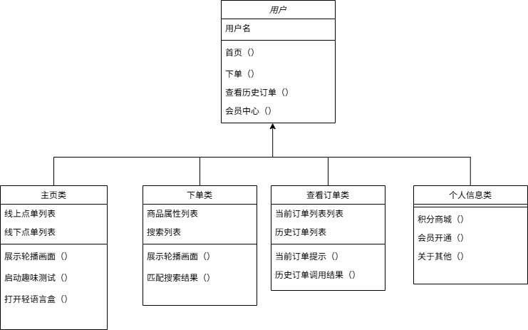
图4 学校面包房小程序类图

基于状态图，系统包含4个核心状态，流转逻辑清晰且贴合用户操作习惯：
初始状态（S0）：小程序启动后，直接进入首页状态（S1）；
首页状态（S1）：包含“轮播展示、点单方式选择、积分展示”功能，可通过底部导航切换至“下单状态（S2）”“订单状态（S3）”“个人信息状态（S4）”；
下单状态（S2）：覆盖“商品属性选择、取餐方式选择、个性化下单、添加购物车、结算支付”流程，支持切回首页状态；
订单状态（S3）：管理“当前订单、历史订单”，可双向切换至首页/下单/个人信息状态；
个人信息状态（S4）：包含“积分商城、任务中心、会员中心”，支持切换至其他状态，最终可退出至结束状态。

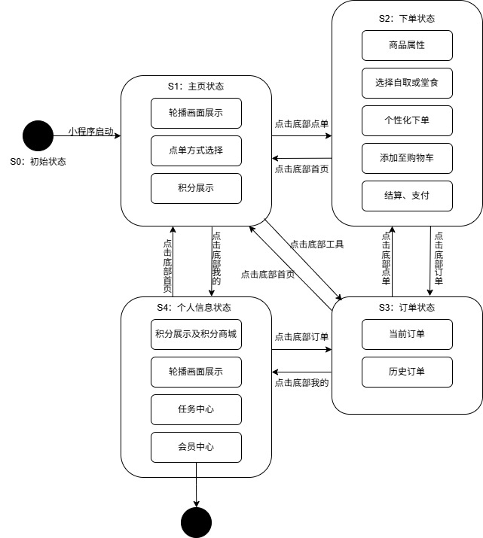
图5 学校面包房小程序状态图
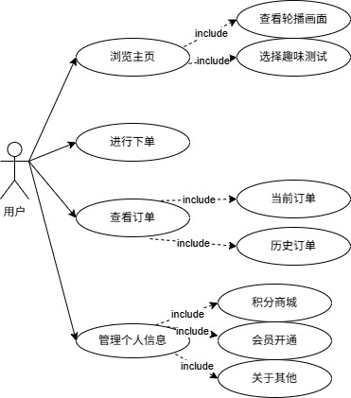
图6 学校面包房小程序用例图

- 系统实现
- 软件系统主要功能代码实现
- 活动banner与点单入口页
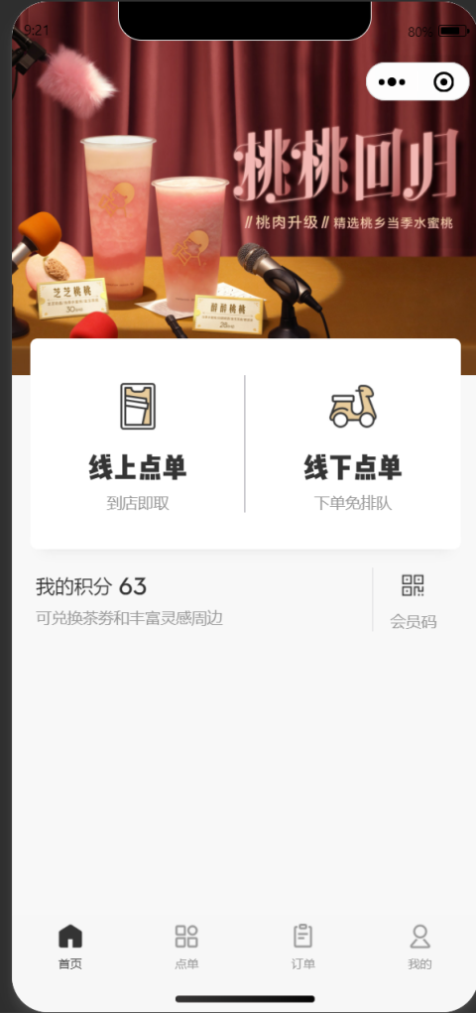
活动展示功能：通过顶部banner轮播形式展示当前品牌营销活动，如新品上线或限时优惠；
点单方式选择功能：为用户提供“线上点单（预点单取餐）”与“线下点单（现场下单）”两种入口，满足不同消费场景；
积分预览功能：展示用户当前可用积分，并提示积分可兑换的相关权益。
- 点单功能测试

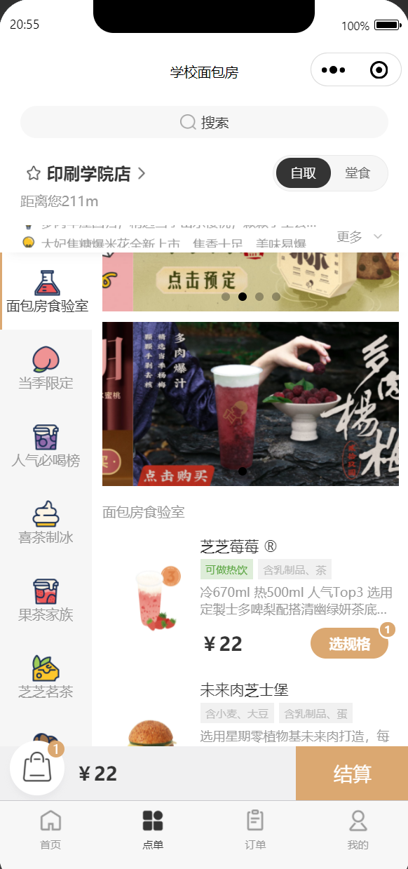 | 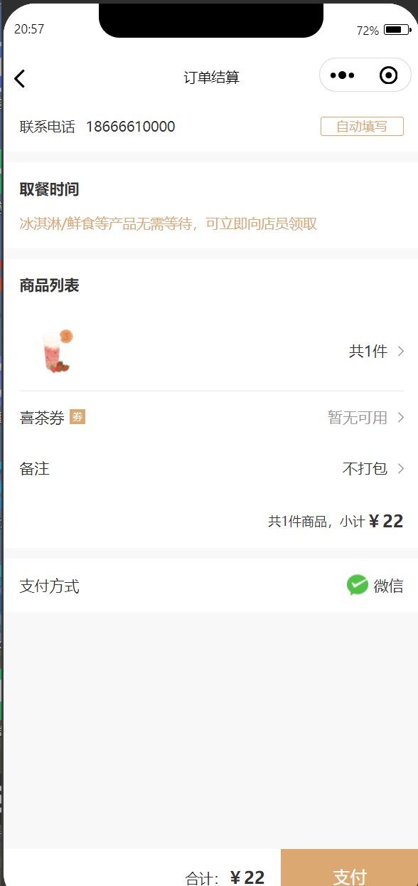

门店关联功能：显示当前选定门店名称及距离信息，确保取餐或配送门店准确；
商品展示功能：展示商品图片、名称、规格、价格及使用说明（如容量规格选择）；
结算触发功能：用户选择商品后，可点击 “结算” 按钮进入支付流程。
- 订单及历史订单测试
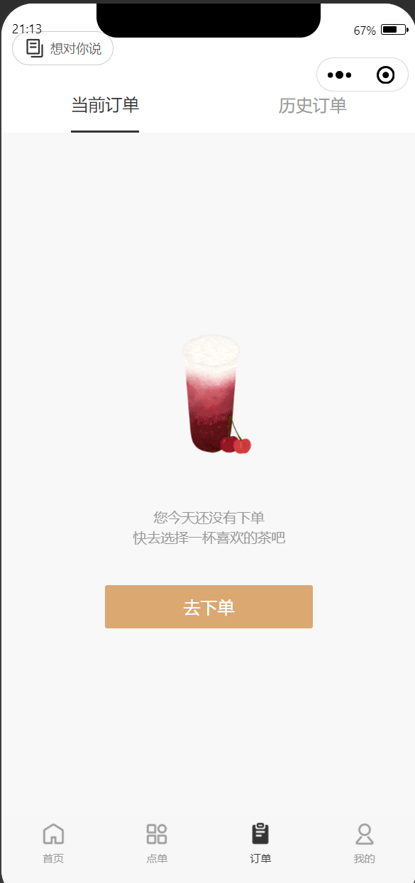 | 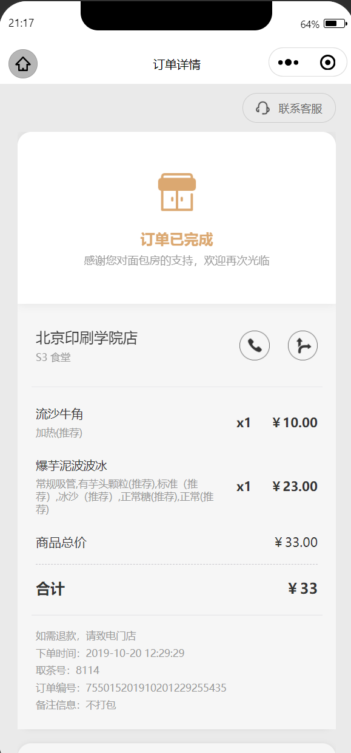

订单分类功能：通过 “当前订单” 与 “历史订单” 标签对订单进行分类管理；
订单信息展示功能：展示订单编号、下单时间、订单金额及所属门店；
订单操作功能：提供开发票、查看评价、再次下单等操作入口。
- 个人中心页功能
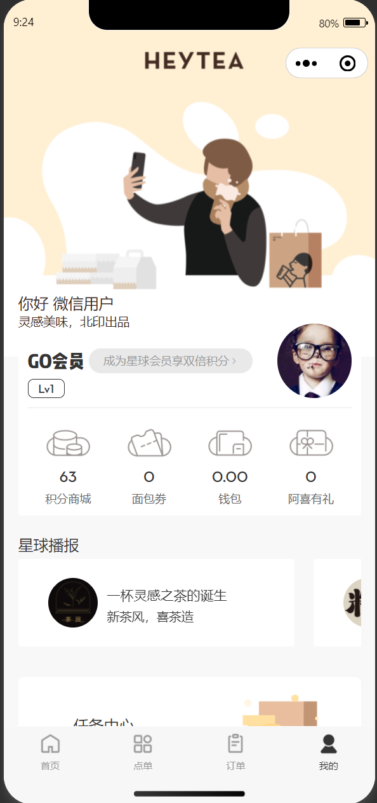
用户信息展示功能：显示当前登录用户的基本信息与欢迎提示；
会员入口功能：提供会员、积分、钱包、优惠券等功能入口；
品牌动态展示功能：通过“品牌播报”模块展示新品及活动资讯。
- 积分与优惠券管理页
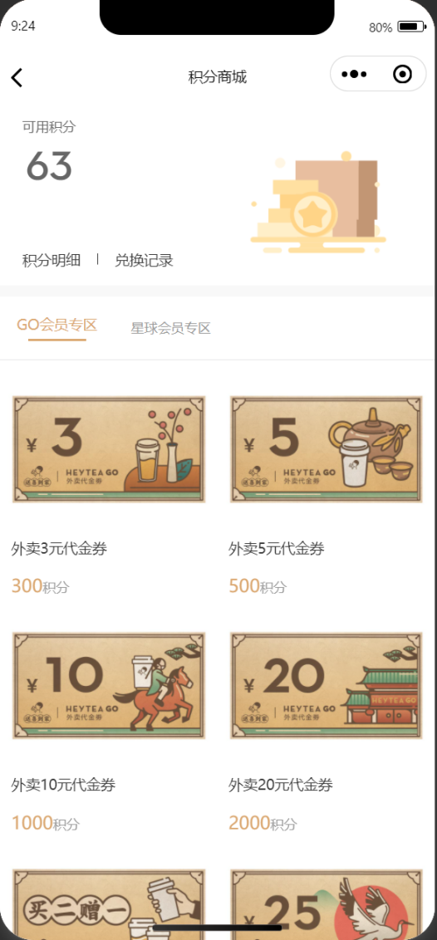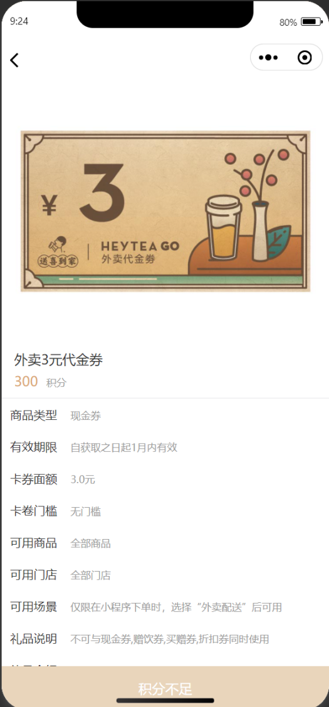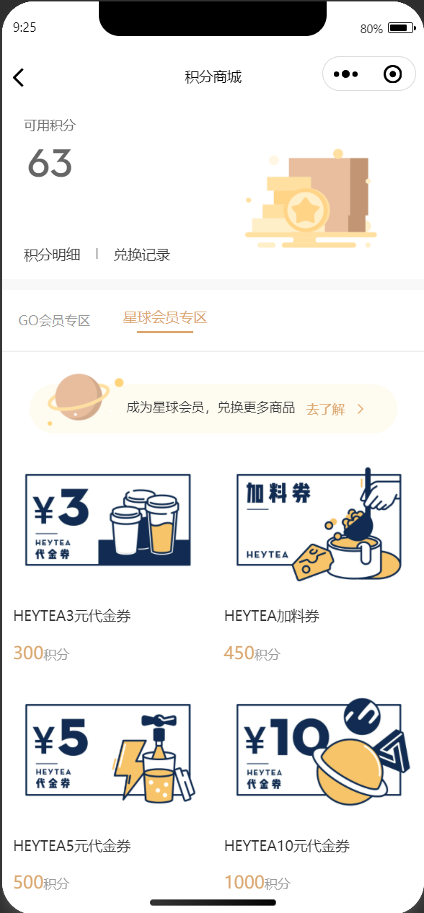积分管理功能：展示用户当前可用积分，并提供积分兑换优惠券的操作；
优惠券管理功能：展示用户已获取的优惠券信息，包括面额、有效期及使用规则。
- 会员中心页
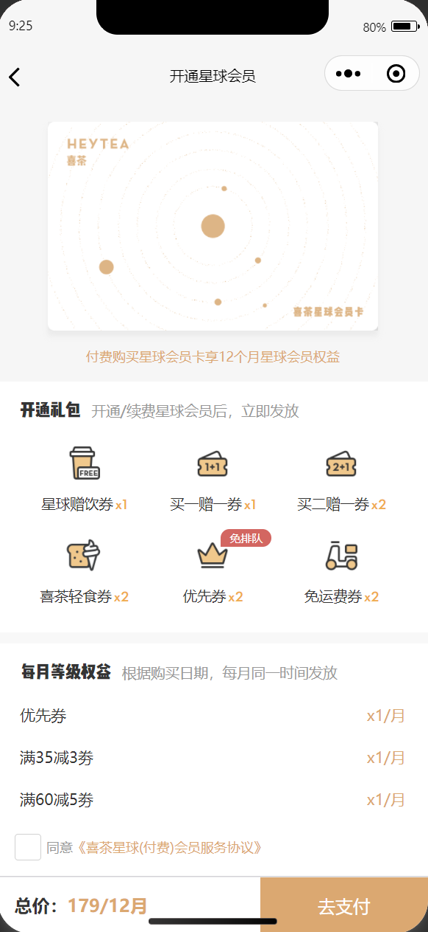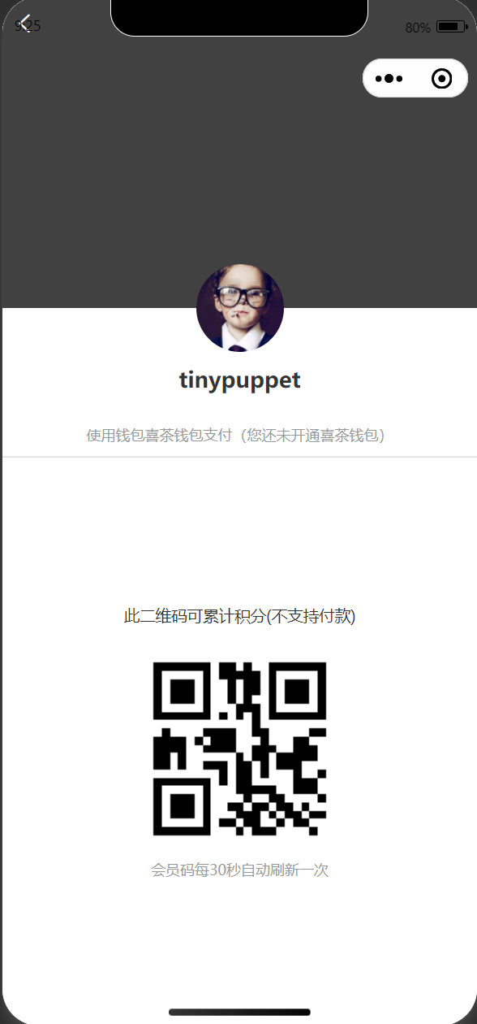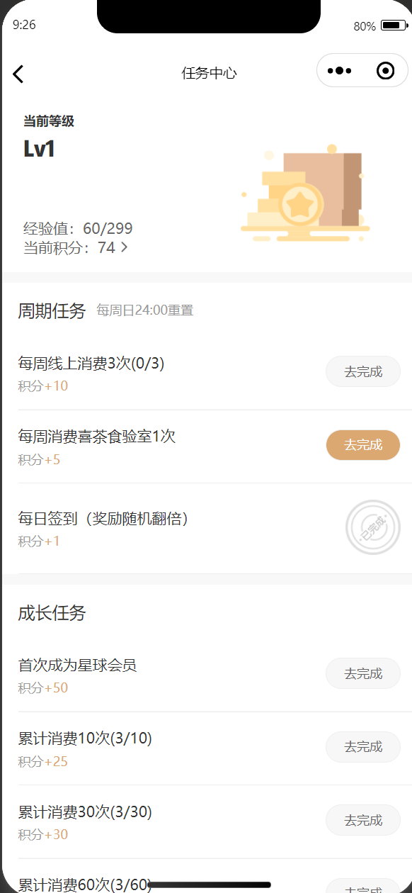
会员信息展示功能：展示会员等级、经验值及当前积分；
任务体系功能：包含每日签到、周期任务和成长任务，完成任务可获得积分奖励；
会员权益展示功能：展示会员礼包及各等级专属权益；
会员码功能：提供用于积分累计的会员码，并支持定时刷新。

- 总结与展望
- 总结
本项目围绕面包房点单小程序的设计与实现展开研究，结合当前餐饮行业数字化、移动化的发展趋势，对系统的用户需求与业务需求进行了系统分析，并完成了主要功能模块的设计与实现。
在需求分析阶段，从用户角度出发，明确了便捷点单、订单管理、会员权益及信息获取等核心需求；从业务角度分析了订单流转、会员运营、营销触达和数据沉淀等关键业务目标，为系统功能设计奠定了基础。
在系统实现阶段，按照页面划分功能模块，完成了首页点单入口、商品选择与结算、订单管理、个人中心、积分与会员体系等核心页面的功能设计与界面说明。系统整体结构清晰，功能模块划分合理，能够满足面包房日常点单及用户管理的基本需求，同时具备一定的扩展性与实用价值。
通过本次系统的设计与实现，不仅加深了对小程序开发流程和前端页面设计思想的理解，也提升了将实际业务需求转化为系统功能的能力，达到了课程设计（或毕业设计）的预期目标。

- 展望
虽本系统已实现面包房点单小程序的核心功能，但仍存在进一步优化和拓展的空间，未来可从以下几个方面进行改进：
- 功能完善方面
后续可引入更完整的支付功能，与真实支付接口对接，实现在线支付与退款流程；同时可增加订单评价、售后服务等功能，提升用户使用体验。
- 系统性能与安全方面
未来可结合后端服务器与数据库，对用户信息、订单数据进行统一管理，加强数据校验与权限控制，提升系统的安全性与稳定性。
- 会员与营销体系优化方面
可进一步细化会员等级规则，增加个性化推荐、精准优惠推送等功能，结合用户行为数据实现智能化运营，提高用户复购率。
- 多平台与可扩展性方面
在现有小程序基础上，未来可拓展至H5或App端，实现多端统一服务，为系统的长期发展提供更多可能性。

