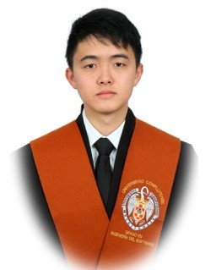

Certificates

Languages

**High School Huelin**

* Bachelor degree in the field of Science and Technology. Graduated in 2015 with an average of 9.97/10.

September 2009 - June 2015

**Complutense University of Madrid**

* Degree of Computer Science, currently studying the last year of the degree, with an average of 8.61/10.

June 2015 – Now

**La Fábrica de Bots S.L.**

* Completed an internship, in a startup. Assisted the daily operations and handled specific tasks assigned by supervisors in many departments.

February 2018 – July 2018

|  |  |
| --- | --- |
| * **C** | * **C++** |
| * **C#** | * **Python** |
| * **Java** | * **HTML** |
| * **CSS** | * **JavaScript** |
| * **SQL** | * **NoSQL** |
| * **Spring** | * **NodeJS** |
| * **Microservices** | * **React** |

* **Chinese**: Native
* **Spanish**: Native
* **English**: Cambridge First Certificate B2 Level
* **Exam 774** : Perform Cloud Data Science with Azure Machine Learning (Microsoft)

Studies

Knowledge

Work experience

**Birthdate**

1997-April-05

**Phone number**

+34 688168288

**Email**

zhong.9745@gmail.com

**GitHub**

<https://github.com/ZReKoJ>

**Zihao Hong**

Information