

**CZ4052**

**Cloud Computing Project**

**Name:** Chua Zi Jian (U2022354J)

**Project Topic:** 7 (Software-as-a-Service)

# Table of Contents

Table of Contents 1

Chapter 1 Introduction 2

1.1 Background 2

1.2 Problem Statement 2

1.3 Proposed Solution & Design 2

Chapter 2 Preparation 5

2.1 Programming Tools 5

Chapter 3 Website Development 7

3.1 Database Design 7

3.2 UI Design 9

3.3 QA Testing 16

Chapter 4 Conclusions and Future Work 21

4.1 Conclusions 21

Appendix 22

# 

# Introduction

This chapter discusses the details of the background and the problem faced which leads to the development of this software-as-a-service solution.

## Background

In recent years, the business industry has undergone a big changes, which is largely propelled by the exponential growth of e-commerce. With the advent of the digital age and the widespread accessibility of the internet, shopping habits have changed dramatically. Today, e-commerce has become a modern way of purchasing items, which has revolutionized the way people buying and shopping.

## Problem Statement

Due to the rapidly evolving of e-commerce, e-commerce business entrepreneurs will have to face the challenge of efficiently managing and optimizing various aspects of their operations. Traditional methods of tracking customer information, analyzing sales data, and monitoring affiliate performance often lack integration and real-time insights. As a result, they tend to struggle to make informed decisions, maximize revenue, and foster growth in the competitive market of e-commerce.

## Proposed Solution & Design

Hence, I proposed a solution to the challenges faced by e-commerce business entrepreneur. Introducing E-commerce Dashboard website, a comprehensive e-commerce dashboard solution designed to empower businesses with actionable insights and streamlined management capabilities. Our platform provides essential functions, including:

1. Customer Information Management:

Access detailed profiles and purchasing histories to better understand customer preferences and behavior, enabling targeted marketing and personalized experiences.

1. Product Rating and Reviews:

Gain valuable feedback from customers through product ratings and reviews, fostering trust and enhancing the shopping experience.

1. Transaction History:

Track and analyze transaction histories to identify trends, optimize inventory management, and forecast future demand.

1. Geographic Insights:

Utilize the interactive map feature to visualize the geographical distribution of customers, enabling targeted marketing campaigns and expansion strategies.

1. Revenue and Profit Overview:

Gain a comprehensive understanding of your business's financial performance with intuitive graphs and charts displaying revenue, profit margins, and trends over time.

1. Sales Analytics:

Monitor daily and monthly sales trends, identify peak periods, and capitalize on opportunities for growth.

1. Product Category Breakdown:

Analyze sales data by product category to identify top-performing products, optimize inventory, and tailor marketing strategies.

1. Admin Management:

Streamline administrative tasks with a centralized dashboard for managing user roles, permissions, and access to data.

1. Affiliate Sales Performance:

Track the performance of affiliate partnerships, monitor referral traffic, and optimize commission structures to drive sales and maximize ROI.

1. E-commerce Report Export:

Export the e-commerce summary as PDF Report in order to help e-commerce business entrepreneur for keeping track of records.

By leveraging the comprehensive capabilities of E-commerce Dashboard, e-commerce business entrepreneur can streamline operations, make data-driven decisions, and unlock new avenues for growth in the dynamic e-commerce landscape. Whether you're a small startup or a multinational corporation, our platform provides the tools and insights you need to stay ahead of the competition and thrive in the digital marketplace.

# Preparation

In this chapter, we will talk about the programming tools used in this project.

## Programming Tools

In this project, **MERN** stack is used for development of the website.

**MERN stack**

The MERN stack is a collection of technologies that help developers build robust and scalable web applications using JavaScript. The acronym “MERN” stands for MongoDB, Express, React, and Node.js, with each component playing a role in the development process.

**MongoDB**

MongoDB is a source-available, cross-platform, document-oriented database program. Classified as a NoSQL database product, MongoDB utilizes JSON-like documents with optional schemas. MongoDB is built on a scale-out architecture that has become popular with developers of all kinds for developing scalable applications with evolving data schemas

**Express.js**

Express is a node js web application framework that provides broad features for building web and mobile applications. It is used to build a single page, multipage, and hybrid web application. It's a layer built on the top of the Node js that helps manage servers and routes.

**React.js**

React (also known as React.js or ReactJS) is a free and open-source front-end JavaScript library for building user interfaces based on components.

React can be used to develop single-page, mobile, or server-rendered applications with frameworks like Next.js. Because React is only concerned with the user interface and rendering components to the DOM, React applications often rely on libraries for routing and other client-side functionality. A key advantage of React is that it only re-renders those parts of the page that have changed, avoiding unnecessary re-rendering of unchanged DOM elements.

**Node.js**

Node. js is a single-threaded, open-source, cross-platform runtime environment for building fast and scalable server-side and networking applications. It runs on the V8 JavaScript runtime engine, and it uses event-driven, non-blocking I/O architecture, which makes it efficient and suitable for real-time applications.

As a group, these components make the MERN stack a preferred choice for developers seeking an efficient, full-stack development framework.

**Reason for choosing MERN stack**

MERN stack is used by developers worldwide. The main purpose of using MERN stack is to develop apps using JavaScript only. This is because the four technologies that make up the technology stack are all JS-based. Thus, if one knows JavaScript (and JSON), the backend, frontend, and database can be operated easily.

**Cloud Platform for Deployment of Website Application**

In this project, we will choose Vercel as our cloud platform for deployment of website applications.

**Vercel**

Vercel Inc., formerly ZEIT, is an American cloud platform as a service company. Vercel allows developers to set up their projects to their custom domain (or a free URL) and a free automatic SSL, protecting shared encrypted data between the server and the browser. It integrates directly with GitHub or GitLab, which saves us a lot of trouble when deploying the website.

# Website Development

## Database Design

In this project, even though we are using MongoDB as our database which is NoSQL database, there is still a need to design a database as it helps us to preview the structure of the database before implementing the database.

**ER Diagram**

The Entity Relationship Diagram explains the relationship among the entities present in the database. ER models are used to model real-world objects like a person, a car, or a company and the relation between these real-world objects. ER diagrams provide the purpose of real-world modeling of objects which makes them intently useful. ER diagrams require no technical knowledge and no hardware support and these diagrams are very easy to understand and easy to create even for a naive user. It gives a standard solution for visualizing the data logically. In short, the ER Diagram is the structural format of the database.

The proposed database design is shown as below:

Figure 3.1.1 ER Diagram of Database

Relationship between each Entity:

1. One-to-One Relation
   1. User -> AffiliateStats (key: _id -> userId)
   2. User -> Transaction (key: _id -> _id)
   3. Product -> ProductStat (key: _id -> productId)
2. One-to-Many Relation
   1. AffiliateStats -> Transaction (key: _id -> affiliated)
   2. Transaction -> Product (key: products -> _id)

## UI Design

This section will shows the design of each pages in the website.

In our website, we have following pages:

1. Landing Page (Intro Page)

This is the introduction page of the website.

1. Dashboard Page

This page shows the summary of the user current e-commerce businesses.

1. Products Page

This page shows the product ratings given by the customers.

1. Customers Page

This page lists the table of customer information.

1. Transactions Page

This page lists the table of transactions made by customers.

1. Geography Page

This page shows the map distribution of the customers among the world.

1. Overview Page

This page illustrates the overview graph of the general revenue and profit.

1. Daily Page

This page illustrates the daily graph of the sales of e-commerce products.

1. Monthly Page

This page illustrates the monthly graph of the sales of e-commerce products.

1. Breakdown Page

This page illustrates the pie-chart of the categories of the products sold.

1. Admin Page

This page lists the table of admins users information.

1. Performance Page

This page lists the affiliate sales of the user.

Below figures show the design of each pages mentioned above:

**Landing Page**

Figure 3.2.1 Landing Page

**Dashboard Page**

Figure 3.2.2 Dashboard Page

**Products Page**

Figure 3.2.3 Products Page

**Customers Page**

Figure 3.2.4 Customers Page

**Transactions Page**

Figure 3.2.5 Transactions Page

**Geography Page**

Figure 3.2.6 Geography Page

**Overview Page**

Figure 3.2.7 Overview Page

**Daily Page**

Figure 3.2.8 Daily Page

**Monthly Page**

Figure 3.2.9 Monthly Page

**Breakdown Page**

Figure 3.2.10 Breakdown Page

**Admin Page**

Figure 3.2.11 Admin Page

**Performance Page**

Figure 3.2.12 Performance Page

The code for the website can be found in **Appendix I** and the link to the deployed website can be found in **Appendix II**.

## QA Testing

Quality assurance (QA) testing is a process organizations use to ensure their products and services meet specified regulations and standards. It's a series of techniques that companies employ to prevent issues from occurring and ensure they satisfy the customer with their finished product.

In our E-commerce Dashboard website application, most of the pages are quite straightforward which is to load the required data from the MongoDB database, and list out the table or illustrate the charts or graph, however we also have some functions which required us to do some simple Manual Testing which does not require to write any automation tests using other tools.

The functions are shown as below:

1. Dashboard page ‘Download Reports’ button to download the E-commerce Summary Report.
2. Products page ‘See More’ button to show the details of each products.
3. Overview page dropdown menu of showing ‘Unit’ graph or ‘Sales’ graph.
4. Daily page date picker tools for showing the sales of different time range.

**1. Download Reports Testing**

By clicking on the ‘Download Reports’ button, we are able to get the e-commerce-report.pdf shown as below:

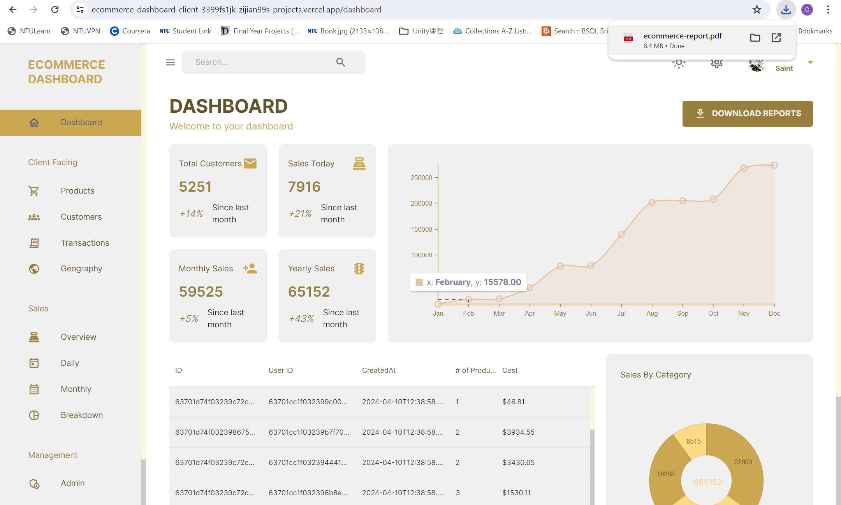

So we are able to confirm that this function works properly.

**2. Products Page ‘See More’ button**

By clicking the ‘See More’ button, we are able to see the details of the products shown as below:

So we are able to confirm that this function works properly.

**3. Overview page dropdown menu of showing ‘Unit’ graph or ‘Sales’ graph.**

By changing the dropdown menu options from ‘Unit’ to ‘Sales’, we are able to see the different graph of the revenue and profit

So we are able to confirm that this function works properly.

**4. Daily page date picker tools for showing the sales of different time range.**

By changing the date range of the date picker, the graph showing the daily sales will change accordingly.

So we are able to confirm that this function works properly.

# Conclusions and Future Work

## Conclusions

In conclusion, E-commerce Dashboard represents a paradigm shift in e-commerce management, offering a holistic solution to the complex challenges faced by businesses in today's digital marketplace. By seamlessly integrating essential functions such as customer information management, sales analytics, and affiliate performance tracking, our platform empowers businesses to unlock actionable insights, streamline operations, and drive sustainable growth.

In a landscape defined by rapid change and fierce competition, the ability to harness data-driven insights is paramount. With E-commerce Dashboard, businesses can navigate this landscape with confidence, armed with the tools and intelligence needed to make informed decisions, capitalize on opportunities, and stay ahead of the curve.

Whether you're a budding entrepreneur or a seasoned industry leader, E-commerce Dashboard is your trusted partner in e-commerce success. Join us on the journey to redefine what's possible in the world of online commerce, and together, let's shape a future where businesses thrive and customers flourish.

# Appendix

**Appendix I:** E-commerce Dashboard GitHub Repository

<https://github.com/zijian99/CZ4052_SaaSProject>

**Appendix II:** E-commerce Dashboard Deployed Demo Website

<https://ecommerce-dashboard-client-3399fs1jk-zijian99s-projects.vercel.app/>