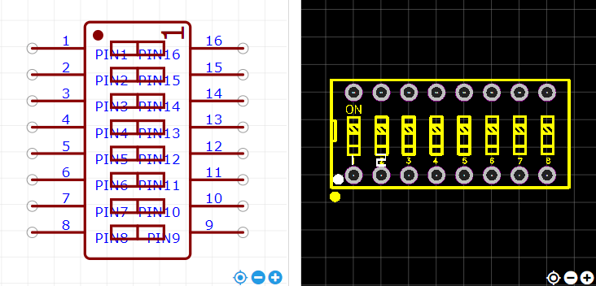
https://item.szlcsc.com/513973.html

