# CS-600-A Homework 11

Zijing Huang 10414952

**R-19.2 Suppose two teams, the Anteaters and the Bears, have a long rivalry in basketball. Suppose further that in any given game, the Anteaters will beat the Bears with probability 2/3, independent of any other games that they play. Give a bound on the probability that, in spite of this, the Bears will win a majority of n games that they play.**

Let  *X*1, ..., *Xn* denotes the events that the Bears win the game on these n games, which takes values {0,1} on each game(win or lose). And let X denote their sum and let *μ* = E[*X*] = n/3 denote the sum's expected value. Then according to Theorem 19.12 in the textbook, for any value *δ* > 0, the Multiplicative Chernoff Bound should be like:

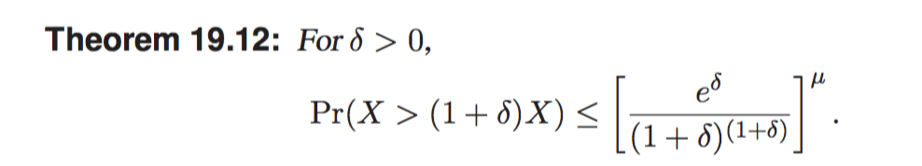

because we want to bound on the probability that the Bears will win a majority of n games, so δ=1/2. Pr(X > (1+1/2)*n/3) = Pr(X>n/2) <=[e1/2/(1+0.5)(1+0.5)]n/3=(1.65/1.83)n/3=0.9n/3

**R-19.3 Draw an example skip list resulting from performing the following sequence of operations on the skip list in Figure 19.18: remove(38), insert(8,x), insert(24,y), remove(55). Assume the coin flips for the first insertion yield two heads followed by tails, and those for the second insertion yield three heads followed by tails.**

1. Remove(38)

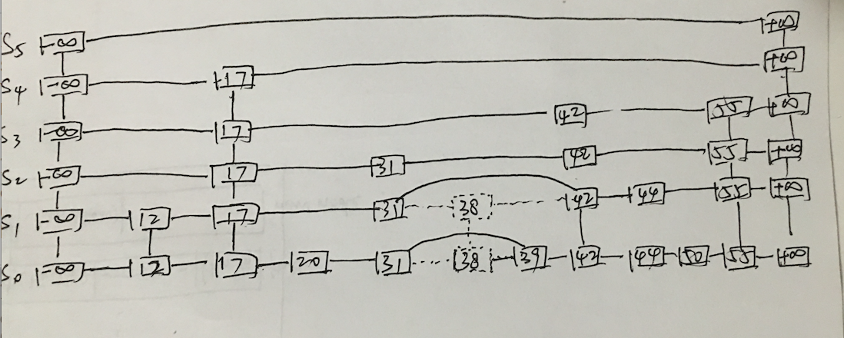

2.Insert(8,x) (the coin flips for the first insertion yield two heads followed by tails)

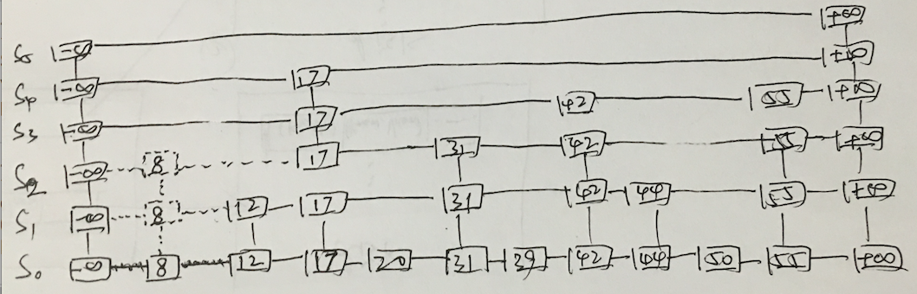

3. Insert(24,y) (the coin flips for the first insertion yield three heads followed by tails)

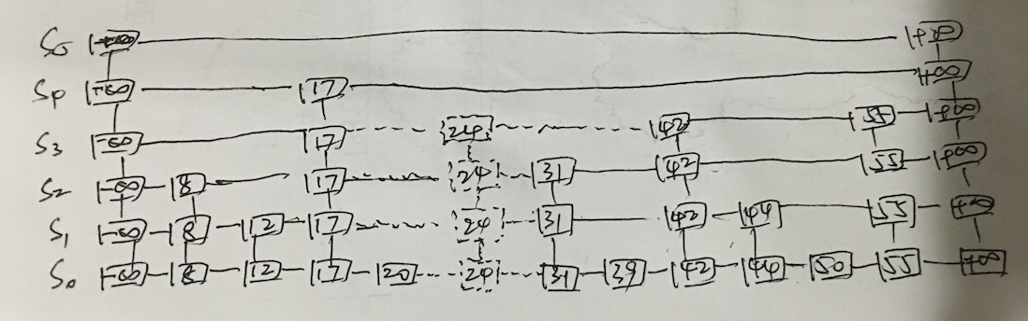

4. Remove(55)

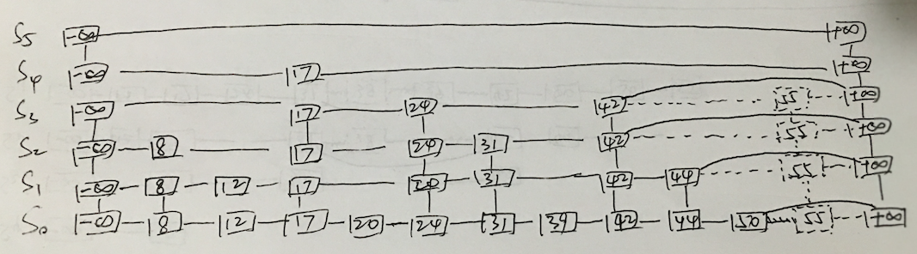

**C-19.7 Suppose that there is a collection of 3n distinct coupons, n of which are colored red and 2n of which are colored blue. Suppose that each time you go to a ticket window to get a coupon, the clerk first randomly decides, with probability 1/2, whether he will give you a red coupon or blue coupon and then he chooses a coupon uniformly at random from among the coupons that are that color. What is the expected number of times that you must visit the ticket window to get all 3n coupons?**

Firstly, suppose we ignore the condition that the clerk randomly give us a red or blue coupon, and what we do is just get the red coupon from one window and get the blue coupon from the other one. By the linearity of expectation, to collect all red coupons we need nHn trips. Because blue color coupons are two times to the red one, to collect all blue coupons we need 2nHn trips. Now we go back to the question that there is only one window and the clerk will randomly give us a red or blue coupon with probability 1/2. That is to say, to collect all the blue coupons in this case, we need 4nH2n trips. Still, we need nHn trips to collect all the red coupons. But fortunately, since there is 1/2 chance that we get red coupon, which means when we are using 4nH2n trips to collect blue coupons, the half of the trips we will get red coupons, which is 2nH2n. And this number of trips is more than the trips we need to collect red. It implies when we finish collecting blue coupons, we already finished collecting red coupons. So the expected number of times that we must visit the ticket window to get all 3n coupons is 4nH2n.