Left behind
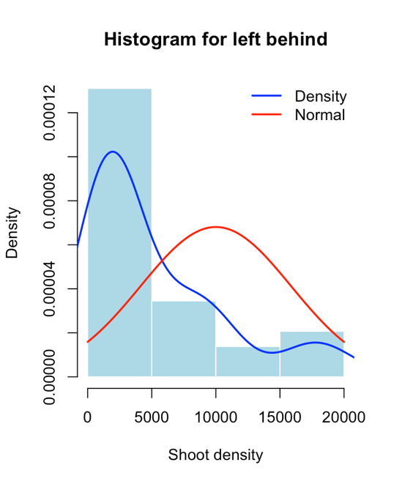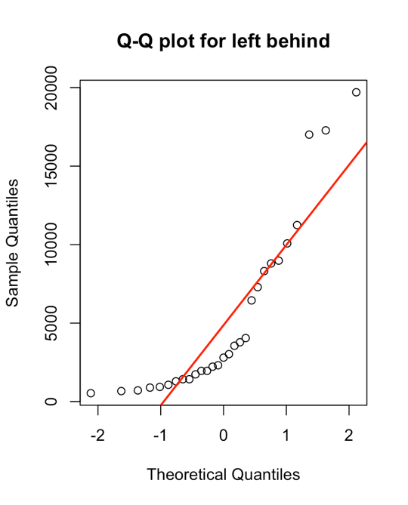
Shapiro-Wilk normality test

data: x
W = 0.79296, p-value = 6.261e-05

Not normally distributed

Left between
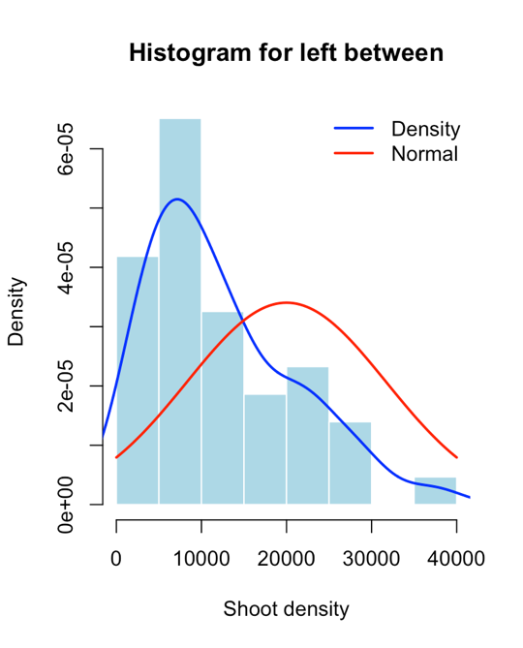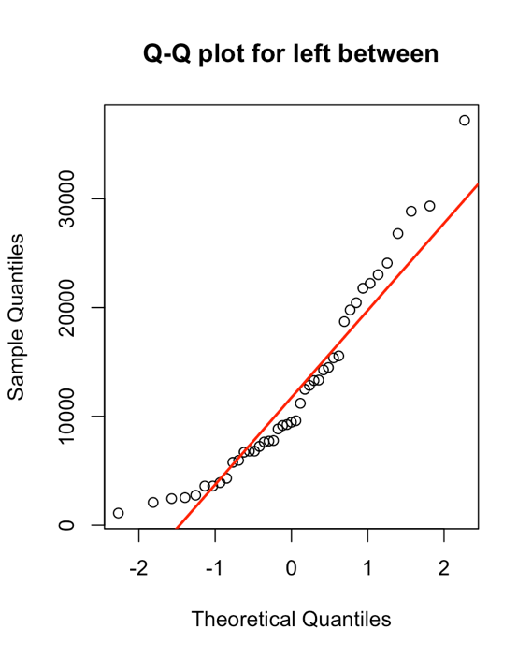
Shapiro-Wilk normality test

data: x
W = 0.91832, p-value = 0.004723
Not normally distributed

Right between
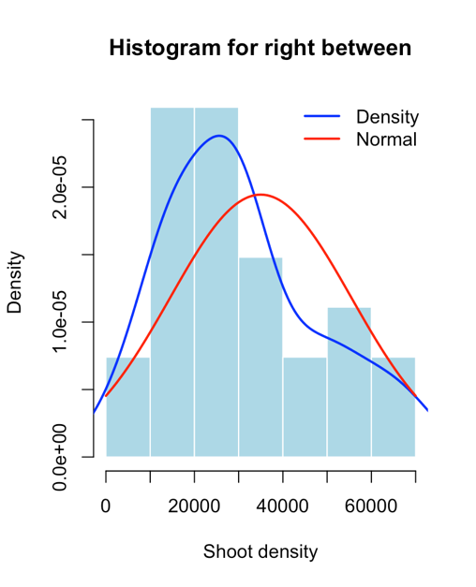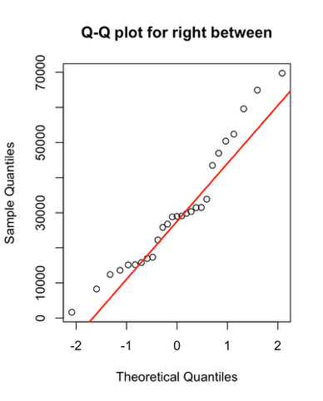
Shapiro-Wilk normality test

data: x
W = 0.93938, p-value = 0.1176
Normally distributed

Right behind
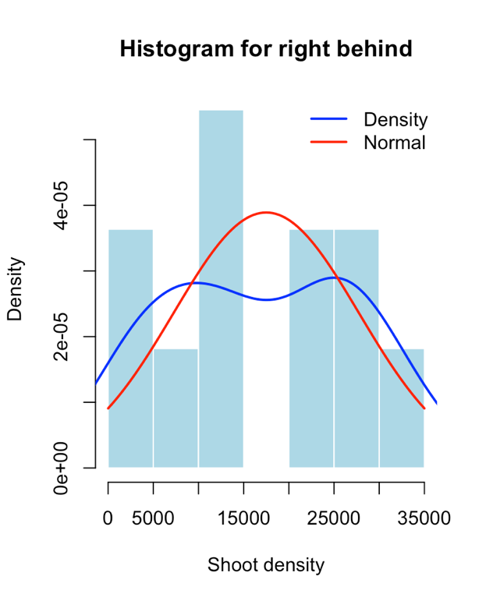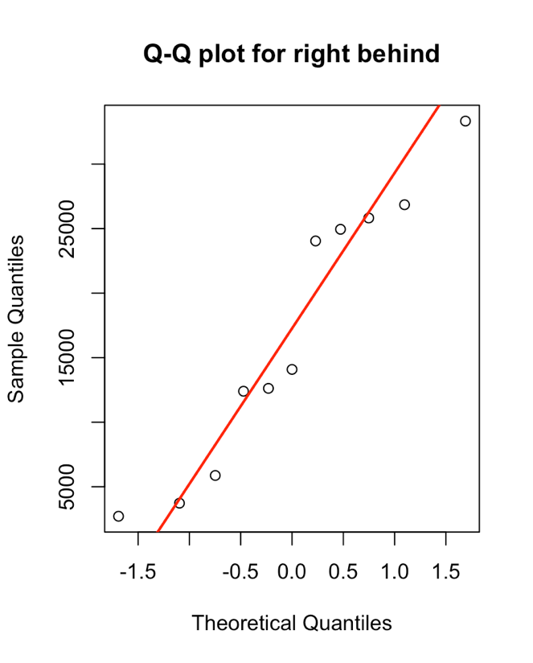
Shapiro-Wilk normality test

data: x
W = 0.91999, p-value = 0.3186
Normally distributed

F test to compare two variances

data: x and y
F = 0.36021, num df = 10, denom df = 26, p-value = 0.09391
alternative hypothesis: true ratio of variances is not equal to 1
95 percent confidence interval:
0.1391021 1.2047679
sample estimates:
ratio of variances
0.360212

X →right behind
Y→ right between

