(a)

First, assume the solution has the form:

$$u\left(x,t\right)=v(x)w(t)$$

The original equation then becomes:

$$\frac{1}{w\left(t\right)}\frac{dw\left(t\right)}{dt}=\frac{1}{v\left(x\right)}\frac{d^{2}v\left(x\right)}{dx^{2}}=-λ$$

where λ is an arbitrary constant. This gives us two ODE’s:

$$\frac{dw\left(t\right)}{dt}+λw\left(t\right)=0, \frac{d^{2}v\left(x\right)}{dx^{2}}+λv\left(x\right)=0.$$

Given initial values $u\left(x,0\right)=sin⁡(πx)$, boundaries $u\left(0,t\right)=0, u\left(1,t\right)=0$, we have

$$v\left(x\right)w\left(0\right)=\sin\left(πx\right), v\left(0\right)u\left(t\right)=0, v\left(1\right)u\left(t\right)=0.$$

For a non-trivial solution, consider boundaries to be $$v\left(0\right)=0, v\left(1\right)=0.$$

Let us first look at the spatial problem

$$\frac{d^{2}v\left(x\right)}{dx^{2}}+λv\left(x\right)=0, v\left(0\right)=0, v\left(1\right)=0.$$

The solution is of the form:

$$v\left(x\right)=c_{1}\cos\left(\sqrt{λ}x\right)+c_{2}\sin\left(\sqrt{λ}x\right)$$

which gives:

$${v\left(0\right)=0=c}_{1}, v\left(1\right)=0=c_{2}\sin\left(\sqrt{λ}\right).$$

For a non-trivial solution, we have $\sin\left(\sqrt{λ}\right)=0,$ so

$$λ={\left(nπ\right)}^{2}, v\left(x\right)=\sin\left(nπx\right), n=1,2,3…$$

For the time problem

$$\frac{dw\left(t\right)}{dt}+λw\left(t\right)=0, w\left(0\right)=1,$$

the solution is

$$w\left(t\right)=e^{-λt}$$

which gives the solution to the original equation

$$u\left(x,t\right)=sin\left(πx\right)e^{-π^{2}t}$$

as we let $n=1.$

(b)

Use Euler’s method (forward/explicit)

LHS:

$$\frac{∂u(x,t)}{∂t}|_{t=t_{j}}=\frac{u\left({x,t}_{j+1}\right)-u\left(x,t_{j}\right)}{Δt}$$

(forward difference formula)

RHS:

$$\frac{∂^{2}u(x,t)}{∂x^{2}}|_{x=x_{i}}=\frac{u\left(x_{i-1},t\right)-2u\left(x_{i},t\right)+u\left(x_{i+1},t\right)}{Δx^{2}}$$

(centered three-point formula)

Ignoring error terms and equating the two:

$$\frac{u\left({x_{i},t}_{j+1}\right)-u\left(x_{i},t_{j}\right)}{Δt}=\frac{u\left(x_{i-1},t_{j}\right)-2u\left(x_{i},t_{j}\right)+u\left(x_{i+1},t_{j}\right)}{Δx^{2}}$$

Simplifying:

$$u\left({x_{i},t}_{j+1}\right)=\frac{Δt}{Δx^{2}}u\left(x_{i-1},t_{j}\right)+(1-2\frac{Δt}{Δx^{2}})\left(x_{i},t_{j}\right)+\frac{Δt}{Δx^{2}}u\left(x_{i+1},t_{j}\right)$$

Given initial values $u\left(x,0\right)=sin⁡(πx)$, boundaries $u\left(0,t\right)=0, u\left(1,t\right)=0$, straightforward to solve for $u\left({x_{i},t}_{j+1}\right)$.

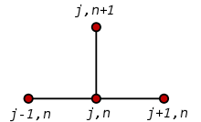

Computing using linear system:

$$\left(\begin{matrix}u(x_{1},t_{j+1}) \\ u(x_{2},t_{j+1}) \\ ⋮ \\ u(x_{n-1},t_{j+1})\end{matrix}\right)=\left(\begin{matrix}\frac{Δt}{Δx^{2}} & 1-\frac{2Δt}{Δx^{2}} & \frac{Δt}{Δx^{2}} & 0 & ⋯ & 0 & 0 & 0 \\ 0 & \frac{Δt}{Δx^{2}} & 1-\frac{2Δt}{Δx^{2}} & \frac{Δt}{Δx^{2}} & ⋯ & 0 & 0 & 0 \\ ⋮ & ⋮ & ⋮ & ⋮ & ⋱ & ⋮ & ⋮ & ⋮ \\ 0 & 0 & 0 & 0 & ⋯ & \frac{Δt}{Δx^{2}} & 1-\frac{2Δt}{Δx^{2}} & \frac{Δt}{Δx^{2}}\end{matrix}\right)\left(\begin{matrix}u(x_{0},t_{j}) \\ u(x_{1},t_{j}) \\ u(x_{2},t_{j}) \\ u(x_{3},t_{j}) \\ ⋮ \\ u(x_{n},t_{j})\end{matrix}\right)$$

Use Euler’s method (backward/implicit):

LHS:

$$\frac{∂u(x,t)}{∂t}|_{t=t_{j}}=\frac{u\left({x,t}_{j}\right)-u\left(x,t_{j-1}\right)}{Δt}$$

(backward difference formula)

RHS:

$$\frac{∂^{2}u(x,t)}{∂x^{2}}|_{x=x_{i}}=\frac{u\left(x_{i-1},t\right)-2u\left(x_{i},t\right)+u\left(x_{i+1},t\right)}{Δx^{2}}$$

(centered three-point formula)

Ignoring error terms and equating the two:

$$\frac{u\left({x_{i},t}_{j}\right)-u\left(x_{i},t_{j-1}\right)}{Δt}=\frac{u\left(x_{i-1},t_{j}\right)-2u\left(x_{i},t_{j}\right)+u\left(x_{i+1},t_{j}\right)}{Δx^{2}}$$

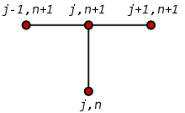

Given initial values $u\left(x,0\right)=sin⁡(πx)$, boundaries $u\left(0,t\right)=0, u\left(1,t\right)=0$, construct linear system to solve for $u\left({x,t}_{j}\right)$.

Simplify above equation:

$$u\left(x_{i},t_{j-1}\right)=\left(\frac{2Δt}{Δx^{2}}+1\right)u\left({x_{i},t}_{j}\right)-\frac{Δt}{Δx^{2}}u\left(x_{i-1},t_{j}\right)-\frac{Δt}{Δx^{2}} u\left(x_{i+1},t_{j}\right)$$

Construct linear system accordingly, for each j:

$$\left(\begin{matrix}-\frac{Δt}{Δx^{2}} & \frac{2Δt}{Δx^{2}}+1 & -\frac{Δt}{Δx^{2}} & 0 & ⋯ & 0 & 0 & 0 \\ 0 & -\frac{Δt}{Δx^{2}} & \frac{2Δt}{Δx^{2}}+1 & -\frac{Δt}{Δx^{2}} & ⋯ & 0 & 0 & 0 \\ ⋮ & ⋮ & ⋮ & ⋮ & ⋱ & ⋮ & ⋮ & ⋮ \\ 0 & 0 & 0 & 0 & ⋯ & -\frac{Δt}{Δx^{2}} & \frac{2Δt}{Δx^{2}}+1 & -\frac{Δt}{Δx^{2}}\end{matrix}\right)\left(\begin{matrix}u(x_{0},t_{j}) \\ u(x_{1},t_{j}) \\ u(x_{2},t_{j}) \\ u(x_{3},t_{j}) \\ ⋮ \\ u(x_{n},t_{j})\end{matrix}\right)=\left(\begin{matrix}u(x_{1},t_{j-1}) \\ u(x_{2},t_{j-1}) \\ ⋮ \\ u(x_{n-1},t_{j-1})\end{matrix}\right)$$

where $n$ is number of partitions.

Initial values: when $j-1=0$, $u\left(x,0\right)=\sin\left(πx\right)$. So we should loop starting from j=1. Boundary values: $x_{0}=0, { x}_{n}=1$, so we always have $u\left(x_{0},t_{j}\right)=u\left(x_{n},t_{j}\right)=0$.

Use Crank-Nicolson:

LHS:

$$\frac{∂u(x,t)}{∂t}|_{t=t_{j}}=\frac{u\left({x,t}_{j+1}\right)-u\left(x,t_{j}\right)}{Δt}$$

(forward difference formula)

RHS:

$$\frac{∂^{2}u(x,t)}{∂x^{2}}|_{x=x_{i}, t=t_{j}}=\frac{1}{2}(\frac{u\left(x_{i-1},t_{j+1}\right)-2u\left(x_{i},t_{j+1}\right)+u\left(x_{i+1},t_{j+1}\right)}{Δx^{2}}+\frac{u\left(x_{i-1},t_{j}\right)-2u\left(x_{i},t_{j}\right)+u\left(x_{i+1},t_{j}\right)}{Δx^{2}})$$

(centered three-point formula applied twice)

Ignoring error terms and equating the two:

$$\frac{u\left({x_{i},t}_{j+1}\right)-u\left(x_{i},t_{j}\right)}{Δt}=\frac{1}{2}(\frac{u\left(x_{i-1},t_{j+1}\right)-2u\left(x_{i},t_{j+1}\right)+u\left(x_{i+1},t_{j+1}\right)}{Δx^{2}}+\frac{u\left(x_{i-1},t_{j}\right)-2u\left(x_{i},t_{j}\right)+u\left(x_{i+1},t_{j}\right)}{Δx^{2}})$$

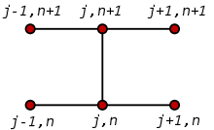

Simplifying:

$$-\frac{Δt}{Δx^{2}}u\left(x_{i-1},t_{j+1}\right)+(2+\frac{2Δt}{Δx^{2}})u\left(x_{i},t_{j+1}\right)-\frac{Δt}{Δx^{2}}u\left(x_{i+1},t_{j+1}\right)=\frac{Δt}{Δx^{2}}u\left(x_{i-1},t_{j}\right)+(2-\frac{2Δt}{Δx^{2}})u\left(x_{i},t_{j}\right)+\frac{Δt}{Δx^{2}}u\left(x_{i+1},t_{j}\right)$$

Construct linear system accordingly, for each j:

$$\left(\begin{matrix}-\frac{Δt}{Δx^{2}} & 2+\frac{2Δt}{Δx^{2}} & -\frac{Δt}{Δx^{2}} & 0 & ⋯ & 0 & 0 & 0 \\ 0 & -\frac{Δt}{Δx^{2}} & 2+\frac{2Δt}{Δx^{2}} & -\frac{Δt}{Δx^{2}} & ⋯ & 0 & 0 & 0 \\ ⋮ & ⋮ & ⋮ & ⋮ & ⋱ & ⋮ & ⋮ & ⋮ \\ 0 & 0 & 0 & 0 & ⋯ & -\frac{Δt}{Δx^{2}} & 2+\frac{2Δt}{Δx^{2}} & -\frac{Δt}{Δx^{2}}\end{matrix}\right)\left(\begin{matrix}u(x_{0},t_{j+1}) \\ u(x_{1},t_{j+1}) \\ u(x_{2},t_{j+1}) \\ u(x_{3},t_{j+1}) \\ ⋮ \\ u(x_{n},t_{j+1})\end{matrix}\right)=\left(\begin{matrix}\frac{Δt}{Δx^{2}} & 2-\frac{2Δt}{Δx^{2}} & \frac{Δt}{Δx^{2}} & 0 & ⋯ & 0 & 0 & 0 \\ 0 & \frac{Δt}{Δx^{2}} & 2-\frac{2Δt}{Δx^{2}} & \frac{Δt}{Δx^{2}} & ⋯ & 0 & 0 & 0 \\ ⋮ & ⋮ & ⋮ & ⋮ & ⋱ & ⋮ & ⋮ & ⋮ \\ 0 & 0 & 0 & 0 & ⋯ & \frac{Δt}{Δx^{2}} & 2-\frac{2Δt}{Δx^{2}} & \frac{Δt}{Δx^{2}}\end{matrix}\right)\left(\begin{matrix}u(x_{0},t_{j}) \\ u(x_{1},t_{j}) \\ u(x_{2},t_{j}) \\ u(x_{3},t_{j}) \\ ⋮ \\ u(x_{n},t_{j})\end{matrix}\right)$$

Results:

6 x nodes, 6 t nodes:

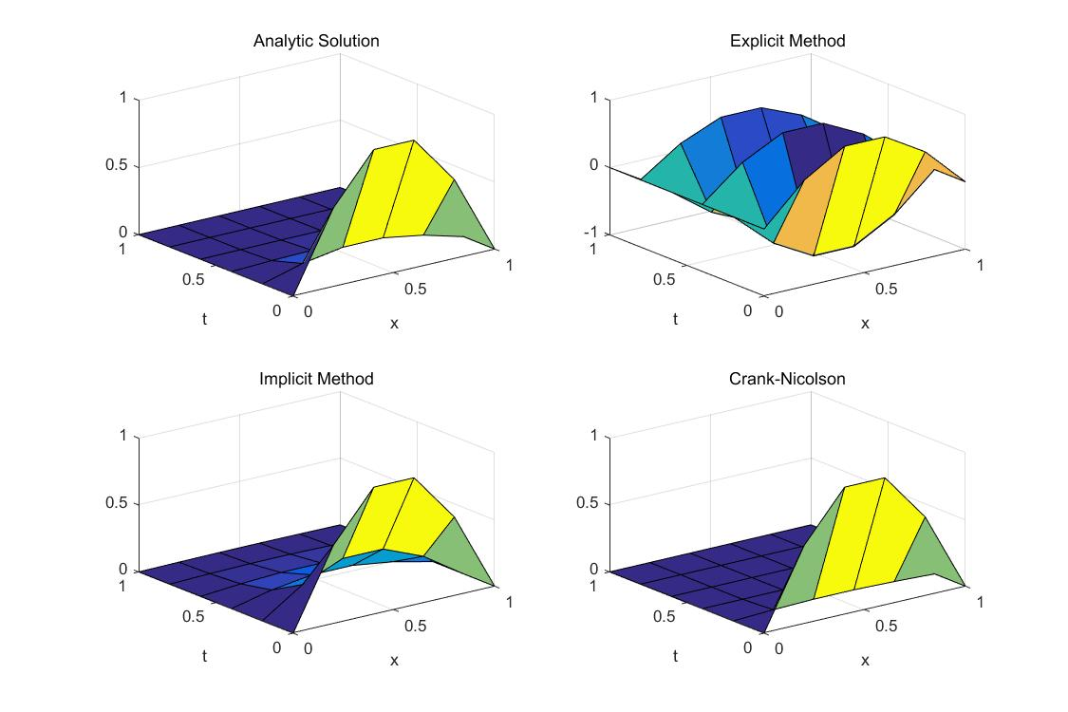

(note the divergence of Explicit Method)

10 x nodes, 100 t nodes:

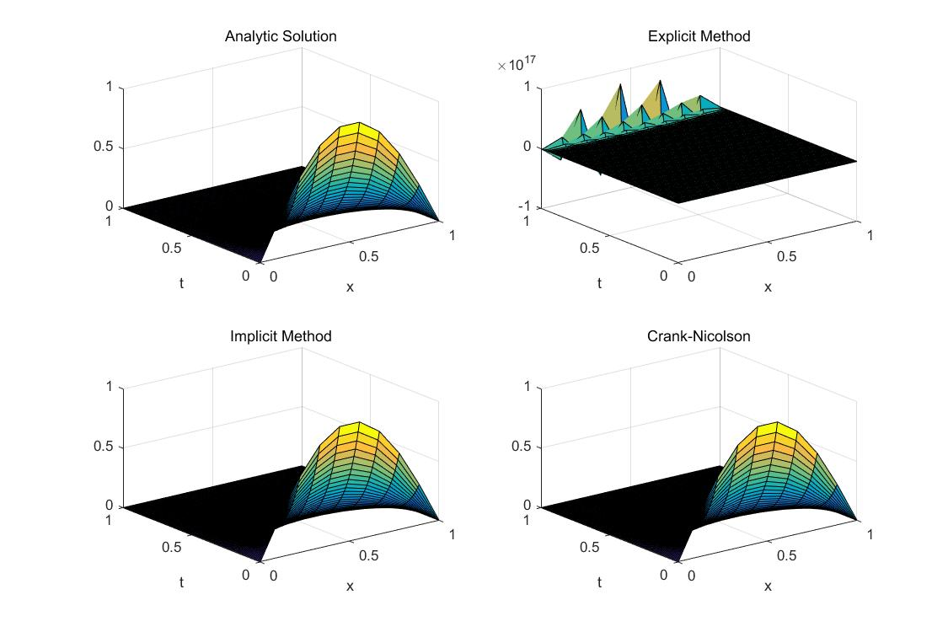

(note overall improved smoothness and still divergence of Explicit Method.)

10 x nodes, 200 t nodes:

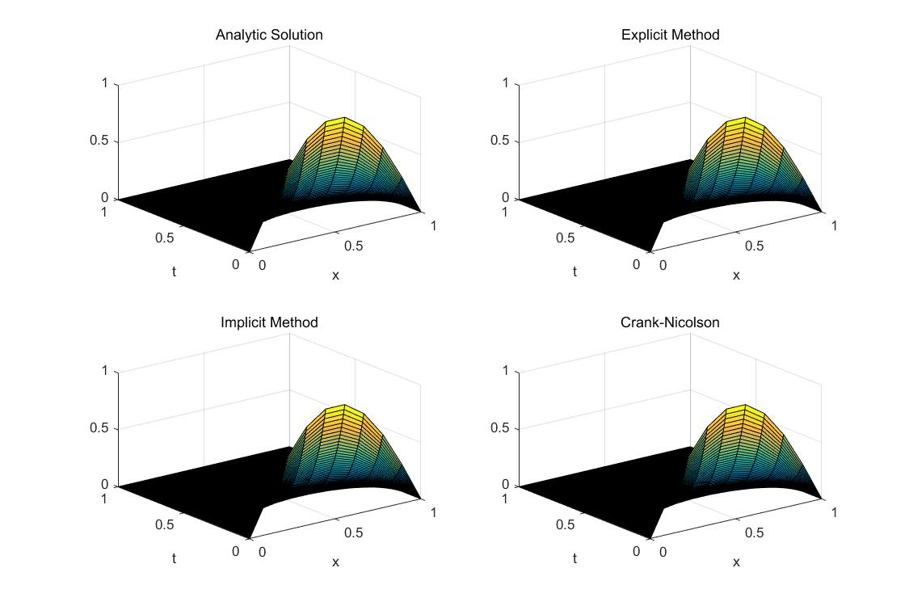

(note the convergence of Explicit Method)

On convergence of Explicit Method: in this problem in particular, it is guaranteed that no point in the solution should have a value that is negative. Since ranges of $x$ and $t$ are equal, $\frac{Δt}{Δx^{2}}≤\frac{1}{2} iff {2\left(N-1\right)}^{2}≤M-1,$ where $M$ denotes number of t nodes and $N$ denotes number of x nodes.

In this problem, however, the Explicit Method solution starts converging as soon as $\frac{Δt}{Δx^{2}}≈0.6,$ although producing a quite inaccurate solution, as in the case where 10 x nodes and 135 t nodes are used ($\frac{Δt}{Δx^{2}}=0.6045$):

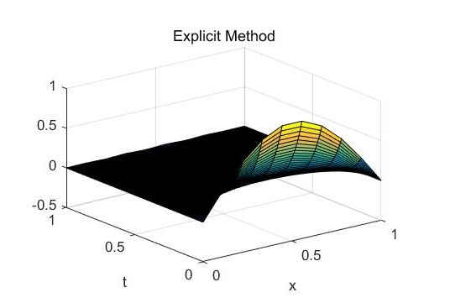

Error Analysis:

We ran 100 tests on each method, where number of x nodes can be any of 10, 15...55, and number of t nodes can be any of 100, 200...1000. We calculate $SSE$ (sum of squared errors) using the analytic solution. The following graphs showing $SSE$ of all tests are obtained.

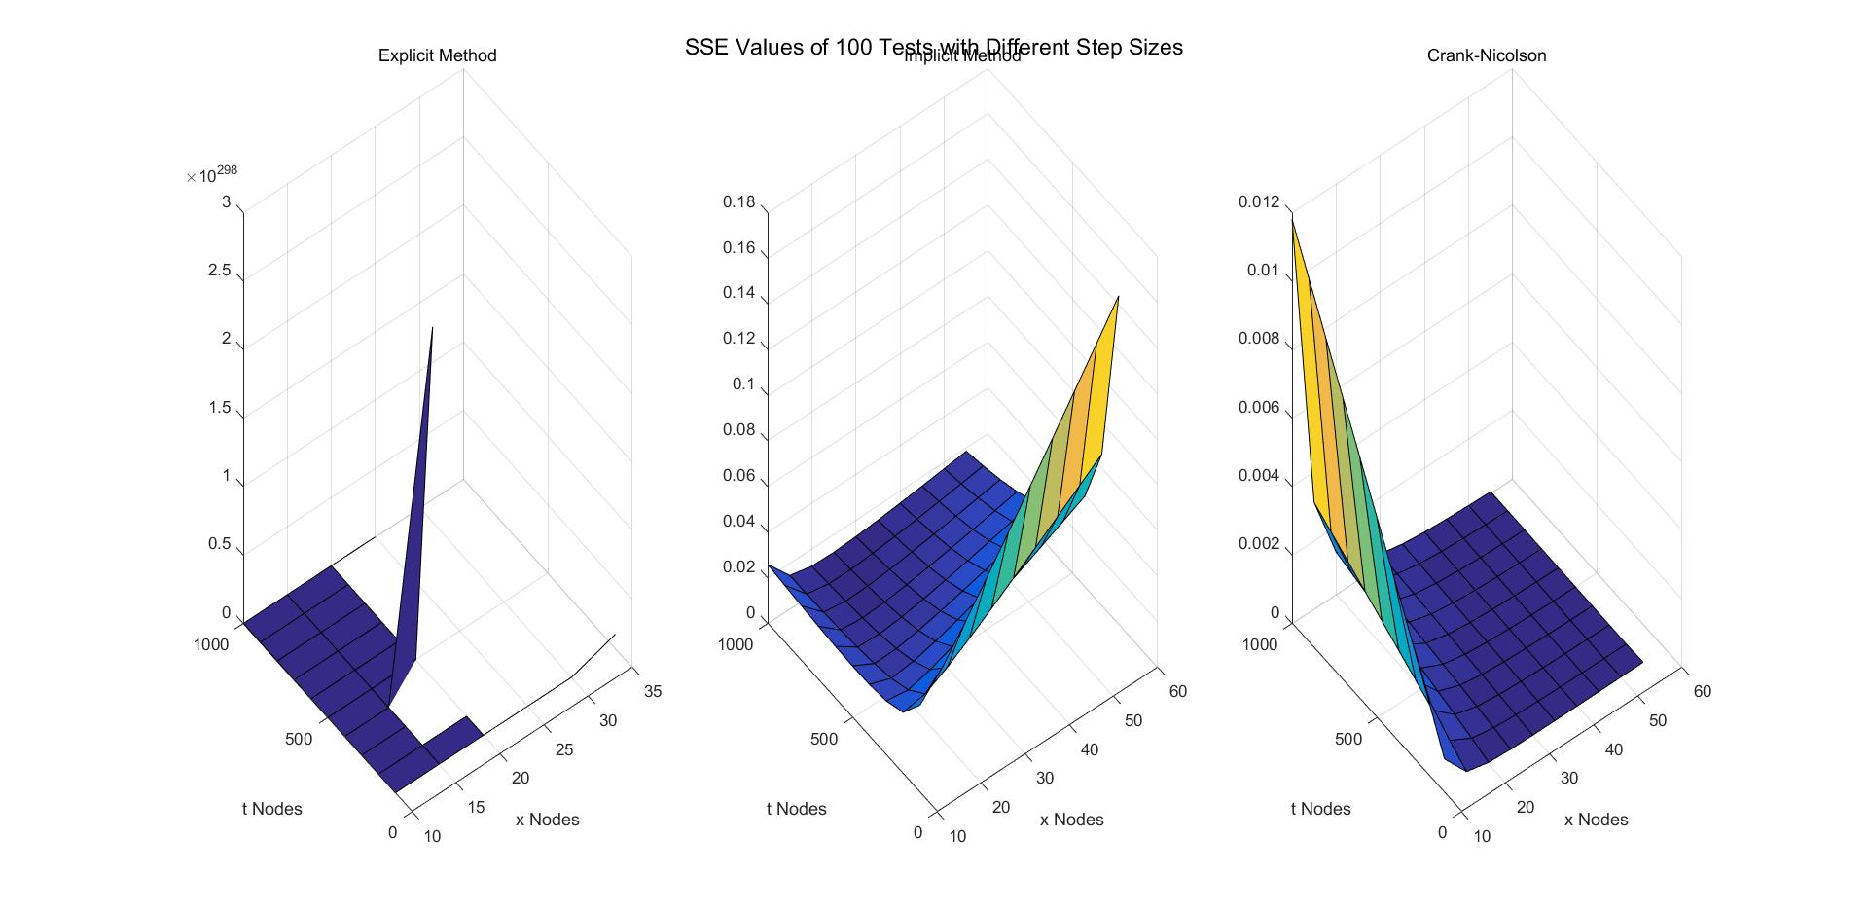

In this problem in particular, it is difficult to make Explicit Method converge while maintaining observation of effects of number of x nodes, so we will focus more on performance of Implicit Method and Crank-Nicolson Method.

Implicit Method generates significantly higher errors when number of x nodes increases while there are not many t nodes. We believe this is due to accumulation of round-off errors. Crank-Nicolson Method, on the other hand, is barely affected by round-off errors in this situation.

Implicit Method also generates slightly higher errors when there are many t nodes and not many x nodes. As number of t nodes decide number of iterations, initial errors due to small number of x nodes are magnified in these significant amount of iterations. On the other hand, Crank-Nicolson Method is significantly affected in like situation. Presumably such behavior can be attributed to same error magnification problem.

In general, Crank-Nicolson Method produces significantly smaller errors. In the tests conducted, $\overline{SSE}=0.0331$ for Implicit Method, while $\overline{SSE}=9.58e-04$ for Crank-Nicolson Method, the latter about ${10}^{2}$ times smaller than the former.

(c)

Initial condition: $u\left(x,y,0\right)=0$ except boundaries. Boundaries: $u\left(0,y,t\right)=100, u\left(x,0,t\right)=100$. $0≤x≤15, 0≤y≤15, 0≤t≤20.$

Use Euler’s method (forward/explicit)

LHS:

$$\frac{∂u(x,y,t)}{∂t}|_{t=t_{k}}=\frac{u\left({x,y,t}_{k+1}\right)-u\left(x,{y,t}_{k}\right)}{Δt}$$

(forward difference formula)

RHS:

$$\frac{k}{cφ}\left(\frac{∂^{2}u\left(x,y,t\right)}{∂x^{2}}|_{x=x_{i}}+\frac{∂^{2}u\left(x,y,t\right)}{∂y^{2}}|_{y=y_{j}}\right)=\frac{k}{cφ}\frac{u\left(x_{i-1},y_{j},t\right)-2u\left(x_{i},y_{j},t\right)+u\left(x_{i+1},y_{j},t\right)}{Δx^{2}}+\frac{k}{cφ}\frac{u\left({x_{i},y}_{j-1},t\right)-2u\left(x_{i},y_{j},t\right)+u\left({x_{i},y}_{j+1},t\right)}{Δy^{2}}$$

(centered three-point formula)

Ignoring error terms and equating the two:

$$\frac{u\left({x_{i},y_{j},t}_{k+1}\right)-u\left(x_{i},{y_{j},t}_{k}\right)}{Δt}=\frac{k}{cφ}\frac{u\left(x_{i-1},y_{j},t_{k}\right)-2u\left(x_{i},y_{j},t_{k}\right)+u\left(x_{i+1},y_{j},t_{k}\right)}{Δx^{2}}+\frac{k}{cφ}\frac{u\left({x_{i},y}_{j-1},t_{k}\right)-2u\left(x_{i},y_{j},t_{k}\right)+u\left({x_{i},y}_{j+1},t_{k}\right)}{Δy^{2}}$$

Simplifying:

$$u\left({x_{i},y_{j},t}_{k+1}\right)=\frac{k}{cφ}\left(\frac{Δt}{Δx^{2}}u\left(x_{i-1},y_{j},t_{k}\right)+\left(\frac{cφ}{k}-\frac{2Δt}{Δx^{2}}-\frac{2Δt}{Δy^{2}}\right)u\left(x_{i},y_{j},t_{k}\right)+\frac{Δt}{Δx^{2}}u\left(x_{i+1},y_{j},t_{k}\right)+\frac{Δt}{Δy^{2}}u\left({x_{i},y}_{j-1},t_{k}\right)+\frac{Δt}{Δy^{2}}u\left({x_{i},y}_{j+1},t_{k}\right)\right)$$

Given $u\left(x,y,0\right)=0$ except boundaries and boundaries $u\left(0,y,t\right)=100, u\left(x,0,t\right)=100$, straightforward to solve for $u\left({x_{i},y_{j},t}_{k+1}\right)$.



Computing using linear system: $\left(\begin{matrix}u(x_{1},{y_{j},t}_{k+1}) \\ u(x_{2},{y_{j},t}_{k+1}) \\ ⋮ \\ u(x_{n-1},{y_{j},t}_{k+1})\end{matrix}\right)=\frac{k}{cφ}\left(\begin{matrix}\frac{Δt}{Δx^{2}} & \frac{cφ}{k}-\frac{2Δt}{Δx^{2}}-\frac{2Δt}{Δy^{2}} & \frac{Δt}{Δx^{2}} & 0 & ⋯ & 0 & 0 & 0 \\ 0 & \frac{Δt}{Δx^{2}} & \frac{cφ}{k}-\frac{2Δt}{Δx^{2}}-\frac{2Δt}{Δy^{2}} & \frac{Δt}{Δx^{2}} & ⋯ & 0 & 0 & 0 \\ ⋮ & ⋮ & ⋮ & ⋮ & ⋱ & ⋮ & ⋮ & ⋮ \\ 0 & 0 & 0 & 0 & ⋯ & \frac{Δt}{Δx^{2}} & \frac{cφ}{k}-\frac{2Δt}{Δx^{2}}-\frac{2Δt}{Δy^{2}} & \frac{Δt}{Δx^{2}}\end{matrix}\right)\left(\begin{matrix}u(x_{0},y_{j},t_{k}) \\ u(x_{1},y_{j},t_{k}) \\ u(x_{2},y_{j},t_{k}) \\ u(x_{3},y_{j},t_{k}) \\ ⋮ \\ u(x_{n},y_{j},t_{k})\end{matrix}\right)$ + $\frac{k}{cφ}\left(\begin{matrix}\frac{Δt}{Δy^{2}} & \frac{Δt}{Δy^{2}} & 0 & 0 & ⋯ & 0 & 0 & 0 \\ 0 & 0 & \frac{Δt}{Δy^{2}} & \frac{Δt}{Δy^{2}} & ⋯ & 0 & 0 & 0 \\ ⋮ & ⋮ & ⋮ & ⋮ & ⋱ & ⋮ & ⋮ & ⋮ \\ 0 & 0 & 0 & 0 & ⋯ & 0 & \frac{Δt}{Δy^{2}} & \frac{Δt}{Δy^{2}}\end{matrix}\right)\left(\begin{matrix}u(x_{1},y_{j-1},t_{k}) \\ u(x_{1},y_{j+1},t_{k}) \\ u(x_{2},y_{j-1},t_{k}) \\ u(x_{2},y_{j+1},t_{k}) \\ ⋮ \\ u(x_{n-1},y_{j-1},t_{k}) \\ u(x_{n-1},y_{j+1},t_{k})\end{matrix}\right)$

Use Euler’s method (backward/implicit):

LHS:

$$\frac{∂u\left(x,y,t\right)}{∂t}|_{t=t_{k}}=\frac{u\left({x,y,t}_{k}\right)-u\left(x,{y,t}_{k-1}\right)}{Δt}$$

(backward difference formula)

RHS:

$$\frac{k}{cφ}\left(\frac{∂^{2}u\left(x,y,t\right)}{∂x^{2}}|_{x=x_{i}}+\frac{∂^{2}u\left(x,y,t\right)}{∂y^{2}}|_{y=y_{j}}\right)=\frac{k}{cφ}(\frac{u\left(x_{i-1},y_{j},t\right)-2u\left(x_{i},y_{j},t\right)+u\left(x_{i+1},y_{j},t\right)}{Δx^{2}}+\frac{u\left({x_{i},y}_{j-1},t\right)-2u\left(x_{i},y_{j},t\right)+u\left({x_{i},y}_{j+1},t\right)}{Δy^{2}})$$

(centered three-point formula)

Ignoring error terms and equating the two:



$$\frac{u\left({x_{i},y_{j},t}_{k}\right)-u\left(x_{i},{y_{j},t}_{k-1}\right)}{Δt}=\frac{k}{cφ}\left(\frac{u\left(x_{i-1},y_{j},t_{k}\right)-2u\left(x_{i},y_{j},t_{k}\right)+u\left(x_{i+1},y_{j},t_{k}\right)}{Δx^{2}}+\frac{u\left({x_{i},y}_{j-1},t_{k}\right)-2u\left(x_{i},y_{j},t_{k}\right)+u\left({x_{i},y}_{j+1},t_{k}\right)}{Δy^{2}}\right)$$

Simplifying:

$$u\left({x_{i},y_{j},t}_{k-1}\right)=\frac{k}{cφ}\left(-\frac{Δt}{Δx^{2}}u\left(x_{i-1},y_{j},t_{k}\right)+\left(\frac{cφ}{k}+\frac{2Δt}{Δx^{2}}+\frac{2Δt}{Δy^{2}}\right)u\left(x_{i},y_{j},t_{k}\right)-\frac{Δt}{Δx^{2}}u\left(x_{i+1},y_{j},t_{k}\right)-\frac{Δt}{Δy^{2}}u\left({x_{i},y}_{j-1},t_{k}\right)-\frac{Δt}{Δy^{2}}u\left({x_{i},y}_{j+1},t_{k}\right)\right)$$

Given $u\left(x,y,0\right)=0$ except boundaries and boundaries $u\left(0,y,t\right)=100, u\left(x,0,t\right)=100$, construct linear system, for each j for each k:

$\frac{k}{cφ}\left(\begin{matrix}-\frac{Δt}{Δx^{2}} & \frac{cφ}{k}+\frac{2Δt}{Δx^{2}}+\frac{2Δt}{Δy^{2}} & -\frac{Δt}{Δx^{2}} & 0 & ⋯ & 0 & 0 & 0 \\ 0 & -\frac{Δt}{Δx^{2}} & \frac{cφ}{k}+\frac{2Δt}{Δx^{2}}+\frac{2Δt}{Δy^{2}} & -\frac{Δt}{Δx^{2}} & ⋯ & 0 & 0 & 0 \\ ⋮ & ⋮ & ⋮ & ⋮ & ⋱ & ⋮ & ⋮ & ⋮ \\ 0 & 0 & 0 & 0 & ⋯ & -\frac{Δt}{Δx^{2}} & \frac{cφ}{k}+\frac{2Δt}{Δx^{2}}+\frac{2Δt}{Δy^{2}} & -\frac{Δt}{Δx^{2}}\end{matrix}\right)\left(\begin{matrix}u(x_{0},y_{j},t_{k}) \\ u(x_{1},y_{j},t_{k}) \\ u(x_{2},y_{j},t_{k}) \\ u(x_{3},y_{j},t_{k}) \\ ⋮ \\ u(x_{n},y_{j},t_{k})\end{matrix}\right)-\frac{k}{cφ}\left(\begin{matrix}\frac{Δt}{Δy^{2}} & \frac{Δt}{Δy^{2}} & 0 & 0 & ⋯ & 0 & 0 & 0 \\ 0 & 0 & \frac{Δt}{Δy^{2}} & \frac{Δt}{Δy^{2}} & ⋯ & 0 & 0 & 0 \\ ⋮ & ⋮ & ⋮ & ⋮ & ⋱ & ⋮ & ⋮ & ⋮ \\ 0 & 0 & 0 & 0 & ⋯ & 0 & \frac{Δt}{Δy^{2}} & \frac{Δt}{Δy^{2}}\end{matrix}\right)\left(\begin{matrix}u(x_{1},y_{j-1},t_{k}) \\ u(x_{1},y_{j+1},t_{k}) \\ u(x_{2},y_{j-1},t_{k}) \\ u(x_{2},y_{j+1},t_{k}) \\ ⋮ \\ u(x_{n-1},y_{j-1},t_{k}) \\ u(x_{n-1},y_{j+1},t_{k})\end{matrix}\right)$ = $\left(\begin{matrix}u(x_{1},{y_{j},t}_{k-1}) \\ u(x_{2},{y_{j},t}_{k-1}) \\ ⋮ \\ u(x_{n-1},{y_{j},t}_{k-1})\end{matrix}\right)$

Use Crank-Nicolson:

LHS:

$$\frac{∂u(x,y,t)}{∂t}|_{t=t_{k}}=\frac{u\left({x,y,t}_{k+1}\right)-u\left(x,{y,t}_{k}\right)}{Δt}$$

(forward difference formula)

RHS：

$$\frac{k}{cφ}\left(\frac{∂^{2}u\left(x,y,t\right)}{∂x^{2}}|_{x=x_{i}}+\frac{∂^{2}u\left(x,y,t\right)}{∂y^{2}}|_{y=y_{j}}\right)=\frac{k}{2cφ}\left(\frac{u\left(x_{i-1},y_{j},t\right)-2u\left(x_{i},y_{j},t\right)+u\left(x_{i+1},y_{j},t\right)}{Δx^{2}}+\frac{u\left({x_{i},y}_{j-1},t\right)-2u\left(x_{i},y_{j},t\right)+u\left({x_{i},y}_{j+1},t\right)}{Δy^{2}}+\frac{u\left(x_{i-1},y_{j},t\right)-2u\left(x_{i},y_{j},t\right)+u\left(x_{i+1},y_{j},t\right)}{Δx^{2}}+\frac{u\left({x_{i},y}_{j-1},t\right)-2u\left(x_{i},y_{j},t\right)+u\left({x_{i},y}_{j+1},t\right)}{Δy^{2}}\right)$$

Ignoring error terms and equating the two:



$$\frac{u\left({x_{i},y_{j},t}_{k+1}\right)-u\left(x_{i},y_{j},t_{k}\right)}{Δt}=\frac{k}{2cφ}\left(\frac{u\left(x_{i-1},y_{j},t_{k}\right)-2u\left(x_{i},y_{j},t_{k}\right)+u\left(x_{i+1},y_{j},t_{k}\right)}{Δx^{2}}+\frac{u\left({x_{i},y}_{j-1},t_{k}\right)-2u\left(x_{i},y_{j},t_{k}\right)+u\left({x_{i},y}_{j+1},t_{k}\right)}{Δy^{2}}+\frac{u\left(x_{i-1},y_{j},t_{k}\right)-2u\left(x_{i},y_{j},t_{k}\right)+u\left(x_{i+1},y_{j},t_{k}\right)}{Δx^{2}}+\frac{u\left({x_{i},y}_{j-1},t_{k}\right)-2u\left(x_{i},y_{j},t_{k}\right)+u\left({x_{i},y}_{j+1},t_{k}\right)}{Δy^{2}}\right)$$

Simplifying:

$$-\frac{k}{2cφ}\left(\frac{Δt}{Δx^{2}}u\left(x_{i-1},y_{j},t_{k+1}\right)-\left(\frac{2cφ}{k}+\frac{2Δt}{Δx^{2}}+\frac{2Δt}{Δy^{2}}\right)u\left(x_{i},y_{j},t_{k+1}\right)+\frac{Δt}{Δx^{2}}u\left(x_{i+1},y_{j},t_{k+1}\right)+\frac{Δt}{Δy^{2}}u\left({x_{i},y}_{j-1},t_{k+1}\right)+\frac{Δt}{Δy^{2}}u\left({x_{i},y}_{j+1},t_{k+1}\right)\right)=\frac{k}{2cφ}\left(\frac{Δt}{Δx^{2}}u\left(x_{i-1},y_{j},t_{k}\right)+\left(\frac{2cφ}{k}-\frac{2Δt}{Δx^{2}}-\frac{2Δt}{Δy^{2}}\right)u\left(x_{i},y_{j},t_{k}\right)+\frac{Δt}{Δx^{2}}u\left(x_{i+1},y_{j},t_{k}\right)+\frac{Δt}{Δy^{2}}u\left({x_{i},y}_{j-1},t_{k}\right)+\frac{Δt}{Δy^{2}}u\left({x_{i},y}_{j+1},t_{k}\right)\right)$$

Construct linear system accordingly, for each j for each k:

$$-\frac{k}{2cφ}\left(\begin{matrix}\frac{Δt}{Δx^{2}} & -\left(\frac{2cφ}{k}+\frac{2Δt}{Δx^{2}}+\frac{2Δt}{Δy^{2}}\right) & \frac{Δt}{Δx^{2}} & 0 & ⋯ & 0 & 0 & 0 \\ 0 & \frac{Δt}{Δx^{2}} & -\left(\frac{2cφ}{k}+\frac{2Δt}{Δx^{2}}+\frac{2Δt}{Δy^{2}}\right) & \frac{Δt}{Δx^{2}} & ⋯ & 0 & 0 & 0 \\ ⋮ & ⋮ & ⋮ & ⋮ & ⋱ & ⋮ & ⋮ & ⋮ \\ 0 & 0 & 0 & 0 & ⋯ & \frac{Δt}{Δx^{2}} & -\left(\frac{2cφ}{k}+\frac{2Δt}{Δx^{2}}+\frac{2Δt}{Δy^{2}}\right) & \frac{Δt}{Δx^{2}}\end{matrix}\right)$$

$$\left(\begin{matrix}u\left(x_{0},y_{j},t_{k+1}\right) \\ u\left(x_{1},y_{j},t_{k+1}\right) \\ u\left(x_{2},y_{j},t_{k+1}\right) \\ u\left(x_{3},y_{j},t_{k+1}\right) \\ ⋮ \\ u\left(x_{n},y_{j},t_{k+1}\right)\end{matrix}\right)-\frac{k}{2cφ}\left(\begin{matrix}\frac{Δt}{Δy^{2}} & \frac{Δt}{Δy^{2}} & 0 & 0 & ⋯ & 0 & 0 & 0 \\ 0 & 0 & \frac{Δt}{Δy^{2}} & \frac{Δt}{Δy^{2}} & ⋯ & 0 & 0 & 0 \\ ⋮ & ⋮ & ⋮ & ⋮ & ⋱ & ⋮ & ⋮ & ⋮ \\ 0 & 0 & 0 & 0 & ⋯ & 0 & \frac{Δt}{Δy^{2}} & \frac{Δt}{Δy^{2}}\end{matrix}\right)\left(\begin{matrix}u(x_{1},y_{j-1},t_{k+1}) \\ u(x_{1},y_{j+1},t_{k+1}) \\ u(x_{2},y_{j-1},t_{k+1}) \\ u(x_{2},y_{j+1},t_{k+1}) \\ ⋮ \\ u(x_{n-1},y_{j-1},t_{k+1}) \\ u(x_{n-1},y_{j+1},t_{k+1})\end{matrix}\right)=$$

$$\frac{k}{2cφ}\left(\begin{matrix}\frac{Δt}{Δx^{2}} & \frac{2cφ}{k}-\frac{2Δt}{Δx^{2}}-\frac{2Δt}{Δy^{2}} & \frac{Δt}{Δx^{2}} & 0 & ⋯ & 0 & 0 & 0 \\ 0 & \frac{Δt}{Δx^{2}} & \frac{2cφ}{k}-\frac{2Δt}{Δx^{2}}-\frac{2Δt}{Δy^{2}} & \frac{Δt}{Δx^{2}} & ⋯ & 0 & 0 & 0 \\ ⋮ & ⋮ & ⋮ & ⋮ & ⋱ & ⋮ & ⋮ & ⋮ \\ 0 & 0 & 0 & 0 & ⋯ & \frac{Δt}{Δx^{2}} & \frac{2cφ}{k}-\frac{2Δt}{Δx^{2}}-\frac{2Δt}{Δy^{2}} & \frac{Δt}{Δx^{2}}\end{matrix}\right)$$

$$\left(\begin{matrix}u(x_{0},y_{j},t_{k}) \\ u(x_{1},y_{j},t_{k}) \\ u(x_{2},y_{j},t_{k}) \\ u(x_{3},y_{j},t_{k}) \\ ⋮ \\ u(x_{n},y_{j},t_{k})\end{matrix}\right)+\frac{k}{2cφ}\left(\begin{matrix}\frac{Δt}{Δy^{2}} & \frac{Δt}{Δy^{2}} & 0 & 0 & ⋯ & 0 & 0 & 0 \\ 0 & 0 & \frac{Δt}{Δy^{2}} & \frac{Δt}{Δy^{2}} & ⋯ & 0 & 0 & 0 \\ ⋮ & ⋮ & ⋮ & ⋮ & ⋱ & ⋮ & ⋮ & ⋮ \\ 0 & 0 & 0 & 0 & ⋯ & 0 & \frac{Δt}{Δy^{2}} & \frac{Δt}{Δy^{2}}\end{matrix}\right)\left(\begin{matrix}u(x_{1},y_{j-1},t_{k}) \\ u(x_{1},y_{j+1},t_{k}) \\ u(x_{2},y_{j-1},t_{k}) \\ u(x_{2},y_{j+1},t_{k}) \\ ⋮ \\ u(x_{n-1},y_{j-1},t_{k}) \\ u(x_{n-1},y_{j+1},t_{k})\end{matrix}\right)$$

Results:

9 space nodes, 9 t nodes:

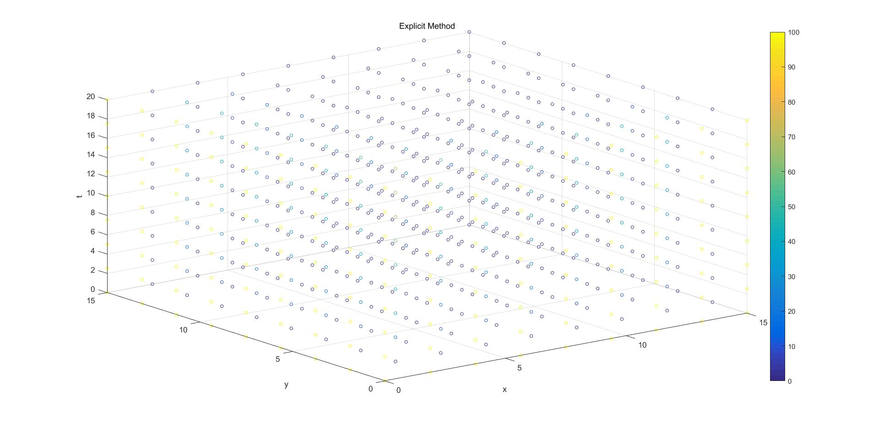

20 space nodes, 200 t nodes:

