04 Swagger

IOp - Hub

Exported on May 30, 2018

Table of Contents

1 What is it? 4

2 How to start Swagger? 5

2.1 Download httpster, a mini-server that runs websites 5

2.2 Run httpster 5

3 Where is the source code? 7

4 How to install 12

5 Troubleshooting 13

6 How to adapt Swagger? 14

7 API 16

7.1 Tolltickets API 16

7.2 API Scheduler Configuration 16

8 Contacts 18

* What is it?
* How to start Swagger?
  + Download httpster, a mini-server that runs websites
  + Run httpster
* Where is the source code?
* How to install
* Troubleshooting
* How to adapt Swagger?
* API
  + Tolltickets API
  + API Scheduler Configuration
* Contacts

# What is it?

Swagger UI is a dependency-free collection of HTML, JavaScript, and CSS assets that dynamically generate documentation from a Swagger-compliant API.

# How to start Swagger?

## Download httpster, a mini-server that runs websites

Simple http server for quick loading of content.

Installation is done via npm, which is installed along with NodeJS on most platforms.

npm -g install httpster

Open: How to install it without internet access?

Precondition:

You need the package loade "npm", so you need to install nodejs <https://nodejs.org/en/>

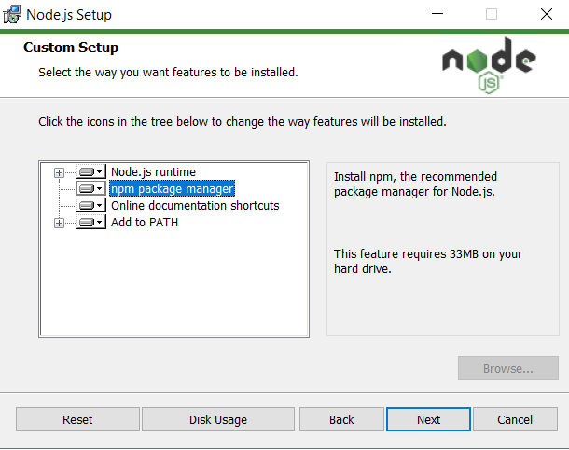

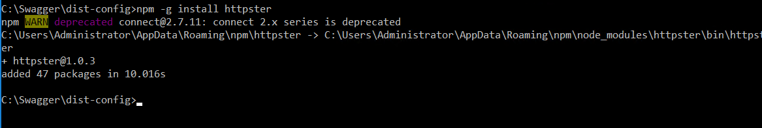

## Run httpster

Run local http server and setup dist folder as startup folder.

**httpster -d dist**

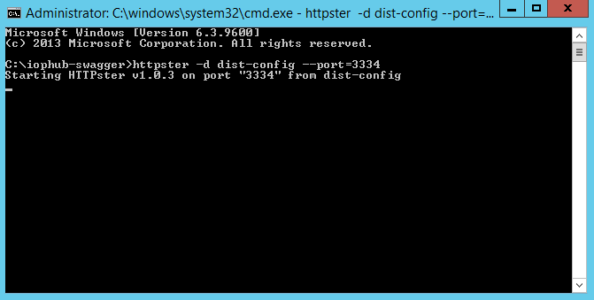

Start **IOpHub App Server** web service

Open you web browser and type:

[**http://localhost:3333/**](http://localhost:3333/)

If everything is running correctly you should see the next image on your local machine.

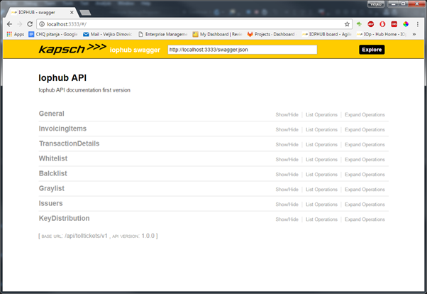

Your swagger is now up and running.

# Where is the source code?

The location of the source code is

* general application: <http://swagger.io>
* IOP-Hub-adaption: in Git in iophub\Sources\iophub-swagger

Code Block 1 Files in swagger directory

|  |
| --- |
| |-- .dockerignore |-- .gitattributes |-- .gitignore |-- .jshintignore |-- .jshintrc |-- .npmignore |-- .travis.yml |-- CONTRIBUTING.md |-- Dockerfile |-- ISSUE_TEMPLATE.md |-- LICENSE |-- README.md |-- bower.json |-- composer.json |-- directory.txt |-- dist | |-- css | | |-- print.css | | |-- reset.css | | |-- screen.css | | |-- style.css | | `-- typography.css | |-- fonts | | |-- DroidSans-Bold.ttf | | `-- DroidSans.ttf | |-- images | | |-- collapse.gif | | |-- expand.gif | | |-- explorer_icons.png | | |-- favicon-16x16.png | | |-- favicon-32x32.png | | |-- favicon.ico | | |-- logo_small.png | | |-- pet_store_api.png | | |-- throbber.gif | | `-- wordnik_api.png | |-- index.html | |-- lang | | |-- ca.js | | |-- el.js | | |-- en.js | | |-- es.js | | |-- fr.js | | |-- geo.js | | |-- it.js | | |-- ja.js | | |-- ko-kr.js | | |-- pl.js | | |-- pt.js | | |-- ru.js | | |-- tr.js | | |-- translator.js | | `-- zh-cn.js | |-- lib | | |-- backbone-min.js | | |-- es5-shim.js | | |-- handlebars-4.0.5.js | | |-- highlight.9.1.0.pack.js | | |-- highlight.9.1.0.pack_extended.js | | |-- jquery-1.8.0.min.js | | |-- jquery.ba-bbq.min.js | | |-- jquery.slideto.min.js | | |-- jquery.wiggle.min.js | | |-- js-yaml.min.js | | |-- jsoneditor.min.js | | |-- lodash.min.js | | |-- marked.js | | |-- object-assign-pollyfill.js | | |-- sanitize-html.min.js | | `-- swagger-oauth.js | |-- o2c.html | |-- swagger-.json | |-- swagger-10.json | |-- swagger-11.json | |-- swagger-12.json | |-- swagger-13.json | |-- swagger-14.json | |-- swagger-15.json | |-- swagger-16.json | |-- swagger-17.json | |-- swagger-18.json | |-- swagger-19.json | |-- swagger-2.json | |-- swagger-3.json | |-- swagger-4.json | |-- swagger-5.json | |-- swagger-6.json | |-- swagger-7.json | |-- swagger-8..json | |-- swagger-9.json | |-- swagger-ui.js | |-- swagger-ui.min.js | `-- swagger.json |-- gulpfile.js |-- index.js |-- karma.conf.js |-- lang | |-- ca.js | |-- el.js | |-- en.js | |-- es.js | |-- fr.js | |-- geo.js | |-- it.js | |-- ja.js | |-- ko-kr.js | |-- pl.js | |-- pt.js | |-- ru.js | |-- tr.js | |-- translator.js | `-- zh-cn.js |-- lib | |-- backbone-min.js | |-- handlebars-4.0.5.js | |-- highlight.9.1.0.pack.js | |-- highlight.9.1.0.pack_extended.js | |-- jquery-1.8.0.min.js | |-- jquery.ba-bbq.min.js | |-- jquery.slideto.min.js | |-- jquery.wiggle.min.js | |-- js-yaml.min.js | |-- jsoneditor.min.js | |-- lodash.min.js | |-- marked.js | |-- object-assign-pollyfill.js | |-- sanitize-html.min.js | `-- swagger-oauth.js |-- nginx.conf |-- package.json |-- src | `-- main | |-- html | | |-- css | | | |-- print.css | | | |-- reset.css | | | |-- screen.css | | | |-- style.css | | | `-- typography.css | | |-- fonts | | | |-- DroidSans-Bold.ttf | | | `-- DroidSans.ttf | | |-- images | | | |-- collapse.gif | | | |-- expand.gif | | | |-- explorer_icons.png | | | |-- favicon-16x16.png | | | |-- favicon-32x32.png | | | |-- favicon.ico | | | |-- logo_small.png | | | |-- pet_store_api.png | | | |-- throbber.gif | | | `-- wordnik_api.png | | |-- index.html | | |-- o2c.html | | `-- swagger.json | |-- iophub.json | |-- javascript | | |-- SwaggerUi.js | | |-- doc.js | | |-- helpers | | | `-- handlebars.js | | |-- utils | | | `-- utils.js | | `-- view | | |-- ApiKeyAuthModel.js | | |-- ApiKeyAuthView.js | | |-- AuthButtonView.js | | |-- AuthView.js | | |-- AuthsCollection.js | | |-- AuthsCollectionView.js | | |-- BasicAuthModel.js | | |-- BasicAuthView.js | | |-- ContentTypeView.js | | |-- HeaderView.js | | |-- MainView.js | | |-- Oauth2Model.js | | |-- Oauth2View.js | | |-- OperationView.js | | |-- ParameterContentTypeView.js | | |-- ParameterView.js | | |-- PopupView.js | | |-- ResourceView.js | | |-- ResponseContentTypeView.js | | |-- SignatureView.js | | |-- StatusCodeView.js | | `-- partials | | `-- signature.js | |-- less | | |-- auth.less | | |-- highlight_default.less | | |-- print.less | | |-- reset.less | | |-- screen.less | | |-- specs.less | | `-- style.less | `-- template | |-- apikey_auth.handlebars | |-- auth_button.handlebars | |-- auth_button_operation.handlebars | |-- auth_view.handlebars | |-- basic_auth.handlebars | |-- content_type.handlebars | |-- main.handlebars | |-- oauth2.handlebars | |-- operation.handlebars | |-- param.handlebars | |-- param_list.handlebars | |-- param_readonly.handlebars | |-- param_readonly_required.handlebars | |-- param_required.handlebars | |-- parameter_content_type.handlebars | |-- popup.handlebars | |-- resource.handlebars | |-- response_content_type.handlebars | |-- signature.handlebars | |-- status_code.handlebars | `-- templates.js |-- sw `-- test  |-- .jshintrc  |-- e2e  | |-- driver.js  | |-- helpers.js  | |-- servers.js  | |-- v1.js  | `-- v2  | `-- petstore.js  |-- mocha.opts  |-- specs  | |-- v1.2  | | `-- petstore  | | |-- api-docs.json  | | |-- pet.json  | | |-- store.json  | | `-- user.json  | `-- v2  | |-- formats.yaml  | `-- petstore.json  `-- unit  |-- mock.js  `-- view  `-- partials  `-- signatureSpec.js |

# How to install

There are couple of pre-requirements for running our version of swagger-UI locally: GIT and node.js need to be installed on local environment. If node.js is not installed please use next URL for download.

<https://nodejs.org/en/>

Next is step is to install gulp globally. Open **Command prompt** and type next command:

**npm install -g gulp**

All future commands in this document are meant for command prompt.

If everything is installed correctly run **-v** or **--version** commands to display active software versions on your system.

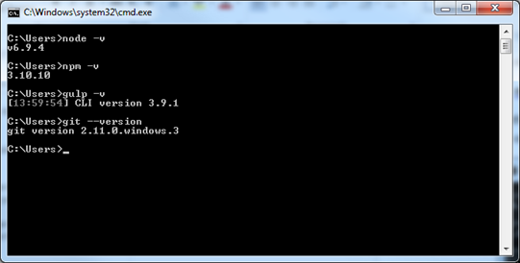

Next step is to clone GIT repository with custom made Swagger-UI and configuration.

**Swagger UI is located on the iop-hub repository under iophub-swagger folder**

[**https://pve2.merann.ru/ktc/iophub/tree/develop/Sources/iophub-swagger**](https://ctogitlab.merann.ru/ktc/iophub/tree/develop/Sources/iophub-swagger)

This repo. is maintained by IOPHUB team and will have the latest updates of API documentation.

Navigate to repo. folder

**cd iophub-swagger**

Install node.js dependencies.

**npm install**

Install httpster – (httpster is node.js package that beehive as http server)

**npm install -g httpster**

# Troubleshooting

Swagger is running but returns no data.

You did start it with **httpster -d dist** and all IOP-services are running.

The problem is that maybe **node.js** process was started and listening 3333 port, so kill node.js process and start swagger again.

Use **netstat -a -b** command to see all active ports.

# How to adapt Swagger?

See ./Swagger/dist/swagger.json

|  |
| --- |
| {  "swagger": "2.0",  "info": {  "title": "IOpHub API",  "description": "IOpHub API documentation",  "version": "1.0.0"  },  "host": "localhost:8765", //call this url, if this is not running, swagger cannot get/post anything  "schemes": [  "http"  ],  "basePath": "/api/tolltickets/v1", //call tollticket apo  "produces": [  "application/json"  ],  "securityDefinitions": {  "Bearer": {  "type": "apiKey",  "name": "Authorization",  "in": "header"  }  },  "paths": {  "/blacklist": { //here is what is called in the URI  "get": {  "security": [  {  "Bearer": []  }  ],  "summary": "Get black list",  "description": "Returns all black list items",  "tags": [  "Blacklist"  ],  "responses": {  "200": {  "description": "An array of black list items",  "schema": {  "type": "array",  "items": {  "$ref": "#/definitions/ExceptionData"  }  }  }  }  },  "delete": {  "security": [  {  "Bearer": []  }  ],  "tags": [  "Blacklist"  ],  "summary": "Delete entire black list",  "responses": {  "200": {  "description": "OK"  },  "404": {  "description": "Not found"  },  "500": {  "description": "Internal Server Error"  }  }  }, |

