Swagger: How to generate pdf and html documentation

IOp - Hub

Exported on May 30, 2018

How to install:

1. Download swagger2markup-cli-master from the following link: <https://github.com/Swagger2Markup/swagger2markup-cli/archive/master.zip>
2. Unpack
3. Run the following command in console to generate jar file: **gradlew assemble**

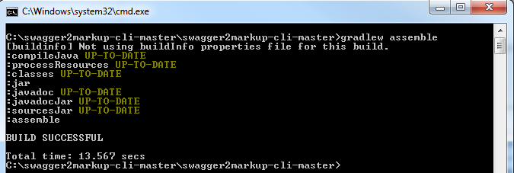

1. Create swagger folder in swagger2markup-cli folder.

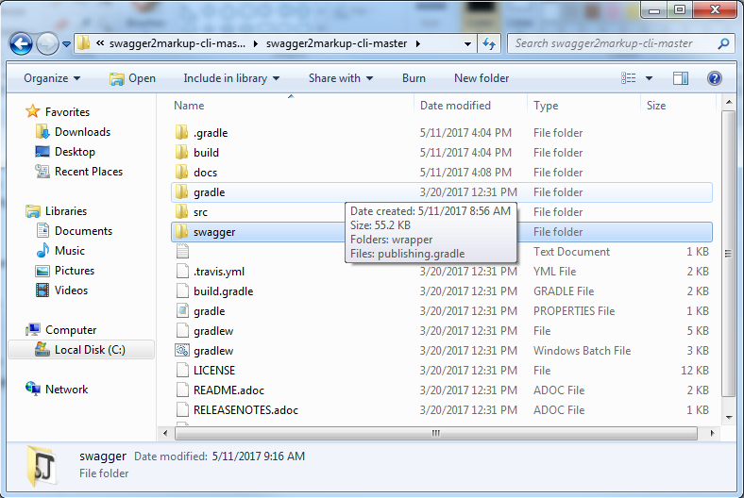

1. Download <https://github.com/Swagger2Markup/spring-swagger2markup-demo/archive/master.zip>
2. Unpack

How to run:

1. **Copy your swagger.json file into \swagger2markup-cli-master\swagger**.
2. Run the following command in console: java -jar "C:\swagger2markup-cli-master\swagger2markup-cli-master\build\libs\swagger2markup-cli-1.3.2.jar" convert -i C:\swagger2markup-cli-master\swagger2markup-cli-master\swagger\swagger.json -f docs/swagger

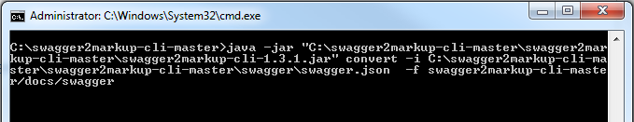

1. Go to docs/swagger folder and there should be swagger.adoc file.
2. Copy your swagger.adoc file to spring-swagger2markup-demo-master\src\docs\asciidoc
3. Replace index.adoc with swagger.adoc in build.gradle file.

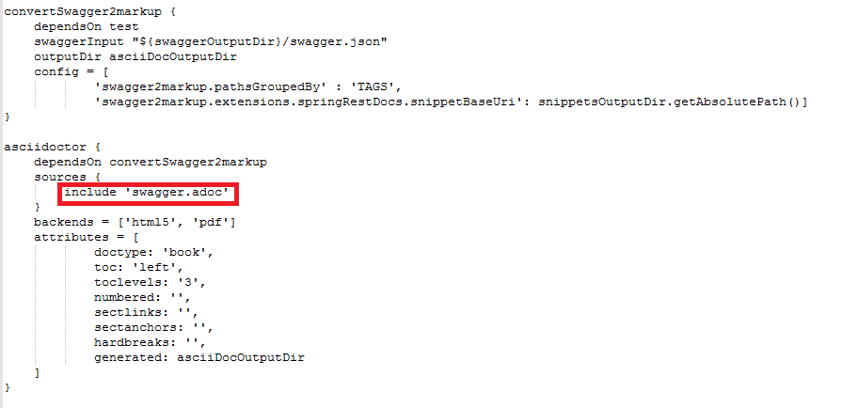

1. Run the following command in console: **gradlew asciidoctor**

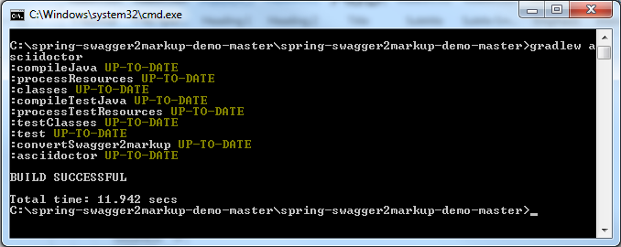

1. See \build\asciidoc\html5 or \build\asciidoc\pdf there should be generated file for your swagger.