
Lab 03_Report
OOP

October 30, 2026
name: Siem khattyavatey
Student ID: p20250056

Practice 1: Library Management
Problem: Design a program to manage a book in a library
- Flowchart

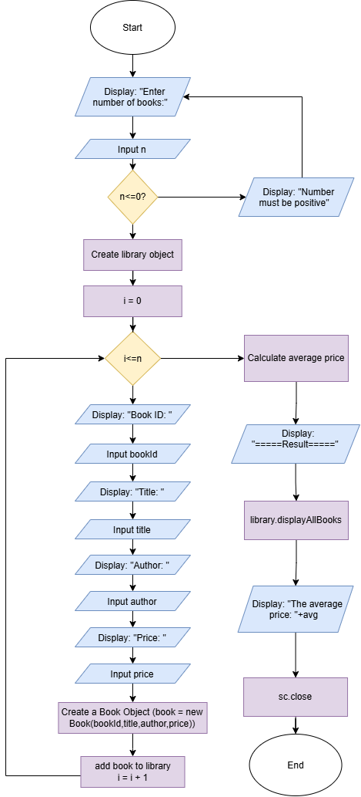

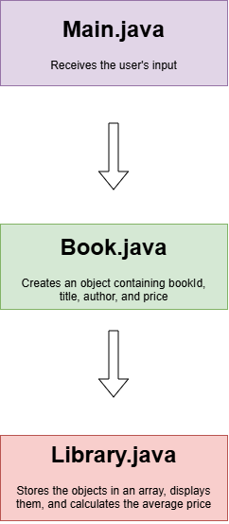

Figure 1: Flowchart Figure 2: Structure of
how classes work together
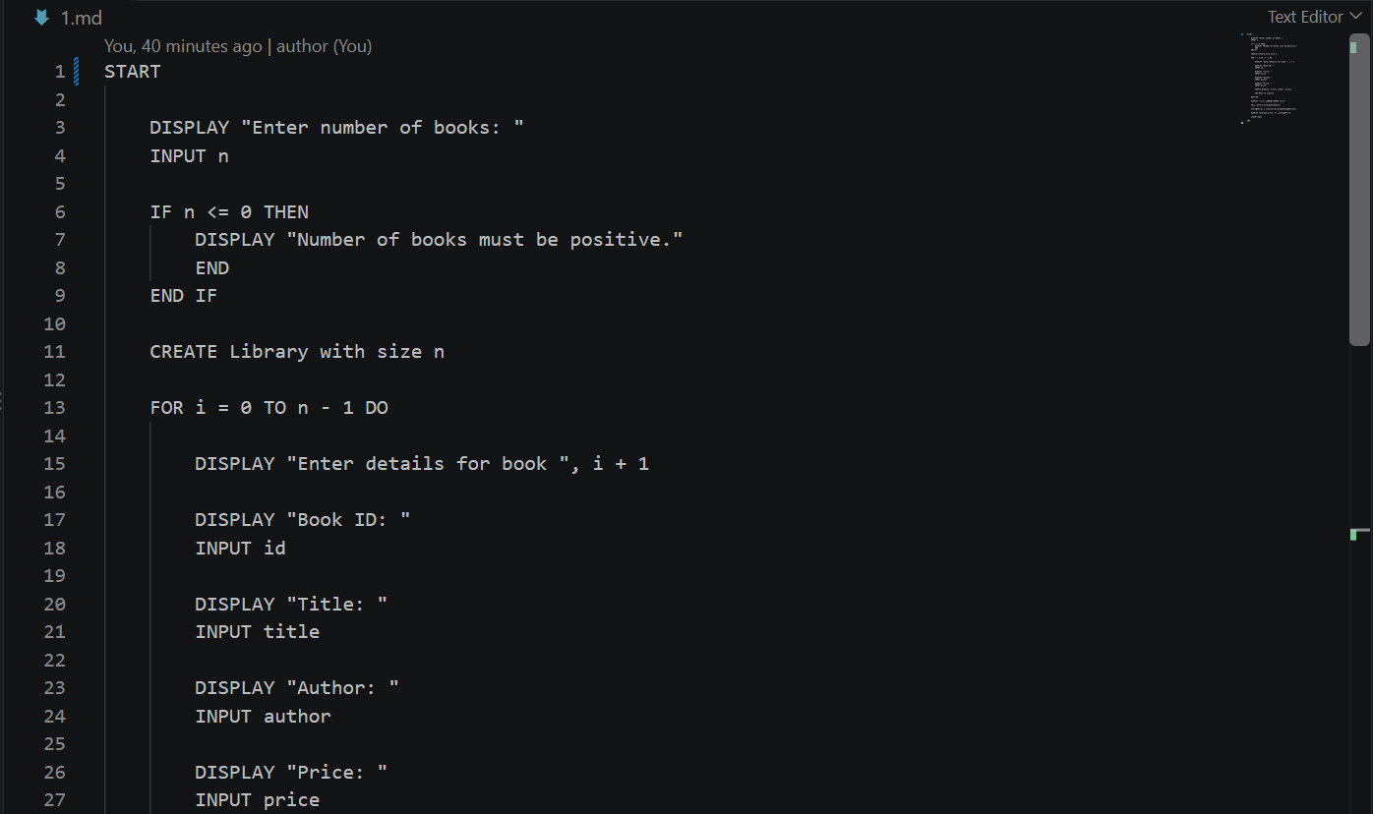
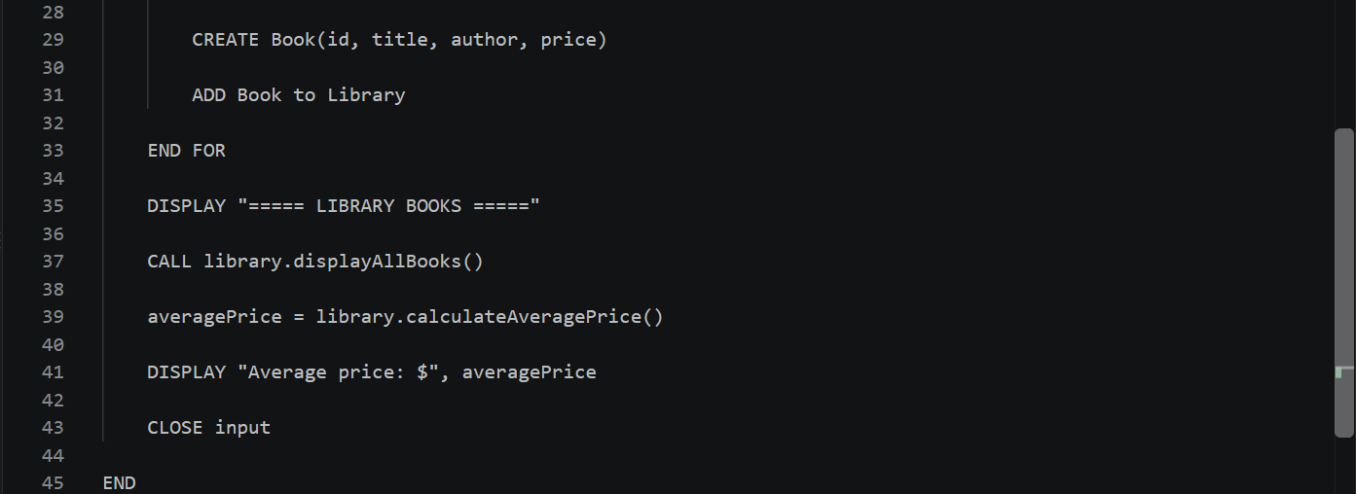
- Pseudocode: Library Management System

- Sample solution:
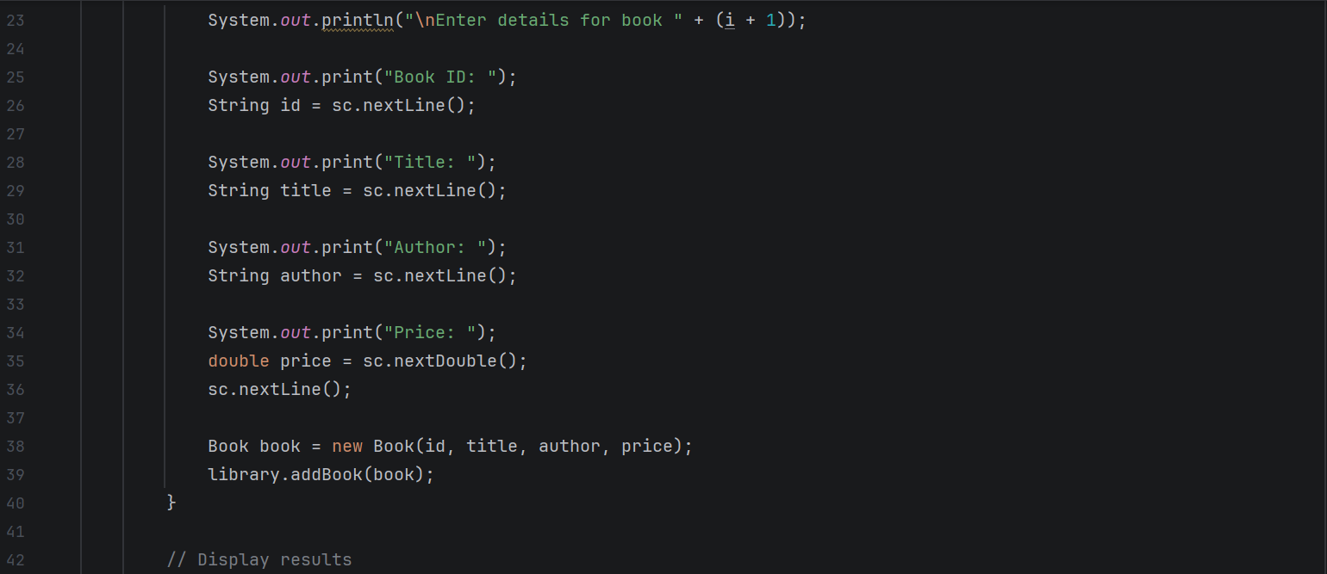
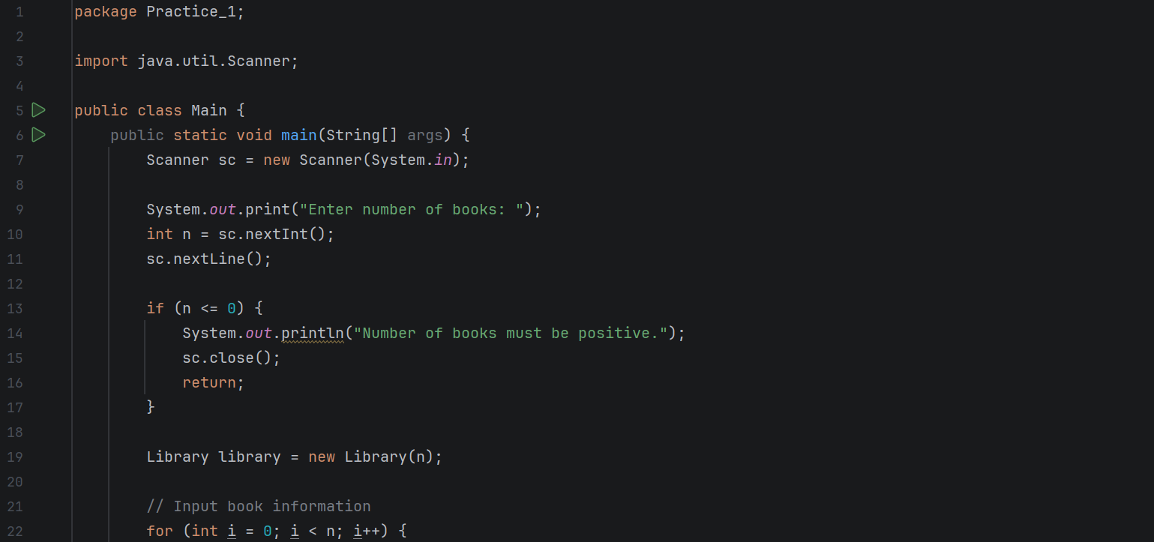
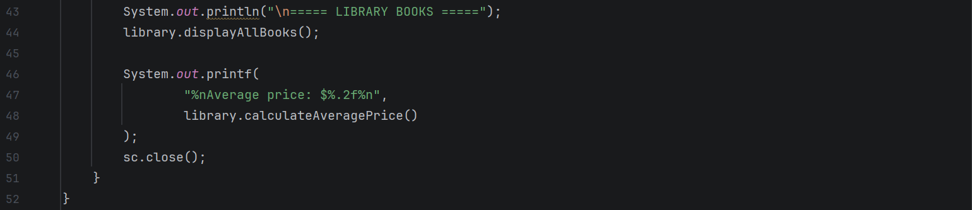
Main.java: Used to receive input from the user

  - Library library = new Library(n): creates a Library object with a capacity to store the specified number of books.
  - Book book = new Book(id, title, author, price): creates a Book object containing the book's ID, title, author, and price.
  - library.calculateAveragePrice(): calculates the average price of all books
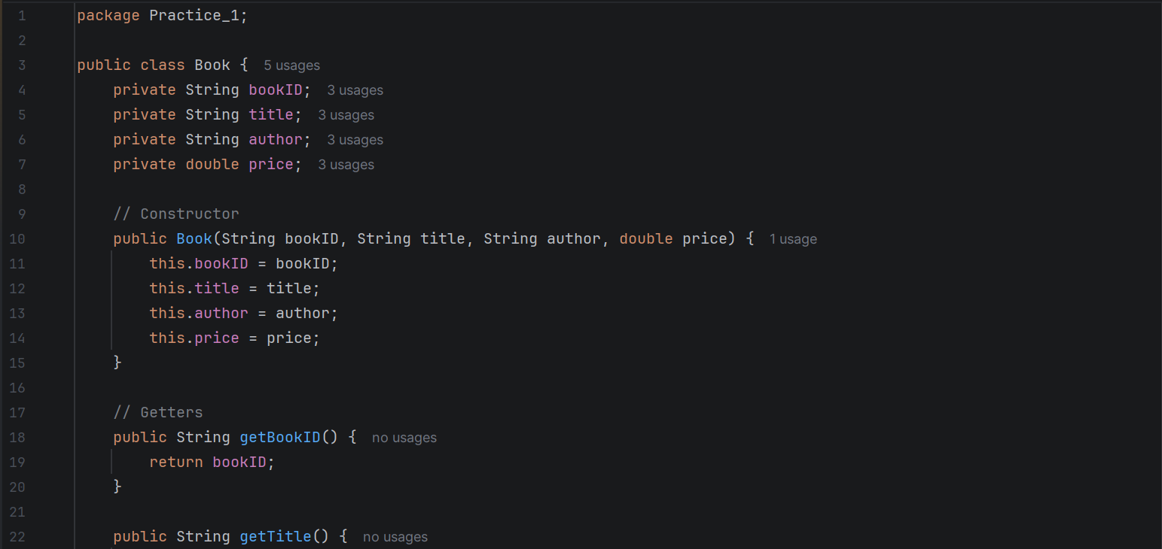
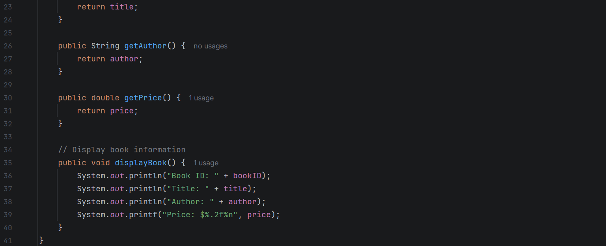
Book.java: Creates objects that contain bookId, title, author, and price

  - public Book(String bookID, String title, String author, double price): initializes a new Book object with the information provided.
  - this: Statements such as this.title = title: assigns the parameter value to the object's
  - displayBook(): displays the book's ID, title, author, and price.
  - The attributes are declared private, so they cannot be accessed directly from outside the Book class.
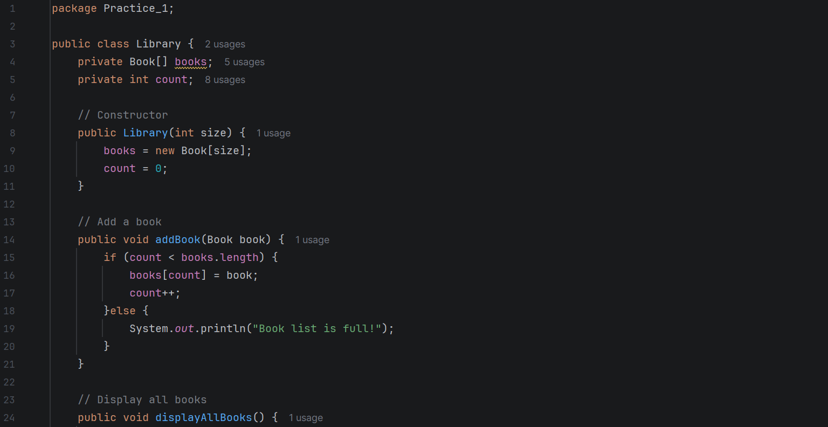
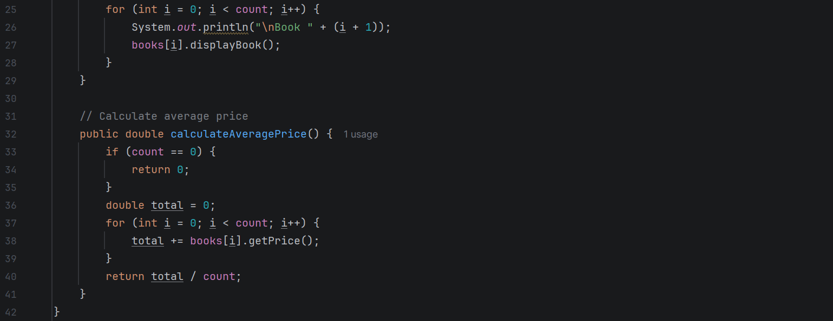
Library.java: Stores the objects in an array and calculates the average price.

- public void displayAllBooks(): uses a for loop to go through the stored books and display each book's information by calling books[i].displayBook().
- total += books[i].getPrice(): retrieves each book's price using getPrice() and adds it to the total.
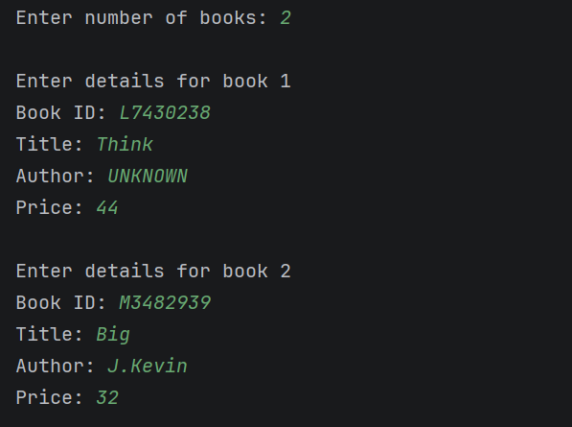
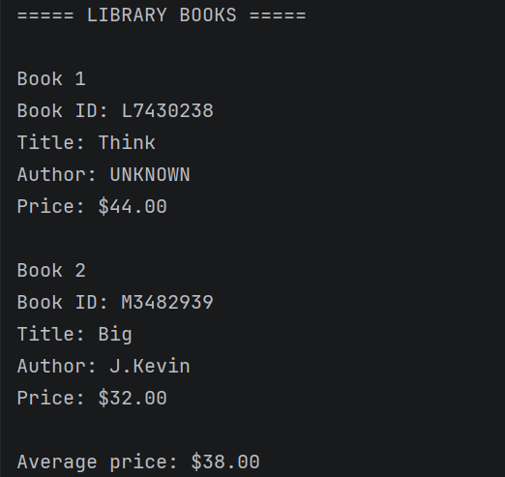
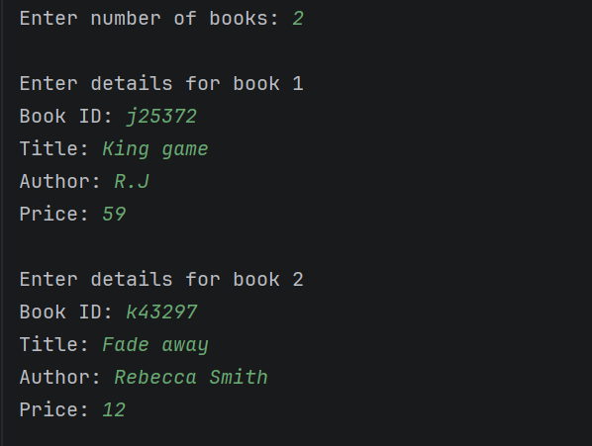
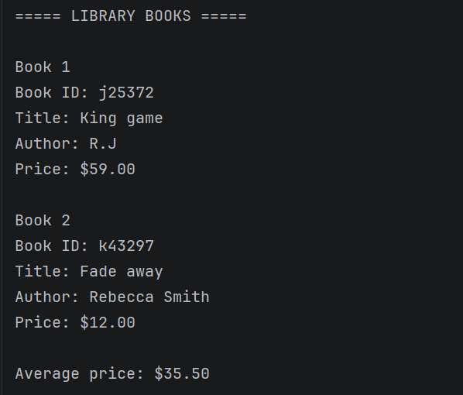
Output:

Practice 2: Temperature Conversion
Problem: Write a program that reads the temperature of N cities in Celsius and converts them to Fahrenheit
- Flowchart

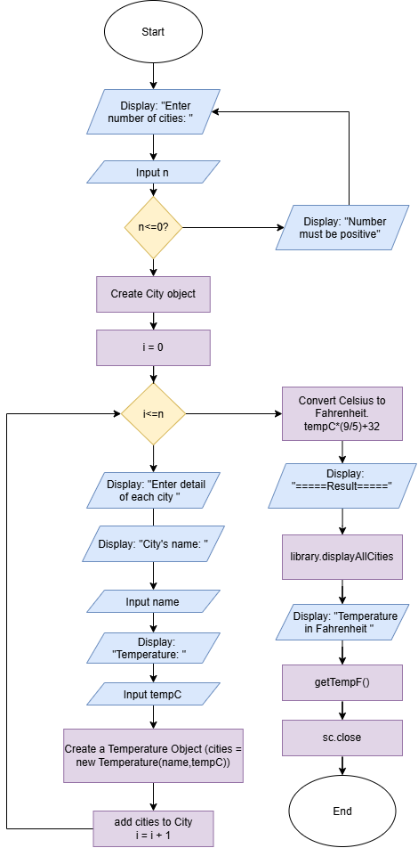
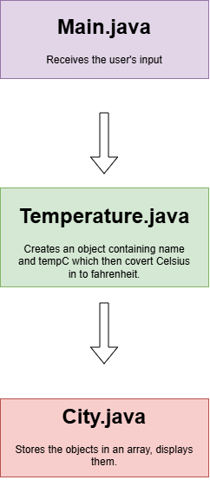

Figure 3: Flowchart Figure 4: Structure of
how classes work together
- Pseudocode:
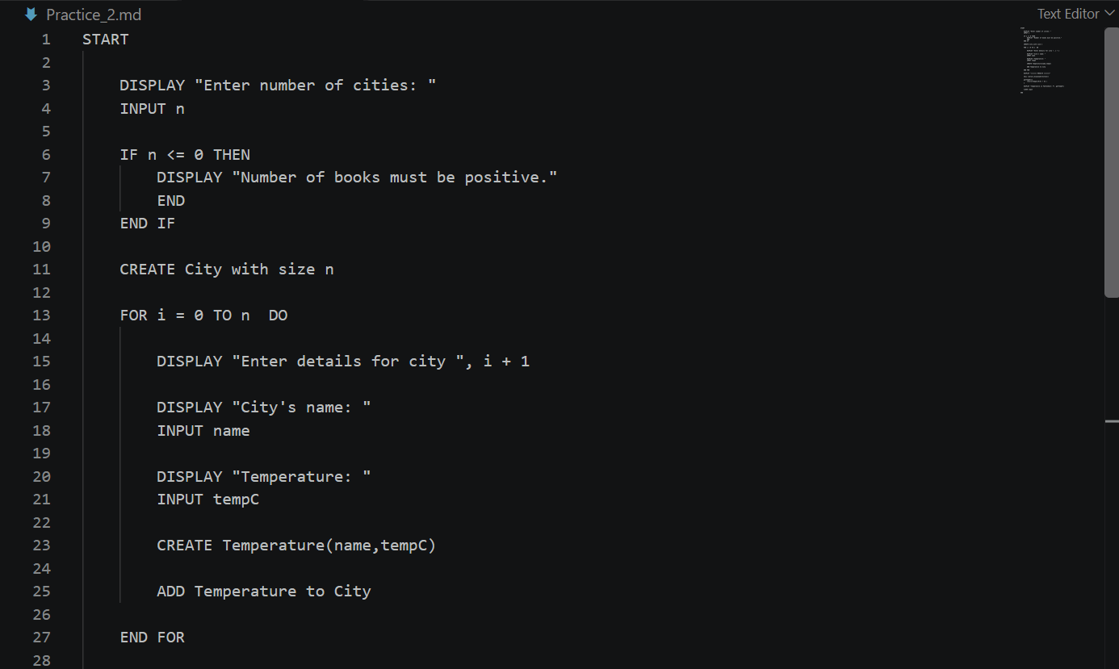
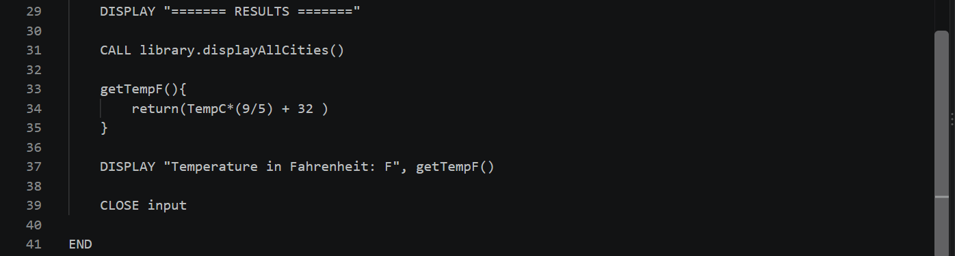

- Sample solution:
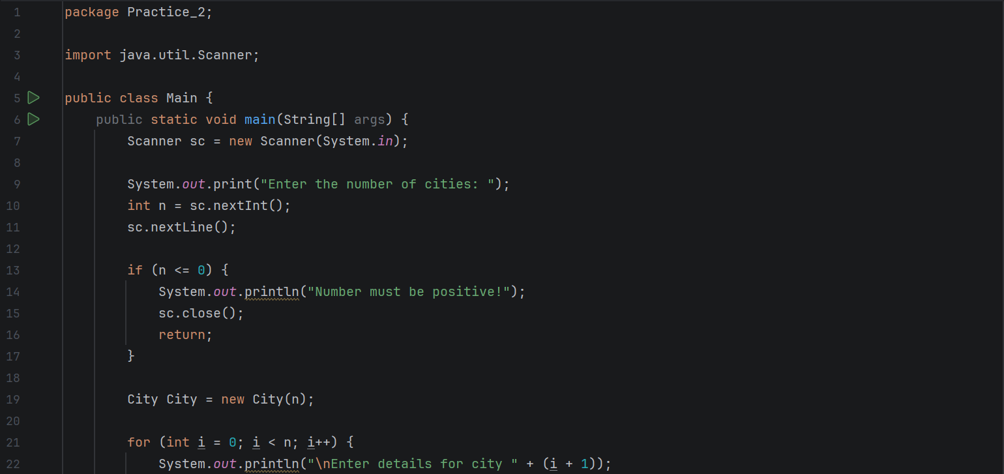
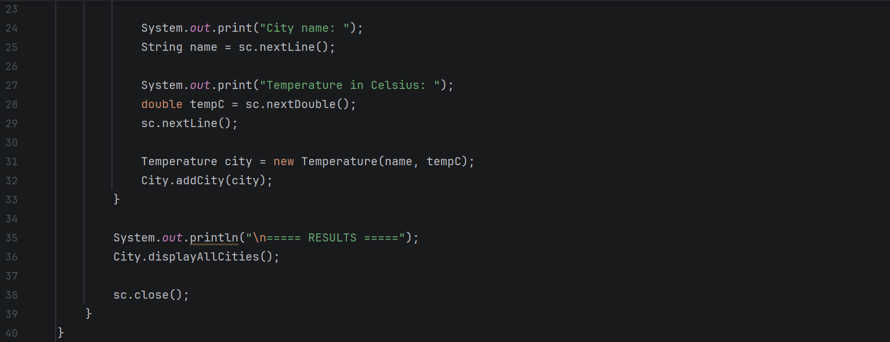
Main.java: Receive input from User
- City City = new City(n): creates a City object with capacity for n cities.
- The for loop repeats the input process for each city, asking for its name and temperature in Celsius.
- Temperature city = new Temperature(name, tempC): creates a Temperature object containing the city name and its Celsius temperature.
- City.addCity(city): adds that object to the City collection.
Temperature.java: Creates objects that contain name and tempC.
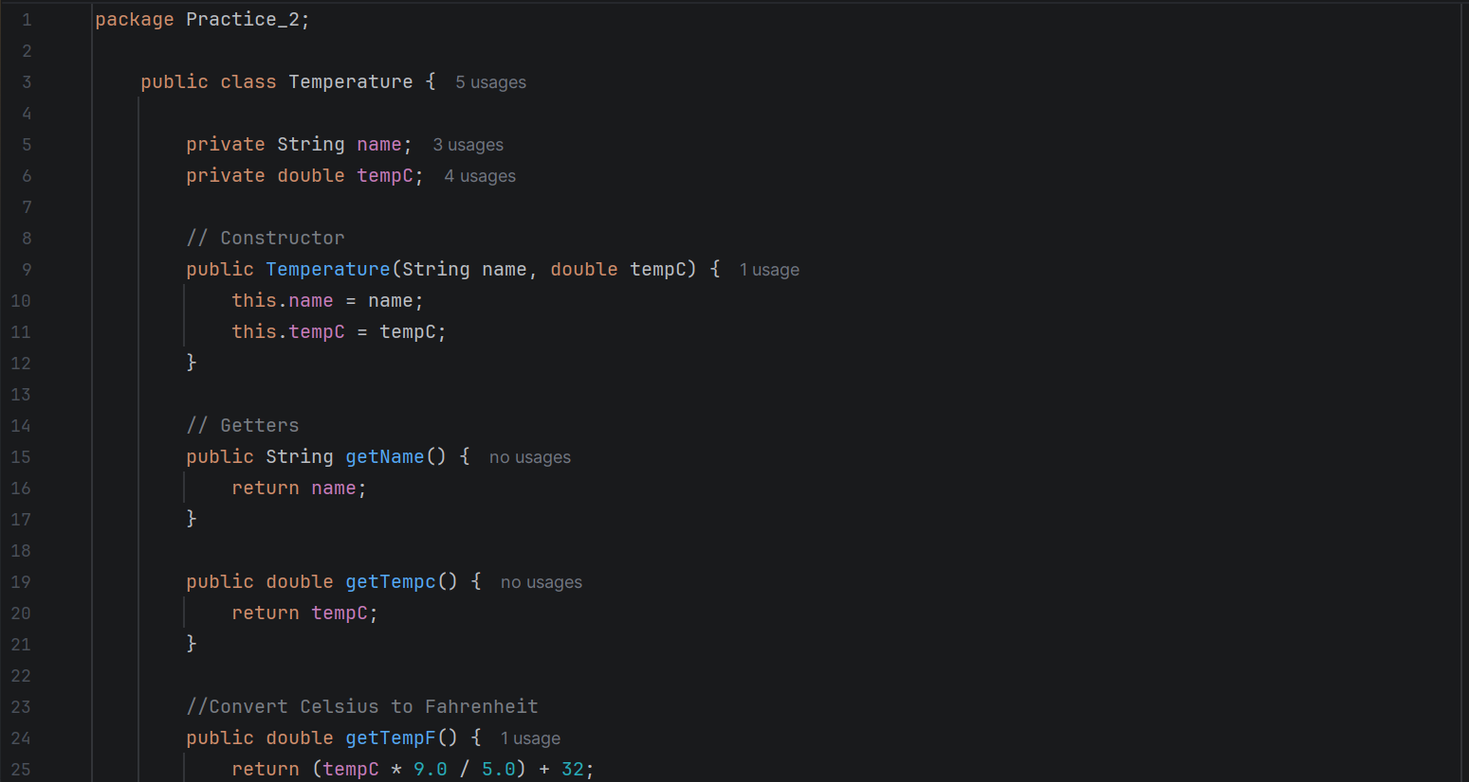
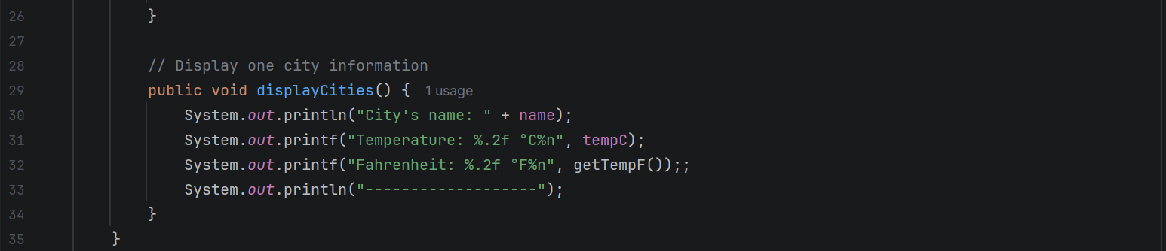
Then convert Celsius to Fahrenheit.

  - Temperature(String name, double tempC): Initializes a new Temperature object.
  - getName() and getTempC (): Allow other classes to retrieve the private variables' values.
  - getTempF(): Converts Celsius into Fahrenheit using the formula:
°F = (°C \times 9/5) + 32
  - displayCities(): Displays the city's name, Celsius temperature, and Fahrenheit temperature.
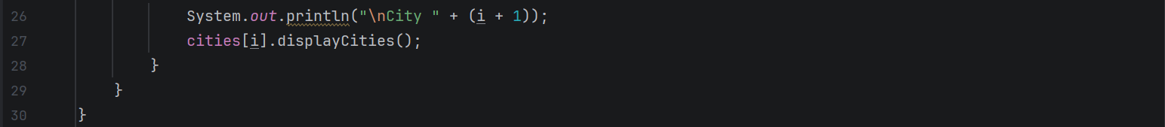
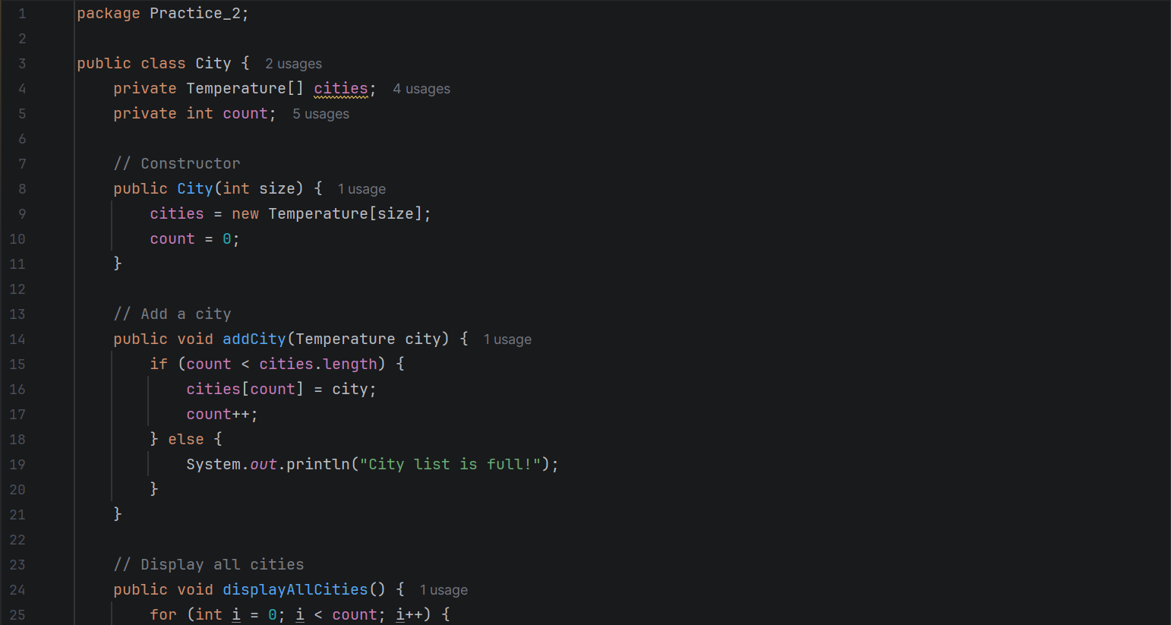
City.java: Store objects in the array and display them.
- City(int size): Initializes a new City object with a specified storage capacity.
- cities = new Temperature[size]: creates an array that can hold the specified number of Temperature objects.
- addCity(Temperature city): Adds a Temperature object to the array.
- cities[i].displayCities(): calls the displayCities() method from the Temperature class to display the city's name and temperatures.
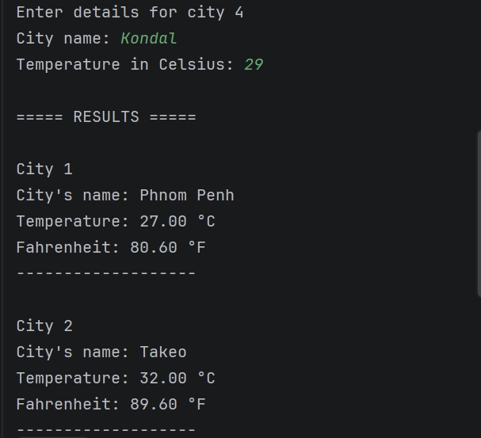
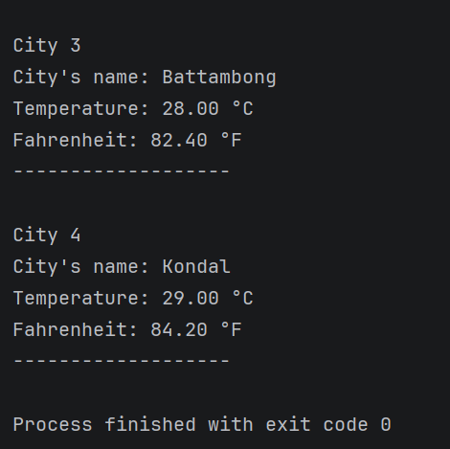
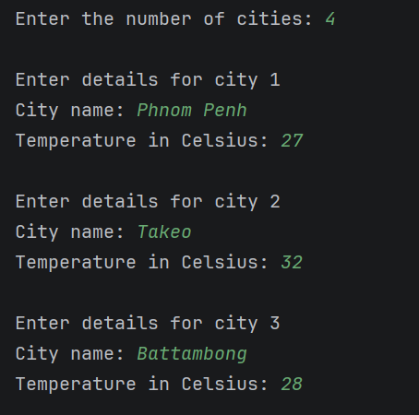
Output:

Practice 3: Employee Salary Management
Problem: Store and display the salaries of N employees
- Flowchart

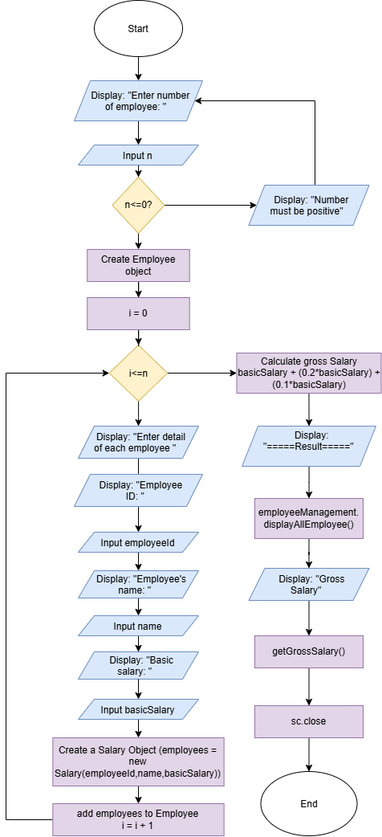

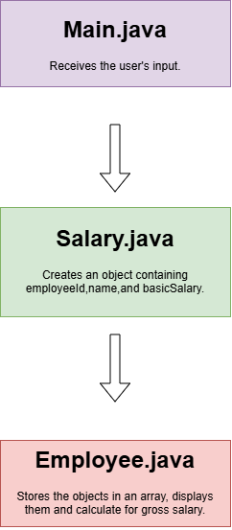

Figure 5: Flowchart Figure 6: Structure of
how classes work together
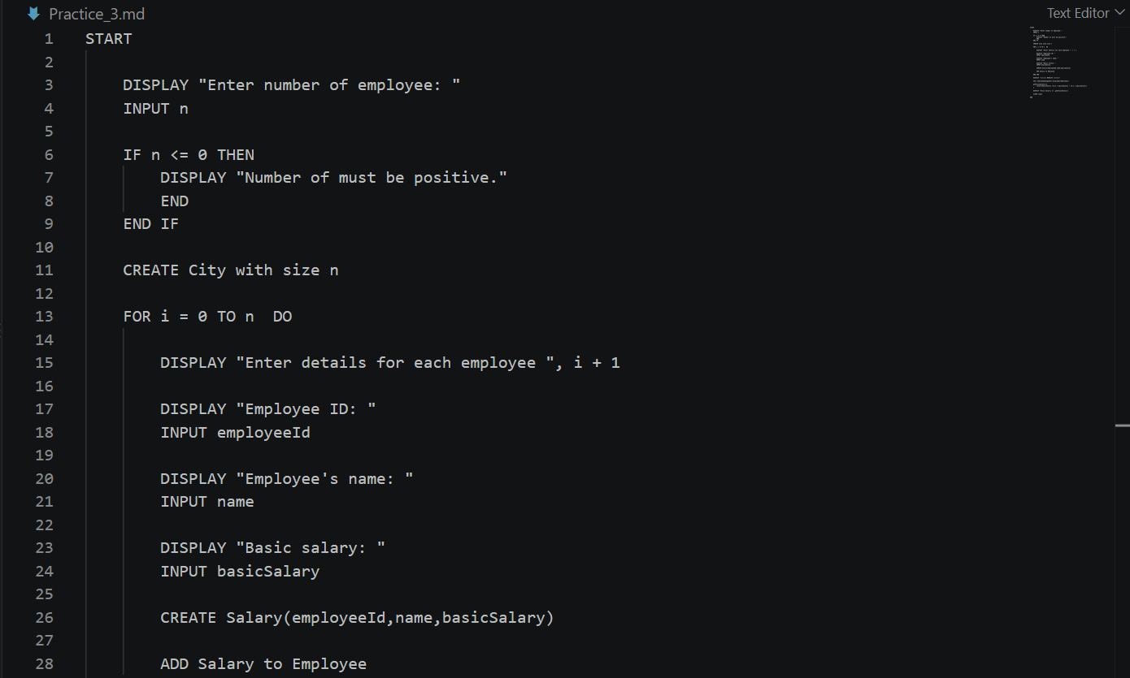
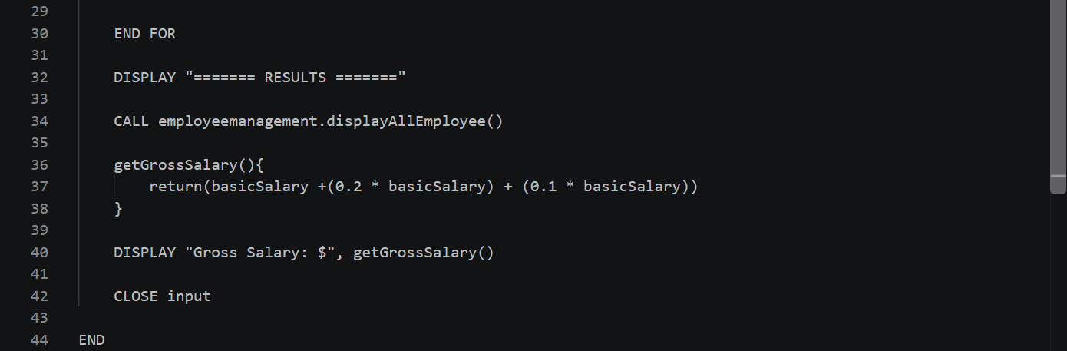
- Pseudocode:

- Sample solution:
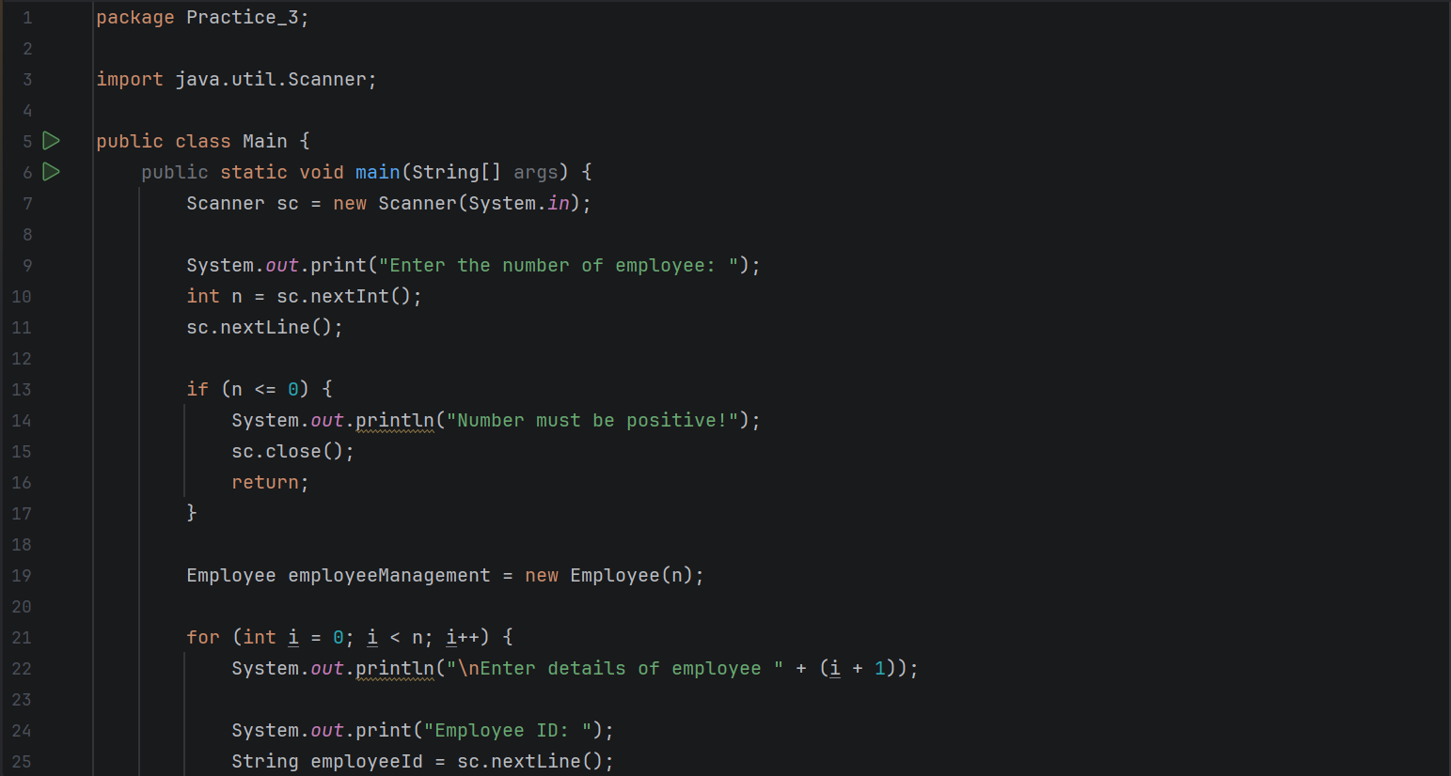
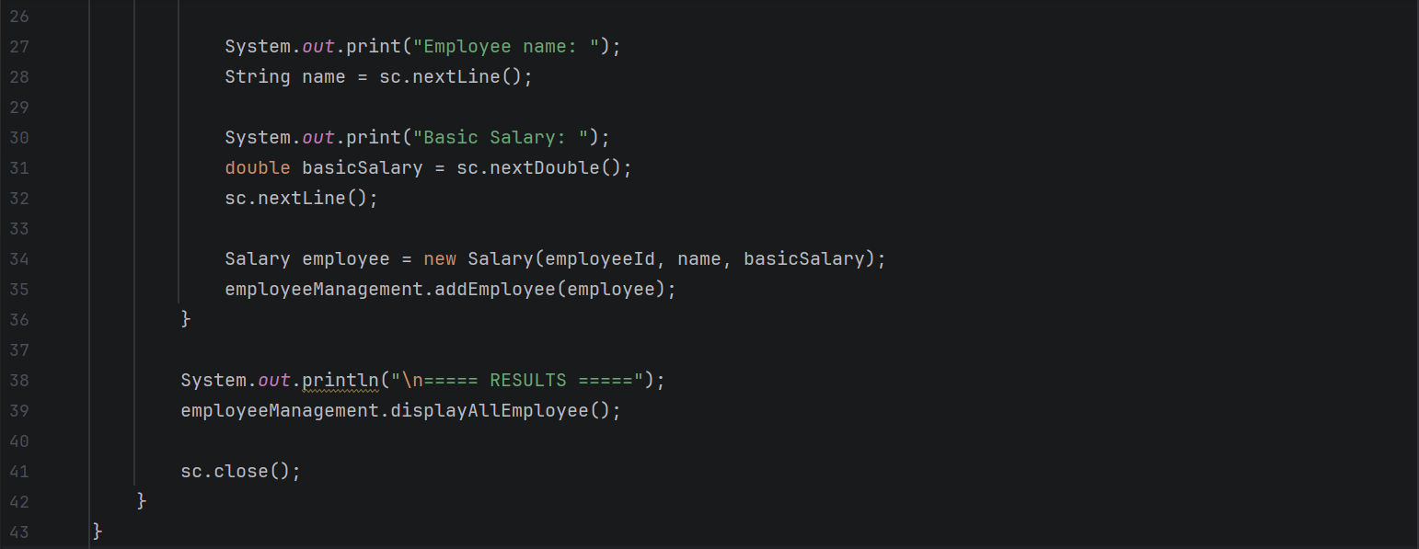
Main.java: The program asks for the number of employees, validates the number, collects each employee's ID, name, and basic salary, stores the records using the Employee class, and displays the results.

- Employee employeeManagement = new Employee(n): creates an Employee object with a capacity of n employees.
- Salary employee = new Salary(employeeId, name, basicSalary): creates a Salary object containing the employee's ID, name, and basic salary.
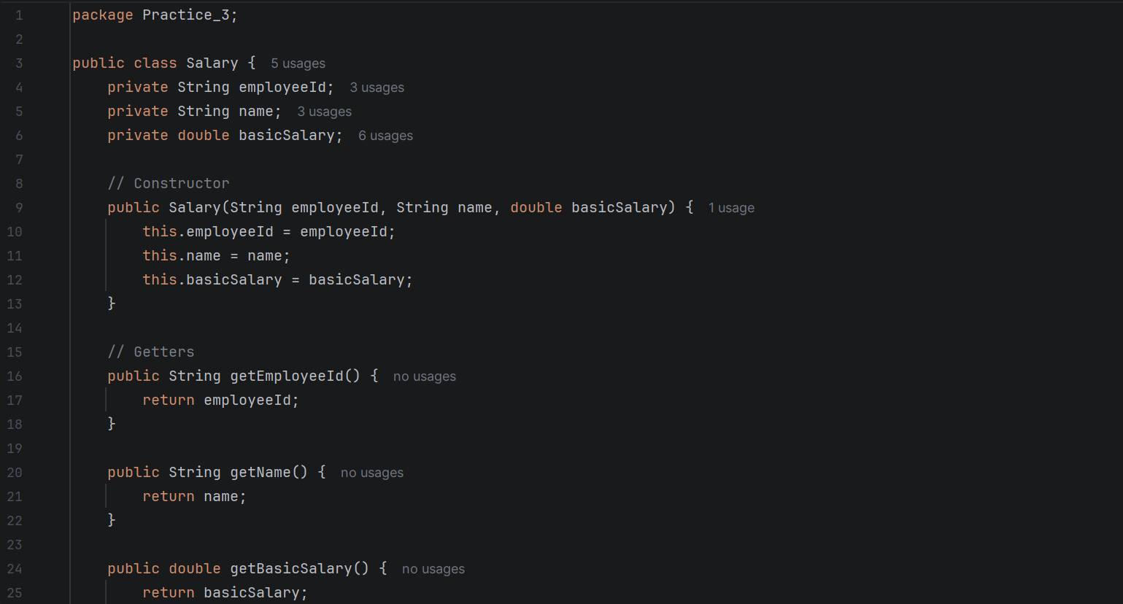
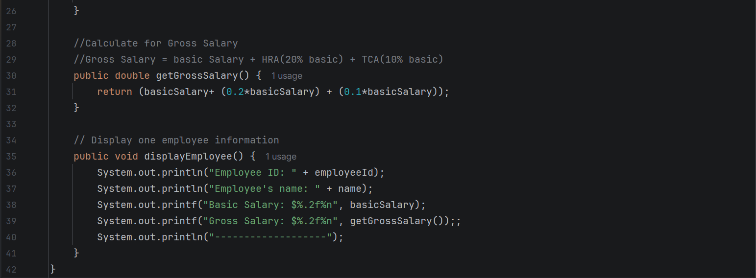
Salary.java: The Salary class stores employee information, provides getter methods to access the data, calculates gross salary by adding the 20% HRA and 10% TCA allowances, and displays the employee's salary details.
- getEmployeeId(), getName(), getBasicSalary(): These methods allow other classes to retrieve the private variables' values.
- getGrossSalary(): Calculates the employee's gross salary by adding the basic salary, Housing Rent Allowance (HRA), and Transport Allowance (TCA).
- displayEmployee(): Displays the employee's ID and name.
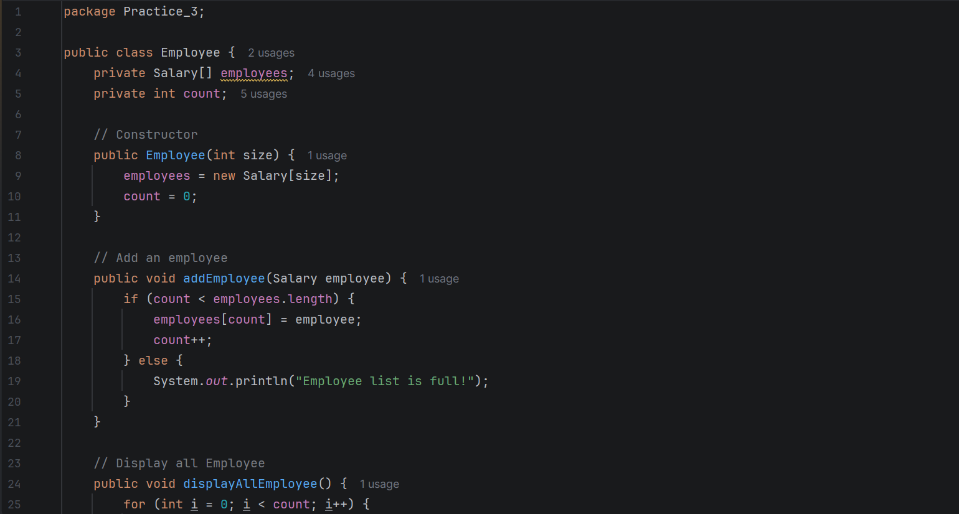
Employee.java: The Employee class stores and manages multiple employee records, checks whether the array has available space, and displays the salary information of every employee stored in the array.

  - Salary[] employees: creates an array to store Salary objects containing employee information.
  - Employee(int size): Initializes an Employee object.
  - employees = new Salary[size]: creates an array that can hold the specified number of employee records
- employees[i].displayEmployee(): calls the displayEmployee() method from the Salary class to display each employee's ID, name, basic salary, and gross salary.
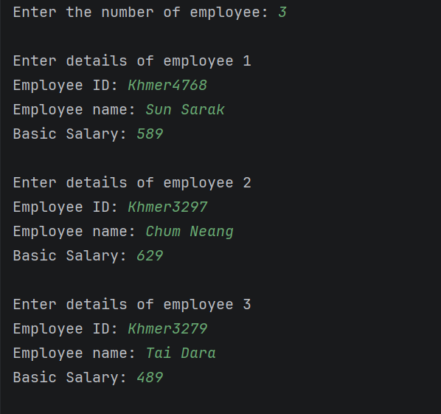
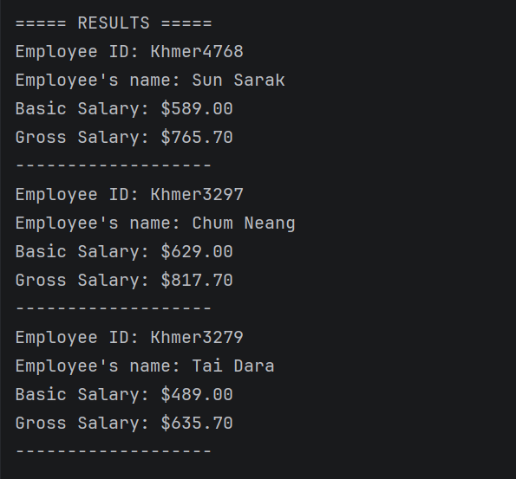
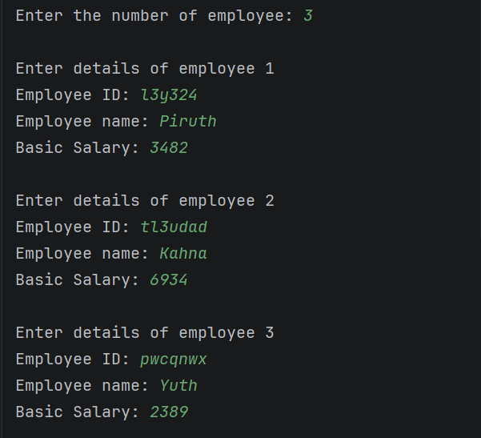
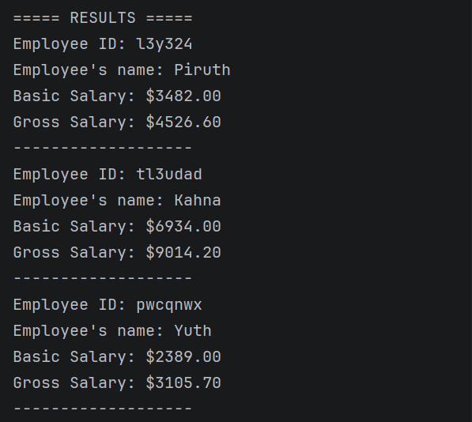
Output:
Example1 Example2

Practice 4: Student Grade Calculation
Problem: Calculate and display students' grades based on marks
- Flowchart

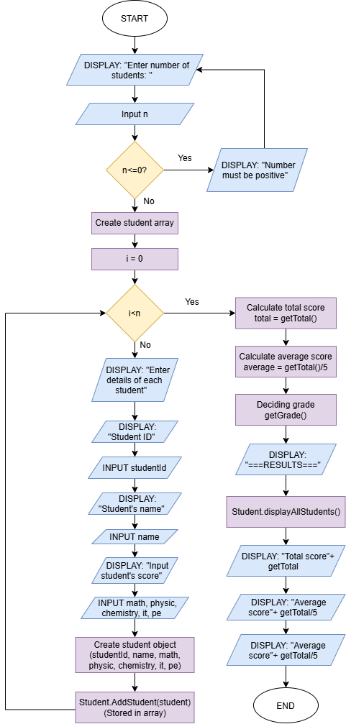

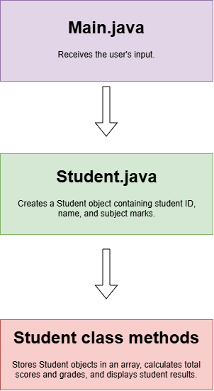

Figure 7: Flowchart Figure 8: Structure of
how classes work together
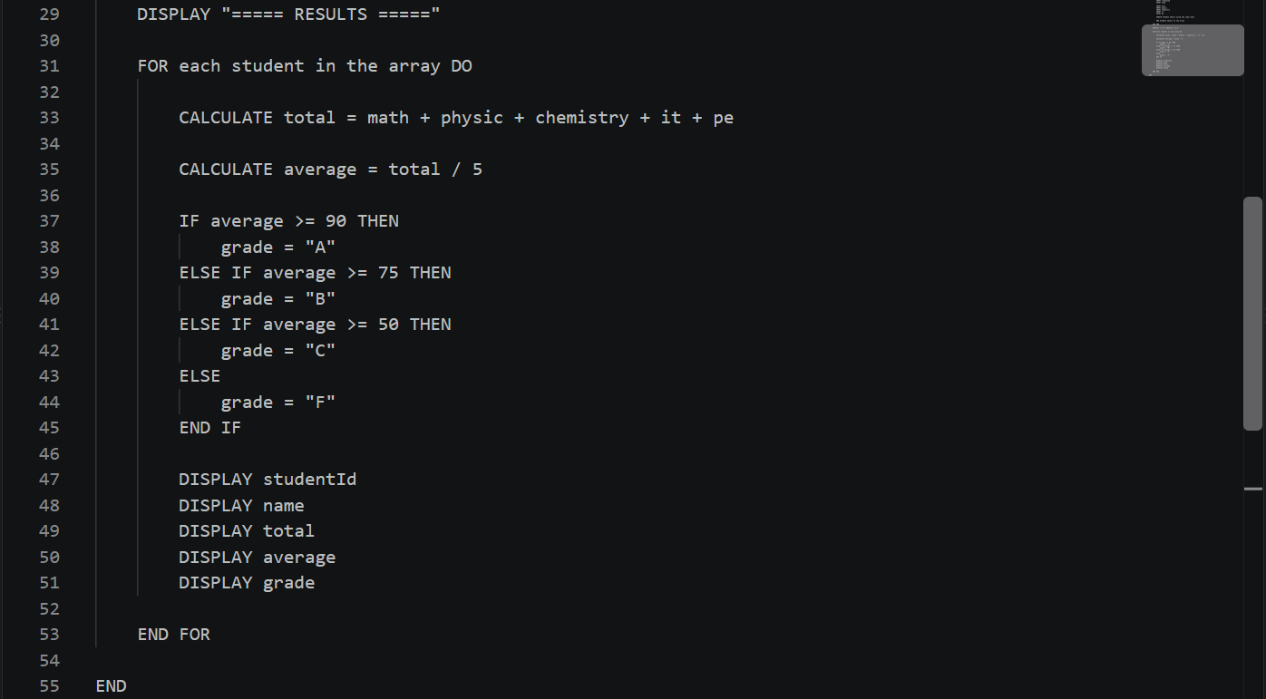
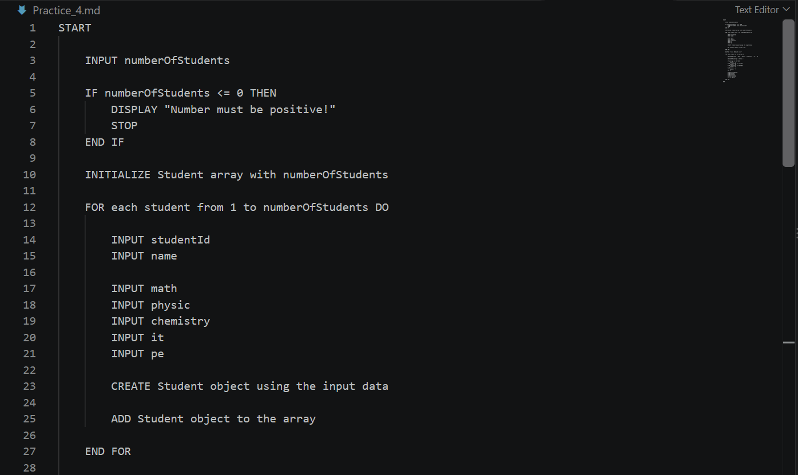
- Pseudocode:

- Sample solution
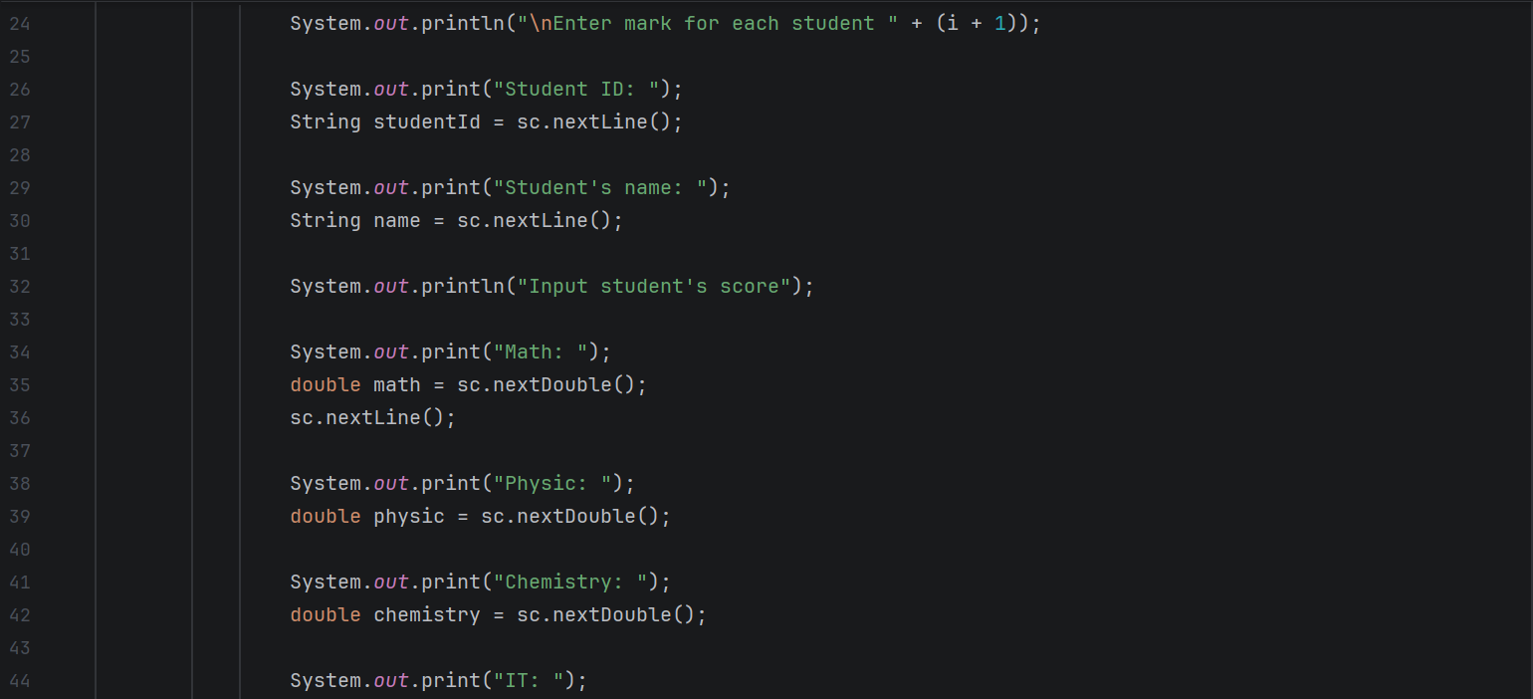
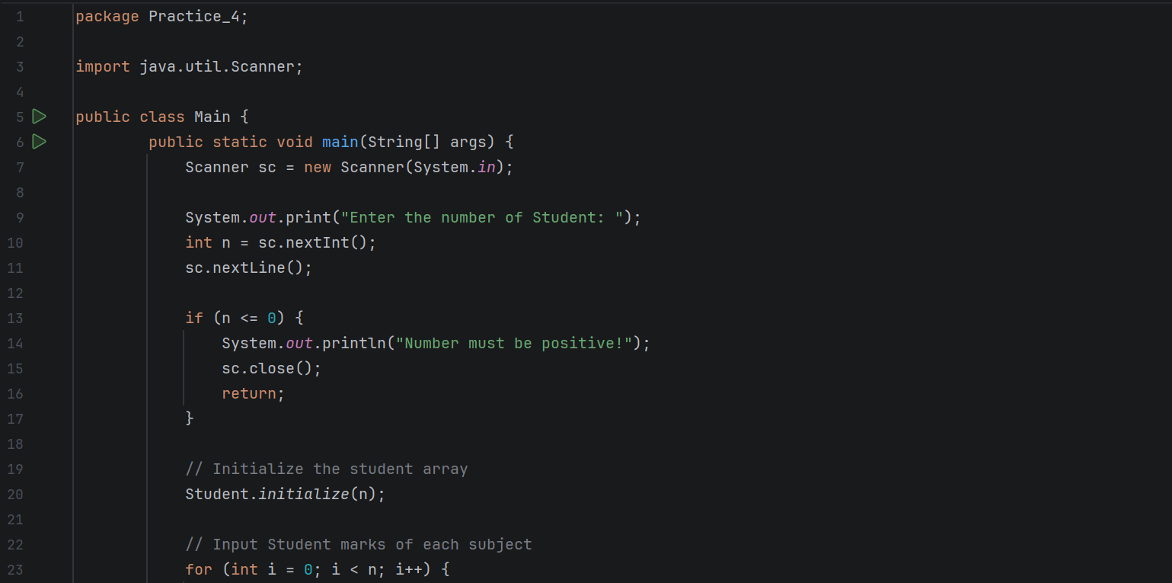
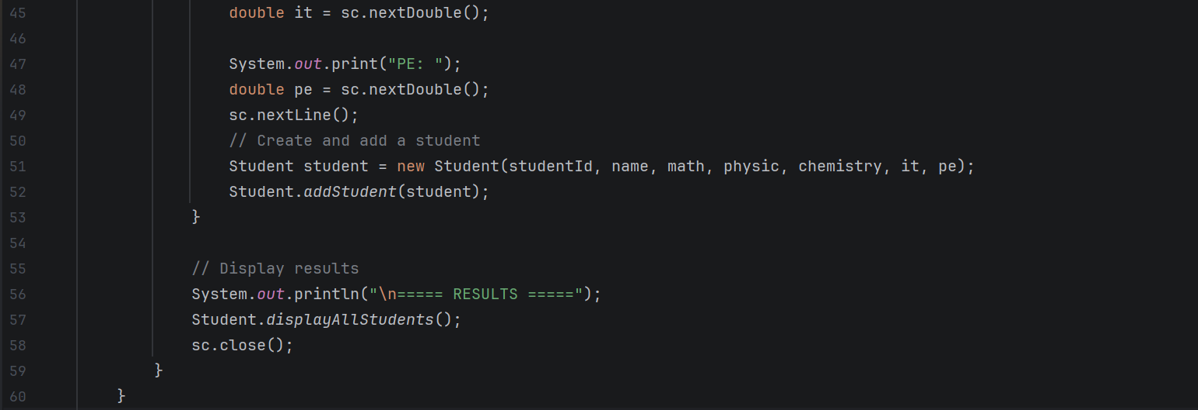
Main.java: Receive input from User
- Scanner sc = new Scanner(System.in): creates a Scanner object to receive input from the keyboard.
- int n = sc.nextInt(): reads and stores the number of students entered by the user.
- for (int i = 0; i < n; i++): repeats the input process for each student until all students have been entered.
- Student student = new Student(studentId, name, math, physic, chemistry, it, pe): creates a student object containing the student's ID, name, and subject marks.
Student.java: Creates a Student object containing student ID, name, and subject marks.
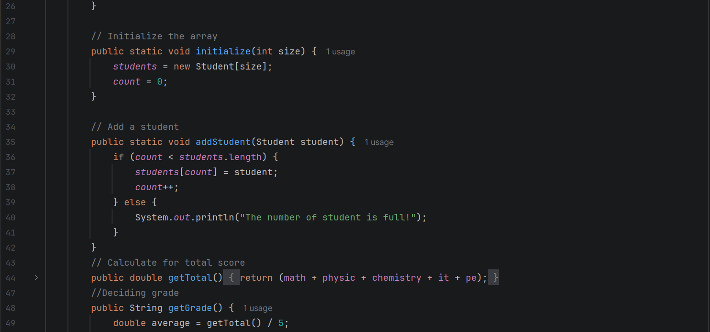
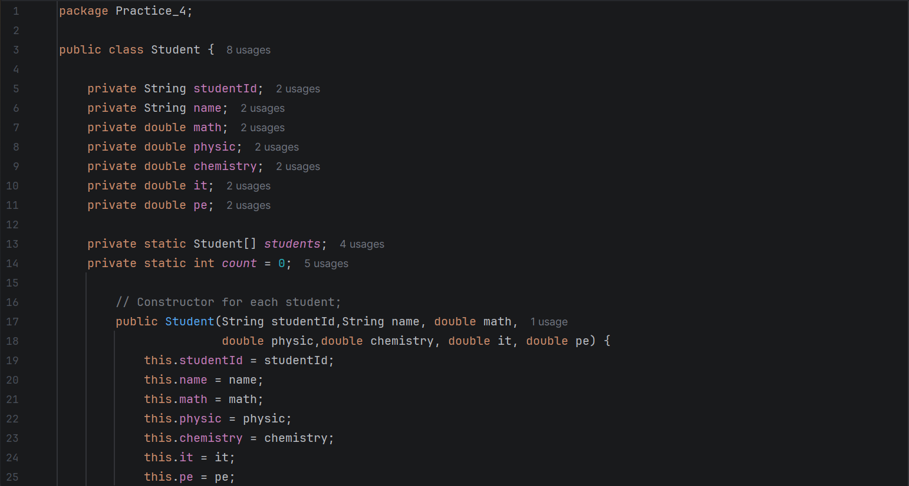
Stores Student objects in an array, calculates total scores and grades, and displays student results

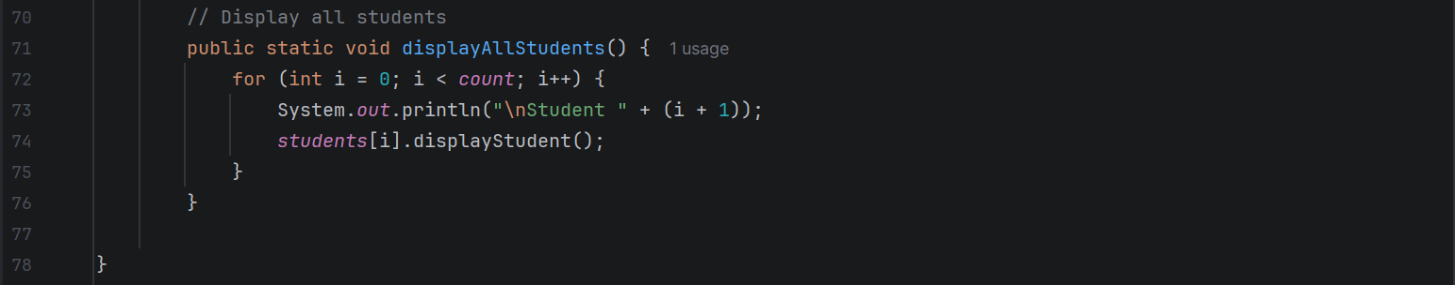
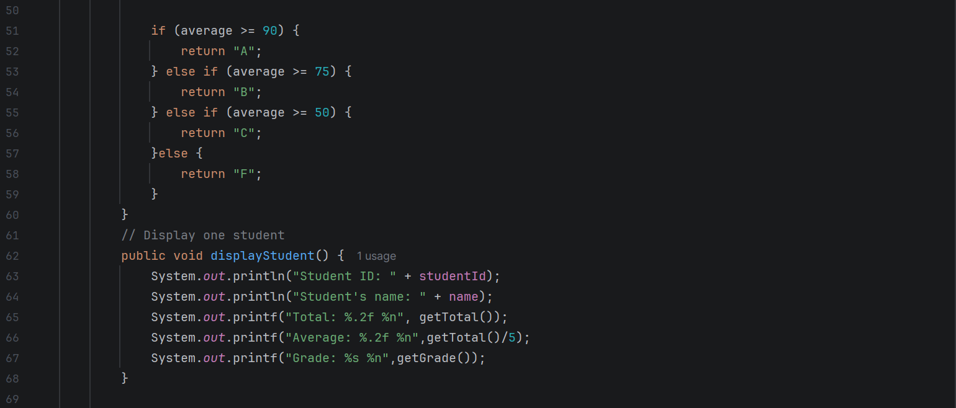
- public void displayStudent(): displays the student's ID, name, total marks, average marks, and grade.
- public static void displayAllStudents(): uses a for loop to display the information of every student stored in the array.
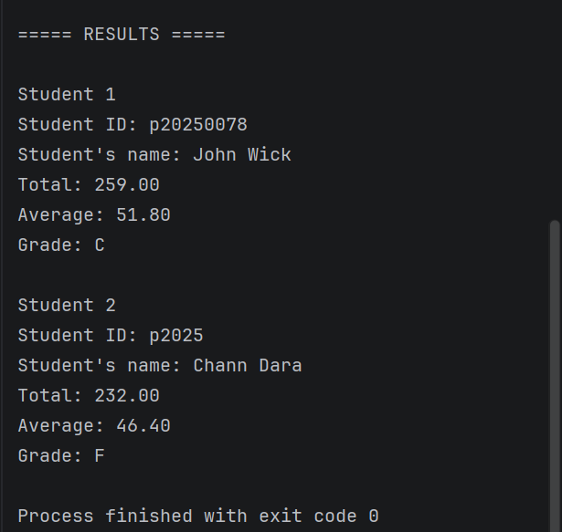
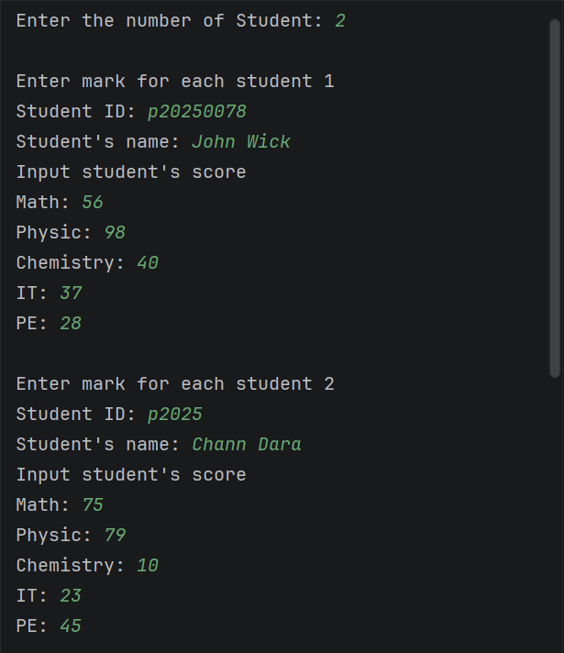
Output:

Input from user Display the result
Practice 5: Simple banking system
Problem: Simulate a banking system.
- Flowchart
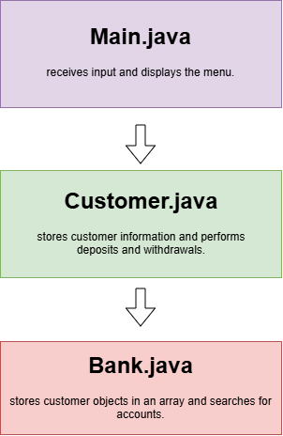
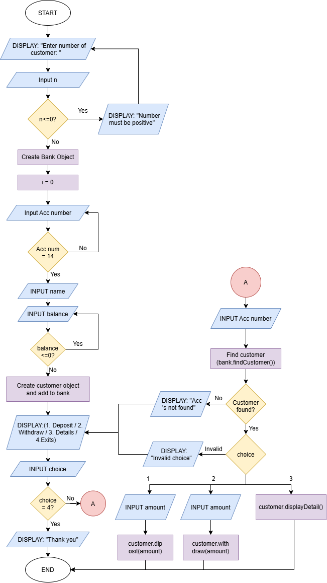

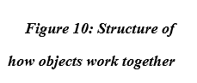

Figure 9: Flowchart
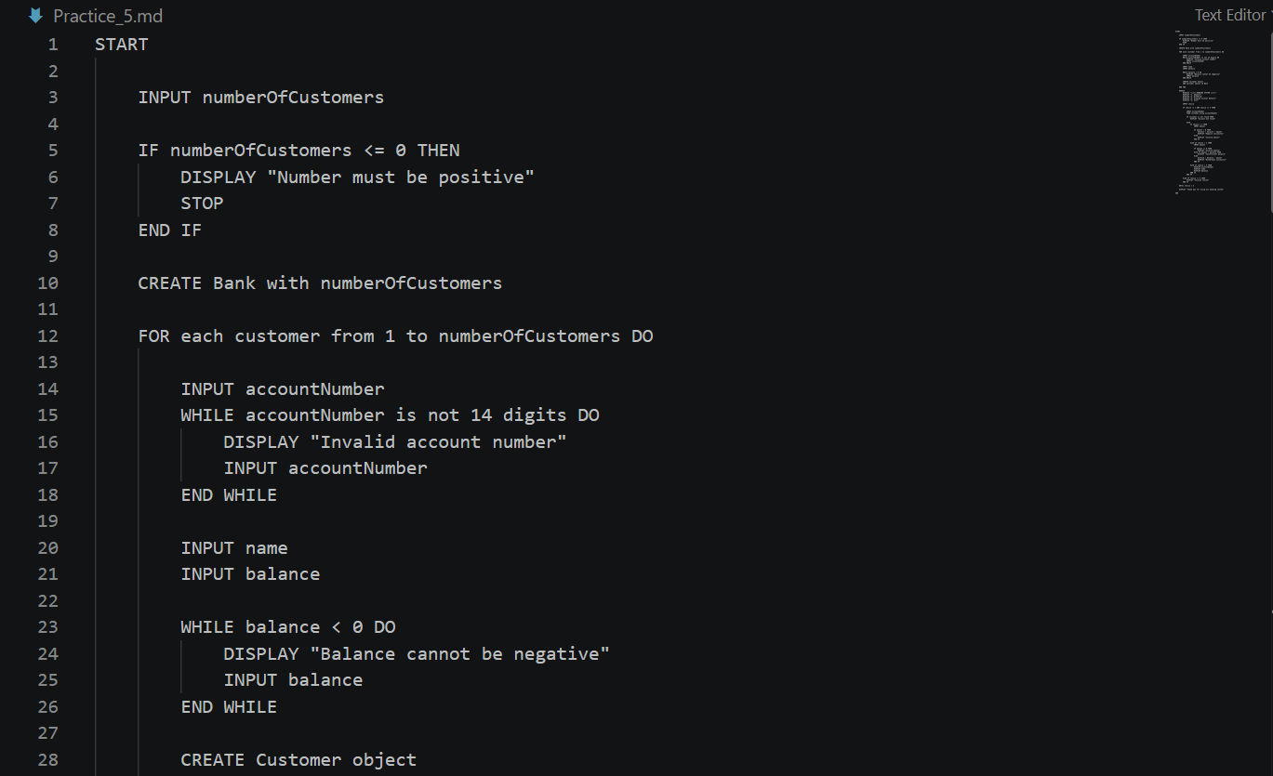
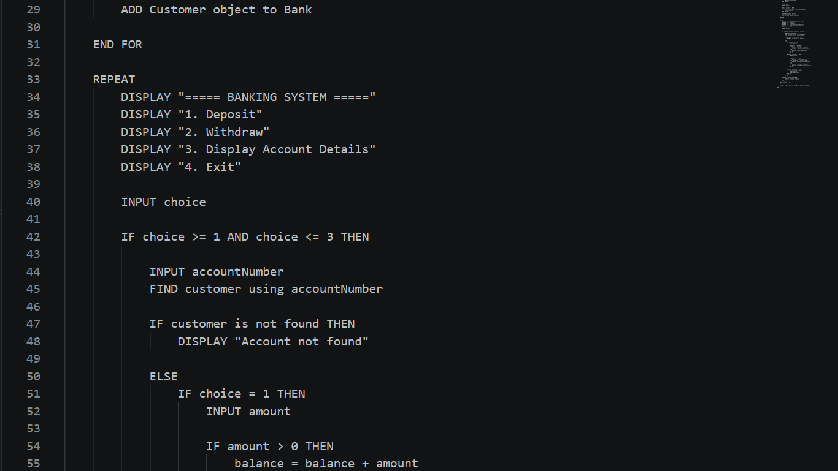
- Pseudocode:

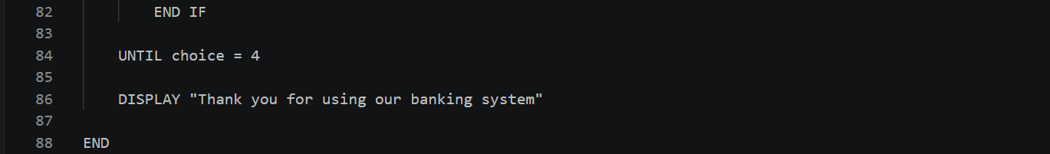
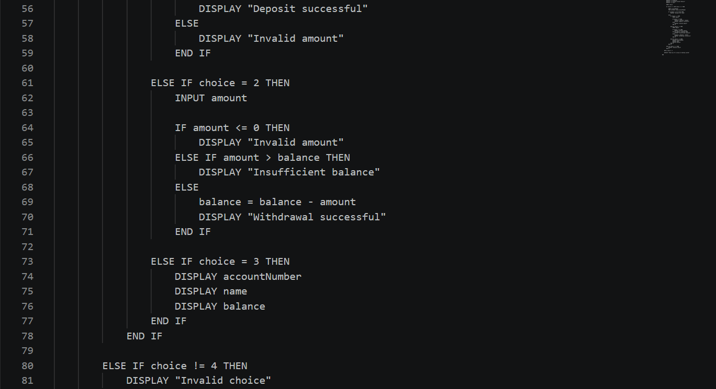
- Sample solution

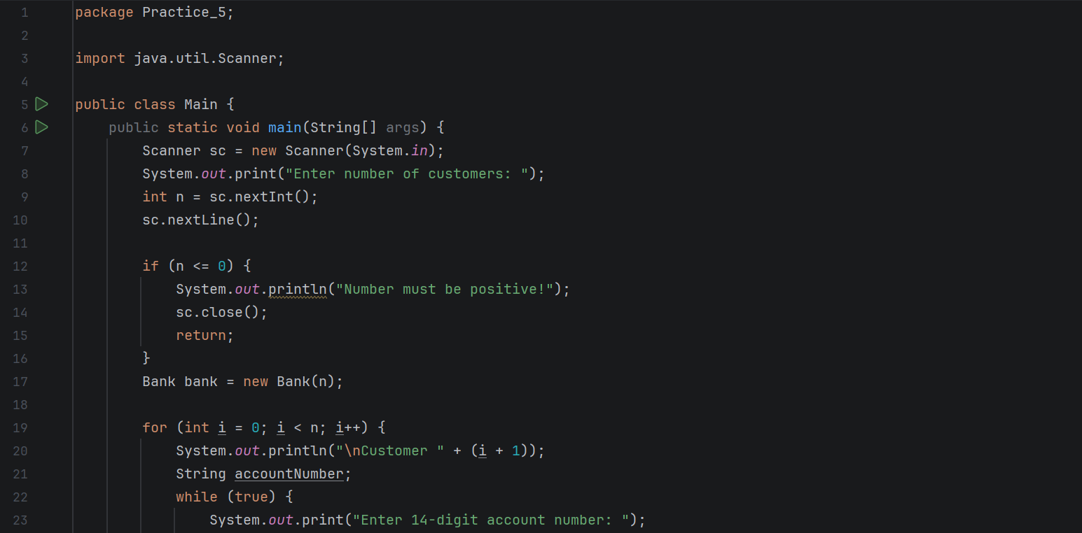
Main.java: receives input and displays the menu.
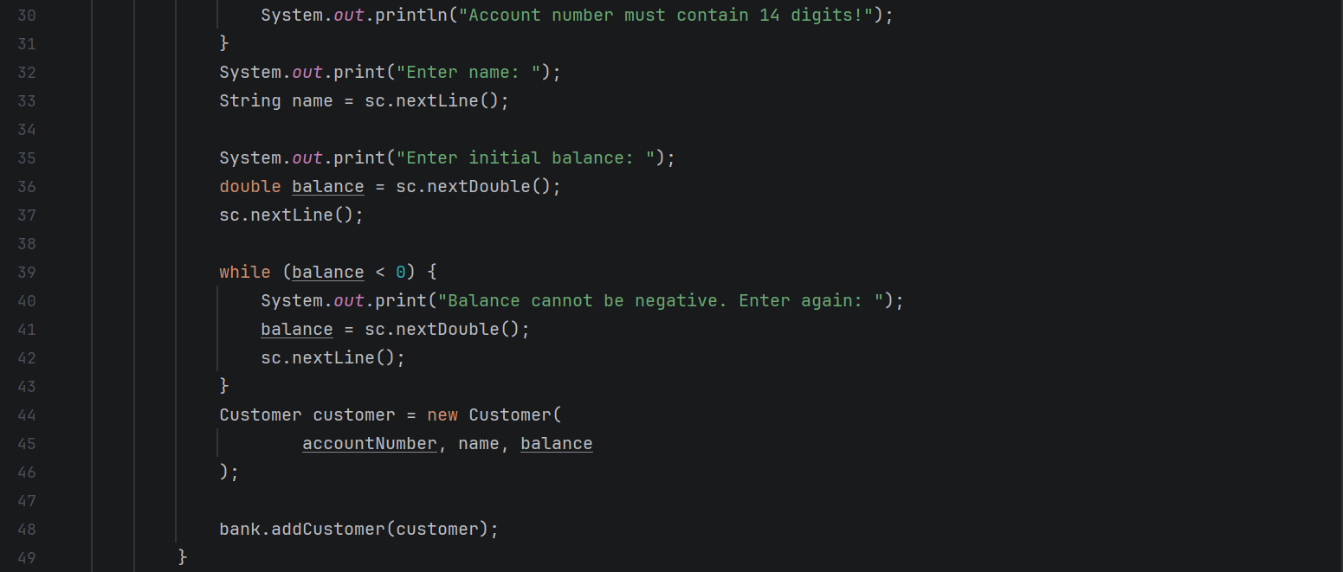
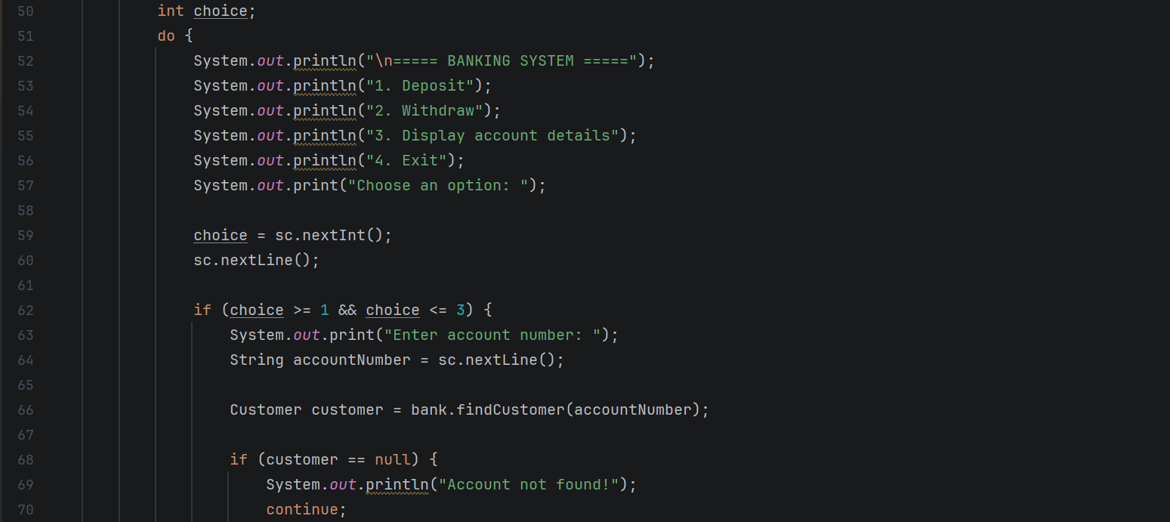
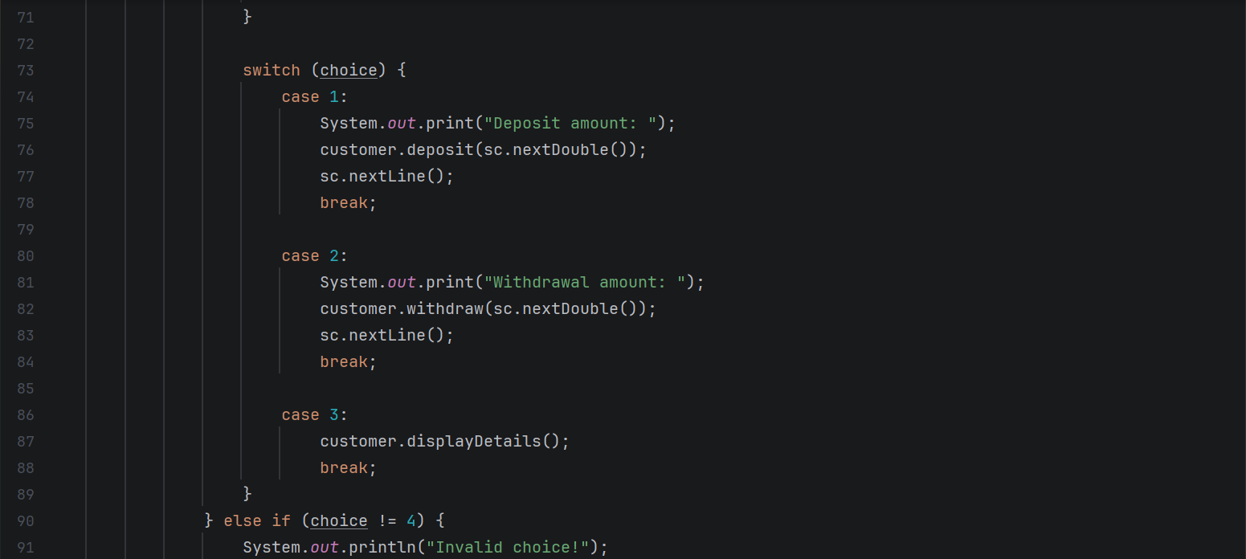
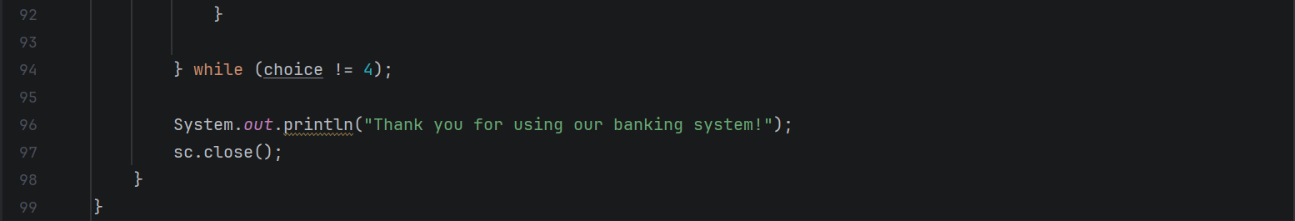
- Bank bank = new Bank(n): creates a Bank object to store customer records.
- for (int i = 0; i < n; i++): loops to input each customer's account number, name, and initial balance.
- Customer customer = new Customer(accountNumber, name, balance): creates a Customer object with the customer's information.
- bank.addCustomer(customer): adds the customer object to the bank's array.
- do-while loop: repeatedly displays the banking menu until the user chooses to exit.
- bank.findCustomer(accountNumber): searches for a customer using their account number.
- customer.deposit(amount): adds money to the customer's balance after validating the amount.
- customer.withdraw(amount): subtracts money from the balance if the amount is valid and sufficient funds are available.
- customer.displayDetails(): displays the customer's account number, name, and balance.
- switch (choice): executes the selected banking operation based on the user's menu choice.
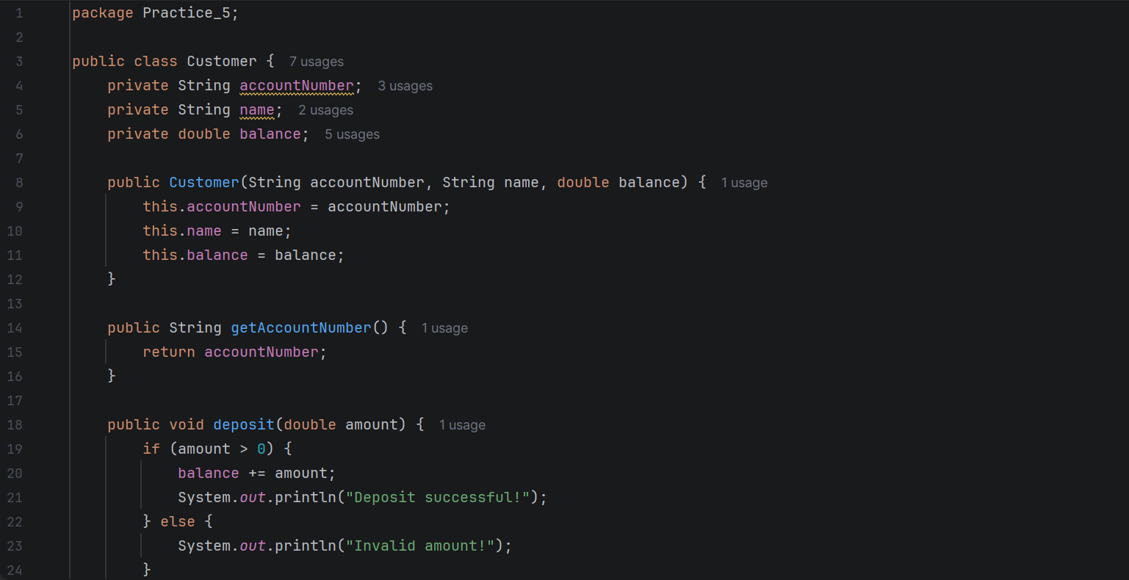
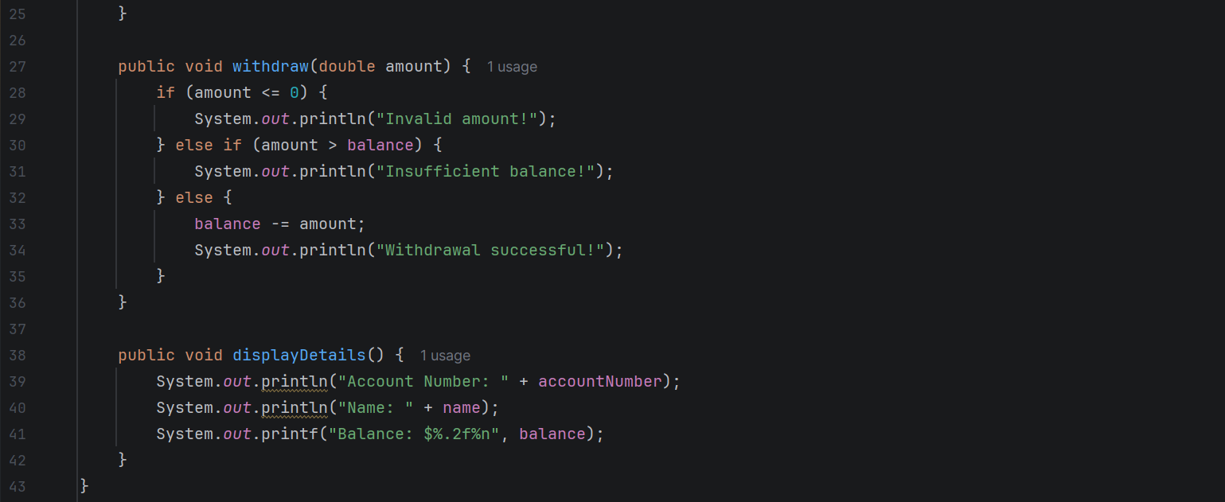
Customer.java: stores customer information and performs deposits and withdrawals.
- public Customer(String accountNumber, String name, double balance): constructor that initializes the customer's account number, name, and balance.
- public String getAccountNumber(): returns the customer's account number for searching.
- public void deposit(double amount): checks whether the deposit amount is positive and adds it to the balance.
- public void withdraw(double amount): checks whether the withdrawal amount is valid and whether the customer has enough money before deducting it.
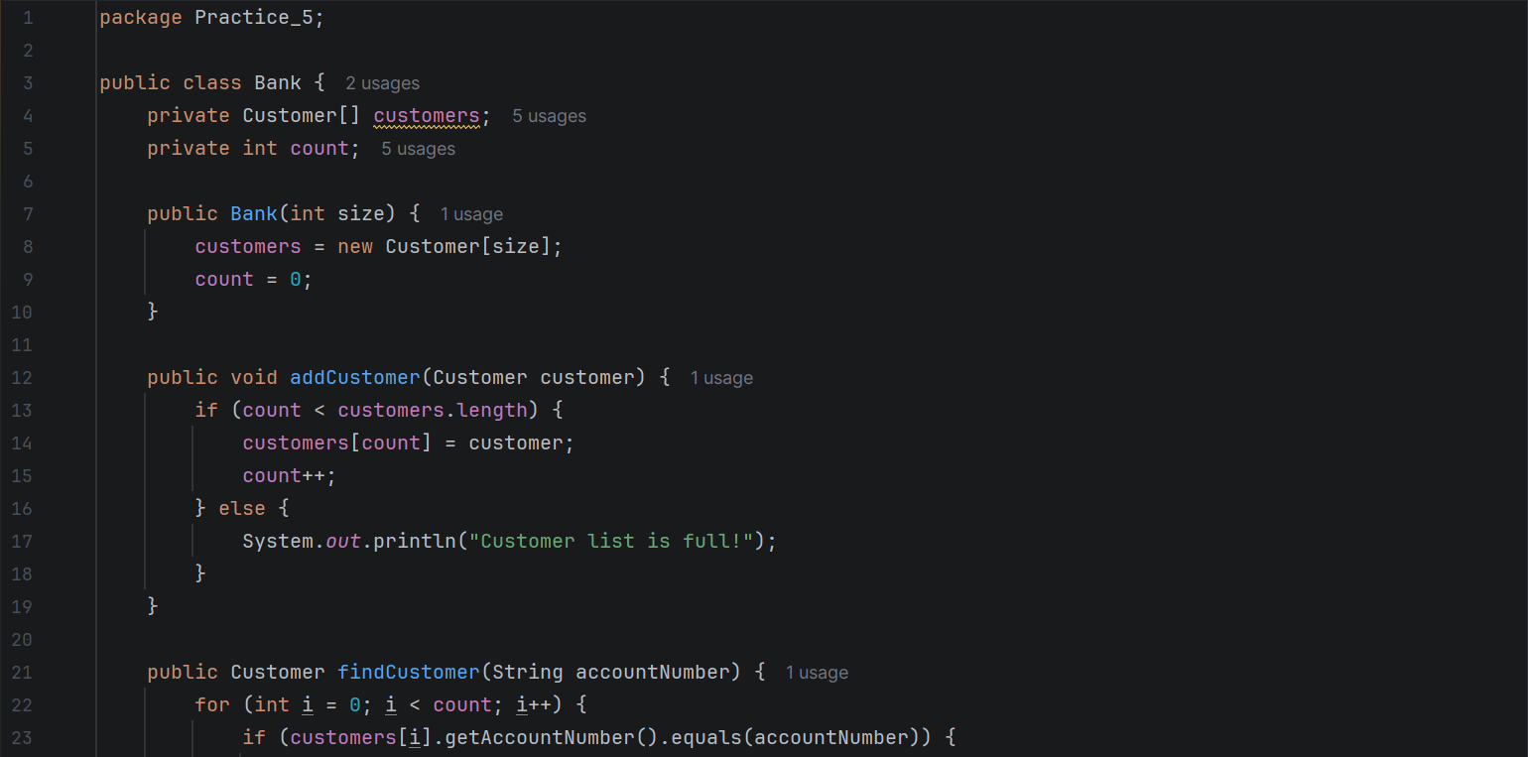
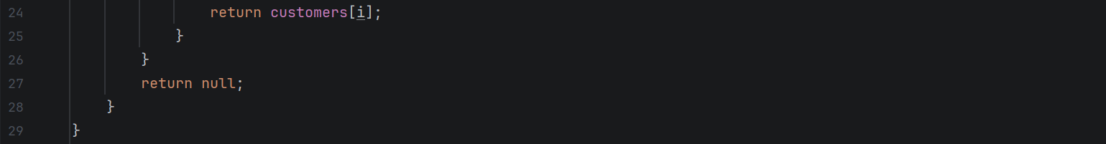
Bank.java: stores customer objects in an array and searches for accounts.

- private Customer[] customers: stores an array of Customer objects.
- private int count: tracks the number of customers currently stored in the array.
- public Bank(int size): constructor that initializes the customer array with the specified capacity and sets count to zero.
- public void addCustomer(Customer customer): adds a customer object to the array if space is available; otherwise, displays a message that the list is full.
- public Customer findCustomer(String accountNumber): uses a for loop to search for a customer by account number. Returns the matching customer if found, or null if the account does not exist.
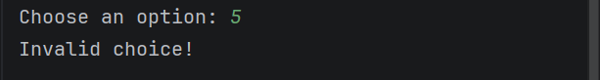
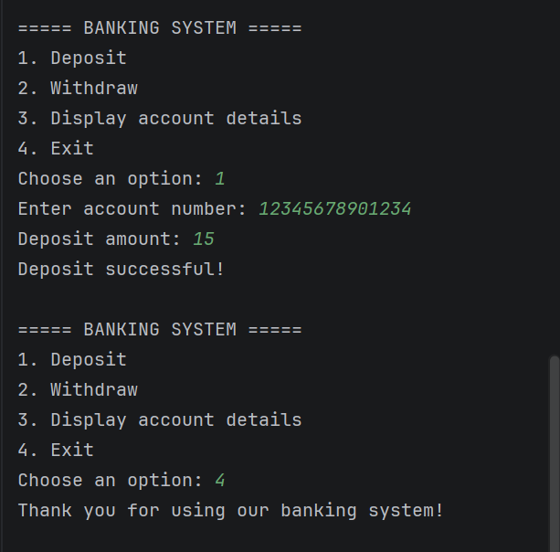
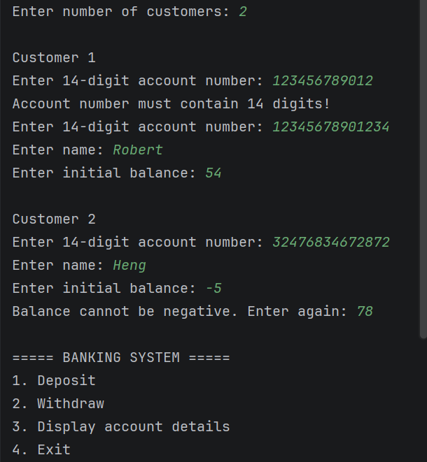
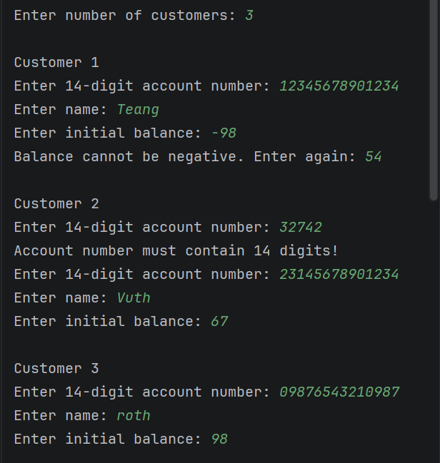
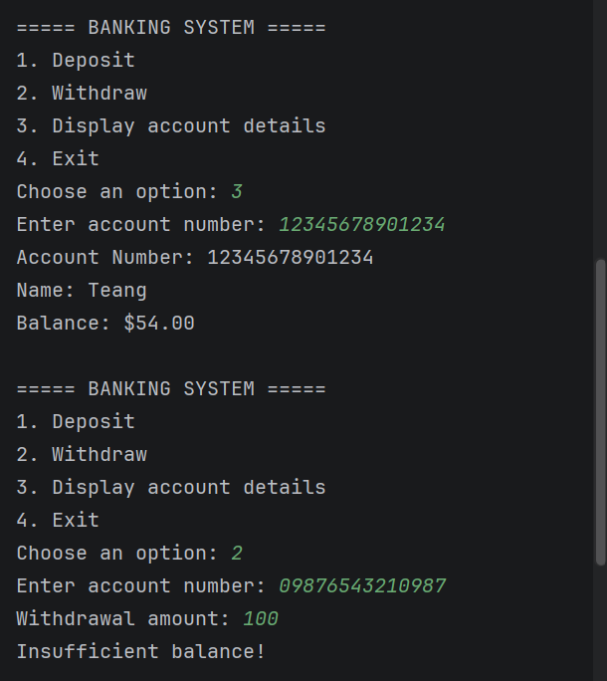
Output:
Example1 Example2

THE END

