
lab 06_report
Inheritance OOP

November 14, 2026
Name: Siem Khattyavatey
Student ID: p20250056
GIT URL: https://github.com/zikkyiscool/PDI.git

Practice 1:
Use case: A transport company wants a common structure for different vehicles.
Goal: Understand simple inheritance.
Instructions:
- Create a base class Vehicle with:
- properties: brand, year
- method: start()
- Create a derived class Car that inherits from Vehicle.
- Add car-specific property: num_doors.
- Add method: honk().
Task: Create objects of both classes and call their methods to show that Car has access to Vehicle methods.
Class diagram


Implement:
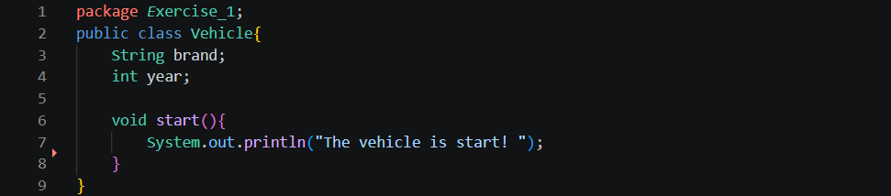
Vehicle.java: This file defines the common properties and behaviors shared by vehicles.

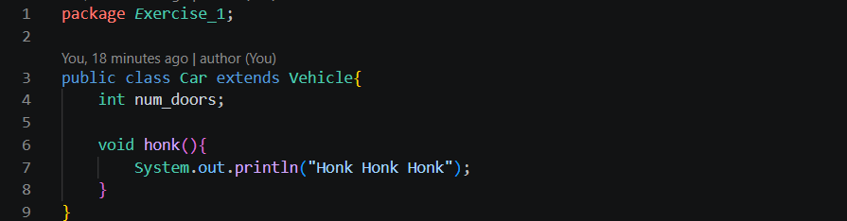
Car.java: This file defines the Car class, which inherits from Vehicle.
Main.java: This file runs the program. It creates objects and calls their methods.
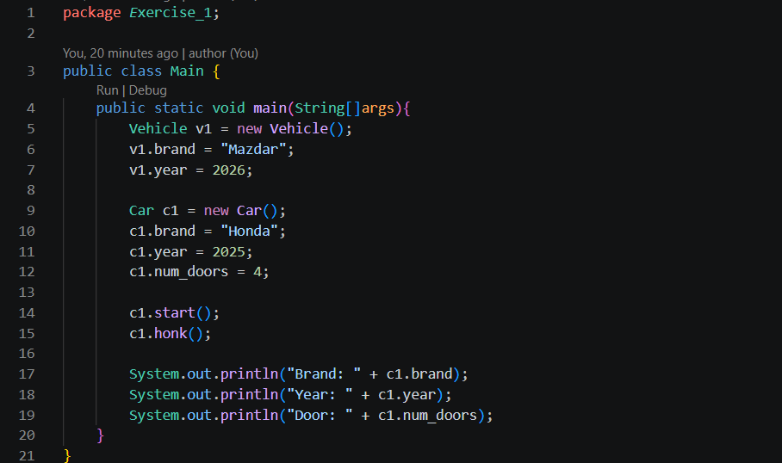
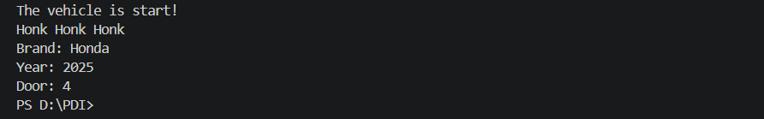
Output:

Practice 2: Method Overriding — “Employee & Manager”
Use case: A company payroll system needs different bonus calculations.
Goal: Use overridden methods.
Instructions:
- Base class Employee with:
- name, salary
- method: calculate_bonus() → returns 10% of salary
- Create a derived class Car that inherits from Vehicle.
- Add car-specific property: num_doors.
- Add method: honk().
Task: Print the bonus for each type to show polymorphism.
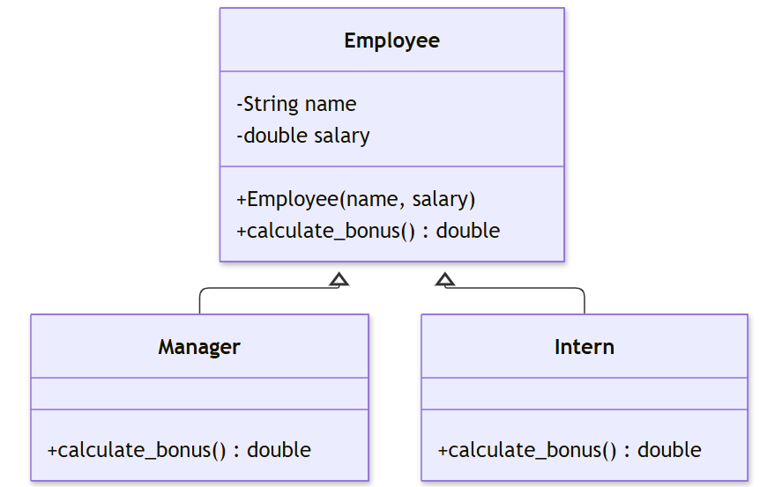
Class diagram

Implement:
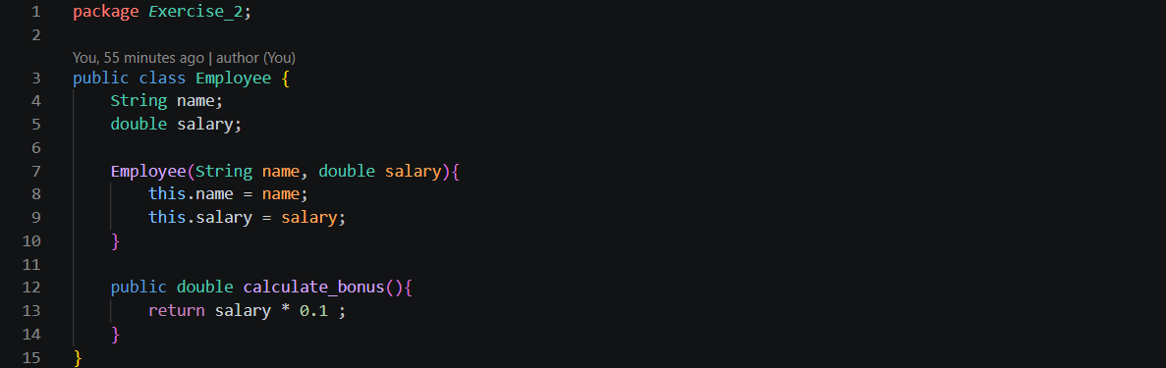
Employee.java: This file defines the base Employee class with name and salary attributes. It also contains the calculate_bonus() method, which calculates a default bonus of 10% of the employee's salary.
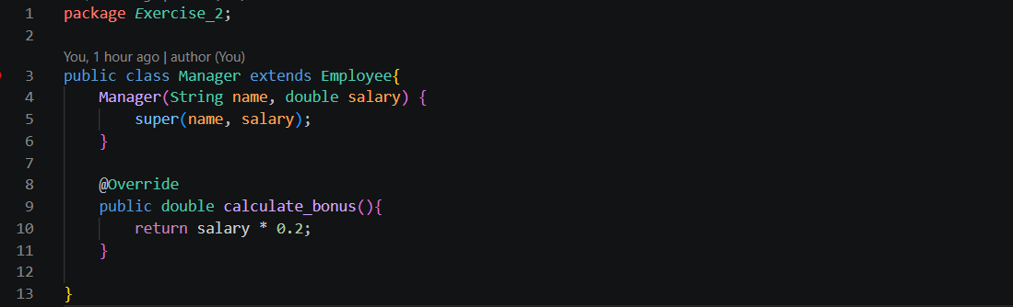
Manager.java: This file defines the Manager class, which inherits from Employee. It overrides the calculate_bonus() method to calculate a 20% bonus instead of the default 10%.
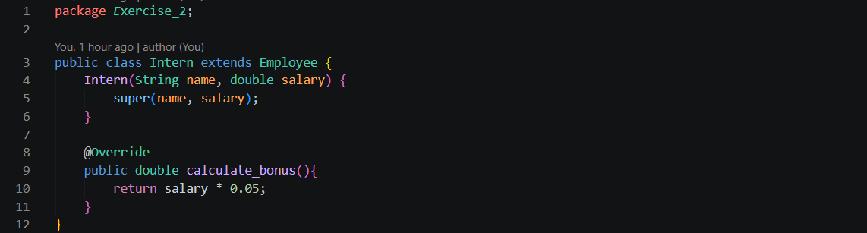
Intern.java: This file defines the Intern class, which inherits from Employee. It overrides the calculate_bonus() method to calculate a 5% bonus.

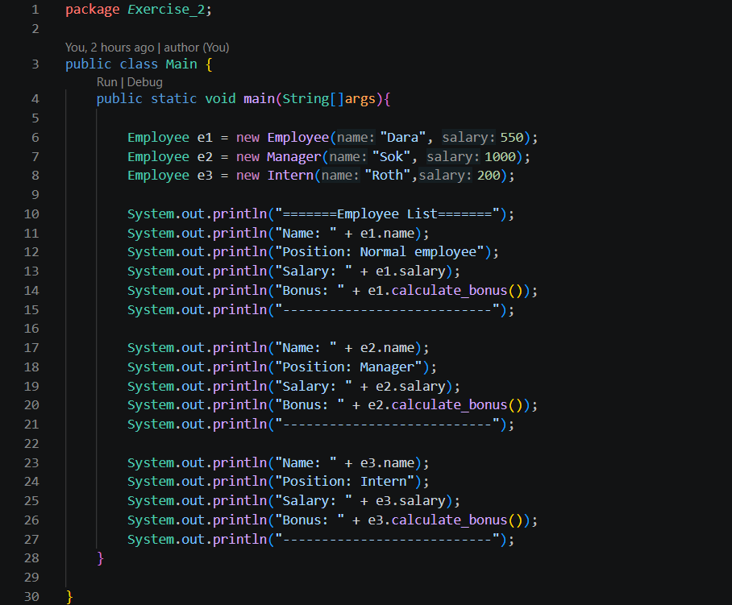
Main.java: This file runs the program by creating Employee, Manager, and Intern objects. It uses a loop to call calculate_bonus() for each object, demonstrating polymorphism because the same method produces different results depending on the object type.
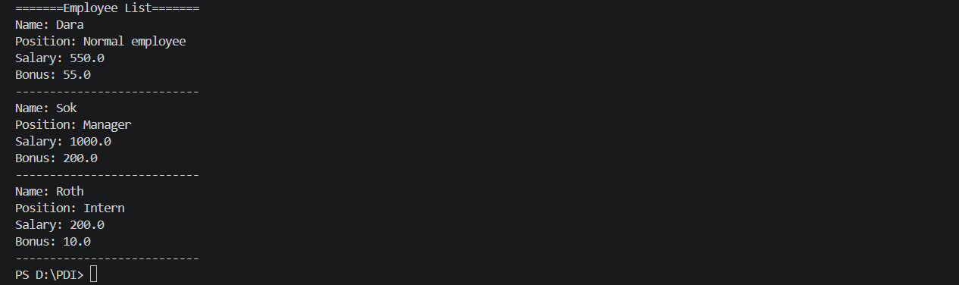
Output:

Practice 3: Multi-Level Inheritance — “Person → Student → OnlineStudent”
Use case: A university system has different student types.
Goal: Build a multi-level class chain.
Instructions:
- Base: Person → name
- Derived: Student → student_id
- Derived: OnlineStudent → zoom_id
Task: Instantiate OnlineStudent and confirm it inherits all data from both parent classes.
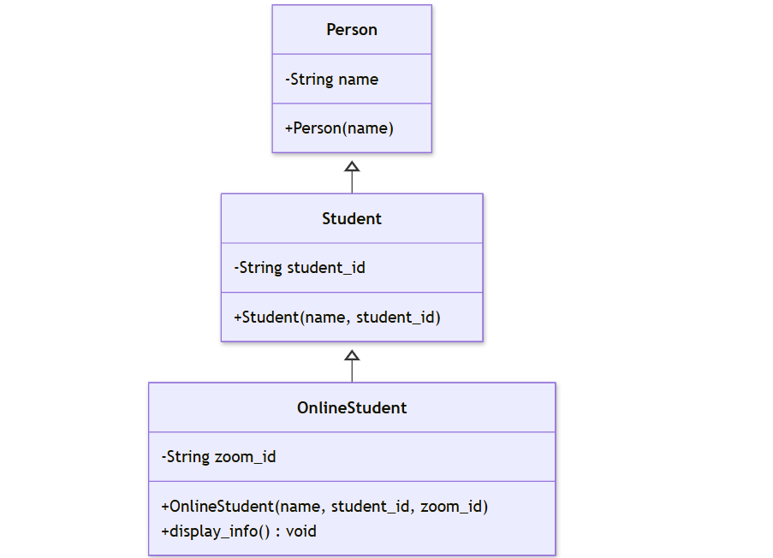
Class diagram

Implement:
Person.java: This file defines the Person class with a name attribute. It provides a constructor to initialize the person's name and a getter method to access it.
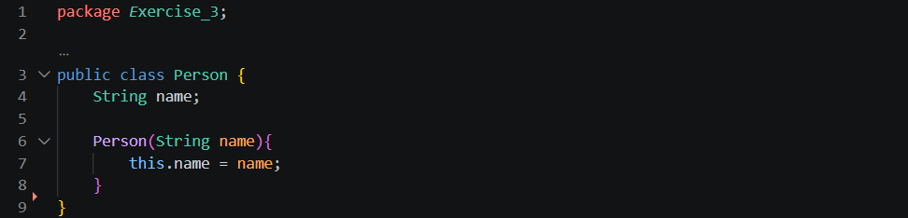
Student.java: This file defines the Student class, which inherits from Person. It adds a student_id attribute and uses super(name) to initialize the name inherited from the parent class.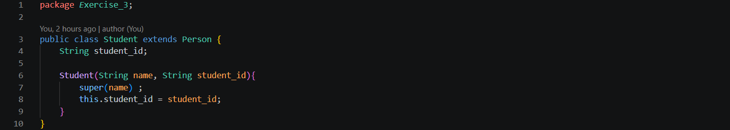
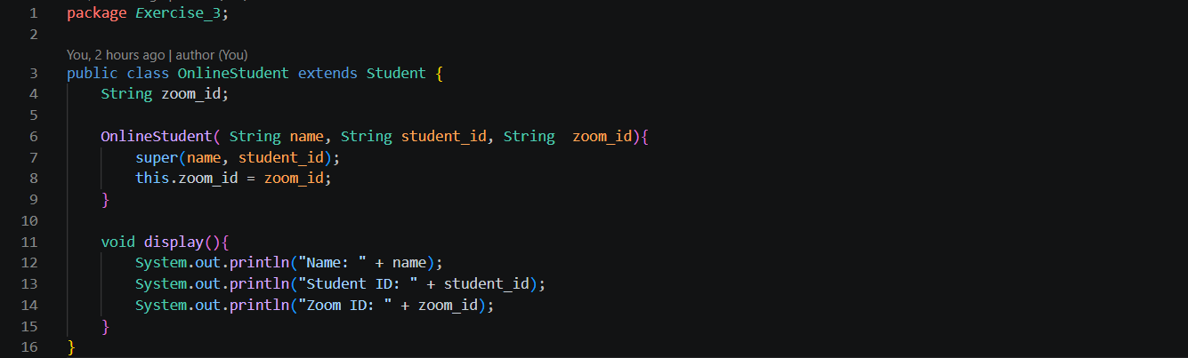
OnlineStudent.java: This file defines the OnlineStudent class, which inherits from Student. It adds a zoom_id attribute and uses super(name, student_id) to initialize the information inherited from both parent classes. The display_info() method displays all three attributes.
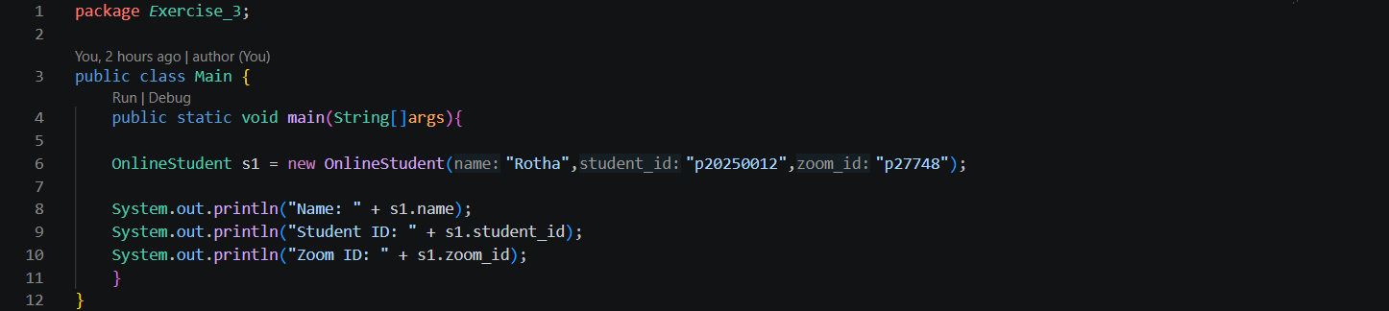
Main.java: This file creates an OnlineStudent object and calls display_info() to demonstrate that the object can access data inherited from both Person and Student, as well as its own zoom_id.
Output:

Practice 4: Calling Parent Constructor — “Bank Account Types”
Use case: A bank system with multiple account categories.
Goal: Learn super() or base-constructor calls.
Instructions:
- Base: BankAccount
  - constructor: accepts account_number, balance
- Derived: SavingsAccount
  - constructor: also takes interest_rate
  - must call the base constructor
Task: Show correct initialization of subclass properties.
Class diagram
This exercise demonstrates how a child class uses super() to call the constructor of its parent class.

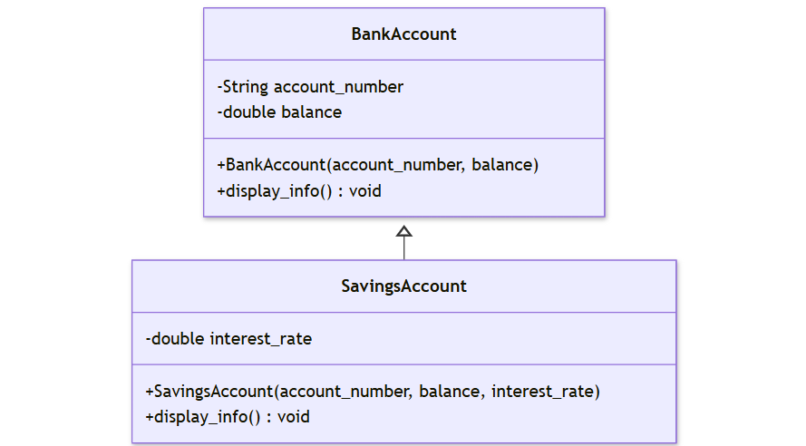

Implement:
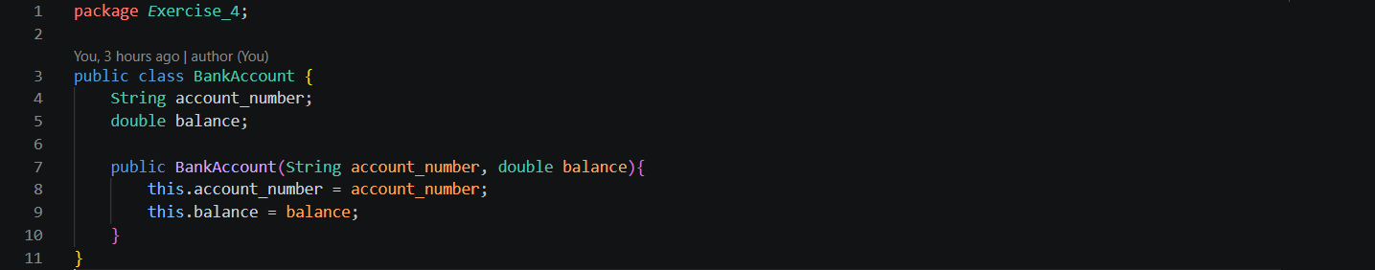
BankAccount.java: This file defines the parent BankAccount class with account_number and balance attributes. Its constructor initializes these two properties when a bank account object is created.
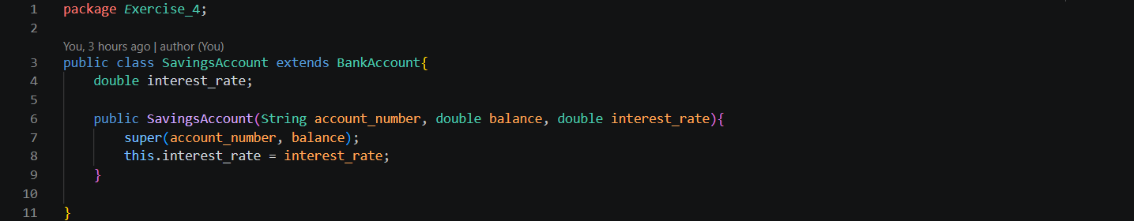
SavingsAccount.java: This file defines SavingsAccount, which inherits from BankAccount. It adds an interest_rate attribute and uses super(account_number, balance) to call the parent constructor and initialize the inherited properties.
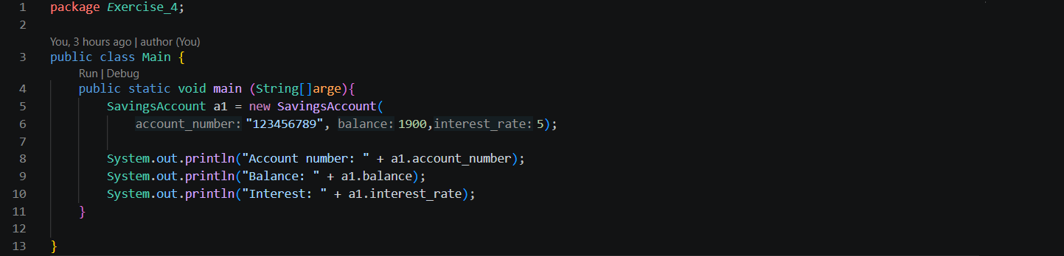
Main.java: This file creates a SavingsAccount object with an account number, balance, and interest rate. It then calls display_info() to display all the initialized information.
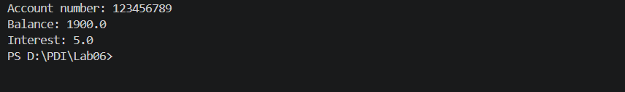
Output:
Practice 5: Using Protected Members — “Library Resources”
Use case: A library manages different resource types: books, magazines, journals. Goal: Practice protected attributes and subclass access.
Instructions:
- Base class LibraryItem
  - protected: _title, _id
  - method: display_info()
- Derived class Book
  - method: display_info() → formats book output differently
Task: Demonstrate how _title is accessible in the subclass but not outside.
Class diagram
This exercise demonstrates protected attributes, which allow a child class to access its parent's attributes directly.
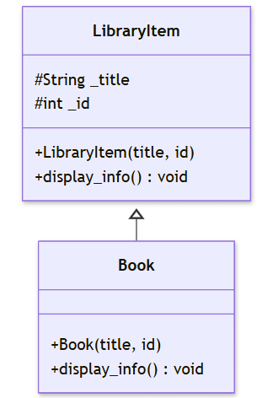

Implement:
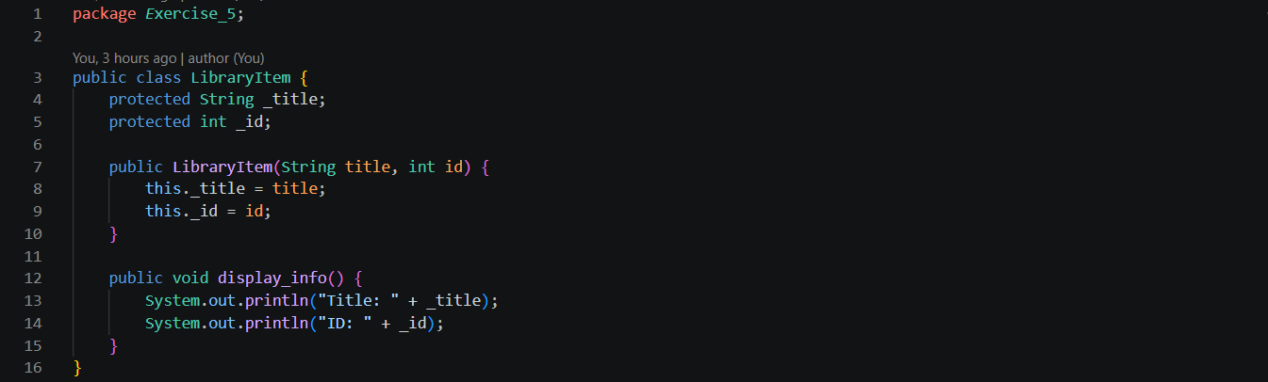
LibraryItem.java: This file defines the parent LibraryItem class with two protected attributes, _title and _id. The constructor initializes these attributes, while display_info() displays the library item's information.
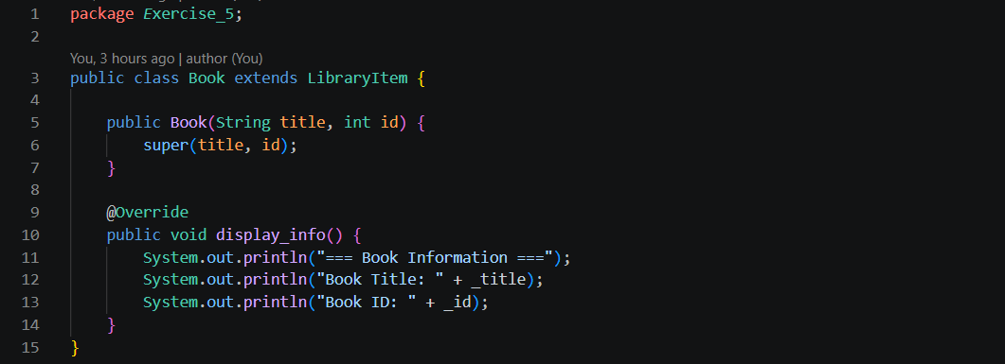
Book.java: This file defines the Book class, which inherits from LibraryItem. It uses super() to initialize the parent's attributes and overrides display_info() to format the book information differently. Because _title and _id are protected, the Book subclass can access them directly.
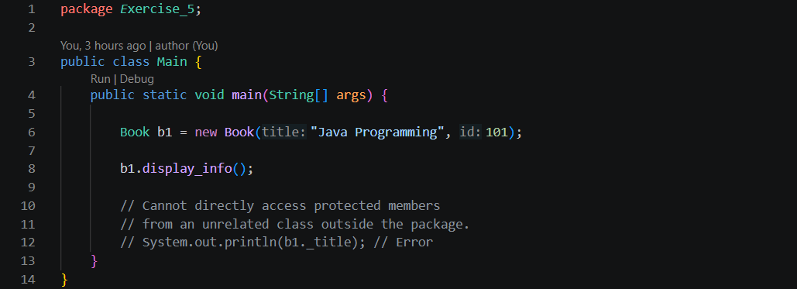
Main.java: This file creates a Book object and calls display_info() to display its information. It does not directly access _title or _id because Main is outside the library package.
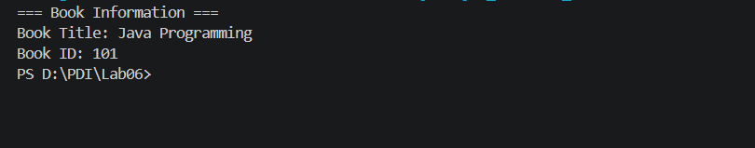
Output:
Practice 6: Hierarchical Inheritance — “Shape → Circle, Rectangle, Triangle”
Use case: A drawing application must compute areas of different shapes.
Goal: Use one parent with multiple children.
Instructions:
- Base: Shape o method: area() → returns 0 (default)
- Child: Circle
- Child: Rectangle
- Child: Triangle
- Each child overrides area().
Task: Store different shape objects in a list and print their areas.
Class diagram
This exercise demonstrates hierarchical inheritance, where multiple child classes inherit from one parent class.

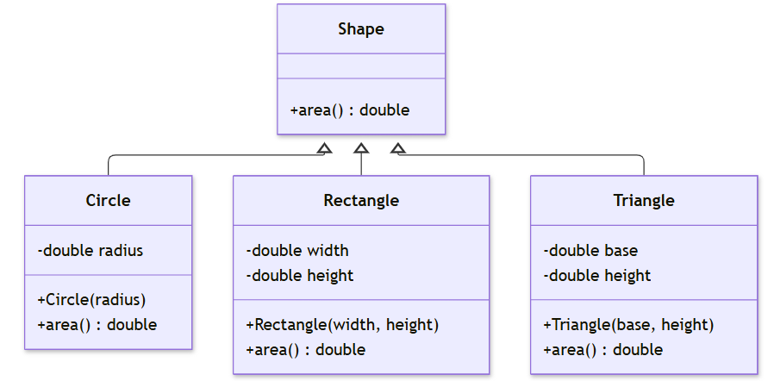

Implement:
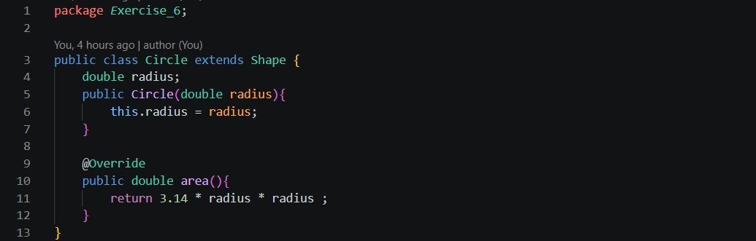
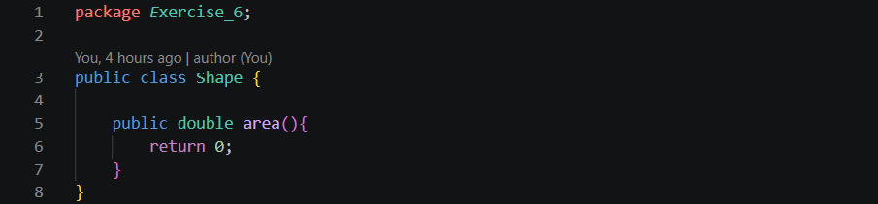
Shape.java: This file defines the parent Shape class with a default area() method that returns 0. The child classes inherit this method and override it to calculate their own areas.
Circle.java: This file defines the Circle class, which inherits from Shape. It adds a radius attribute and overrides area() to calculate the circle's area $π×radius×radius$.
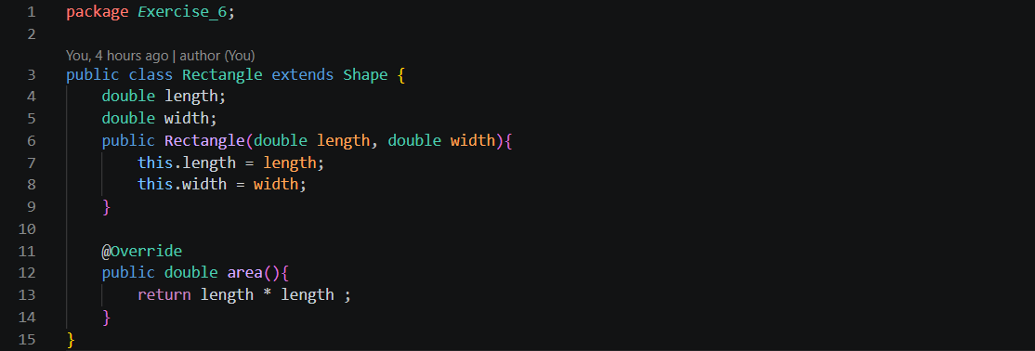
Rectangle.java: This file defines the Rectangle class, which inherits from Shape. It adds width and height attributes and overrides area() to calculate the rectangle's area by multiplying its width by its height.
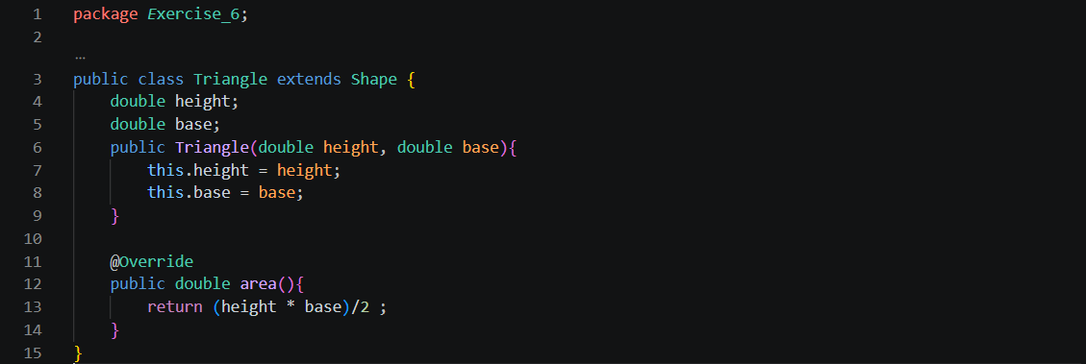
Triangle.java: This file defines the Triangle class, which inherits from Shape. It adds base and height attributes and overrides area() to calculate the triangle's area using half of its base multiplied by its height.
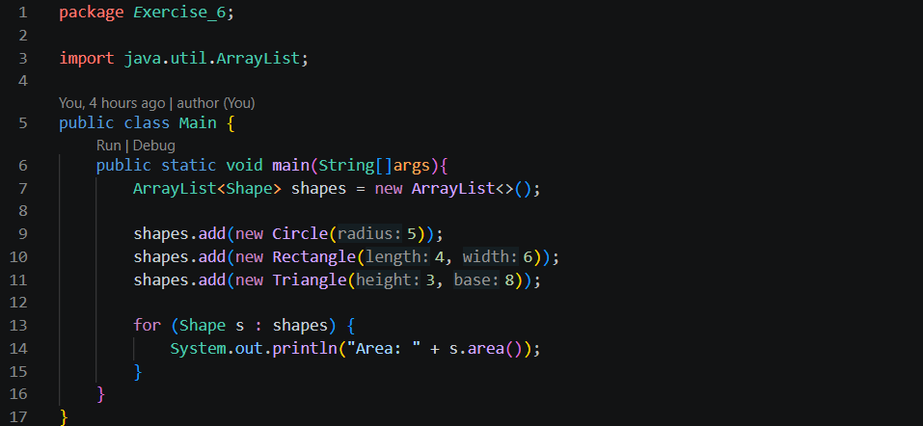
Main.java: This file creates an ArrayList that stores different shape objects. It adds a Circle, Rectangle, and Triangle, then uses a for-each loop to call area() on each object. Java automatically executes the overridden method belonging to each actual object.
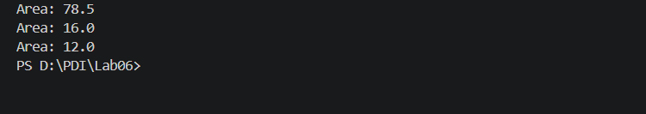
Output:

Practice 7: Abstract Classes — “Payment Methods”
Use case: E-commerce needs different payment implementations.
Goal: Use abstract classes and enforce method overriding.
Instructions:
- Abstract class: Payment
  - abstract method: process_payment(amount)
- Derived:
  - CreditCardPayment
  - PayPalPayment
  - BankTransferPayment
Task: Invoke each payment method and show different behavior.

Class diagram
This exercise demonstrates abstraction, where an abstract parent class defines a method that every child class must implement.

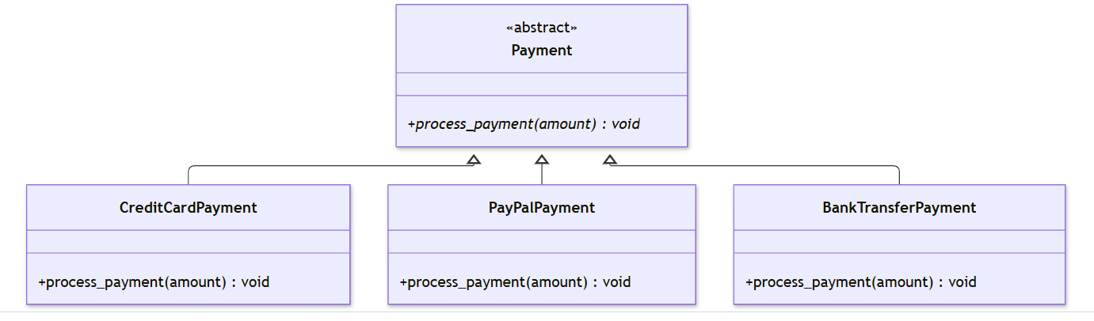

Implement:
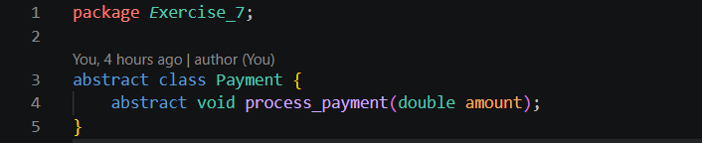
Payment.java: This file defines the abstract parent class Payment. It declares an abstract method process_payment() without providing an implementation. Every child class must override this method to define its own payment behavior.

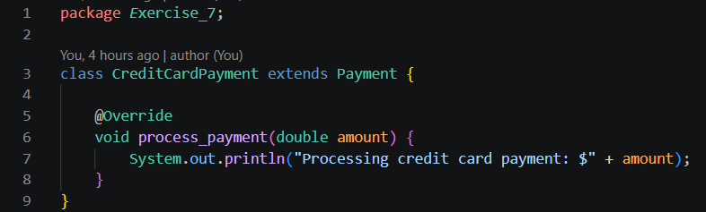
CreditCardPayment.java: This file defines CreditCardPayment, which inherits from Payment. It overrides process_payment() to display a message indicating that the payment is being processed using a credit card.

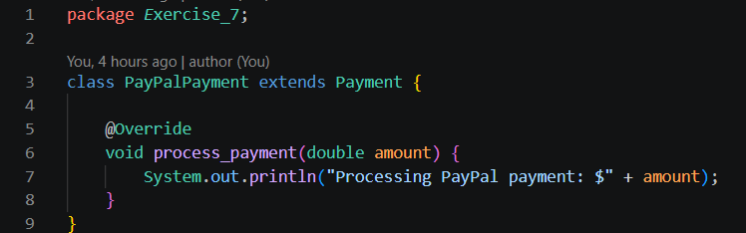
PayPalPayment.java: This file defines PayPalPayment, which inherits from Payment. It overrides process_payment() to display a message indicating that the payment is being processed through PayPal.
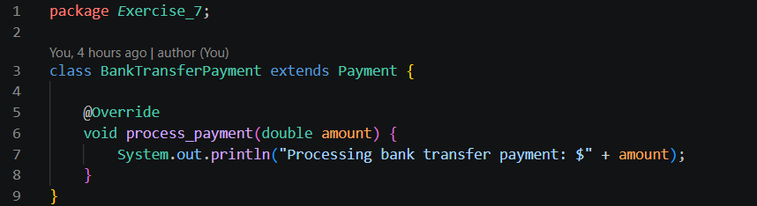
BankTransferPayment.java: This file defines BankTransferPayment, which inherits from Payment. It overrides process_payment() to display a message indicating that the payment is being processed through a bank transfer.
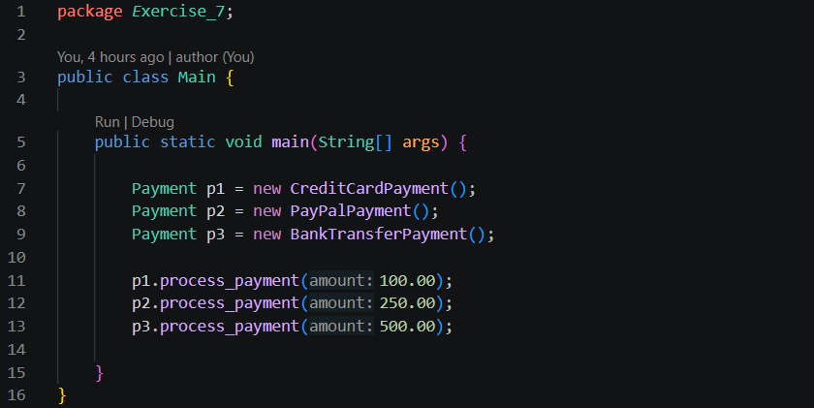
Main.java: This file creates three different payment objects using the Payment reference type. It calls process_payment() for each object to demonstrate polymorphism, where the same method call produces different behavior depending on the payment type.

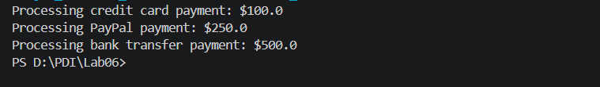
Output:
Practice 8: Inheritance + Polymorphism + Data Structures — “E-commerce Product Catalog”
Use case: Online store with several product types.
Goal: Work with lists of parent-class types containing child objects.
Instructions:
- Base class Product: name, price
- Derived:
  - Electronics → warranty
  - Clothing → size
  - Book → author
- Add method get_info() in each class (overridden).
Task: Create a product list containing all types and print info using polymorphism.

Class diagram
This exercise demonstrates inheritance, method overriding, polymorphism, and ArrayList. One parent class has three child classes, each with its own implementation of get_info().

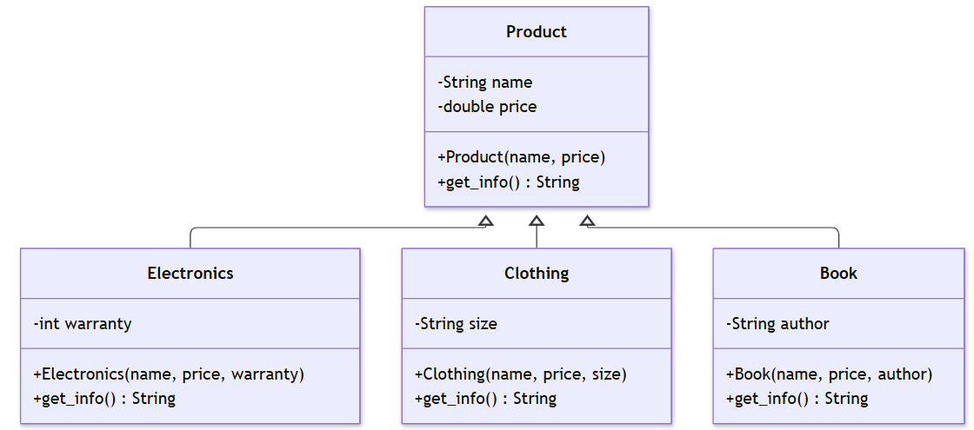

Implement:
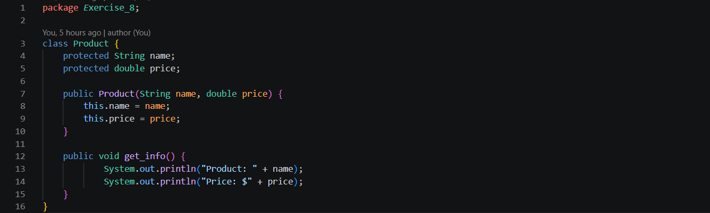
Product.java: This file defines the parent Product class with name and price attributes. It provides a constructor to initialize product information, getter methods to access the attributes, and a default get_info() method that returns product details.
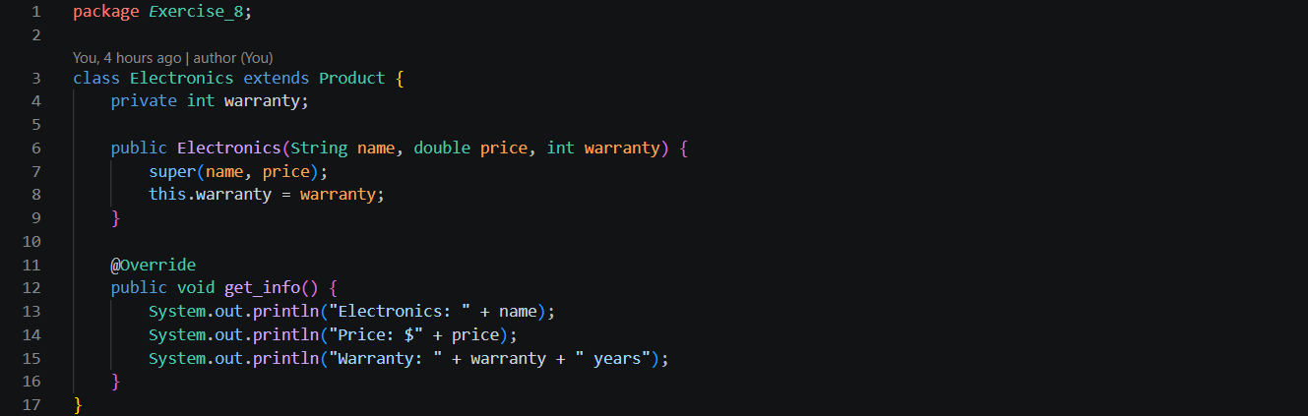
Electronics.java: This file defines the Electronics class, which inherits from Product. It adds a warranty attribute and overrides get_info() to display the product name, price, and warranty period.
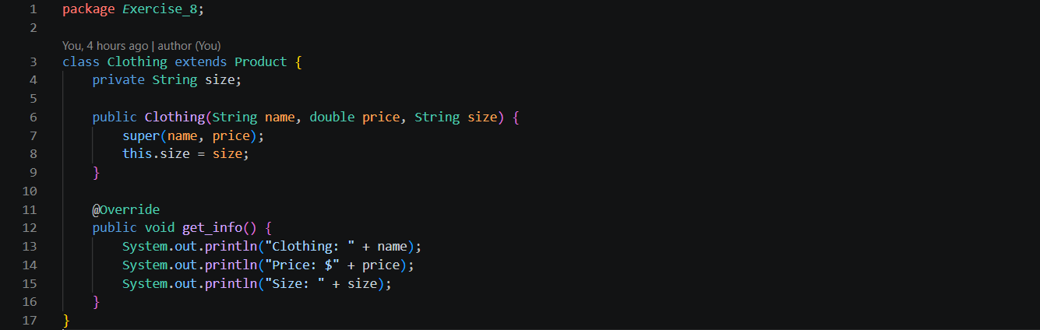
Clothing.java: This file defines the Clothing class, which inherits from Product. It adds a size attribute and overrides get_info() to display the clothing name, price, and size.
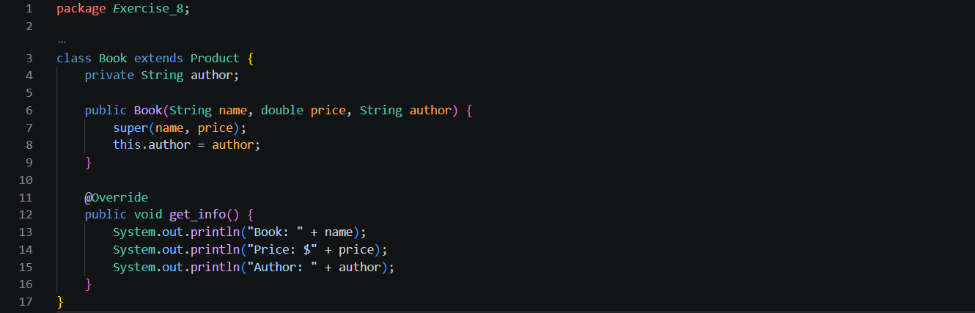
Book.java: This file defines the Book class, which inherits from Product. It adds an author attribute and overrides get_info() to display the book name, price, and author's name.
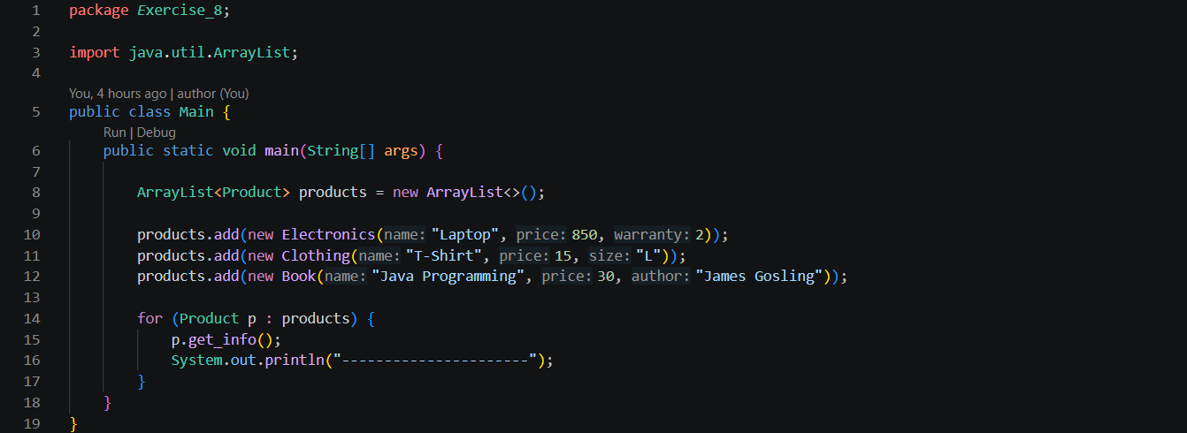
Main.java: This file creates an ArrayList<Product> that stores Electronics, Clothing, and Book objects. It uses a for-each loop to call get_info() on each product. Java automatically executes the overridden method belonging to the actual object, demonstrating polymorphism.
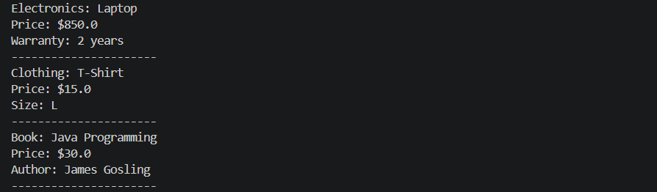
Output:
Practice 9: Advanced Real-World Project — “Transportation System with Pricing Rules”
Use case: A city transportation app calculates fares for different transport modes.
Goal: Use inheritance, overriding, polymorphism, abstract classes, and real logic.
Instructions:
- Abstract class: Transport
  - property: distance
  - abstract method: calculate_fare()
- Derived:
  - BusTransport → fare = distance × 1.5
  - MetroTransport → fare = base 10 + (distance × 2)
  - TaxiTransport → starting fee 20 + distance × 5
- Add method: display_fare()
Task: Create a list of multiple transport types with various distances and show each fare computed using the overridden methods.

Class diagram
This exercise combines abstract classes, inheritance, method overriding, polymorphism, and ArrayList.

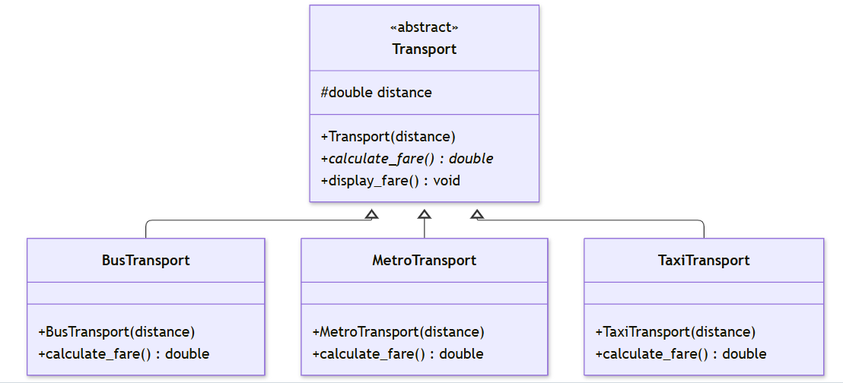

Implement:
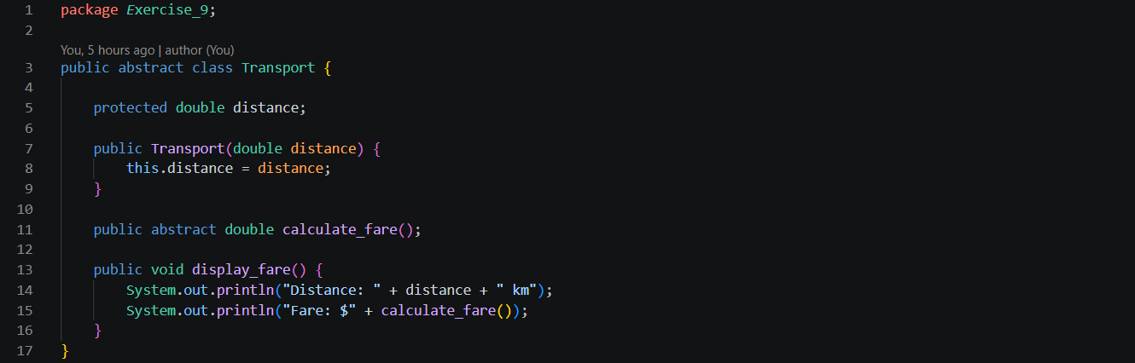
Transport.java: This file defines the abstract parent class Transport with a protected distance attribute. It declares the abstract method calculate_fare(), which must be implemented by child classes. It also provides display_fare() to display the distance and calculated fare.
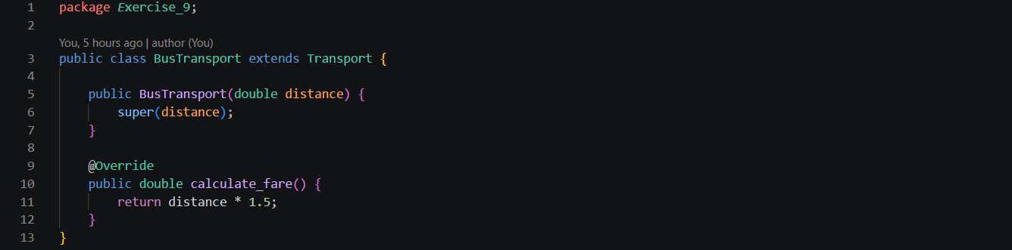
BusTransport.java: This file defines the BusTransport class, which inherits from Transport. It uses super(distance) to initialize the parent's distance attribute and overrides calculate_fare() to calculate the bus fare at $1.50 per kilometer.
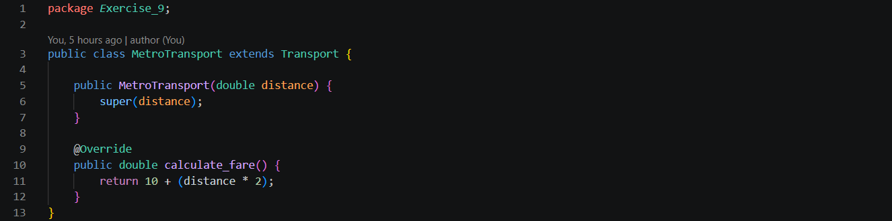
MetroTransport.java: This file defines the MetroTransport class, which inherits from Transport. It overrides calculate_fare() to calculate the metro fare using a base fare of $10 plus $2 per kilometer.
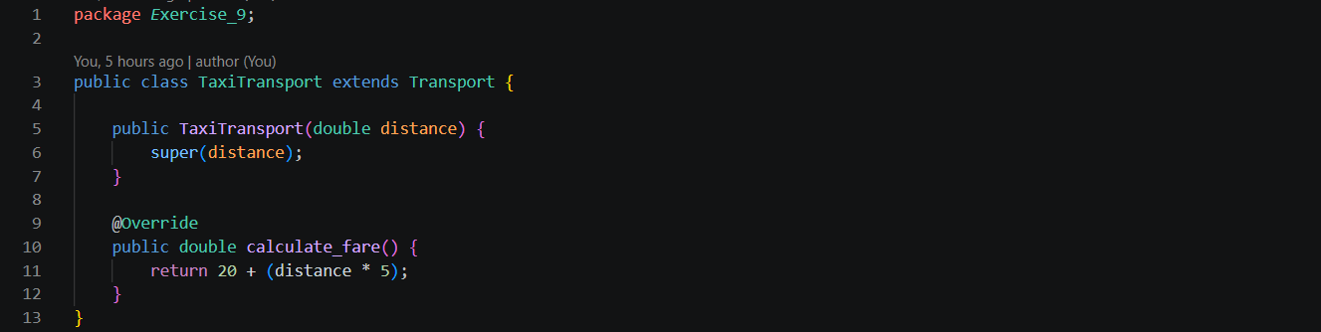
TaxiTransport.java: This file defines the TaxiTransport class, which inherits from Transport. It overrides calculate_fare() to calculate the taxi fare using a starting fee of $20 plus $5 per kilometer.
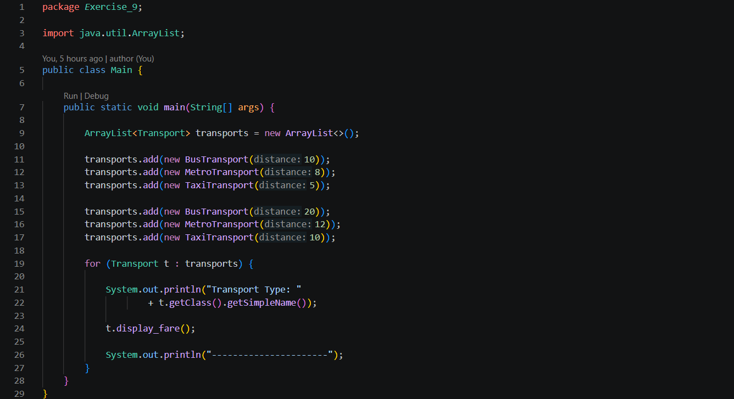
Main.java: This file creates an ArrayList<Transport> to store BusTransport, MetroTransport, and TaxiTransport objects. It uses a for-each loop to call display_fare() for each object. Inside that method, Java automatically calls the correct overridden calculate_fare() based on the actual transport type.
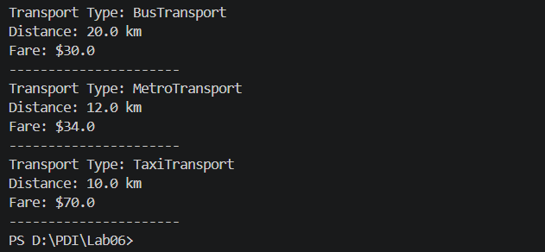
Output:
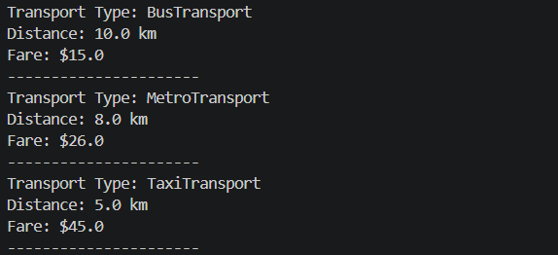

THE END

