First Part : Import DataSet

We use cv2 to get picture from training video

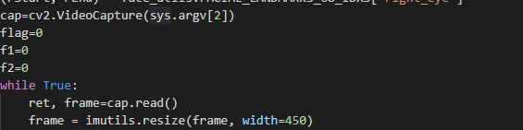  
after this we pre trained model 68 landsmark to detect faces from frames & we use face_utile for get eye marks from model



We use this marks (6 for left eye / 6 for right ) to calculate the EAR

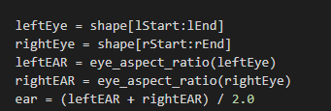

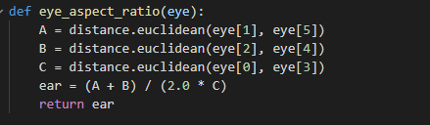

Then if ear<tresh ( random int <1) in this study we use 0,25

Then the system detect that it’s drowsy and save this image in the output

Els

Save image in the folder name alert

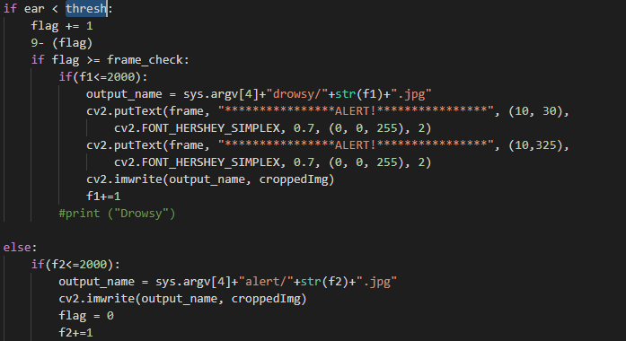

Seconde Part

we use the tensorflow Hub /image_classifier to create graph model with the collected data set

then w use this graph to extract feature from the training data from CNN module and save it as sequence of matrix to use it as Input from LTSM

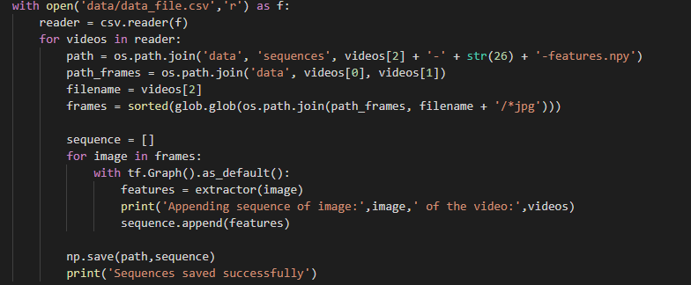

After this we run the train.py to get the final predictions for the test sequence of data and the alarm will sound if the model predicts the sequence to be in a drowsy state.

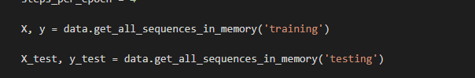

For training Data / Testing Data

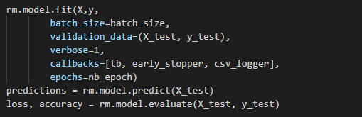

We use the production vector to get if the driver drowsy or no and play alarm

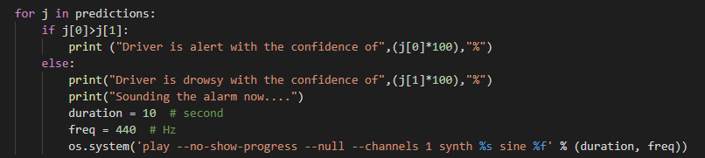

The Parametre :

