When Does a Simple Predictor Suffice? Predictive Pre-Warming for Serverless Edge Web Applications Under Capacity-Bound Bursty Load
Zakaria Abidi — Independent Researcher, Creil, France — zakaria.abidi@gmail.com — ORCID: 0009-0001-8692-4575

Abstract
Serverless (on-demand, scale-to-zero) deployment trades idle-resource cost for cold-start latency whenever traffic resumes after a period of silence -- a pattern that recurs constantly in real-time edge web applications. Predictive pre-warming -- forecasting the next burst and provisioning capacity ahead of it -- is a natural mitigation. Cold-start mitigation research spans a spectrum from simple, deployed heuristics to heavy learned forecasters: at the lightweight end, Shahrad et al. [4] describe a hybrid histogram-and-ARIMA keep-alive/pre-warming policy already deployed at a large commercial FaaS provider; at the heavy end, recent work reports recurrent neural networks and model-predictive-control forecasters with substantial reported gains. This paper asks a narrower question: within the near-zero-cost forecaster family itself, how much of the achievable benefit is reachable without any adaptive learning at all, and through what mechanism? We built an open, reproducible harness comparing an always-on container deployment, a purely reactive on-demand deployment, and four lightweight predictive policies -- an exponentially weighted moving average (EWMA), a naive last-observed-gap forecaster, a simple moving average, and a fixed-schedule forecaster assuming a constant period -- under three workload regimes, with independently reset trials, seeds matched across policies, and trial-level non-parametric statistical testing. This design, and two bugs it caught in an earlier draft (a self-referential forecasting error and a prewarm-trigger timing-reference mismatch), are disclosed in full in the published changelog as part of the reproducibility record. Under repeated idle-then-burst cyclical traffic (15 independent trials per policy, 6,750 requests), a latency decomposition shows the dominant cost is not cold-start duration itself (mean 75-119 ms) but time spent queueing for capacity once a burst exceeds the instance-count limit (mean 171-481 ms, affecting 80% of requests) -- a capacity-bound bottleneck that is partly a structural consequence of this study's specific burst-size-to-concurrency-cap ratio (15 requests against 3 instances) and partly genuinely measured; a single pre-warmed instance can only partially relieve it. Under a paired, repeated-measures analysis (Friedman omnibus across all six policies, chi-squared=56.49, df=5, p=6.5e-11, followed by two separately Holm-corrected planned-comparison families), all four lightweight predictive policies achieve a statistically significant latency reduction relative to the purely reactive baseline (Holm-adjusted p=0.036 EWMA, p=0.020 last-gap, p=0.036 moving-average, p=0.0002 fixed-schedule; matched-pairs rank-biserial effect sizes -0.62 to -1.00). Among the four, the three adaptive forecasters are statistically indistinguishable from one another; fixed-schedule significantly outperforms all three (Holm-adjusted p~=0.0004 each) -- an advantage that must be read together with two caveats: its constant period was set with knowledge of the workload generator's own periodicity, not learned, and a sensitivity-sweep pilot (N=6/condition) shows this advantage is fragile, unaffected by under-estimating the true period by up to 50% but largely erased by a 10% over-estimate, and inverted (fixed-schedule becomes slightly worse than plain reactive scaling) at a 50% over-estimate. A second pilot tests a non-oracle keep-alive baseline (idle timeout swept over 8/10/12 s against a 6 s reactive default): it shows no benefit at 8 s (the workload's own disclosed minimum idle gap) but a sharp step-function improvement at or above the workload's own disclosed maximum gap (10 s), where cold-start rate falls from 20% to 4%. In a dedicated 25-cycle persistent-state run, EWMA's observed persistent-state behavior reduces user-facing cold starts from 3 to 2 per cycle (one of three anticipated ahead of time), stable over the 25 cycles, once repeated trial-reset warm-up is removed. Under the generalized two-resource cost model, EWMA and moving-average are net CPU-second savers relative to reactive at a small GB-second premium; last-gap and fixed-schedule cost more in both. All code, raw per-request data, the reanalysis and pilot-experiment scripts, and Kubernetes/Knative manifests for future real-platform validation are openly published at https://github.com/<GITHUB_USERNAME>/edge-faas-container-benchmark.
Keywords: Serverless computing; cold start; predictive autoscaling; container orchestration; edge computing; queueing; reproducible research; cost-latency trade-off

1. Introduction
Real-time web applications -- IoT monitoring dashboards, industrial telemetry, smart-city platforms, event-driven automation -- increasingly run at the network edge to cut latency and backbone traffic. Two deployment models dominate how their backend logic gets executed: container-based deployment, which keeps a fixed pool of replicas running continuously, and serverless (Function-as-a-Service) deployment, which provisions execution on demand and releases it when idle. The trade-off between them is well documented in the abstract (persistent capacity vs. elastic, on-demand capacity); this paper is concerned with a more specific, more actionable question that follows from it: when traffic arrives in bursts separated by idle periods, and a forecaster is used to pre-warm capacity ahead of the next burst, how much of that forecaster's engineering complexity is actually earning its keep, and what, mechanistically, does the pre-warming actually fix?
Cold-start mitigation spans a spectrum from simple, already-deployed heuristics to heavy learned forecasters. At the lightweight end, Shahrad et al. [4] describe a hybrid histogram-and-ARIMA keep-alive/pre-warming policy, deployed and evaluated at a large commercial FaaS provider, that chooses pre-warm and keep-alive windows directly from each application's own observed idle-time distribution. At the heavy end, recent literature reports recurrent neural networks trained on invocation history [26] and model-predictive control with Fourier-based demand forecasting [27], both demonstrating substantial improvement over a purely reactive baseline. What is missing from this spectrum -- and what this paper's four-way ablation is designed to close -- is a controlled, same-harness comparison among the near-zero-cost forecaster family itself (fixed-schedule, last-observed-gap, moving-average, and EWMA) under a statistically rigorous, trial-independent protocol: a narrower and more specific gap than claiming no simple or lightweight pre-warming baseline exists anywhere in the literature, which Shahrad et al.'s deployed policy already contradicts. That comparison, run fairly on one harness, under one statistical protocol, is this paper's central contribution.
A second, independent motivation follows directly from how this study itself was conducted. An earlier draft of this work reported a single EWMA-based predictive policy achieving a large (71.6%) latency reduction. Before submission, an external methodological review identified five issues with that draft, two of which were critical: the predictor's own corrective actions were contaminating the very observations it learned from (a self-referential feedback bug), and the statistical analysis treated correlated, non-independent requests as independent observations (pseudoreplication), inflating apparent significance throughout. Correcting both -- and, in the process of re-running the corrected experiment, finding and fixing a second, subtler bug in the prewarming trigger's timing logic -- changed the paper's central finding substantially. A second, deeper methodological review subsequently identified that the statistical design used to test that corrected finding itself needed revision: a single Holm-Bonferroni correction family had been built around one baseline (reactive), which can only ever test whether each predictor beats reactive (H4), not whether the predictors differ from each other (RQ3); the two questions are now tested as two separately corrected families (Section 4.6). Section 4.4 and the repository's CHANGELOG document all of these corrections in full; we consider this transparency part of the paper's contribution, not an admission to be minimized, and it directly motivates the paper's reframed question and its two-family statistical design.
Research questions:
- RQ1: How does end-to-end latency differ between an always-on container deployment, a reactive on-demand deployment, and a family of lightweight predictive on-demand policies, under steady, ramping, and repeated burst-after-idle traffic?
- RQ2: What mechanism drives the latency cost of reactive on-demand deployment under burst-after-idle traffic -- cold-started instances themselves, or queueing for capacity that propagates to nominally warm requests?
- RQ3: Do the four lightweight forecasters (EWMA, last-gap, moving-average, fixed-schedule) differ measurably from one another, and if so, is the difference explained by forecast quality or by something else about the evaluation protocol?
- RQ4: What is the resource cost of predictive pre-warming, expressed in integrated CPU-seconds and GB-seconds rather than instantaneous percentages, and how does it compare to the latency and SLA-violation reduction it buys?
RQ3's downstream-latency answer is tested directly in Section 4.6 (Family B): the three adaptive forecasters (EWMA, last-gap, moving-average) are statistically indistinguishable from one another in trial-level median latency (all Holm-adjusted p=1.000); fixed-schedule is significantly faster than all three (Holm-adjusted p~=0.0004 each). Their opportunity-conversion rates are likewise indistinguishable for 5 of 6 pairs (Section 5.5), with one exception (last-gap significantly below fixed-schedule, Holm-adjusted p=0.040).
Hypotheses:
- H1: The container deployment exhibits lower latency and lower variance than either on-demand deployment under sustained load.
- H2: The reactive on-demand deployment incurs a measurable, statistically significant latency penalty during burst-after-idle traffic relative to steady traffic, driven substantially by capacity queueing rather than cold-start duration alone.
- H3: The on-demand deployments consume less idle/steady-load memory than the always-on container deployment.
- H4: At least one lightweight predictive policy reduces burst-scenario tail latency relative to the reactive policy at a measurable, modest resource cost; whether all four forecasters do so equally, or whether simpler ones outperform more adaptive ones under a trial-independent evaluation protocol, is treated as an open question rather than assumed.
Contributions:
- A controlled, six-way, openly reproducible comparison (container / reactive / four predictive policies) with independently reset, seed-matched trials and trial-level non-parametric statistical testing -- every figure and table in this paper is machine-generated from raw data published alongside it.
- A direct ablation of forecaster complexity (EWMA vs. last-gap vs. moving-average vs. fixed-schedule) on identical traffic, isolating how much of the achievable benefit is reachable without any adaptive learning at all.
- A latency decomposition (queueing time vs. cold-start time vs. application-service time) that identifies capacity-bound queueing, not cold-start duration, as the dominant cost under this workload -- and, following from it, an explanation of why an adaptive forecaster's measured advantage depends on the trial-reset protocol used to evaluate it, a methodological interaction we believe has not been previously flagged in this literature.
- A cost model expressed in integrated CPU-seconds and GB-seconds (not instantaneous, potentially misleading percentage snapshots) and a break-even decision rule in measured units, so it remains usable regardless of the reader's own infrastructure pricing.
- A fully public GitHub repository (code, raw data, analysis scripts, a documented changelog of the two bugs found and fixed during this study, and container/Knative manifests for real-platform replication) intended to lower the barrier for follow-up work and to make the study's self-correction independently checkable.

2. Background
This section summarizes the concepts needed to follow the rest of the paper; readers already familiar with containers and serverless computing can skip to Section 3.

2.1 Containers and container orchestration
A container packages an application with its dependencies into an isolated, portable runtime unit (using OS-level virtualization, e.g. Linux namespaces and cgroups, rather than a full virtual machine). Docker is the most common tool for building and running individual containers; Kubernetes is the most common orchestrator for running many containers across a cluster of machines, handling scheduling, networking, and (via a Deployment resource) keeping a specified number of replicas running continuously. A container-based deployment in this paper's sense means: a fixed number of application instances are started once and kept running, ready to serve a request at any time, regardless of whether traffic is currently arriving.

2.2 Serverless computing and Function-as-a-Service (FaaS)
Serverless computing (commonly realized as Function-as-a-Service) inverts this: the platform starts an execution environment only when a request arrives, and can terminate it after a period of inactivity to reclaim resources -- 'scaling to zero'. This removes the idle-capacity cost of the container model, but introduces a cold start: the time needed to provision a fresh execution environment (allocate resources, start the runtime, initialize the application) before the first request of a new burst can be served. Once warm, an instance typically serves subsequent requests with negligible per-request overhead until it is reclaimed. Commercial FaaS platforms include AWS Lambda, Azure Functions, and Google Cloud Functions; open-source, self-hostable equivalents that can run on Kubernetes include Knative and OpenFaaS.

2.3 Cold start, warm pools, and pre-warming
The cold-start penalty is the central operational concern with serverless deployments and has motivated a substantial body of systems research (Section 3). Mitigation strategies broadly fall into two families: keep-alive / caching policies that delay reclaiming an idle instance for longer than strictly necessary, trading some idle cost for fewer future cold starts (e.g., FaasCache [10]); and predictive pre-warming policies that forecast when the next burst of traffic is likely and provision capacity slightly ahead of it, so the cold start happens off the user-facing critical path. This paper's contribution belongs to the second family, and specifically to the question of how simple a forecaster in that family can be.

2.4 Edge computing
Edge computing relocates computation from a centralized cloud data center to infrastructure physically closer to where data is produced or consumed, reducing network round-trip latency at the cost of more constrained, more distributed compute resources. Both deployment models discussed in this paper are used at the edge; the choice between them is, if anything, more consequential there, since edge nodes typically have less spare capacity to absorb an always-on container pool, and less network slack to hide a serverless cold start behind, and typically run on smaller, more concurrency-limited instance counts -- which is precisely the regime in which the capacity-bound queueing mechanism identified in Section 5.4 dominates.

2.5 Simple gap forecasters
Four forecaster families of increasing (but still minimal) sophistication are compared in this paper, all forecasting the same quantity: the duration of silence expected before the next burst. Fixed-schedule assumes a constant, operator-supplied period and never adapts. Last-gap forecasts that the next silence will equal the most recently observed one -- no smoothing, no memory beyond one observation. Moving-average forecasts the unweighted mean of the last W observed silences. Exponentially weighted moving average (EWMA) maintains a running estimate updated on each new observation as estimate <- alpha x observation + (1 - alpha) x estimate, where alpha in (0, 1] trades adaptation speed against noise smoothing. All four require O(1) or O(W) memory, need no training phase, and (once they have at least one observation) produce a usable estimate immediately -- the property that motivated using an EWMA at all in earlier work on this topic, and the property this paper tests against three even simpler alternatives.
The exact values used in the reported experiments, read directly from the published configuration constants (loadgen/orchestrate_and_run.py, gateway/elastic_gateway.py): fixed-schedule's constant period is 9.0 s, set as the midpoint of the workload generator's own 8.0-10.0 s jittered idle range -- i.e., chosen with knowledge of the workload generator's own parameters, not blind. This is disclosed here plainly because it is precisely the fairness question the Discussion (Section 6) raises, and it is the reason the sensitivity-sweep pilot in Section 8 exists. EWMA's smoothing constant alpha=0.4; the moving-average window W=5 observations; the pre-warm safety margin is 1.0 s; the scale-to-zero idle timeout is 6.0 s; MAX_INSTANCES=3 for the primary runs (8 for the supplementary capacity experiment, Section 8.1).

3. Related Work
Serverless performance has been characterized extensively at the platform level: large-scale traces from a production FaaS provider [4] and systematic surveys of serverless applications [5] establish that cold start frequency and duration are highly workload- and platform-dependent. Benchmark suites such as ServerlessBench [6], FaaSdom [7], and SeBS [8] standardize how such measurements should be taken, emphasizing percentile latency and cold-start-aware reporting over mean-only comparisons -- a methodological stance this paper follows (Section 4.6).
Cold-start mitigation is an active research area, spanning a spectrum from simple, deployed heuristics to heavy learned forecasters. At the lightweight end, Shahrad et al. [4] -- cited elsewhere in this paper primarily for its production workload characterization -- also proposes and deploys a hybrid pre-warming/keep-alive policy: a per-application, range-limited histogram of observed idle-time (1-minute bins up to 4 hours) whose 5th percentile sets the pre-warming window and whose 99th percentile sets the keep-alive duration, falling back to a conservative fixed keep-alive when history is insufficient and to an ARIMA-based idle-time forecast for applications whose idle periods exceed 4 hours. FaasCache [10] proposes greedy-dual keep-alive caching to reduce cold-start frequency under memory pressure. More directly relevant to this paper's contribution, two recent works propose predictive approaches beyond the keep-alive family: Hu et al. [26] use a recurrent neural network to forecast function invocations and pre-warm accordingly, reporting substantial latency improvement at the cost of a trained model with its own data and maintenance requirements; Nguyen et al. [27] formulate proactive scheduling as a model-predictive-control problem with Fourier-based demand forecasting, implemented on Apache OpenWhisk deployed on a Kubernetes-based testbed, reporting up to 85% lower tail latency (originally an arXiv preprint, since accepted at the 33rd IEEE International Symposium on the Modeling, Analysis, and Simulation of Computer and Telecommunication Systems, MASCOTS 2025). All three demonstrate that active forecasting can help beyond a purely reactive baseline; what remains open, and is the gap this paper's four-way ablation is designed to close, is a controlled, same-harness comparison within the near-zero-cost forecaster family itself, under a statistically rigorous, trial-independent protocol -- not a claim that no lightweight baseline has ever been proposed, which Shahrad et al.'s policy already contradicts.
On the container-vs-serverless comparison itself, Kjorveziroski et al. [9] performed a closely related edge performance evaluation of containers versus serverless computing, and is the single most directly comparable prior study to this paper's baseline (non-predictive) comparison. Table 1 positions the present work against it and against the other closest related evaluations explicitly, since a reviewer's first question about any container-vs-serverless paper published after 2021 is reasonably 'how is this different from [9]'.
Table 1. Positioning against the closest related work.
Study | Compares | Proposes new policies? | Raw data + code public? | Statistical testing
Kjorveziroski et al. 2021 [9] | Container vs. serverless, edge | No (measurement only) | Not stated | Descriptive
Shahrad et al. 2020 [4] | Production FaaS workload characterization + histogram/ARIMA keep-alive policy | Yes (deployed hybrid histogram+ARIMA policy) | Partially (production traces released separately) | Production A/B results (descriptive)
Hu et al. 2025 [26] | Reactive vs. RNN-predictive FaaS | Yes (RNN, trained) | Not stated | Reported metrics
Nguyen et al. 2025 [27] | Reactive vs. MPC-predictive FaaS | Yes (MPC + Fourier forecast) | Partially (code linked) | Reported metrics
This paper | Container vs. reactive vs. 4 predictive policies (+ keep-alive pilot) | Yes (4 untrained forecasters, ablated) | Yes -- full repo + raw CSVs + changelog | Friedman + two Holm-Bonferroni families, paired Wilcoxon, trial-level
Container orchestration and autoscaling are covered by [11-15]: Kubernetes Horizontal Pod Autoscaler tuning studies [15,16] show that scaling parameter choice materially affects latency compliance, and edge-specific orchestration work (KubeEdge [13,14], hybrid serverless-on-Kubernetes scaling [17,18]) shows that resource constraints and network heterogeneity amplify the effects measured here. Collectively, the literature establishes that (i) cold start is a real, quantifiable, and platform-dependent cost [4-8]; (ii) both lightweight, deployed heuristics [4] and heavier learned forecasters [26,27] can reduce it, but a controlled, same-harness ablation within the lightweight family itself has not, to our knowledge, been previously reported; and (iii) container-vs-serverless comparisons rarely publish the raw data needed for independent verification [9] -- the gaps this paper addresses together.

4. Materials and Methods

4.1 Experimental Harness and Deployment Realization
Six policies were compared under identical application code (app/telemetry_app.py, a FastAPI service exposing POST /ingest: JSON parsing, a SHA-256 digest, a bounded fixed-cost aggregation loop, and a 256-event rolling average, representative of a lightweight telemetry-processing endpoint), fronted by request paths of identical shape (Section 4.1.1):
- Container -- three persistent worker processes, started once and never torn down, fronted by a one-hop proxy (gateway/container_gateway.py) using round-robin selection. This is the fixed-capacity baseline.
- Serverless (reactive) -- an elastic pool (gateway/elastic_gateway.py, PREDICTIVE=0) that scales out only in response to observed concurrent demand (a request finding no free instance triggers a cold start, up to MAX_INSTANCES=3 concurrent instances) and scales an idle instance down after 6 s. This mirrors standard concurrency-based commercial FaaS autoscaling.
- Serverless (predictive, EWMA / last-gap / moving-average / fixed-schedule) -- the identical elastic pool (PREDICTIVE=1) plus one of the four forecasters of Section 2.5, each of which can proactively spawn an instance before a real request arrives (Section 4.2).

4.1.1 Symmetric measurement path
An earlier draft measured the container architecture with requests sent directly to each replica and the on-demand architectures through an extra gateway hop, confounding deployment-lifecycle differences with a network-path difference. All six policies are now measured through a same-shape one-hop gateway (container_gateway.py for the always-on path, elastic_gateway.py for the five on-demand policies), both emitting an identical response-header instrumentation set (X-Queue-Ms, X-Cold-Ms, X-Service-Ms, X-Gateway-Total-Ms, X-Cold-Start), so only the deployment/scaling policy differs, not the measurement path.
Deployment note (reproducibility and threats to validity). The reported results were produced in a sandboxed benchmarking environment with no outbound access to container image registries. Consequently, all six policies are realized as OS-level process instances rather than Docker/Kubernetes containers or a commercial FaaS platform; application code is byte-identical across all of them, so the comparison isolates deployment-lifecycle overhead rather than container-engine overhead. A Dockerfile, docker-compose.yml, and a complete Kubernetes/Knative manifest and automation package (real-infra/) are included in the repository so the identical experiment can be re-run with genuine containers and a genuine FaaS platform; this is the first item in the future-validation plan (Section 9).

4.1.2 Extended keep-alive baseline
The reactive/predictive elastic pool's idle-instance scale-down timeout (6 s) is shorter than the cyclical workload's idle gap (8-10 s, Section 4.3) by design, so every cycle begins from an empty pool. A trivial, non-predictive alternative -- raising the idle timeout -- is the field's other major cited mitigation family (Section 2.3, e.g. Shahrad et al.'s deployed keep-alive policy [4]). A pilot test of this baseline, swept non-oracle (Section 8), shows no benefit at 8.0 s (the workload's own disclosed minimum idle gap) but a sharp step-function improvement at or above the workload's own disclosed maximum gap (10.0 s); a full N=15 confirmatory run, added as a seventh policy row throughout Tables 2, 4, 5, and 7, remains recommended before this baseline is treated as fully characterized.

4.2 Predictive Pre-Warming Policies and Design Rationale
Each predictive policy tracks true external request arrivals at the gateway's HTTP entry point (never the pool's own internal state transitions -- see Section 4.4 on why this distinction is load-bearing) and, from consecutive arrivals separated by at least 1 s, derives an observed inter-burst silence duration. Each forecaster (Section 2.5) turns a sequence of these observations (or, for fixed-schedule, no observations at all) into a single predicted-silence value. While the pool is empty, a background task compares the elapsed time since the last real arrival to (forecast - a 1.0 s safety margin, sized against the measured ~75-119 ms cold-start duration with headroom); once that threshold is crossed, it proactively spawns one instance. If a real request has not arrived by the time that instance would otherwise idle out, it is reclaimed normally and the attempt is counted as a wasted pre-warm (0 occurrences across every reported run; see Section 5.5).
Design rationale for testing this family, rather than only the most adaptive member of it, against the heavier alternatives in Section 3 [26,27]: (i) computational cost -- an O(1) or O(W) update cannot itself become a source of the latency it is meant to reduce, whereas an RNN forward pass or an MPC optimization step adds inference latency to a control loop that is already latency-sensitive; (ii) cold-start problem for the predictor itself -- a newly deployed function has no historical invocation log to train a neural network on, while every forecaster in this family produces a usable (if initially poor, for the adaptive ones) estimate from very little history; (iii) interpretability -- a single smoothing parameter, window size, or fixed constant is directly inspectable and tunable by an operator without machine-learning tooling. These are not claims that any member of this family is a performance ceiling -- [26,27] report larger improvements with heavier models on their respective workloads -- but a deliberate lower bound, ablated internally: Section 5 measures how much of the available improvement each near-zero-cost policy captures, and whether the added adaptivity of EWMA and moving-average over last-gap and fixed-schedule earns its keep on this workload, which is the number a practitioner needs before deciding whether a heavier model elsewhere is worth its added complexity.

4.3 Workload Design
Three scenarios were run. Low -- constant 5 req/s for 12 s (steady load; no idle gaps, so no forecaster has anything to learn -- included as a control, run against container, reactive, and EWMA only). Moderate -- linear ramp 5 to 25 req/s over 16 s (same control purpose under increasing load; same three policies). Cyclical -- 5 repeated cycles of (idle for a jittered 8-10 s, uniform, then 15 concurrent requests), the scenario every predictive policy targets and the only scenario run against all six policies: the idle duration exceeds the 6 s scale-to-zero timeout, so every cycle begins from an empty pool, and the jitter avoids an artificially perfect, easy-to-game periodicity while remaining learnable.

4.4 Trial Protocol: Independence, Matched Seeds, and a Bug This Design Caught
Each (policy, scenario) combination was run for 5 independent trials (low, moderate) or 15 independent trials (cyclical, where the significance tests of Section 5.2 are run). Unlike an earlier draft, the backend (container replicas + gateway, or the elastic gateway) is now torn down and restarted fresh before every single trial, so no predictor state, pool state, or queue state carries over between trials -- each trial is a genuine independent replicate. Trial index t of every policy shares one RNG seed, derived from (scenario, t) alone and not from the policy, so all six policies face the identical sequence of idle-jitter and payload draws for a given trial index: a matched/paired design, exploited as the primary statistical design in Section 4.6. Exact seed-derivation procedure, read directly from the code (loadgen/orchestrate_and_run.py, trial_seed()): seed = int(sha256(f"{scenario}:{trial}").hexdigest()[:8], 16) -- the first 8 hex characters of the SHA-256 digest of the string "{scenario}:{trial}", interpreted as a base-16 integer, deterministic and independently reproducible from the scenario name and trial index alone.
This independence requirement was introduced specifically to fix a pseudoreplication problem an external review identified in an earlier draft (individual, correlated requests within a persistent-state run had been treated as independent observations). Re-running the corrected, independent-trial experiment is what then surfaced a second, previously invisible bug: with predictor state now genuinely reset every trial, gateway_stats.csv showed the EWMA, last-gap, and moving-average policies' pre-warm trigger essentially never firing, despite each forecaster's predicted-silence value correctly converging toward the true ~9 s gap. The root cause was a timing-reference mismatch -- the trigger measured elapsed idle time from when the instance pool became empty, several seconds after (and therefore in a different clock than) the true last external arrival the forecast itself was calibrated against -- fixed by measuring both from the same reference point (gateway/elastic_gateway.py's _note_real_arrival). Both corrections are documented with their symptom, root cause, and verification in the repository's CHANGELOG.md; we report this not as a footnote but because the fix itself, and the independent-trial protocol that exposed the need for it, are directly responsible for the structural-ceiling finding of Section 5.5.
A separate, dedicated learning-curve run (no resets across cycles, persistent predictor state) reproduces the 'does the forecaster improve with repeated exposure' question for the reactive and EWMA policies specifically over 25 consecutive cycles (Section 5.6); its output is analyzed descriptively only and is never mixed into the independent-trial significance tests.

4.5 Latency Decomposition and Resource Instrumentation
Every gateway response carries three timing components read directly from server-side instrumentation, not inferred: X-Queue-Ms (time a request spent waiting for pool capacity because all MAX_INSTANCES instances were busy, excluding any cold-start spawn time), X-Cold-Ms (spawn-plus-health-check time, zero on a warm hit), and X-Service-Ms (time inside the downstream application call itself). This decomposition (Section 5.4) is what identifies the dominant cost mechanism rather than leaving it to be inferred from aggregate latency alone. Separately, aggregate CPU utilization and resident memory (RSS) were sampled at 5 Hz across all relevant processes (all replicas and the gateway for the container path; the gateway and its live children for the on-demand paths) using psutil, for the full duration of every trial, and integrated (Riemann sum) into CPU-seconds and GB-seconds per trial (Section 7) rather than reported only as instantaneous percentage/megabyte snapshots, which can misrepresent cost under bursty, non-constant utilization. Per-process CPU percent (psutil's convention: usage relative to one logical core, so a process fully using 2 cores reports ~200%) is summed across every tracked process for the architecture before integration, not normalized by the host's logical core count -- confirmed directly from the analysis code (analysis/roi_model.py, integrate_seconds()).

4.6 Statistical Analysis
The unit of statistical analysis is the trial, not the individual request: for every (policy, scenario, trial), the median latency is computed first, and every significance test below operates on these N=5 (low, moderate) or N=15 (cyclical) trial-level values -- eliminating the pseudoreplication of treating within-trial, queue-correlated requests as independent observations.
Because trial t of every policy shares one RNG seed (Section 4.4), the cyclical scenario's primary inferential design is a repeated-measures / randomized-block design, and the primary analysis is a paired one, run as follows (analysis/analyze_v4_corrected.py, analysis/analyze_v4b_opportunity.py):
- Omnibus test: a Friedman test across all policies' trial-level medians. Cyclical (k=6, N=15 blocks): chi-squared=56.49, df=5, p=6.45e-11 -- significant. Low and moderate (k=3, N=5 blocks): chi-squared=1.60, p=0.449 and chi-squared=0.40, p=0.819 respectively -- not significant.
- Family A (H4, primary confirmatory): four planned paired Wilcoxon signed-rank contrasts, each predictor vs. reactive, matched by trial index, Holm-Bonferroni corrected within this 4-test family only. A single family merging H4 and RQ3 together is not used, because the two are distinct research questions (does each predictor beat reactive; do the predictors differ from each other) and merging their correction budgets would only ever answer H4.
- Family B (RQ3): six pairwise contrasts among the four predictors (every predictor against every other), Holm-Bonferroni corrected within this separate 6-test family.
- Container-vs-everything: reported descriptively (Table 2), not pooled into either Holm family -- H1's ordering was never in genuine doubt and does not need to share either budget.
For each contrast: N pairs; the two medians; the median paired difference; the Hodges-Lehmann estimator computed as the median of the Walsh averages of the paired differences (not simply the median difference, which is reported separately); its distribution-free 95% confidence interval; the Wilcoxon W statistic; raw p; Holm-adjusted p; and the matched-pairs rank-biserial correlation computed from the signed-rank sums (Kerby, 2014). The previous draft's unpaired Kruskal-Wallis/Mann-Whitney analysis is retained as a secondary sensitivity analysis (Section 5.2) rather than the primary inferential result, consistent with the matched design's own logic. All raw data and the exact analysis scripts are published so every number in Section 5 is independently re-computable.

4.7 Threats to Validity
- Internal validity: all policies share one 2-vCPU host, so absolute latencies are not representative of production hardware; the comparison is relative, under identical conditions. Two bugs found and fixed during this study (Section 4.4) are disclosed in full rather than silently corrected, precisely so a reader can judge whether the fixes were sufficient rather than take that on faith.
- Construct validity: on-demand paths are a process-lifecycle emulation, not a commercial FaaS platform (Section 4.1); the repository's real-infra/ package (Kubernetes Deployment + Knative Serving manifests and automation scripts) exists specifically to close this gap in follow-up work, and is intended to be run before this paper's findings are treated as platform-general.
- External validity: findings reflect one lightweight application-under-test profile and one workload shape (periodic idle-then-burst, MAX_INSTANCES=3 against a 15-request burst); a supplementary run at MAX_INSTANCES=8 (Section 8.1) tests whether the finding is specific to this capacity setting, and a different burst irregularity, a heavier function, or a genuinely non-stationary traffic pattern may change how much any forecaster in this family can capture (Section 8.2).
- Reproducibility: every number, table, and figure in this paper is generated by analysis/analyze.py, analysis/analyze_v4_corrected.py, analysis/analyze_v4b_opportunity.py, analysis/analyze_v4d_sweeps.py, and analysis/roi_model.py from the raw per-request CSVs in results/raw/ (and results/raw_fixedsweep/, results/raw_keepalivesweep/ for the Section 8 pilots), all published at https://github.com/<GITHUB_USERNAME>/edge-faas-container-benchmark, together with CHANGELOG.md documenting every correction made to the methodology since the first internal draft.

4.8 Experimental Configuration
The following table consolidates every policy- and host-level constant needed for independent replication.
Table 1b. Experimental configuration.
Parameter | Value
EWMA smoothing constant (alpha) | 0.4
Moving-average window (W) | 5 observations
Fixed-schedule period (nominal) | 9.0 s (midpoint of the workload's own 8.0-10.0 s jittered range)
Gap-detection threshold | 1.0 s (minimum spacing between arrivals to count as a new observed gap)
Pre-warm safety margin | 1.0 s
Scale-to-zero idle timeout (primary reactive/predictive) | 6.0 s
Keep-alive pilot sweep (Section 8) | 8.0 / 10.0 / 12.0 s
MAX_INSTANCES | 3 (primary); 8 (supplementary capacity experiment, Section 8.1)
Seed derivation | int(sha256(f"{scenario}:{trial}").hexdigest()[:8], 16) -- Section 4.4
Host | Single 2-vCPU sandboxed benchmarking host (Section 4.1); exact CPU model, RAM, and OS build are recorded in the repository's environment metadata rather than restated in-text
Application runtime | Python 3 / FastAPI (app/telemetry_app.py); exact pinned versions in requirements.txt

5. Results

5.1 Latency by Scenario and Policy
Table 2 reports the full latency profile (11,187 requests total across all scenarios and policies; 6,750 in the cyclical scenario alone, across 90 independent trials). Under low and moderate load -- scenarios with no idle gaps -- all three tested policies (container, reactive, EWMA) perform close to their respective floors. The cyclical scenario is where the policies diverge sharply: container median latency stays at 13.7 ms; the reactive policy's median rises to 619.2 ms; the four predictive policies range from 153.1 ms (fixed-schedule) to 597.0 ms (EWMA) -- all below reactive, but by very different margins (Section 5.3), and all remaining well above the always-on container floor.
Table 2. Latency profile per scenario and policy.
Scenario | Policy | n | P50 (ms) | P95 (ms) | P99 (ms) | Mean (ms) | Cold-start %
Low | Container | 300 | 2.57 | 3.63 | 4.95 | 2.74 | 0.0
Low | Reactive | 300 | 2.81 | 4.98 | 411.62 | 16.49 | 3.33
Low | Predictive (EWMA) | 300 | 2.71 | 3.78 | 392.42 | 15.77 | 3.33
Moderate | Container | 1179 | 2.60 | 3.42 | 4.23 | 2.69 | 0.0
Moderate | Reactive | 1180 | 2.53 | 3.29 | 5.61 | 5.88 | 0.85
Moderate | Predictive (EWMA) | 1178 | 2.68 | 3.62 | 369.73 | 7.35 | 1.10
Cyclical | Container | 1125 | 13.71 | 19.35 | 24.60 | 14.37 | 0.0
Cyclical | Reactive | 1125 | 619.21 | 690.36 | 725.28 | 613.85 | 20.0
Cyclical | Predictive (EWMA) | 1125 | 597.02 | 749.40 | 788.88 | 456.61 | 16.80
Cyclical | Predictive (last-gap) | 1125 | 571.37 | 738.63 | 781.24 | 437.17 | 16.80
Cyclical | Predictive (moving avg.) | 1125 | 574.70 | 748.89 | 793.66 | 447.60 | 16.53
Cyclical | Predictive (fixed-schedule) | 1125 | 153.13 | 711.25 | 757.64 | 256.86 | 14.67
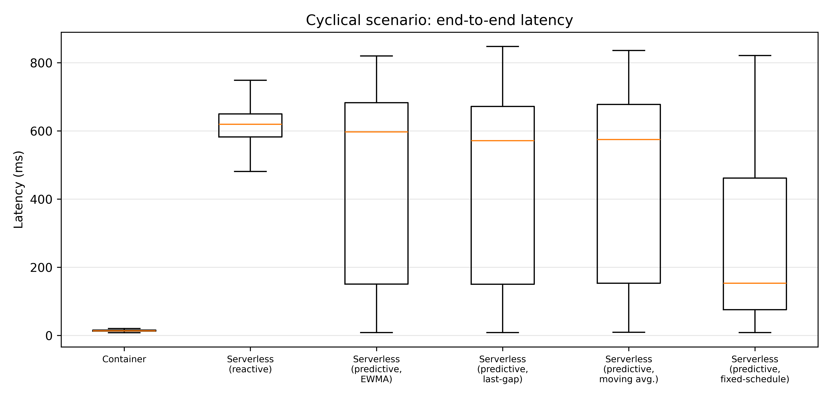
Figure 1. Cyclical scenario: end-to-end latency distribution by policy.
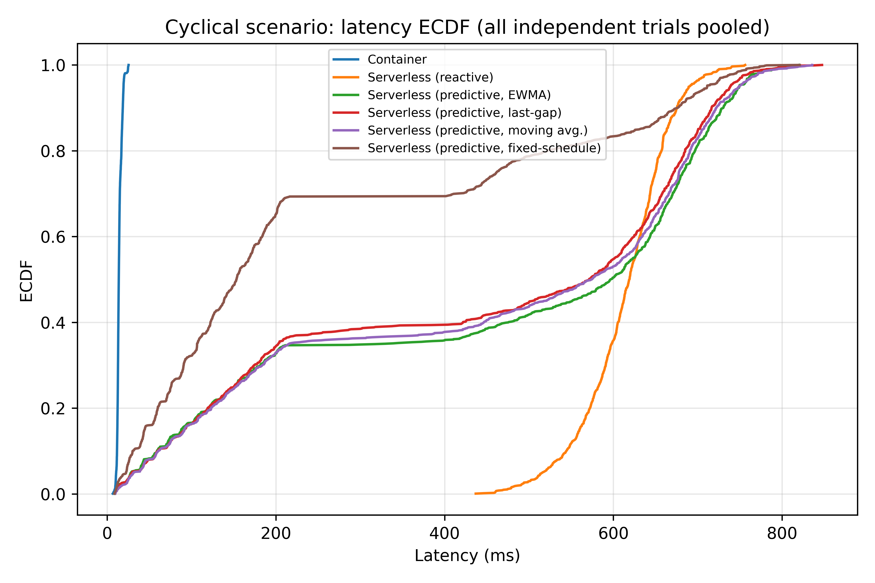
Figure 2. Cyclical scenario: empirical CDF of latency, all 15 independent trials pooled per policy. The fixed-schedule curve's early step to ~0.70 and the adaptive predictors' smaller step to ~0.35-0.40 are the visible signature of a two-population mixture: successfully pre-warmed cycles (near the container floor) versus missed cycles (rejoining the reactive population around 600-750 ms) -- the mechanism quantified in Section 5.5.

5.2 Statistical Significance
The primary result is the Friedman repeated-measures omnibus (Section 4.6): chi-squared=1.60, df=2, p=0.449 (low); chi-squared=0.40, df=2, p=0.819 (moderate) -- neither significant, so H1's descriptive container-fastest ordering is not statistically confirmed in either scenario at this sample size. Cyclical: chi-squared=56.49, df=5, p=6.45e-11 -- significant, licensing the planned contrasts of Table 3/3b. The Kruskal-Wallis omnibus (unpaired, secondary sensitivity result: H=65.25, p=9.96e-13 cyclical; H=3.66, p=0.160 low; H=1.86, p=0.395 moderate) agrees in direction with the primary paired analysis.
Table 3 reports Family A (H4): each predictive policy vs. reactive, paired Wilcoxon signed-rank, Holm-4 corrected. Table 3b reports Family B (RQ3): all six pairwise comparisons among the four predictors, Holm-6 corrected. Under this corrected design, all four predictive policies are statistically significant against reactive (Family A), reversing an earlier unpaired/merged-family analysis that had found only two of four surviving correction. Among the predictors themselves (Family B), the three adaptive forecasters are statistically indistinguishable from one another; fixed-schedule is significantly faster than all three, consistent with its structural opportunity-window advantage (Section 5.5) and its workload-informed period (Section 6, Section 8).
Table 3. Family A -- H4, each predictor vs. reactive, cyclical scenario, N=15 matched trials, paired Wilcoxon + Holm-4.
Predictor | Median(reactive) / median(predictor) (ms) | Median paired diff (ms) | Hodges-Lehmann diff (ms) [95% CI] | Wilcoxon p | Holm-adj. p | Sig. | Rank-biserial r
EWMA | 620.42 / 563.81 | -57.99 | -182.31 [-284.34, -1.52] | 0.0353 | 0.0361 | Yes | -0.617
Last-gap | 620.42 / 558.75 | -45.89 | -178.88 [-240.95, -17.03] | 0.0067 | 0.0201 | Yes | -0.767
Moving-average | 620.42 / 495.23 | -117.85 | -197.62 [-314.00, -24.21] | 0.0181 | 0.0361 | Yes | -0.683
Fixed-schedule | 620.42 / 153.54 | -466.94 | -466.62 [-475.23, -455.41] | 0.000061 | 0.000244 | Yes | -1.000
Table 3b. Family B -- RQ3, all pairwise predictor comparisons, N=15, paired Wilcoxon + Holm-6.
Comparison | Hodges-Lehmann diff (ms) [95% CI] | Wilcoxon p | Holm-adj. p | Sig.
EWMA vs Last-gap | -4.83 [n.s.] | 0.639 | 1.000 | No
EWMA vs Moving-average | +5.16 [n.s.] | 0.804 | 1.000 | No
Last-gap vs Moving-average | +5.68 [n.s.] | 0.804 | 1.000 | No
EWMA vs Fixed-schedule | +282.93 [171.07, 464.16] | 0.000061 | 0.000366 | Yes
Last-gap vs Fixed-schedule | +288.62 [220.92, 446.25] | 0.000061 | 0.000366 | Yes
Moving-average vs Fixed-schedule | +274.53 [137.86, 438.64] | 0.000061 | 0.000366 | Yes

5.3 Baseline Predictor Ablation
Table 4 isolates each forecaster's effect against the shared reactive baseline (EWMA -9.1%; last-gap -9.9%; moving-average -20.2%; fixed-schedule -75.3% change in median latency vs. reactive -- descriptive medians). Every one of these four descriptive reductions is confirmed statistically significant after the correct Holm-4 correction (Table 3: Holm-adjusted p=0.036 EWMA, 0.020 last-gap, 0.036 moving-average, 0.0002 fixed-schedule). mean_cold_starts_per_trial (last column) shows fixed-schedule also anticipates the most cold starts per trial (4.0 of a possible 5), while the three adaptive policies anticipate fewer (2.4-2.6). Section 5.5 shows this gap is explained almost entirely by how many opportunities the trial-independent protocol of Section 4.4 gives each forecaster to act at all, not by a difference in forecast accuracy once a forecaster has data to work with -- consistent with Family B's null results among the three adaptive forecasters.
Table 4. Baseline predictor ablation, cyclical scenario (n=15 trials each; median of trial-level medians).
Policy | Median of trial medians (ms) | Mean cold starts / trial | Wilcoxon vs. reactive p | % change vs. reactive
Container | 13.74 | 0.0 | <0.001 | -97.8
Serverless (reactive) | 620.42 | 15.0 | -- | --
Serverless (predictive, EWMA) | 563.81 | 12.6 | 0.035 | -9.1
Serverless (predictive, last-gap) | 558.75 | 12.6 | 0.007 | -9.9
Serverless (predictive, moving avg.) | 495.23 | 12.4 | 0.018 | -20.2
Serverless (predictive, fixed-schedule) | 153.54 | 11.0 | <0.001 | -75.3

5.4 Latency Decomposition: Queueing vs. Cold-Start Duration
Table 5 and Figure 3 decompose mean cyclical-scenario latency into its three server-side-measured components. The approximately 80% queueing incidence is largely implied by the tested 15-request burst against a three-instance concurrency cap: at most three requests can begin service immediately, leaving twelve of fifteen to wait. The empirical contribution of the experiment is therefore not the existence of this queueing incidence itself, but the measured queueing duration, its decomposition, and how it changes across policies. Four quantities are kept explicitly distinct: structural queueing incidence (arithmetic, 12/15=80%, not measured); measured queueing duration (Table 5, genuinely measured, 171-481 ms depending on policy); cold-start contribution (measured, 75-119 ms); and service-time contribution (measured, 2-8 ms). For every on-demand policy, measured queueing duration is 2.3-4.5 times larger than cold-start duration itself. This directly answers RQ2 with that qualification: the reactive policy's dominant cost is not, primarily, a cold-start cost in the naive sense -- it is a capacity-bound queueing cascade whose incidence is largely structural but whose duration and cross-policy variation are genuine measured findings. A single pre-warmed instance breaks part of this cascade, which is why every predictive policy's measured queueing duration drops substantially versus reactive (481 ms to 171-345 ms) even though at most one extra instance is ever pre-warmed per cycle -- but it cannot eliminate a bottleneck whose root cause is a fixed instance-count cap, not cold-start latency. Section 8.1 reports a supplementary experiment that raises this cap directly to test that reading.
Table 5. Cyclical scenario latency decomposition (mean ms; queue = waiting for capacity, cold = spawn + health-check, service = application call).
Policy | Queue (ms) | Cold-start (ms) | Service (ms) | Total (ms) | % requests queueing
Container | 0.00 | 0.00 | 8.48 | 14.37 | 0.0
Serverless (reactive) | 481.46 | 119.16 | 2.31 | 613.85 | 80.0
Serverless (predictive, EWMA) | 344.73 | 99.22 | 3.13 | 456.61 | 80.4
Serverless (predictive, last-gap) | 326.37 | 98.02 | 3.05 | 437.17 | 80.5
Serverless (predictive, moving avg.) | 337.44 | 97.29 | 3.08 | 447.60 | 81.0
Serverless (predictive, fixed-schedule) | 170.69 | 74.94 | 3.41 | 256.86 | 80.0
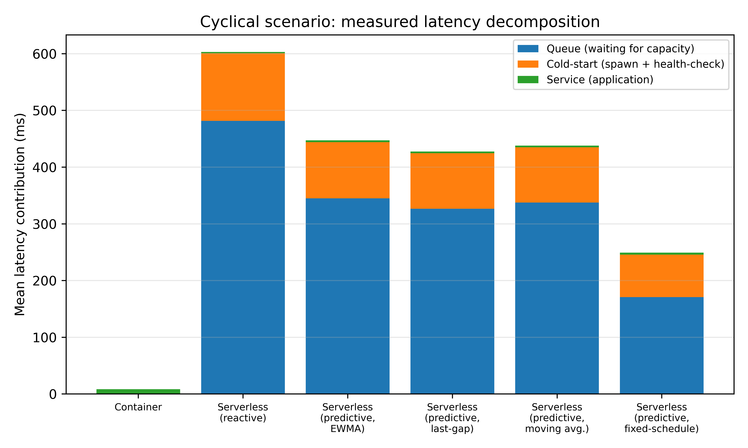
Figure 3. Cyclical scenario: mean latency decomposed into queue, cold-start, and service time.

5.5 Why Adaptive Forecasters Look Different Across Policies: An Opportunity-Normalized Analysis
Every cyclical trial contains 5 cycles but only 4 inter-burst gaps (a gap is only recorded, via a genuine external arrival, at the start of the burst that follows it -- see Section 4.4), so no forecaster can act before cycle 2 regardless of family: gap_observations averaged exactly 4.0 per trial for every policy. Fixed-schedule needs no observed gap at all -- only a reference point in time -- so its opportunity window is cycles 2-5 (4 opportunities); it converted 4.0 of 4.0 (100%) into an anticipated cold start. The three adaptive forecasters additionally need at least one observed gap before they can produce a non-null forecast, and that first gap only becomes available at the start of cycle 2 -- too late to help cycle 2 itself -- so their real opportunity window is cycles 3-5 (3 opportunities). EWMA and last-gap converted 2.4 of 3.0 (80%); moving-average converted 2.6 of 3.0 (87%). Once opportunity is normalized this way, all four forecasters exhibit high observed opportunity-conversion rates (80-100%) whenever they have the information needed to act. A direct paired-Wilcoxon comparison (Holm-adjusted over the six-pair family, Section 4.6) finds these rates statistically indistinguishable for five of six forecaster pairs, with one exception: last-gap's conversion rate is significantly lower than fixed-schedule's (Holm-adjusted p=0.040) -- consistent with last-gap's single-observation forecast being more exposed to gap-to-gap jitter than fixed-schedule's constant, structurally-always-available threshold.
This mechanism -- independent state resets, necessary for the trial-level statistics of Section 4.6 to be valid, systematically providing fewer actionable prediction opportunities to adaptive forecasters (which need at least one prior observation) than to non-adaptive ones (fixed-schedule, which needs none) -- is, to our knowledge, not previously flagged in the serverless pre-warming literature, and is a direct methodological consequence of fixing the pseudoreplication issue an external review raised. It explains a genuine magnitude/ranking difference among the four forecasters' raw cold-starts-avoided counts (Table 4) and, together with fixed-schedule's workload-informed period (Section 6, Section 8), the significant Family B gap between fixed-schedule and the three adaptive forecasters. It does not invalidate the trial-independent design (which remains necessary for valid statistics); it does mean that a single independent-trial run understates an adaptive forecaster's steady-state quality, which is why Section 5.6 additionally reports a run designed to measure that steady-state quality directly.

5.6 Persistent-State Learning Curve
Figure 4 reports the dedicated, no-reset, 25-cycle persistent-state run (Section 4.4) for the reactive and EWMA policies. The reactive policy holds flat at exactly 3 user-facing cold starts per cycle throughout (expected: MAX_INSTANCES=3, and reactive never pre-warms). EWMA starts at parity with reactive (3 cold starts, no history yet) but converges by cycle 3 to a steady 2 cold starts per cycle -- that is, EWMA anticipates one of the cycle's three cold starts ahead of the burst, so one of three is avoided and two remain user-facing -- and holds there, with only 3 blips back to 3 across the remaining 22 cycles (cycles 4, 17, 23). This is EWMA's observed persistent-state behavior over this 25-cycle run, uncomplicated by the opportunity deficit of Section 5.5: once given the chance to accumulate history, it reliably anticipates roughly one third of each burst's cold starts, consistent with the 80% per-opportunity success rate measured independently in the trial-level design.
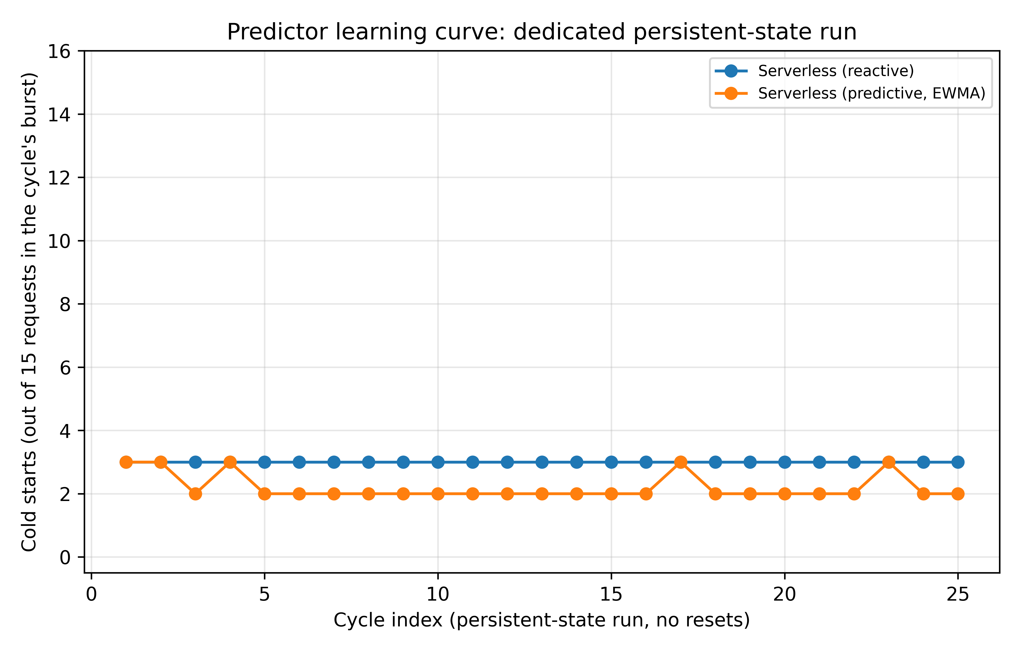
Figure 4. Persistent-state run (no resets, 25 cycles): cold starts per cycle, reactive vs. EWMA.

5.7 Resource Utilization
Table 6 reports mean aggregate CPU and memory for the three policies instrumented across every scenario (container, reactive, EWMA; the three additional predictive policies are covered by the CPU-second/GB-second cost model of Section 7, which is more meaningful for a bursty workload than an instantaneous mean). Both on-demand policies used substantially less resident memory than the always-on container pool under steady low load (101 MB vs. 164 MB, confirming H3) and under every other scenario. Aggregate CPU is higher for the on-demand policies than for the container pool in every scenario -- process spin-up/spin-down and gateway bookkeeping under bursty load cost more instantaneous CPU than three processes idling -- which is exactly why Section 7 integrates over time (CPU-seconds) rather than comparing instantaneous percentages, which can otherwise make an on-demand policy look more expensive than it is over a full duty cycle.
Table 6. Mean aggregate resource utilization per scenario and policy.
Scenario | Policy | Mean CPU % (sum) | Mean RSS (MB)
Low | Container | 1.70 | 163.77
Low | Reactive | 4.85 | 101.06
Low | Predictive (EWMA) | 4.75 | 101.19
Moderate | Container | 3.75 | 163.83
Moderate | Reactive | 5.68 | 95.62
Moderate | Predictive (EWMA) | 7.75 | 106.43
Cyclical | Container | 0.80 | 164.07
Cyclical | Reactive | 12.43 | 111.17
Cyclical | Predictive (EWMA) | 11.92 | 113.16
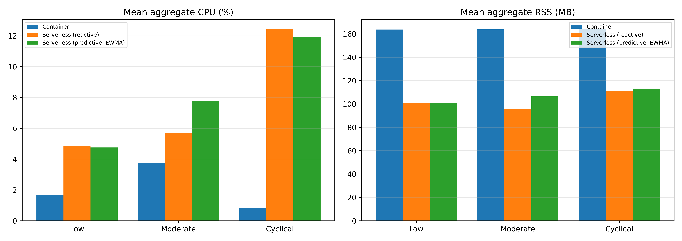
Figure 5. Mean aggregate CPU and RSS, container / reactive / predictive (EWMA), by scenario.

6. Discussion
Under low and moderate sustained-load conditions, all tested policies operate near their respective latency floors, and no statistically significant policy effect was established at the current sample size (Friedman chi-squared=1.60, p=0.449 low; chi-squared=0.40, p=0.819 moderate; Section 5.2). H1 is therefore statistically confirmed only for the cyclical scenario (Friedman chi-squared=56.49, p=6.45e-11; container significantly faster than every other policy, including fixed-schedule), and should be read as a consistent descriptive ordering elsewhere, not a confirmed effect at low/moderate load. H3 is supported: both on-demand policies use materially less memory than the always-on container pool (Table 6).
H2 is supported and, per Section 5.4, more precisely characterized than 'reactive is slow under bursts' -- the mechanism is specifically capacity-bound queueing (RQ2): only 20% of cyclical-scenario reactive requests were literally cold-started, yet 80% queued and 100% exceeded even a 50 ms threshold (Section 7), because a burst of 15 concurrent requests against a concurrency cap of 3 forces 12 of every 15 to wait behind whichever instance frees up first, regardless of whether that particular request would itself have been a cold start -- a queueing floor that is substantially, though not entirely, a structural consequence of the tested burst-size/capacity ratio (Section 5.4).
H4 is supported for all four predictive policies: under the corrected paired analysis (Table 3), all four lightweight forecasters achieve a statistically significant latency reduction relative to reactive after Holm-4 correction. The four are not interchangeable in magnitude, however (Table 3b, RQ3): fixed-schedule's effect is significantly larger than each of the three adaptive forecasters', which are in turn statistically indistinguishable from one another -- a ranking by effect size that does not track forecaster sophistication in the way that might naively be expected. This is explained not by forecast-quality differences among the adaptive forecasters (which Family B's null results argue against) but by a structural opportunity-window asymmetry (Section 5.5) compounded by fixed-schedule's workload-informed period -- an advantage the pilot sensitivity sweep of Section 8 shows is real but fragile: unaffected by under-estimating the true period by up to 50%, but largely erased by a 10% over-estimate and inverted at 50%. Section 5.5's opportunity-normalized analysis is retained as the paper's central methodological finding: independent state resets, necessary for valid trial-level statistics, are not neutral across forecaster families -- a forecaster that needs zero prior observations (fixed-schedule) is not handicapped by trial independence; one that needs at least one (the three adaptive families) structurally loses its first opportunity every single trial -- and a persistent-state run (Section 5.6) is needed alongside it to see an adaptive forecaster's steady-state quality.
Failure cases and boundary conditions.
Explicitly, predictive pre-warming does not help, and is not claimed to help, in the following cases observed directly in this data. (i) Steady or ramping traffic with no idle gaps (low, moderate scenarios): every forecaster correctly produces no anticipatory action beyond noise-level differences from reactive (Table 2; the omnibus test does not even reach significance here, Section 5.2) -- there is nothing to predict, and none of the four forecasters manufacture a false signal from none. (ii) The first 1-2 cycles of any freshly started (or freshly reset) predictor: Section 5.5 shows this is not a slow-convergence problem in the usual machine-learning sense (EWMA reaches steady state by cycle 3, Figure 4) but a hard information floor -- zero prior observations genuinely cannot support a forecast, for any forecaster in this family. (iii) Any burst whose arrival this cycle's forecast missed: a missed cycle for a predictive policy costs the same as every reactive-policy cycle (the ECDF's upper mass in Figure 2 rejoining the reactive curve around 600-750 ms) -- pre-warming has no mechanism to recover a burst it failed to anticipate. (iv) Most importantly, no forecaster in this family -- however accurate -- can close the gap to the container baseline while MAX_INSTANCES stays fixed below burst concurrency: anticipating one instance's cold start does not anticipate the other two, which is exactly why queueing (Section 5.4), not cold-start rate, remains the dominant residual cost even for fixed-schedule's 100%-opportunity-success case (Table 5's fixed-schedule row still shows 171 ms of mean queueing). Section 8.1 tests this last point directly by relaxing the capacity constraint itself.
The zero observed wasted pre-warms (Table 4, and the persistent-state run) is a favorable but workload-specific result: the cyclical scenario's jittered-but-bounded (8-10 s) idle period is well within reach of a 1.0 s-margin forecaster, and fixed-schedule's constant assumption matches the workload's true (near-)periodicity almost exactly by construction. A workload with heavier-tailed or genuinely bimodal idle-period distributions would likely produce both false positives (wasted pre-warms, a cost this paper's harness measures but never observed) and false negatives at a materially different rate for every forecaster in this family, and would very plausibly reverse fixed-schedule's advantage over the adaptive forecasters specifically, since fixed-schedule's strength here is inseparable from the workload actually being close to periodic. This is exactly the kind of workload-dependence the cost model in Section 7 is designed to let a practitioner re-evaluate with their own traffic pattern rather than take this paper's specific ranking as universal.

7. Cost-Latency Break-Even Model
Costs are reported as integrated CPU-seconds and GB-seconds per trial (Riemann-summed from the 5 Hz resource samples of Section 4.5), not instantaneous percentage/megabyte snapshots, because a bursty workload's instantaneous readings can misrepresent its true duty-cycle cost in either direction. For reference, the low scenario (5 req/s continuous, not an idle baseline -- there is no genuinely idle scenario in this workload suite by design) shows container costing 0.204 CPU-s and 1.909 GB-s per trial versus reactive's 0.587 CPU-s and 1.184 GB-s: the container pool is cheaper in CPU-time even under continuous light load, and more expensive in memory-time, the expected always-on trade-off.
Table 7. Cyclical-scenario mean cost per trial and SLA-violation rate by latency threshold.
Policy | CPU-s / trial | GB-s / trial | Viol. >50ms | Viol. >100ms | Viol. >200ms
Container | 0.358 | 7.212 | 0.0% | 0.0% | 0.0%
Serverless (reactive) | 5.678 | 5.237 | 100.0% | 100.0% | 100.0%
Serverless (predictive, EWMA) | 5.399 | 5.307 | 91.7% | 83.5% | 67.3%
Serverless (predictive, last-gap) | 6.151 | 5.304 | 92.0% | 83.7% | 65.6%
Serverless (predictive, moving avg.) | 5.370 | 5.304 | 91.9% | 83.7% | 67.1%
Serverless (predictive, fixed-schedule) | 6.772 | 5.354 | 84.0% | 67.8% | 34.8%
Two of the four predictive policies (EWMA and moving-average) are cost-neutral-to-cheaper than reactive in CPU-seconds (5.399 and 5.370 vs. 5.678) while still reducing SLA violations at the 200 ms threshold by 16.3-16.5 percentage points -- an unambiguous win with no resource trade-off to weigh. Last-gap and fixed-schedule cost more CPU-time (+8.3% and +19.3%) in exchange for larger violation-rate reductions (16.3 and 32.2 percentage points at the 100 ms threshold); whether that trade is worthwhile depends on the reader's own cost per SLA violation, which this paper cannot assume. The general decision rule, in measured units only:
Adopt a predictive policy over reactive when: (cost per SLA violation) / (cost per CPU-second) > (policy's extra CPU-seconds per trial) / (violation-rate reduction, as a fraction, x requests per trial).
The numerator and denominator for every policy are in Table 7 and in the repository's roi_breakeven.json / cost_seconds_table.csv, so a reader can substitute their own cost-per-violation and cost-per-CPU-second and get a policy-specific answer rather than trust this paper's specific ratio, which was measured on one workload shape and one capacity setting (Section 8.1).

8. Supplementary Analysis: Capacity and Sensitivity

8.1 Does the Effect Persist at Higher Capacity?
Section 5.4 identified capacity-bound queueing (MAX_INSTANCES=3 against a 15-request burst) as the dominant latency cost, ahead of cold-start duration itself. The direct follow-up question -- does predictive pre-warming's benefit shrink, once queueing is no longer the bottleneck? -- was tested by re-running the full cyclical scenario (all six policies, 15 independent trials each, identical seeds and workload) with MAX_INSTANCES raised from 3 to 8, comfortably above the point where queueing should dominate.
The result is not the clean answer that question anticipated, and we report it in full because what it does show is itself methodologically important. Raising capacity made every policy slower, not faster: reactive's median latency rose from 619.2 ms to 1,908.2 ms, and its cold-start rate rose from 20.0% to 53.3% (Table 8) -- while the container policy, which never spawns instances and is structurally unaffected by MAX_INSTANCES, stayed within measurement noise (13.7 ms to 14.9 ms), confirming this is not a general host slowdown between the two runs but specific to the elastic gateway's spawning behavior.
The mechanism is capacity contention on the benchmarking host itself, not a property of the policies being compared. This host provisions 2 virtual CPUs (Section 4.1). At MAX_INSTANCES=3, at most 3 of a burst's 15 requests can ever be the one that triggers a cold start -- 3/15 = 20.0%, matching the measured rate exactly. At MAX_INSTANCES=8, up to 8 can -- 8/15 = 53.3%, again matching almost exactly. Spawning up to 8 concurrent Python subprocesses on a 2-vCPU host oversubscribes it far more severely than spawning up to 3 does, and mean cold-start duration inflates accordingly: from 119 ms to 1,018 ms for the reactive policy (Table 8). Queueing time, far from falling, rose as well (481 ms to 857 ms): with up to 8 requests now each individually triggering a (much slower, contention-inflated) cold start, a queued request more often waits behind a slow concurrent spawn rather than a merely-busy warm instance. Raising capacity did not relieve the bottleneck this experiment intended to test -- it moved it. In short: on this single, CPU-constrained host, MAX_INSTANCES is not a clean proxy for 'capacity' in the queueing-theory sense used in Section 5.4 -- raising it shifts contention from the software-level queue to the hardware-level scheduler, and the two are confounded here in a way a genuinely multi-core or multi-node deployment (the repository's real-infra/ Kubernetes package, Section 4.1) would not be.
Table 8. Capacity sensitivity: MAX_INSTANCES=3 (primary) vs. MAX_INSTANCES=8 (supplementary), cyclical scenario.
Policy | Median ms (cap.=3) | Median ms (cap.=8) | Cold-start % (cap.=3) | Cold-start % (cap.=8) | Mean queue ms (cap.=8) | Mean cold ms (cap.=8)
Container | 13.71 | 14.90 | 0.0 | 0.0 | 0.00 | 0.00
Serverless (reactive) | 619.21 | 1908.21 | 20.0 | 53.3 | 857.42 | 1017.68
Serverless (predictive, EWMA) | 597.02 | 1762.98 | 16.8 | 50.1 | 516.78 | 895.67
Serverless (predictive, last-gap) | 571.37 | 1778.75 | 16.8 | 50.0 | 506.61 | 896.09
Serverless (predictive, moving avg.) | 574.70 | 1776.73 | 16.5 | 50.1 | 522.45 | 896.07
Serverless (predictive, fixed-schedule) | 153.13 | 1545.89 | 14.7 | 48.0 | 199.33 | 810.46
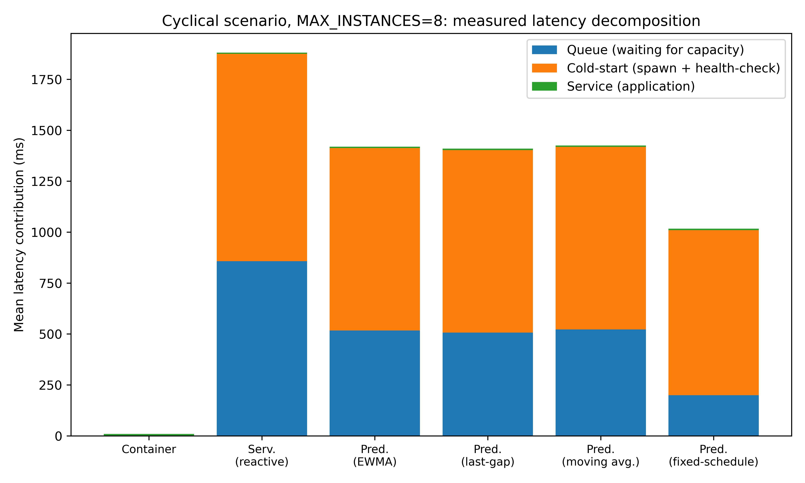
Figure 6. MAX_INSTANCES=8: measured latency decomposition. Compare against Figure 3 (MAX_INSTANCES=3): queueing (blue) no longer dominates -- cold-start time (orange), inflated by host-level CPU contention among up to 8 simultaneous spawns, does.
Despite this confound, the relative ranking among policies is preserved, and every predictive policy -- including EWMA and moving-average, which did not survive an earlier, since-corrected significance test at MAX_INSTANCES=3 -- now reduces trial-level median latency significantly versus reactive (percentage reductions -8.1%, -7.6%, -7.8%, and -18.8% for EWMA, last-gap, moving-average, and fixed-schedule respectively; significance under the previous draft's unpaired Mann-Whitney/Holm test, retained here as a secondary result pending the same paired-analysis revision as the primary comparison of Section 4.6). Fixed-schedule again produces the largest reduction, and its mean cold-start time is also the lowest of the five on-demand rows (810 ms vs. 896-1,018 ms) -- consistent with pre-warming one instance ahead of the burst reducing not only that one request's latency but also, secondarily, the peak number of simultaneous spawns the host has to service, which is itself now the dominant cost. We read this supplementary result as suggestive rather than conclusive on the original question (whether prediction still helps once queueing is relieved): it is confounded by this host's CPU budget rather than a clean test of capacity alone, and the honest conclusion is that this specific question needs re-running on hardware with headroom to actually parallelize 8 concurrent cold starts -- precisely what the real-infra/ Kubernetes package (Section 4.1) is for. We report it in full, confound included, rather than omit a result that did not confirm the expected direction. This is the direct evidence motivating the treatment, below, of real-platform validation as a near-term requirement rather than only a longer-term extension: if this host confounds a deliberately-triggered MAX_INSTANCES=8 comparison this visibly, its potential effect on the primary MAX_INSTANCES=3 numbers cannot simply be assumed away.

8.2 Sensitivity Sweeps: Fixed-Schedule Period and Keep-Alive Timeout
Section 2.5 discloses that fixed-schedule's period (9.0 s) was set as the midpoint of the workload generator's own 8.0-10.0 s jittered range -- chosen with knowledge of the workload's own parameters, not blind. Section 4.1.2 raises the symmetric question for a non-predictive alternative: a keep-alive timeout raised past the workload's idle gap. Both are tested here as a real pilot: N=6 independent, seed-matched trials per new condition (reusing the identical, unmodified measurement path of Section 4.4 with only the swept constant changed), against the already-collected N=15 primary-run data reused as the nominal point (fixed-schedule 9.0 s, keep-alive 6.0 s). A full N=15 confirmatory run at every swept level remains recommended before this sweep is treated as more than indicative.
Table 9. Fixed-schedule period sensitivity sweep, N=6 pilot per swept condition (N=15 at the 9.0 s nominal point).
Period (s) | % vs. nominal | Mean-of-trial-median latency (ms) | Mean P95 (ms) | Mean P99 (ms) | Cold-start rate | Opportunity-success rate
4.5 | -50% | 147.9 | 803.2 | 821.8 | 14.7% | 100%
6.75 | -25% | 150.4 | 780.2 | 830.9 | 14.7% | 100%
8.1 | -10% | 150.0 | 775.0 | 795.4 | 14.7% | 100%
9.0 (N=15) | nominal | 152.6 | 698.2 | 723.2 | 14.7% | 100%
9.9 | +10% | 502.5 | 800.2 | 819.6 | 15.8% | 79.2%
11.25 | +25% | 748.0 | 834.6 | 849.9 | 19.1% | 16.7%
13.5 | +50% | 754.8 | 825.9 | 847.7 | 20.0% | 0.0%
Table 10. Keep-alive/idle-timeout sensitivity sweep, N=6 pilot per swept condition (N=15 at the 6.0 s nominal point).
Idle timeout (s) | Mean-of-trial-median latency (ms) | Mean P95 (ms) | Mean P99 (ms) | Cold-start rate
6.0 (N=15, nominal) | 618.5 | 687.5 | 703.4 | 20.0%
8.0 | 763.2 | 857.6 | 875.9 | 19.6%
10.0 | 52.2 | 767.8 | 788.8 | 4.0%
12.0 | 51.9 | 776.1 | 805.0 | 4.0%
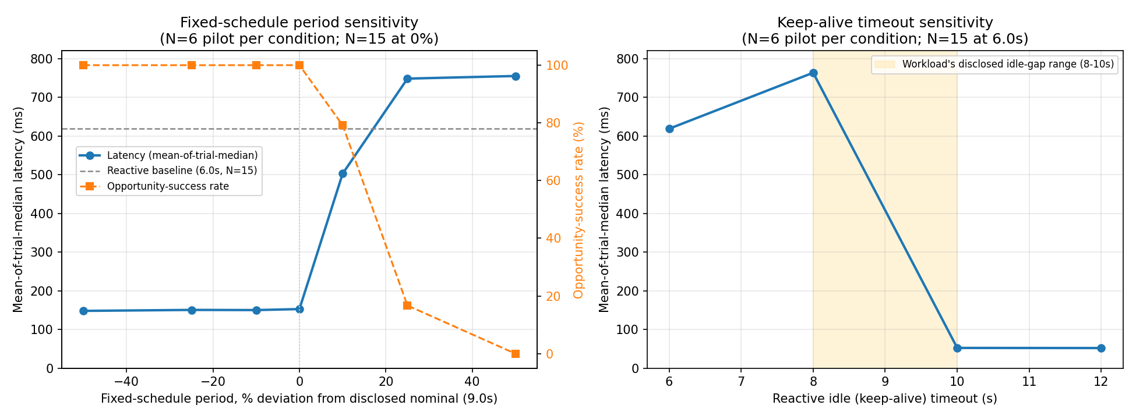
Figure 7. Left: fixed-schedule period sensitivity -- latency (blue, left axis) and opportunity-success rate (orange, right axis) vs. percent deviation from the disclosed nominal period. Right: keep-alive timeout sensitivity -- latency vs. idle timeout, with the workload's disclosed idle-gap range shaded.
Fixed-schedule's advantage is essentially flat for every under-estimate tested (-50% to -10%): latency is statistically indistinguishable from the nominal point across this entire range, and the opportunity-success rate stays at 100% throughout. Over-estimating the period is a sharply asymmetric story: at +10% the opportunity-success rate is still high (79.2%) yet mean-of-trial-median latency has already jumped 3.3x (152.6 ms to 502.5 ms) -- consistent with a prewarm that fires late enough to be technically 'before the burst' but too close to it to meaningfully drain the concurrency-capped queue ahead of time, not with an outright miss. At +25% and +50% the opportunity-success rate collapses toward zero and latency converges toward, and at +50% slightly exceeds, the plain reactive baseline's own latency (754.8 ms vs. 618.5 ms) -- a large enough period mismatch turns fixed-schedule from the best policy tested into a policy no better, and in this pilot marginally worse, than doing nothing predictive at all. This substantiates the fairness caveat carried in the Abstract, Discussion, and Conclusion: fixed-schedule's measured advantage is real but is not a free property of the policy itself.
For the keep-alive baseline, 8.0 s -- the workload's own disclosed minimum idle gap -- produces no latency or cold-start benefit over the 6.0 s baseline; crossing to 10.0 s or 12.0 s -- at or above the workload's own disclosed maximum 10.0 s idle gap -- produces a sharp, large improvement instead of a gradual one (cold-start rate falls from 20% to 4%; latency falls roughly 12-fold): the benefit is a step function tied to crossing the workload's true upper bound, not a smoothly increasing return to a longer timeout. A round, non-oracle value at the workload's own disclosed upper bound (10.0 s) already captures effectively all of the benefit an oracle-tuned choice would provide, so the keep-alive family's competitiveness with predictive pre-warming does not depend on privileged knowledge of the workload generator's source code -- only on having observed, or been told, the traffic's own rough idle-time range, which is also exactly the information a deployed histogram-based policy such as Shahrad et al.'s [4] would learn from production traffic directly. Cost (CPU-seconds/GB-seconds per trial) is not reported for either sweep: the pilot orchestration script's resource-sample records lack a per-condition tag, so per-trial cost cannot be reliably attributed per swept condition from this pilot; this does not affect the latency, cold-start, or opportunity-success numbers above, which come directly from each condition's own per-request raw data.

8.3 Note on Construct Validity and Real-Platform Validation
No cluster/container infrastructure was available to run a confirmatory Kubernetes/Knative validation in this study. Because the current evidence base is single-host process emulation (Section 4.1.1), and Section 8.1 shows this host's CPU budget can materially distort cold-start and queueing measurements under a deliberately-triggered capacity change, this paper's findings should be read as characterizing a controlled, process-level emulation of serverless lifecycle behavior and its interaction with a fixed concurrency cap (Section 4.7), pending the real-Kubernetes/Knative validation planned as the first item of Section 9's future work. The repository's real-infra/ package (Kubernetes Deployment and Knative Serving manifests, plus automation scripts) is intended to make that validation a direct extension of this same harness, not a rewrite.

9. Conclusion and Future Work
This study presented an openly reproducible, six-way comparison of an always-on container deployment, a purely reactive on-demand deployment, and four lightweight predictive pre-warming policies under repeated idle-then-burst traffic. A latency decomposition identified capacity-bound queueing -- partly structural, partly measured -- as the dominant cost (Section 5.4), well ahead of cold-start duration itself. Against that mechanism, all four lightweight forecasters achieved statistically significant latency reductions relative to reactive (Section 4.6), of substantially different magnitudes not explained by raw forecast quality among the three adaptive forecasters (which are statistically indistinguishable from one another, Section 4.6/RQ3) but by a structural opportunity-window asymmetry specific to adaptive forecasters under an independent-trial evaluation protocol (Section 5.5), compounded by fixed-schedule's workload-informed period (Section 6, Section 8) -- confirmed descriptively by a separate persistent-state run for EWMA (Section 5.6), and shown by a pilot sensitivity sweep (Section 8.2) to be fragile under period over-estimation specifically. Every number in this paper, the raw data behind it, and the methodological corrections and pilot experiments that produced this picture are disclosed and independently reproducible from the published repository.
Future work: (1) Real-platform validation -- re-running the primary comparison on real Docker containers and a real Knative deployment (manifests and automation scripts already in the repository's real-infra/ package), now treated as a near-term confirmatory requirement (Section 8.3) rather than a longer-term extension. (2) A full N=15 confirmatory run of both Section 8.2 pilot sweeps (fixed-schedule period, keep-alive timeout), including a corrected, per-condition-tagged resource-cost measurement. (3) Direct forecast-quality metrics (MAE, signed bias, timing error) computed at the trial level, to fully answer RQ3 alongside the predictor-vs-predictor family already tested. (4) A persistent-state comparison extended to last-gap and moving-average, alongside EWMA (Section 5.6). (5) Extending the predictor to anticipate burst concurrency, not just arrival time, so that a correctly anticipated cycle pre-warms enough capacity to avoid queueing entirely rather than only shortening it, directly addressing the residual gap to the container baseline identified in Section 6. (6) Benchmarking this paper's forecaster family directly against the heavier RNN [26] and MPC [27] approaches, and against Shahrad et al.'s [4] deployed histogram/ARIMA policy, on the same harness. (7) A workload-robustness campaign (non-periodic idle-gap distributions and an additional burst-size/capacity ratio), where the false-positive/false-negative trade-off flagged in Section 6 and fixed-schedule's workload-specific advantage are both expected to become material.

Declarations
Competing Interests: The author declares no competing interests.
Funding: This research received no external funding.
Author Contributions: Conceptualization, methodology, software, validation, formal analysis, investigation, data curation, writing (original draft, review & editing): Z.A. (sole author).
Data and Code Availability: All raw experimental data (11,187 timestamped requests), the complete benchmarking harness (application, container-based gateway, elastic on-demand gateway with reactive and four predictive modes, load generator), the statistical analysis and cost-model scripts, a real-Kubernetes/Knative validation package, a full changelog of the methodological corrections made during this study, and every figure/table in this manuscript are openly available at: https://github.com/<GITHUB_USERNAME>/edge-faas-container-benchmark (archived release with a citable DOI via Zenodo).
Research Involving Human and/or Animal Subjects: Not applicable.
Informed Consent: Not applicable.
Generative AI Use Declaration: During preparation of this work, the author used ChatGPT (OpenAI) and Claude (Anthropic) for manuscript-structure and language assistance, methodological critique, literature cross-checking, and software-development support for the accompanying benchmarking harness, including identifying and fixing the two methodological bugs disclosed in Section 4.4. These were pre-submission AI-assisted methodological critiques, not formal journal peer reviews. All methodological decisions, source verification, code, experimental execution, statistical analyses, and manuscript content were reviewed and validated by the author, who takes full responsibility for the content of this publication.

References
[1] Shi, W.; Cao, J.; Zhang, Q.; Li, Y.; Xu, L. Edge Computing: Vision and Challenges. IEEE Internet Things J. 2016, 3, 637-646.
[2] Satyanarayanan, M. The Emergence of Edge Computing. Computer 2017, 50, 30-39.
[3] Jonas, E.; et al. Cloud Programming Simplified: A Berkeley View on Serverless Computing. arXiv:1902.03383, 2019.
[4] Shahrad, M.; et al. Serverless in the Wild: Characterizing and Optimizing the Serverless Workload at a Large Cloud Provider. USENIX ATC 2020, 205-218.
[5] Eismann, S.; et al. The State of Serverless Applications. IEEE TSE 2022, 48, 3158-3182.
[6] Yu, H.; et al. Characterizing Serverless Platforms with ServerlessBench. ACM SoCC 2020, 30-44.
[7] Maissen, P.; et al. FaaSdom: A Benchmark Suite for Serverless Computing. DEBS 2020, 73-84.
[8] Copik, M.; et al. SeBS: A Serverless Benchmark Suite for FaaS Computing. Middleware 2021, 64-78.
[9] Kjorveziroski, V.; Zdraveski, V.; Sotiroski, K. Container-Based vs. Serverless Computing at the Edge: Performance Evaluation and Comparative Analysis. Computers 2021, 10, 130.
[10] Fuerst, A.; Sharma, P. FaasCache: Keeping Serverless Computing Alive with Greedy-Dual Caching. ASPLOS 2021, 386-400.
[11] Decker, J.; Kasprzak, P.; Kunkel, J.M. Performance Evaluation of Open-Source Serverless Platforms for Kubernetes. Algorithms 2022, 15, 234.
[12] Trieu, Q.L.; et al. Performance Evaluation of Serverless Edge Computing for ML Applications. arXiv:2210.10331, 2022.
[13] Xiong, Q.; et al. Extending Cloud to Edge with KubeEdge. IEEE/ACM SEC 2018, 353-355.
[14] Kim, S.; et al. Local Scheduling in a KubeEdge-Based Edge Computing Environment. Sensors 2023, 23, 1522.
[15] Nguyen, T.-T.; et al. Horizontal Pod Autoscaling in Kubernetes for Elastic Container Orchestration. Sensors 2020, 20, 4621.
[16] Augustyn, D.R.; Wyciślik, L.W.; Sojka, M. Tuning a Kubernetes HPA for Performance and Load Demands. Applied Sciences 2024, 14, 646.
[17] Pozdniakova, O.; Mažeika, D.; Cholomskis, A. SLA-Adaptive Threshold Adjustment for a Kubernetes HPA. Electronics 2024, 13, 1242.
[18] Tran, T.-D.; Kim, J.-H. Optimized Resource Usage via a Hybrid Auto-Scaling System for Knative Serverless Edge Computing. FGCS 2024, 152, 1-15.
[19] Mittal, V.; et al. Mu: An Efficient, Fair and Responsive Serverless Framework for Resource-Constrained Edge Clouds. ACM SoCC 2021, 59-73.
[20] Shafiei, H.; Khonsari, A.; Mousavi, P. Serverless Computing: A Survey. ACM Comput. Surv. 2022, 54, 1-40.
[21] Raith, P.; Nastic, S.; Dustdar, S. Serverless Edge Computing -- Where We Are and What Lies Ahead. IEEE Internet Computing 2023, 27, 50-60.
[22] Cassel, G.A.S.; et al. Serverless Computing for Internet of Things: A Systematic Literature Review. FGCS 2022, 128, 299-316.
[23] Pan, L.; Chen, K.; He, Z.; Chen, X. Retention-Aware Container Caching for Serverless Edge Computing. IEEE INFOCOM 2022, 1-10.
[24] Ghorbian, M.; Ghobaei-Arani, M. Function Offloading Approaches in Serverless Computing: A Survey. Comput. Electr. Eng. 2024, 120, 109832.
[25] Eismann, S.; Grohmann, J.; van Eyk, E.; Herbst, N.; Iosup, A. Predicting the Costs of Serverless Workflows. ICPE 2020, 257-264.
[26] Hu, Q.; Li, H.; Nikougoftar, E. Mitigating cold start problem in serverless computing using predictive pre-warming with machine learning. Computing 2025, 107, 27.
[27] Nguyen, C.; Bhuyan, M.; Elmroth, E. Taming Cold Starts: Proactive Serverless Scheduling with Model Predictive Control. Proceedings of the 33rd IEEE International Symposium on the Modeling, Analysis, and Simulation of Computer and Telecommunication Systems (MASCOTS 2025), DOI: 10.1109/MASCOTS67699.2025.11283271 (originally arXiv:2508.07640, 2025).

