Zachary Ikpefua

Performance Analysis

Implementation:

I chose a one way linked list implementation because it is easier to imagine a one way linked list. I feel like a one way linked list would be faster for searching items because there is only one way that the list can go. This is the most efficient for searching and allocating memory because of the last reason, the speed. The first fit is slower than the best fit. This means that the best fit policies are better because it leads to less fragmentation issues. The rover could affect fragmentation by pointing to a location where the information is not needed. Coalescing dramatically decreases the run time of the program and decreases the fragmentation to an almost zero amount.

Tests:

Equilibrium without coalescing [first fit]

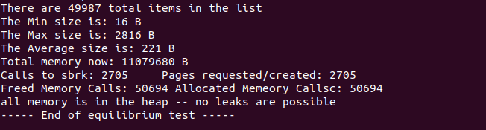

Equilibrium with coalescing [first fit]

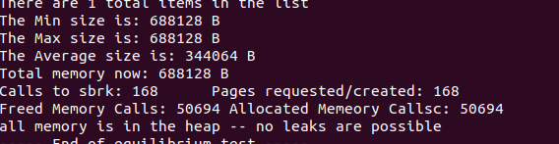

Special Case –r 0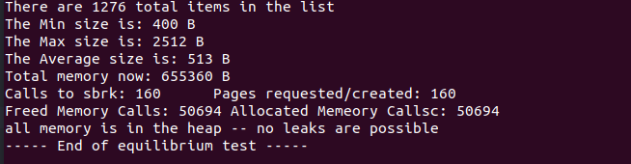

Comparing to the system free and system malloc has a slight decrease in both time and in size. In other words, the system malloc and free are faster than our implementation with coalescing