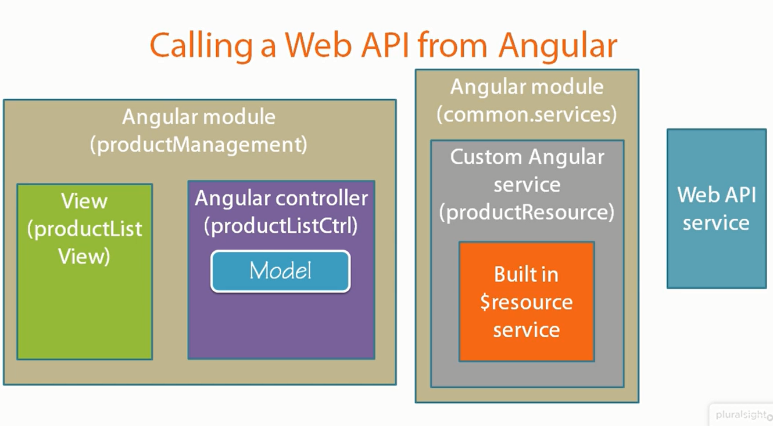

Serialization:

Is the process of translating data structures or object state into a format that can be stored or transmitted across a network connection. In ours case that will be json or XML. Client can request json or xml in Header (Accept: application/json), framework will automatically translate business object from controller (Model) to json or XML through Serializer.

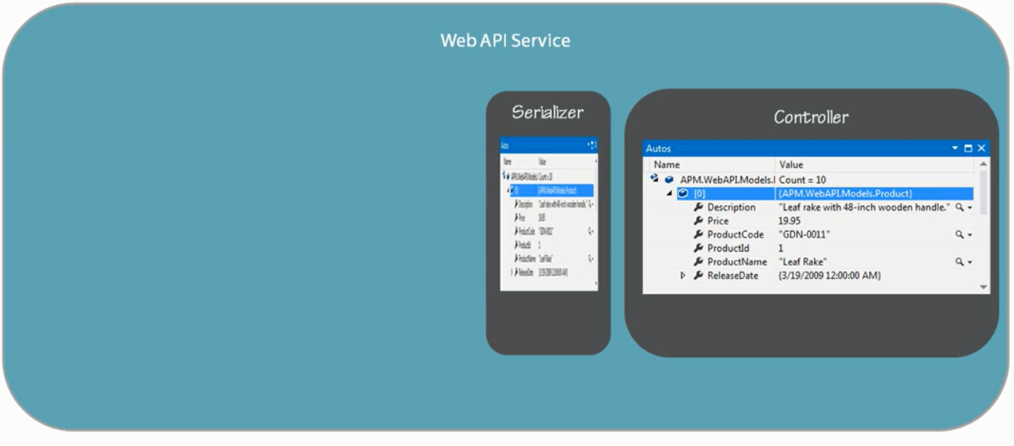

Serializer defines property like is define in Business logic,

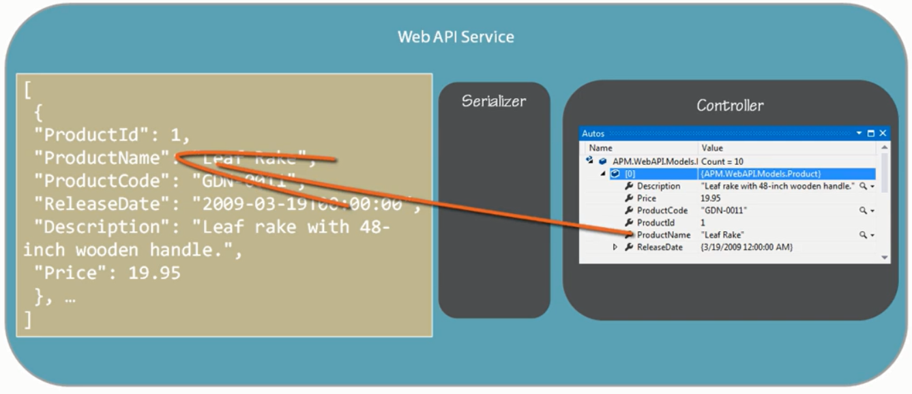

this is **problem** because Angular is Case sensitive then we use

ProductCase - Pascal Case is property on web api side

productCase - Camel Case is on angular side

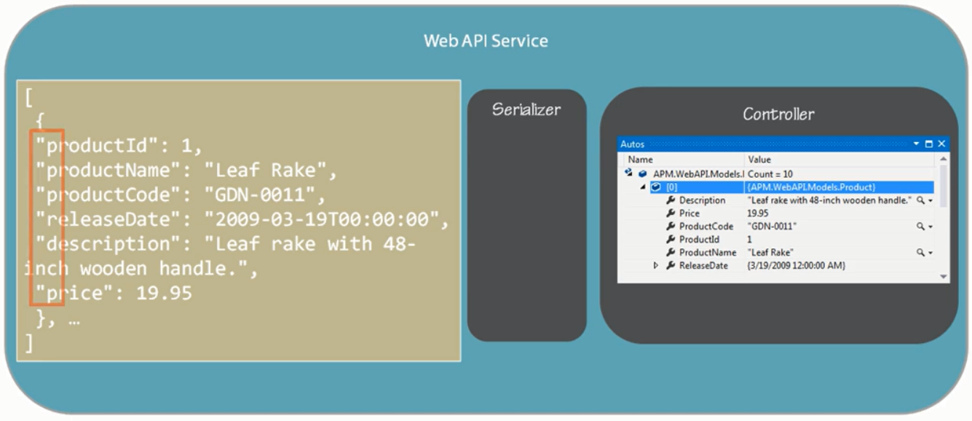

Web api provides json and xml serializations

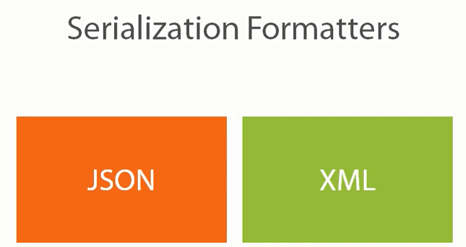

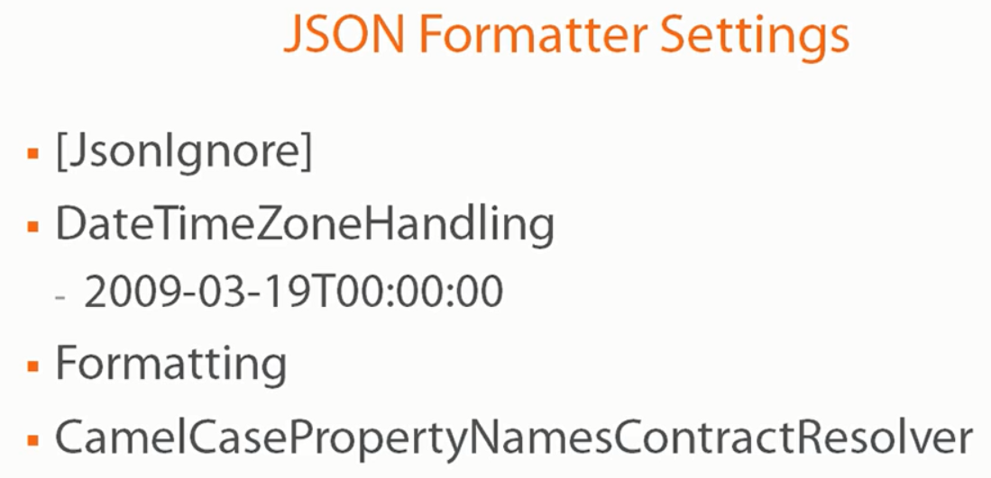

Two way of passing parameters with **Query Strings or URL Path**

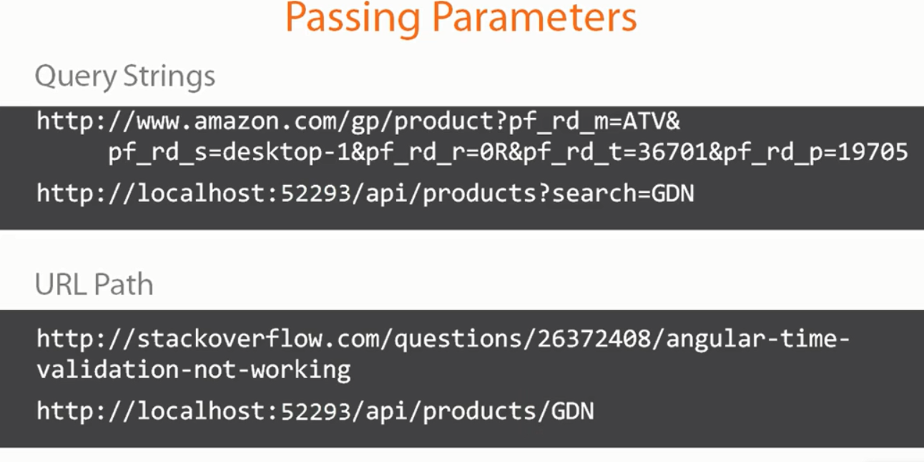

**URL path** is more complex because not using ? to separated url with parameters and routing don’t know what is parameter and what is url.

**Angular side Query String:**

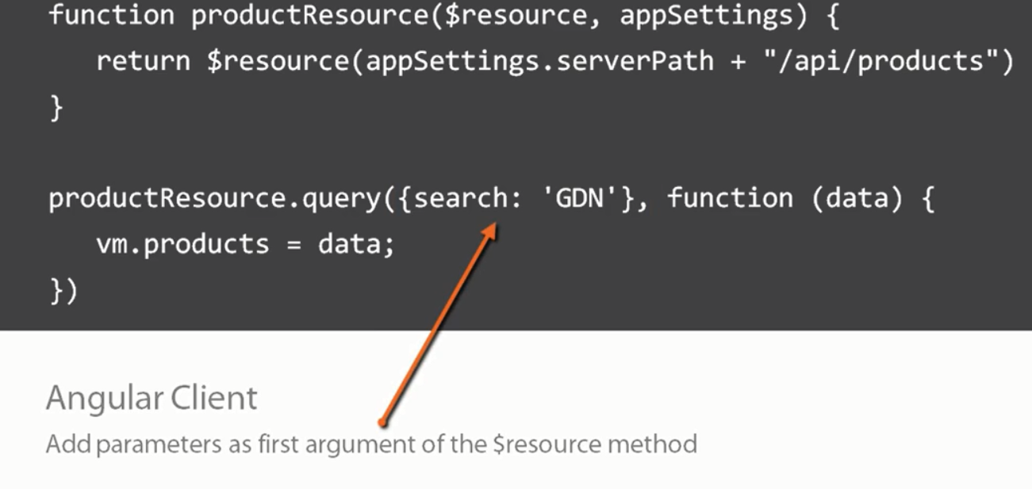

**Angular side URL path:**

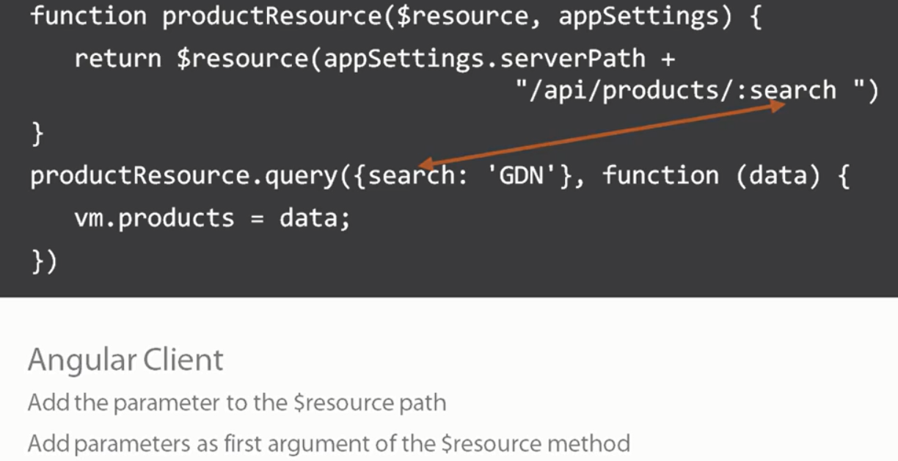

Web api side Query String:



Web api side URL Path:

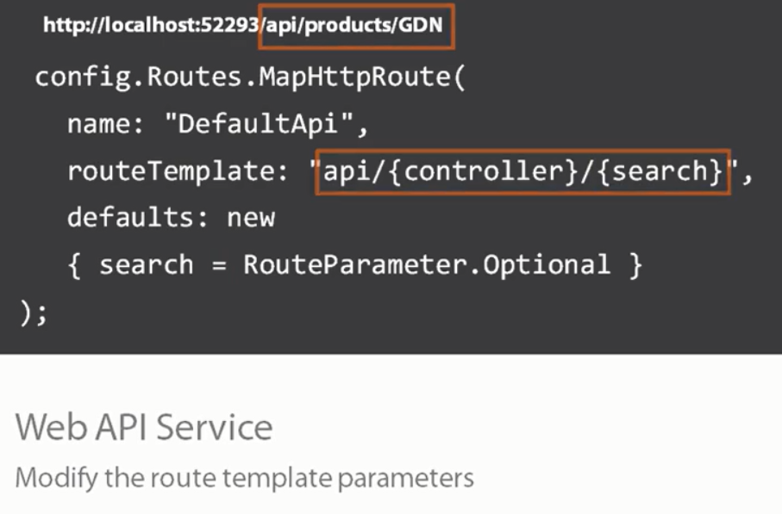

**Difference between Query String and URL path**

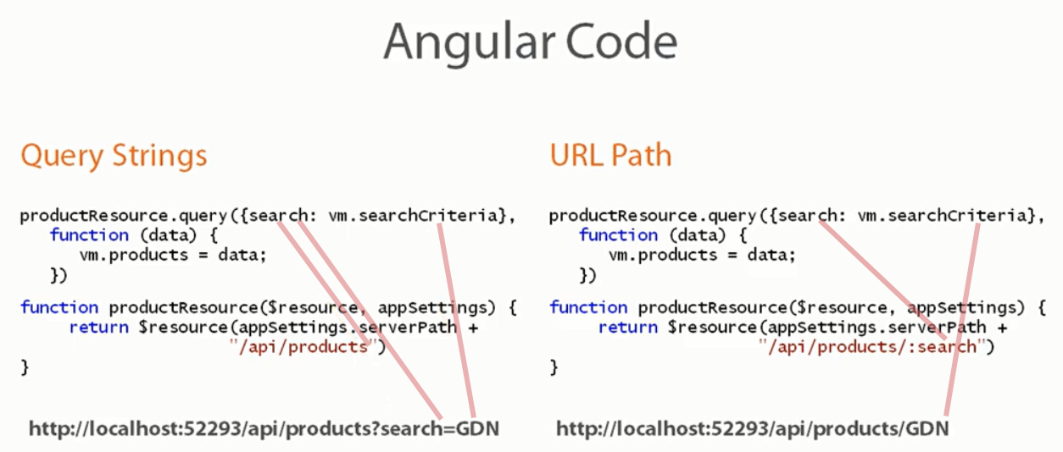

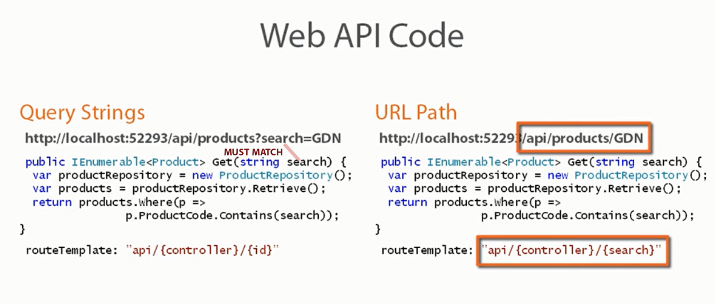

**Save data**

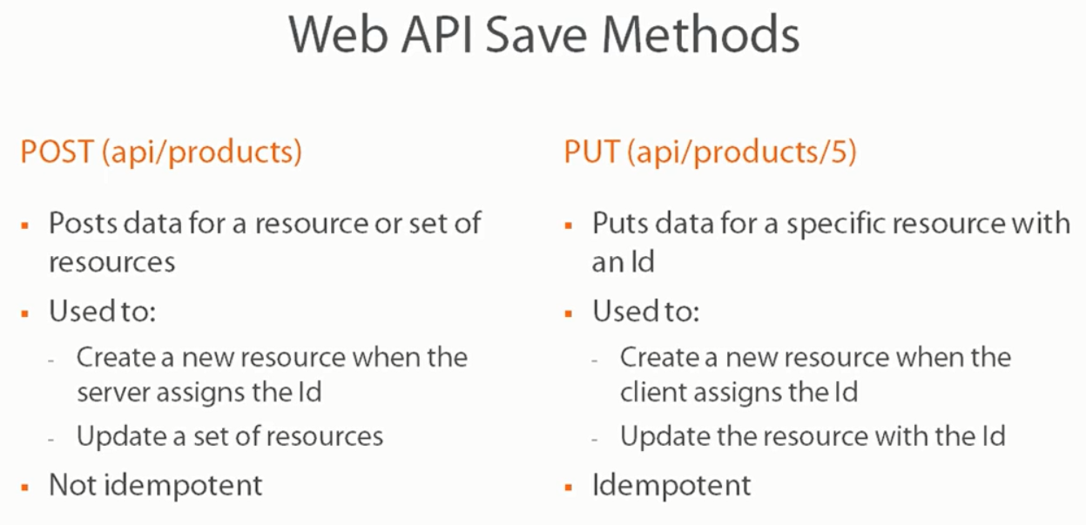

Idempotent – multiple same put request not have additional effect

Not Idempotent – multiple post request not have same effect for e.g. we will have multiple records in database.