
UNIVERSITI TEKNIKAL MALAYSIA MELAKA

FACULTY OF INFORMATION TECHNOLOGY AND COMMUNICATION

DISTRIBUTED APPLICATION DEVELOPMENT
BITP 3123

Group Project: Pop Quiz

NAME | MATRIC NO
CHUAH MING XUAN | B032320027
MUHAMMAD ZIKRI BIN KASHIM | B032320063
ISKANDAR ZULKANAIN BIN ROSMI | B032320033
KHAIRUL ADZHAR BIN NORAIDI | B032320036
MUHAMMAD HAZIQ BIN FADHLAN FAIZAL | B032320052
MUHAMMAD QIWAMUDDIN ABQARI BIN NOREFENDI | B032320057
WAN MOHAMAD IRFAN BIN MOHD ROSLAN | B032320101

PRESENTATION VIDEO

https://www.youtube.com/watch?v=S4xIYNnN9cI

ERD IN MSSQL
-docker service in the remote server

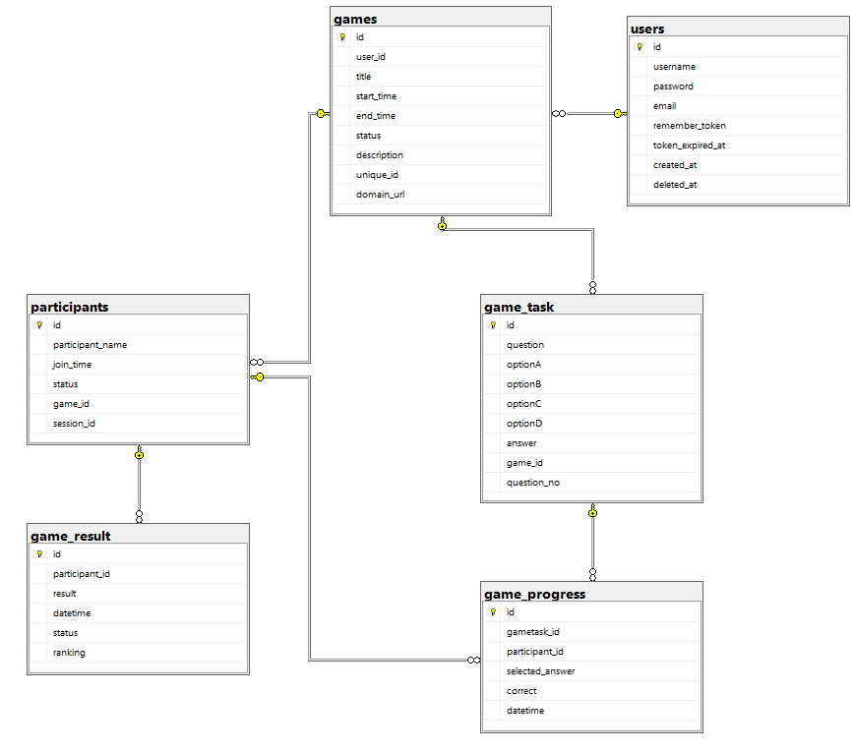

ASP NET CORE API DOCUMENTATION IN C#
-implement session validation in header using remember token (user) and session id (participant)
-implement web socket for the progress synchronization
- Qr code generation for the quiz for easy sharing
- production url: http://156.67.218.162:5000/swagger/index.html

1. Auth
Register for user/admin
curl -X 'POST' \
'https://localhost:7268/api/auth/register' \
-H 'accept: text/plain' \
-H 'Content-Type: application/json' \
-d '{
"username": "admin",
"password": "Abc!23",
"email": "test@gmail.com"

}'

Login for admin
curl -X 'POST' \
'https://localhost:7268/api/auth/login' \
-H 'accept: */*' \
-H 'Content-Type: application/json' \
-d '{
"username": "admin",
"password": "Abc!23"

}
'
*It return token for user/admin/teacher
{
"token": "WNIXV07hDlcM7QfvYypj020250917504006"
}

Validate user
curl -X 'GET' \
'https://localhost:7268/api/auth/validate' \
-H 'accept: */*' \
-H 'token: WNIXV07hDlcM7QfvYypj020250917504006'

2. Game Data example (you may update the domain url for testing)
{
"title": "RESTful API Knowledge Quiz",
"startTime": "2025-06-18T10:00:00Z",
"endTime": "2025-06-18T10:20:00Z",
"description": "Test your understanding of RESTful API concepts and best practices.",
"domainUrl": "https://10.131.78.105:7268/games/join/",
"gameTasks": [
{
"question": "What does REST stand for?",
"optionA": "Remote Execution Standard Transfer",
"optionB": "Representational State Transfer",
"optionC": "Reliable Endpoint Secure Transport",
"optionD": "Request Event Session Transfer",
"answer": "Representational State Transfer"
},
{
"question": "Which HTTP method is typically used to retrieve data?",
"optionA": "POST",
"optionB": "PUT",
"optionC": "GET",
"optionD": "DELETE",
"answer": "GET"
},
{
"question": "Which HTTP status code indicates a successful request?",
"optionA": "200",
"optionB": "400",
"optionC": "404",
"optionD": "500",
"answer": "200"
},
{
"question": "What is the correct HTTP method to update a resource?",
"optionA": "GET",
"optionB": "DELETE",
"optionC": "POST",
"optionD": "PUT",
"answer": "PUT"
},
{
"question": "Which status code indicates resource not found?",
"optionA": "403",
"optionB": "404",
"optionC": "201",
"optionD": "500",
"answer": "404"
},
{
"question": "Which of the following formats is commonly used in REST APIs for data exchange?",
"optionA": "XML",
"optionB": "CSV",
"optionC": "JSON",
"optionD": "HTML",
"answer": "JSON"
},
{
"question": "What does the POST method usually do in REST?",
"optionA": "Retrieves a resource",
"optionB": "Deletes a resource",
"optionC": "Updates a resource",
"optionD": "Creates a resource",
"answer": "Creates a resource"
},
{
"question": "Which HTTP method is **idempotent**?",
"optionA": "GET",
"optionB": "PUT",
"optionC": "DELETE",
"optionD": "All of the above",
"answer": "All of the above"
},
{
"question": "What status code is returned after creating a resource?",
"optionA": "200",
"optionB": "201",
"optionC": "202",
"optionD": "204",
"answer": "201"
},
{
"question": "Which principle is NOT part of REST?",
"optionA": "Stateless interactions",
"optionB": "Client-server architecture",
"optionC": "Multiple layered architecture",
"optionD": "Server-side session tracking",
"answer": "Server-side session tracking"
}
]
}

Create game (not need do in the web)
curl -X 'POST' \
'https://localhost:7268/api/Games' \
-H 'accept: text/plain' \
-H 'token: WNIXV07hDlcM7QfvYypj020250917504006' \
-H 'Content-Type: application/json' \
-d '{
"title": "RESTful API Knowledge Quiz",
"startTime": "2025-06-18T10:00:00Z",
"endTime": "2025-06-18T10:20:00Z",
"description": "Test your understanding of RESTful API concepts and best practices.",
"domainUrl": "https://10.131.78.105:7268/games/join/",
"gameTasks": [
{
"question": "What does REST stand for?",
"optionA": "Remote Execution Standard Transfer",
"optionB": "Representational State Transfer",
"optionC": "Reliable Endpoint Secure Transport",
"optionD": "Request Event Session Transfer",
"answer": "Representational State Transfer"
},
{
"question": "Which HTTP method is typically used to retrieve data?",
"optionA": "POST",
"optionB": "PUT",
"optionC": "GET",
"optionD": "DELETE",
"answer": "GET"
},
{
"question": "Which HTTP status code indicates a successful request?",
"optionA": "200",
"optionB": "400",
"optionC": "404",
"optionD": "500",
"answer": "200"
},
{
"question": "What is the correct HTTP method to update a resource?",
"optionA": "GET",
"optionB": "DELETE",
"optionC": "POST",
"optionD": "PUT",
"answer": "PUT"
},
{
"question": "Which status code indicates resource not found?",
"optionA": "403",
"optionB": "404",
"optionC": "201",
"optionD": "500",
"answer": "404"
},
{
"question": "Which of the following formats is commonly used in REST APIs for data exchange?",
"optionA": "XML",
"optionB": "CSV",
"optionC": "JSON",
"optionD": "HTML",
"answer": "JSON"
},
{
"question": "What does the POST method usually do in REST?",
"optionA": "Retrieves a resource",
"optionB": "Deletes a resource",
"optionC": "Updates a resource",
"optionD": "Creates a resource",
"answer": "Creates a resource"
},
{
"question": "Which HTTP method is **idempotent**?",
"optionA": "GET",
"optionB": "PUT",
"optionC": "DELETE",
"optionD": "All of the above",
"answer": "All of the above"
},
{
"question": "What status code is returned after creating a resource?",
"optionA": "200",
"optionB": "201",
"optionC": "202",
"optionD": "204",
"answer": "201"
},
{
"question": "Which principle is NOT part of REST?",
"optionA": "Stateless interactions",
"optionB": "Client-server architecture",
"optionC": "Multiple layered architecture",
"optionD": "Server-side session tracking",
"answer": "Server-side session tracking"
}
]
}
'

Get all game
curl -X 'GET' \
'https://localhost:7268/api/Games/get' \
-H 'accept: text/plain' \
-H 'token: WNIXV07hDlcM7QfvYypj020250917504006'\'''

Get game qr by the unique id of the game
curl -X 'GET' \
'https://localhost:7268/api/Games/h7wZd8ls1' \
-H 'accept: text/plain'

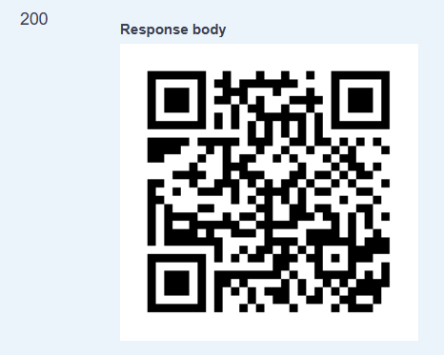

Join the game using name and unique id (the name used was session id here)
curl -X 'POST' \
'https://localhost:7268/api/Games/join' \
-H 'accept: text/plain' \
-H 'Content-Type: application/json' \
-d '{

"participantName": "student1",

"sessionId": "h7wZd8ls1"

}'

Connect web socket
https://localhost:7268/games/connect (view the socket the connection)
Emulate the other user update the progress and view the message from the url above
curl -X 'GET' \
'https://localhost:7268/api/Games/socket' \
-H 'accept: */*' \
-H 'token: test_Bfr5l8m4vMOt6tnOxzV420251017075006'

Get the question from the game using the session id
curl -X 'GET' \
'https://localhost:7268/api/Games/session' \
-H 'accept: */*' \
-H 'id: test_Bfr5l8m4vMOt6tnOxzV420251017075006'

Submit the answer (called again the api/games/session after that)
curl -X 'POST' \
'https://localhost:7268/api/Games/answer' \
-H 'accept: */*' \
-H 'session: mx_BCXI6FLUNtgobOkAd1IB20251117314806' \
-H 'Content-Type: application/json' \
-d '{

"gametaskId": 13,

"selectedAnswer": "Reliable Endpoint Secure Transport"

}'

View game result for participant
curl -X 'GET' \
'https://localhost:7268/api/Games/result' \
-H 'accept: */*' \
-H 'token: test_Bfr5l8m4vMOt6tnOxzV420251017075006'

View the game result for the admin
curl -X 'GET' \
'https://localhost:7268/api/Games/result?id=h7wZd8ls1' \
-H 'accept: */*' \
-H 'token: WNIXV07hDlcM7QfvYypj020250917504006'\'''

Laravel web (with docker support)

https://github.com/zikrimzk/pop-quiz-dad

Flutter mobile (android)
app-release.apk in the zip file

