
The Intelligent Swimmer Imitates Water Strider
Group: Set Sail
Tony, Aaron, Eric, Johny, Millis

Abstract: This is a project by university students to design and build their bionic swimming robots. We choose to imitate the structure of a water strider. The swimmer designed after the water strider has the advantages of high flexibility, strong stability, and high swimming efficiency. The swimmer uses the Cheryshev linkage on both sides to achieve propulsion, while the foam boards at the bottom of the four spider legs provide buoyancy. The goal of this project is to avoid obstacles in the water and reach the designated target location.
Keywords: Water strider swimmer; Chebyshev linkage; Automatic obstacle avoidance

Introduction
The ocean is mysterious. Creatures in nature have evolved millions of years to have the most adapted movement patterns to their environment. One of them that surprises us is the water strider. Water striders use the tension of water to float on the water surface and use the swing of their legs to achieve free movements on the water surface.
As the human exploration of the oceans increase and the raise of robot technology, we become increasingly aware of the importance of Aquatic robot technology. To adapt to search and rescue, decontamination, and other operations on the ocean surface, the project "Set Sail" is put forward, which is also the name of our design group. Therefore, our idea, the "bionic water strider robot" came into existence.
In the project Set Sail, We have designed our bionic robot based on the shape and movement of a strider. It can move forward, backward, turn right or left, and avoid obstacles automatically while moving on its own. Additionally, it can start and stop at specified spots. We hope the little strider robot can set sail.

I.Development History
When we knew the requirement of the swimmer, our group members reached an agreement that we could imitate the shape of aquatic animals. Therefore, we listed the following animals:
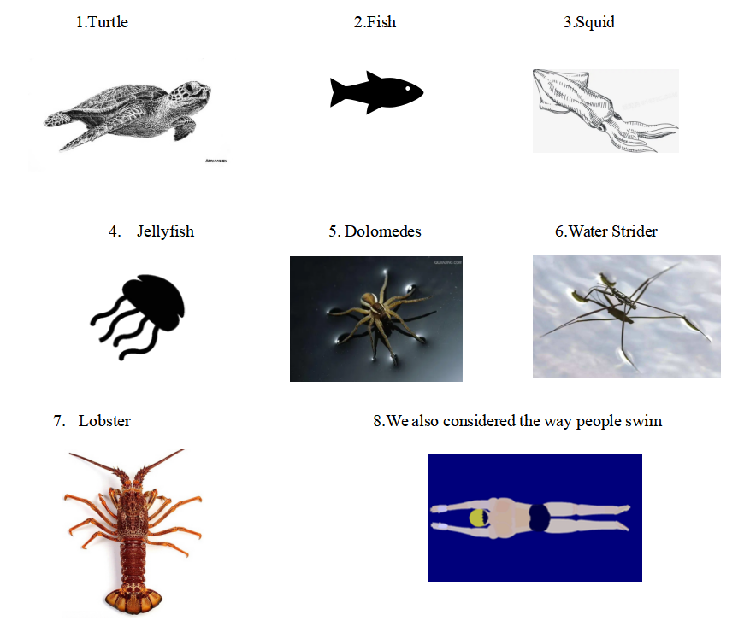
Then we started our discussion. We put squid and jellyfish into one category because they both move forward by absorbing water and spraying water backward. Turtle, stride, and human fall into one category because they all move forward using parts of their bodies as oars. The others each fall into one category.
Finally, after our discussion, we chose a strider as the prototype of the swimmer. That is because turtles, fish, squid, jellyfish, lobster, and human swim with their bodies beneath the water, if we use the structure of water strider, we can avoid the waterproof problem.
After our research, we discovered that the creature can float on water because of surface tension. However, our swimmer can't be as light as the insect, so we prefer to attach some plastic blocks to the end of the legs so the swimmer can float on the water. We also made some adjustments to the way it moves. Then we have the embryonic form of our swimmer.

II.Design of the Robot
(I) The SolidWorks Modeling
This part is all about SolidWorks modeling and 3D painting. We used SolidWorks to model the structure of the water strider, including an arc top shelf, a base, four legs, four floating plates, and also the propulsion system. Given the stability and balance, the legs are specially designed and updated according to the real strider shape and motion ways. Also, the floating plates are reconfigurable which allows us to adjust the load according to the need. Besides the gearing system combines the 3D model with the bearing structure to reduce friction and thus make it more stable and smooth.
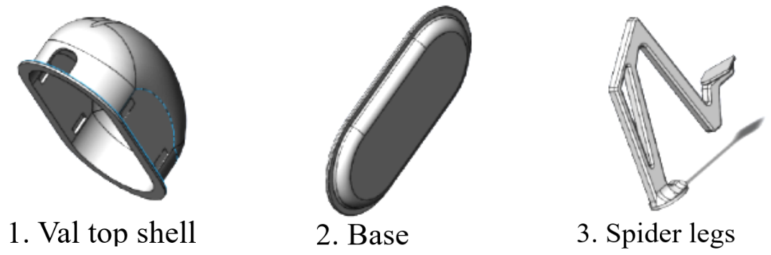
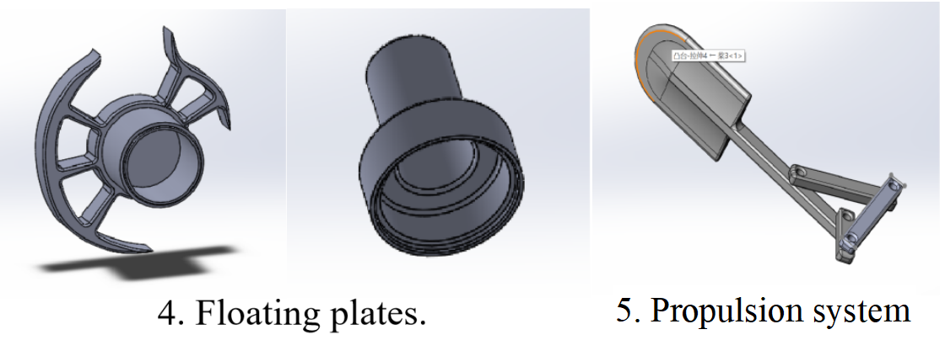

(II)Mechanical Section
(i) The Linkage System
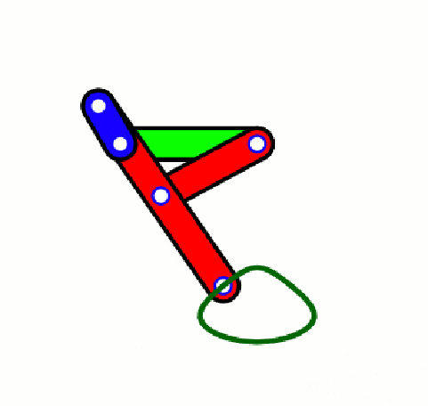
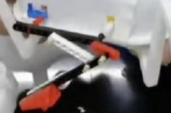
As it's shown in the graph, we used a structure called Chebyshev linkage, which helps us to convert the rotation of the motor into not only up and down movement, but also front and backward movement, which helps our strider robot move like a real one.

(ii)The TT speed-reducing motor
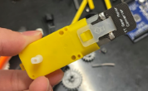

We used a kind of motor called TT speed-reducing motor because when we use a normal DC motor to drive our linkage system, it cannot provide enough strength under the low voltage provided by the motor control board, while the TT speed-reducing motor can reduce speed with increased output torque, therefore it can power our linkage system under a low voltage.

(III) Programming Section

In the early stage of coding, three requirements were set for the strider to instruct the coding later on, which are automatic moving, automatic obstacle avoidance, and autonomous stopping. Before constructing the whole structure, we mainly focused on enabling each function.
For the moving part, since TT speed-reducing motors work in the same way as DC motors, we coded them just as how we code DC motors, that is, using high and low voltage differences to drive the motors. In addition, in case the motors rotate at a different speed, we decided to use PWM (Pulse Width Modulation) to refine the code. (PWM let an analog voltage signal be obtained from a digital signal by changing the duty cycle of the square wave output from the IO port. )
For the automatic obstacle-avoiding part, as the strider needs to sense the distance, ultrasonic sensors are used. Ultrasonic sensors release ultrasonic waves and wait for their echo. It automatically receives the echo and outputs the time interval. By assuming that the speed of sound is constant at a speed of 340 meters/second, we can calculate the distance.
For the autonomous stopping part, we plan to use color sensors to achieve the function. With respective commands, the sensor can output RGB value, allowing the strider to identify the place it is and do different execution. We will set a color Sticker in the expected destination, when the color is detected the color, it will control the robot to stop.
Based on the three basic customized functions above, we construct several further customized functions and the main structure.
The following diagram shows how the strider detects the obstacle.
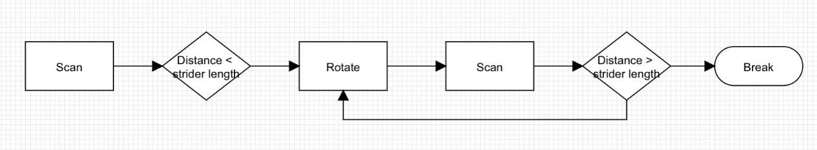

When the program executes this part of the commands, if the distance of the obstacle is less than a value, the strider will automatically rotate itself left and right at the same time scanning to find a way to get through.

The following diagram shows how the strider works.
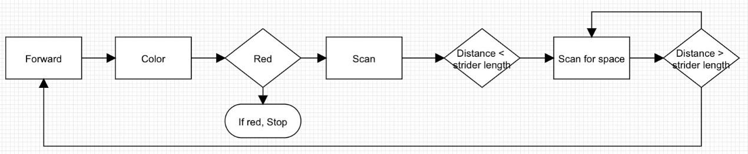
We want the strider to move forward and scan the color below the surface. If the color is red, the strider will stop. If not, meaning the strider isn't in the right stop position, it will move, scan and do a judgment on whether it needs to rotate and change its direction. Since we met a few problems caused by unstable hardware, we simplified the former program into a briefer one.

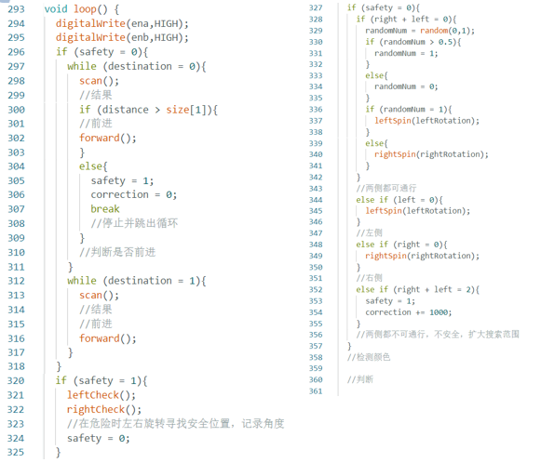
the initial one

the final one
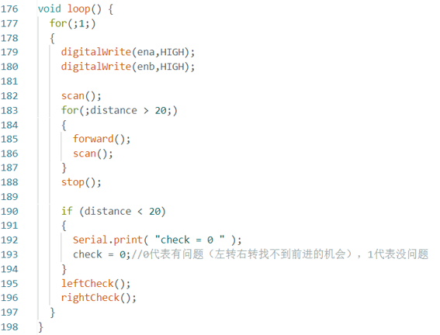

Sensers on the robot:
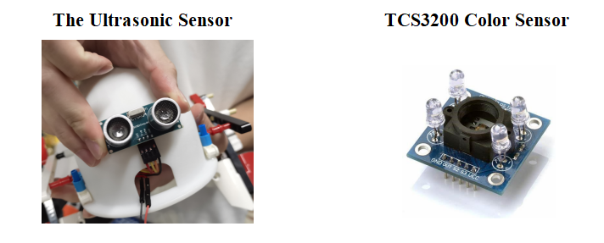
(IV) Electronic Control Section
The initial version
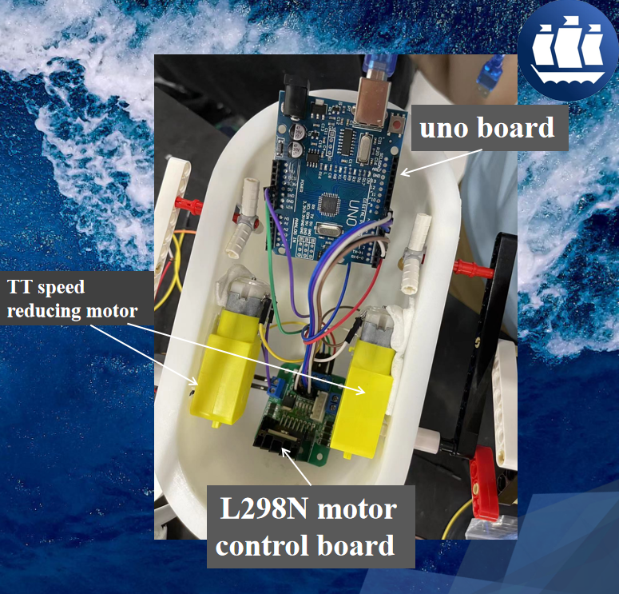

We used a UNO board to conduct the program. It controls one L298N motor control board. This motor control board controls two TT speed-reducing motors.

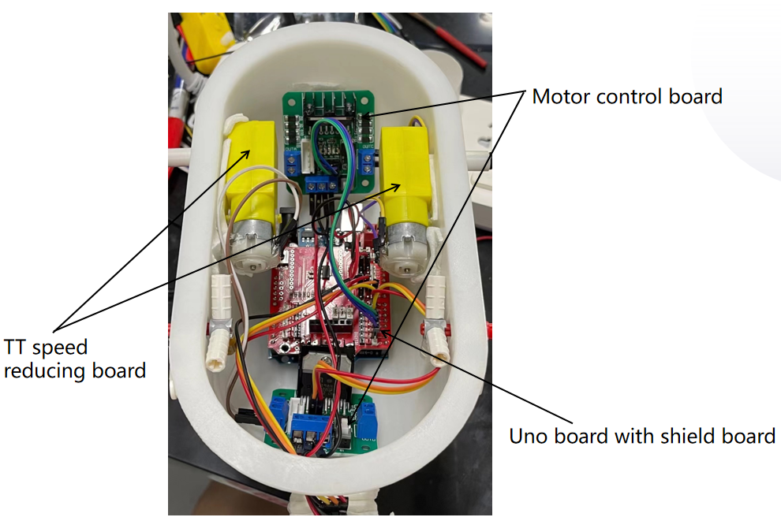

The final version
The UNO board is connected to a shield board to get more interface. It controls two motor control boards. Each motor separately controls a TT speed-reducing motor. We apply this structure to avoid the uneven voltage provided by a single motor control board. Therefore the motor can swing at the same speed.

III. Experimental Procedure
- Stage I
(i)Testing Process
The testing place was a pool with the size, 261cm*172cm, while the depth of water was 25cm.
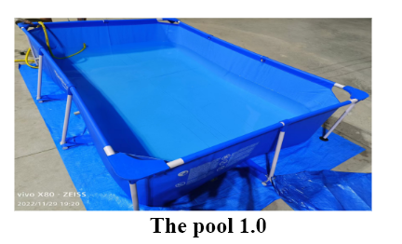
The swimmer was required to present four functions in order: moving forward, moving backward, turning left, and turning right. What's more, the weight of the whole swimmer should not be less than 2kg.

(ii) Testing Results
The swimmer completed the four required functions: move forward, backward, turn left and turn right. Its weight was 1660g.

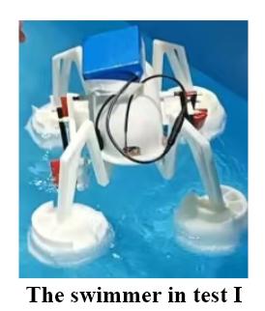
(iii)Problems
1. The direction problem: The swimmer couldn’t move straightly in the moving forward part and moving backward part. The declination angle when moving forward was bigger than the declination angle when moving backward. It’s caused by the different rotation speeds on both sides.
2. The balance problem: The swimmer's left and right draft depths were different. It's mainly because the foam boards' sizes weren't cut into the same size. Moreover, the weight of the swimmer wasn't set equally on two sides, especially the battery box fixed on the top of the swimmer.

- Stage II
(i)Testing Process
The testing place was a pool with a size of 261 cm*172 cm, while the depth of water was 36cm. An obstacle with a size of 30cm in length, 10cm in width, and 21cm in height. The height above the water surface was 12cm and the height in the water was 9cm. Due to keep the position of the obstacle, the obstacle is fixed on a horizontal metal rod, which is 36cm above the water surface. There are also four baffles at four ends of the pool.
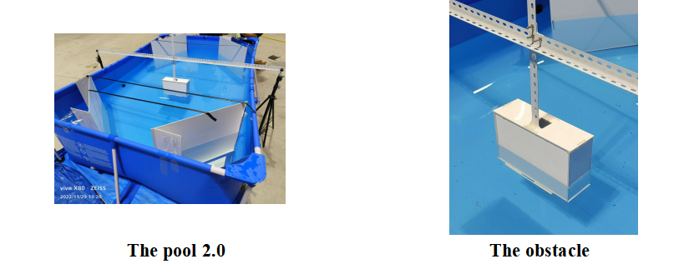

The swimmer was required to start from the middle of one edge of the pool to the other and avoid the obstacle.

(ii) Testing Results
Currently, with sensors working, the spider shape swimmer can achieve the task of obstacle avoidance and other basic motor ability including moving forward, backward, and turning right and left.
However, during the test, the swimmer shows great stability but lack in efficiency.

IV.Discussion & Analysis
- Analysis of Materials
In the first stage, we used engaging materials to build the main structure of the swimmer. The Lego components have the characteristics of lightness and high strength, which saves our time in designing the structure of the swimmer at the initial stage. At the same time, the LEGO components have the function detachable, which is helpful for us to improve the main structure quickly based on the former.
However, Lego components still have limitations on size, scale, and angles, which may affect the assembly of circuit boards and motors. Therefore, we then improve the structure through Modeling & 3D Printing.
As for the 3D painting, we use resin material, which is more stable, for the body structure, and PLA materials, which perform better in rigidity, for the gearing system.

- Analysis of structure
We thought about making all six legs of the water strider move to get more power, but practical tests showed that this would cause the robot to be unstable when moving and not work well, so we finally chose a structure with four fixed legs and two moving legs.

(III)An alysis of Circuit control systems
The initial circuit was complex, but in practical testing, we found that putting the complex circuit into a small box led to unstable execution of the program, after troubleshooting, we found that the connections were stable. Eventually, we guessed that the bending of the wire caused a slight change in voltage, so we did our best to simplify the circuit and improve stability.

V.Co nclusions
The project aims at reducing water fiction to increase the flexibility of the swimmer by lifting the body of a ship above the water and using paddles as gearing, and thus our swimmer can keep the balance in harsh water conditions, which can contribute to future maritime rescue.
Currently, with sensors working, the spider shape swimmer can achieve the task of obstacle avoidance and other basic motor ability including moving forward, backward, and turning right and left.
However, there is still something we can improve, such as improving promotion efficiency, applying lighter and stronger materials, and so on to strengthen its mobility.

VI.Acknowledgement
During the whole process, many people helped us a lot.
As for the technical part, we are grateful for Doctor Chen's advice on our gearing system and encouragement on our spider shape idea, which inspired us. As for the Technology communication part, we sincerely appreciate all those skills of communication and tips on how to write a good essay that Mr. Glenn has taught us. In addition, the problems that he pointed out during the former presentation matter, which set a solid foundation for making the presentation.
Besides Mr. Glenn, Doctor Lu also offer us some advice and make us realize the importance of being rigorous in the presentation, which is of great significance.
As for the practical training, we are thankful to our TA, he helped us a lot in the circuit part.
After all, we are thankful to everyone who has offered us suggestions and encouragement during the whole process.

References
Bentham Science Publishers. (n.d.). Research Progress of Bionic Water Strider Robot: Ingenta Connect. https://www.ingentaconnect.com/content/ben/meng/2022/00000015/00000002/art00003
Gao Tiehong, Cao Junyi, Gao Feng, & Zhu Dunyu. (2006). The research of a bionic robot that can walk on water surface based on water strider. International Technology and Innovation Conference 2006 (ITIC 2006). https://doi.org/10.1049/cp:20061133
Ren, K., & Yu, J. (2021). Research status of bionic amphibious robots: A review. Ocean Engineering, 227, 108862. https://doi.org/10.1016/j.oceaneng.2021.108862
Wang, L., Gao, T., Gao, F., Xue, Y., & Wang, Y. (2010). Experimental research on locomotion characters of water strider and movement realization on a water strider robot. 2010 IEEE International Conference on Robotics and Biomimetics. https://doi.org/10.1109/robio.2010.5723391
Yan, J., Zhang, X., Yang, K., & Zhao, J. (2019). A Single Driven Bionic Water Strider Sliding Robot Mimicking the Spatial Elliptical Trajectory. 2019 IEEE International Conference on Robotics and Biomimetics (ROBIO). https://doi.org/10.1109/robio49542.2019.8961712
Zhao, Y., Chu, C., Zhang, B., Lv, C., & Feng, X. Q. (2022). Experimental and theoretical studies on the dynamic landing of water striders on water. Soft Matter, 18(18), 3575–3582. https://doi.org/10.1039/d2sm00208f

