**Regression and Time Trends Exercise: Identifying the measurement, the sample, and the population.**

Below are three short descriptions of data that environmental scientists collect in order to monitor trends in our atmosphere, biosphere, and oceans. Assume that you want to use linear regression to determine if there is a significant upward or downward trend in these measurements over time. For each study identify and describe the *measurement*, the *sample*, and the *population* that that sample is being drawn from.

1. The National Aeronautics and Space Administration uses satellites to monitor the extent of sea ice in the Arctic. Every month, the satellite measurements are processed to estimate the total area covered by sea ice over that month. Below is a graph of the average extent of sea ice during the month of January in the Arctic from 1990 to 2012 (data from <http://nsidc.org/data/nsidc-0079>):

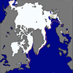 

What is the measurement?

What is the sample?

What is the population?

1. The National Interagency Fire Center (<http://www.nifc.gov/>) collects reports from federal and state agencies on the total area burned by wildfire across the United States in a given year. The graph below shows the estimated total area burned by wildfire in the USA from 1987 to 2012. 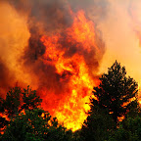

What is the measurement?

What is the sample?

What is the population?

1. Researchers with the Hawaii Ocean Time-series (HOT) program (<http://hahana.soest.hawaii.edu/hot/>) have been making observations of the chemistry of seawater at a location north of Oahu, Hawaii since October 1988. Measurements are taken 5 - 15 times per year at this location, and a normalized pH value (a measure of the acidity of the water) is calculated for each measurement shown below.

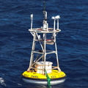

What is the measurement?

What is the sample?

What is the population?