**Regression and Time Trends Exercise: Recognizing autocorrelation in time-series.**

Below are five graphs of time-series data with the same average trend (dotted line) but different levels of autocorrelation. *Three of the trends have strong autocorrelation, but two do not.* Identify the trends that are strongly autocorrelated by circling “y” next to the graph, then answer the questions below.

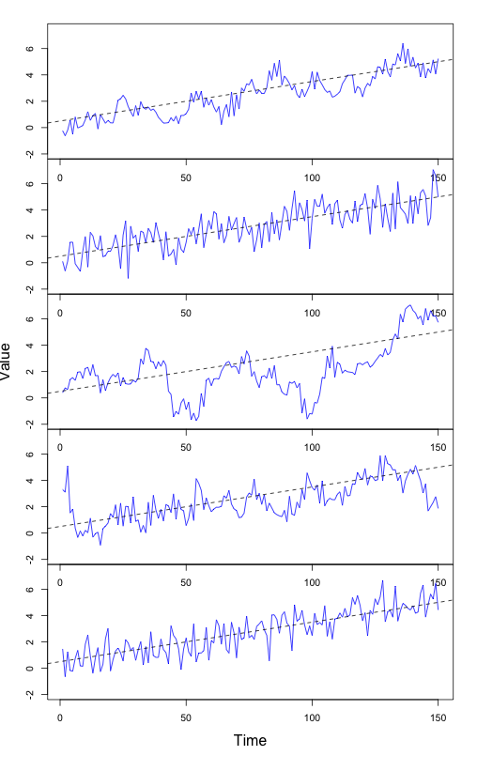

Autocorrelated?

(y / n)

Autocorrelated?

(y / n)

Autocorrelated?

(y / n)

Autocorrelated?

(y / n)

Autocorrelated?

(y / n)

Question: For the time-series that you identified as autocorrelated, why did you choose the ones you did?