**Regression and Time Trends Exercise: Why is autocorrelation a problem for deciding when a trend is real?**

For this exercise, you will be interacting with a web applet available at: <http://spark.rstudio.com/statmos/mod1_slope/>

This app is designed to show the influence of autocorrelation on our estimate of a linear trend over time. The dotted lines represent the slope of a linear regression fit to the observations (white circles) within a certain window of time (gray shading). The top trend does not have strong autocorrelation, but the one plotted below does have autocorrelation. You can control the position of the time-window that is used to fit the regression, as well as the width of the window, using the controls. Spend some time exploring the app, and then use it to answer the questions below.

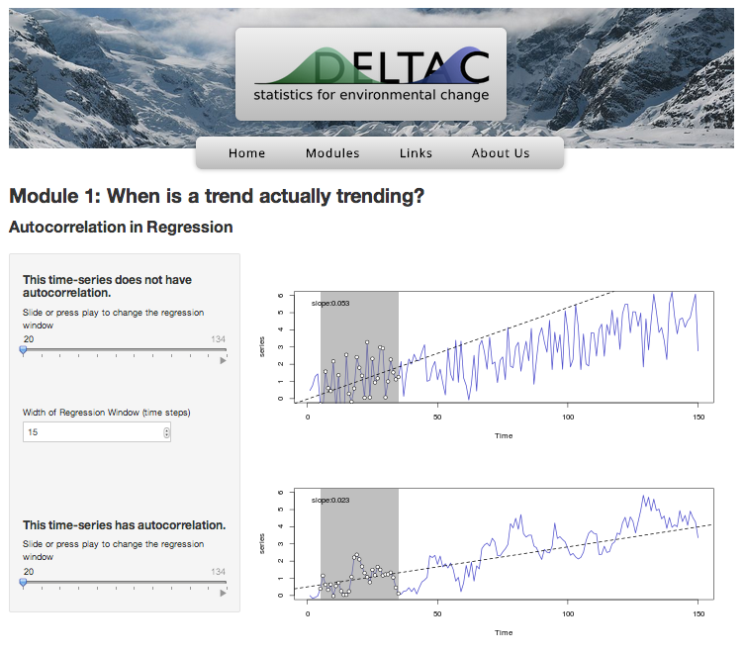

Questions:

1. How does changing the width of the regression window affect how much variation there is in the slopes of the regression lines fit to different windows of time? Why does this occur?
2. Set the width of the regression window to the default (15 time-steps), and bring the slider for the top graph back to its original starting position. Record the value of the slope of the regression line on the top graph (printed in the top-right corner of the graph) in the table below. Next, advance the slider by 15 time-steps, and record the new value of the slope, filling in the table below with the new value. Do this for every time-step that you can on both the top graph and the bottom-graph.

|  |  |  |  |  |  |  |  |  |  |
| --- | --- | --- | --- | --- | --- | --- | --- | --- | --- |
|  | Center of Time Window | | | | | | | | |
| Time-Series | 20 | 35 | 50 | 65 | 80 | 95 | 110 | 125 | **Std. Dev.** |
| Not Autocorrelated |  |  |  |  |  |  |  |  |  |
| Autocorrelated |  |  |  |  |  |  |  |  |  |

1. Now compute the standard deviation of the group of slope estimates for the two time-series. Which time-series shows more variation in the slope, the one with autocorrelation, or the one without autocorrelation? Why does this occur?
2. Based on this result, how might autocorrelation interfere with our ability to measure long-term trends using linear regression?