PRESENTATION SPEECH SCRIPT
Islam and Psychology: Understanding the Emotional Body
Iman Zainab | Reg. No. 113 | BSCS 8D | Assignment 4 | 29 June 2026

Note to speaker: This script is designed for a 10-minute presentation across 5 slides. Speak naturally and at a steady pace. Do not rush — pauses between sections help the audience absorb information. Key phrases are in bold so you can glance down and pick up your place easily.

SLIDE 1 — Introduction (approx. 1.5 minutes)
Assalamu alaikum wa rahmatullahi wa barakatuh. Good morning/afternoon everyone.
My name is Iman Zainab. I am from BSCS 8D, Registration Number 113. Today I will be presenting Assignment 4 for our Islamic Studies course, under the guidance of Mr. Imran Farid.
The topic of my research is Islam and Psychology — and specifically, how Islamic teachings address our emotional and mental health. I researched this topic using Chapter 4 of the book Healing Body and Soul, which is titled 'The Emotional Body.' This is a remarkable chapter that brings together modern psychology and Islamic wisdom in a way that is both deeply scholarly and incredibly practical.
Now, before I begin, I want to ask you something. How many of you have felt stressed this week? And how many of you have felt genuinely, deeply happy recently?
Most of us are somewhere in between — managing stress, chasing happiness, but not quite sure where to find it. What I want to show you today is that Islam has not only diagnosed the problem but also prescribed the cure — and this has been confirmed by modern science.
My presentation has five slides. I will take you through the sources of stress, how stress damages the body, the Islamic understanding of happiness, and then the practical Islamic prescriptions — ten time-tested tips from the Quran and Sunnah — that help us achieve genuine emotional wellbeing.
Let us begin.

SLIDE 2 — Stress: Sources & the Body's Response (approx. 2.5 minutes)

Opening
The chapter opens with a powerful and scientifically proven statement: mental and emotional stresses affect body tissues and secretions. Destructive emotions — fear, resentment, worry, envy, boastfulness, and egotism — literally poison the body. This is not just a spiritual metaphor. This is biology. And it is also exactly what Islam has been telling us for 1400 years.
So, what causes stress? The chapter identifies three major sources.

Source 1: Personality Factors
Two American cardiologists — Friedman and Rosenman — divided people into two personality types. Type A people are fastidious, meticulous, hot-tempered, and stubborn. They always want to be better than others, they get angry at the slightest mistake, and they are far more likely to develop cardiovascular disease.
Type B people, on the other hand, are carefree, easy to please, not quick-tempered, and generally relaxed. They tend to be healthier.
There is a haunting real-life example in the book. During the Gulf War of 1991, Iraqi missiles were launched at Israeli civilians. The missiles were practically ineffective — they caused little physical damage. But the mortality rate among Israeli civilians increased alarmingly after the attacks. Why? Not because of the missiles — but because of the fright, apprehension, and panic. Most victims already had pre-existing heart conditions that were triggered by sudden panic. This is the mind-body connection in devastating action.
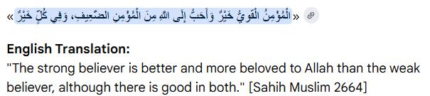
Islam teaches us to be the strong believer. The Prophet ﷺ said: 'The strong believer is more loved by Allah than the weak one, and there is benefaction in both.' A positive sense of personal control — which primarily comes from faith — is shown by studies to significantly reduce susceptibility to stress.

Source 2: Environmental Factors
Modern life puts the body in a continuous state of anxiety. Divorce, job loss, the death of a loved one, traffic jams, financial pressures — all of these keep us in a persistent state of tension. The chapter highlights the remarkable example of divorce — widely considered one of the most devastating life events.
And yet — the Quranic chapter of Talaq, which literally means 'Divorce,' is one of the most comforting and compassionate passages in the entire Quran. It promises: 'And whosoever fears Allah, He will make a way for him to get out from every difficulty, and He will provide for him from sources he never could imagine.' Reading these verses with true belief and trust in Allah's Wisdom significantly reduces stress and restores hope.
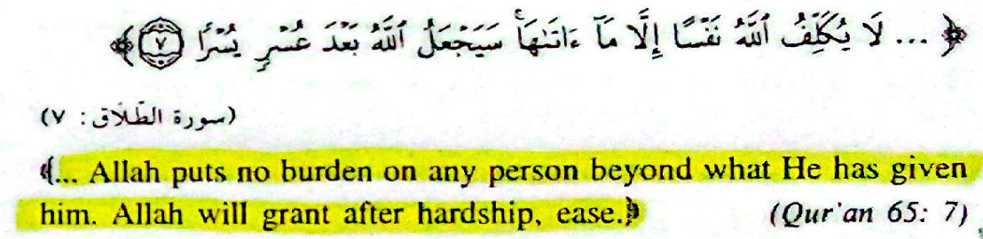

Source 3: Social Factors
The third source of stress is social. Being surrounded by a happy, loving, and caring environment increases our ability to cope with stress. The Prophet ﷺ said: 'The believers are to each other like a solid building, they strengthen each other.' On the contrary, living in a hostile environment, feeling rejected, lonely, or experiencing poverty — these are major stressors. Research confirms a strong link between low socioeconomic status and poor health, family disunity, and unhappiness.

The Body's Response
When stress hits, the body responds in two ways. The first is physiological — involuntary. Acute stress triggers the sympathetic nervous system to release adrenaline and noradrenaline, preparing us for 'fight, flight, or fright.' This is protective and temporary.
But chronic stress — ongoing, long-term stress — releases cortisol from the adrenal cortex. And high cortisol levels have a devastating effect on the immune system. They reduce white blood cells, suppress lymphocyte production, increase vulnerability to illness, and contribute to cellular dysfunction and even tumours. They raise blood pressure, disrupt digestion, elevate blood sugar, and cause dangerous fat mobilisation that builds up on artery walls — contributing to heart disease. Chronic stress also permanently activates the sympathetic nervous system, leading to a body that is always on high alert, always running on empty.
The second response is cognitive — how we consciously perceive and interpret stress. And this is where faith changes everything. Psychologist Richard Lazarus showed that people who see problems as menacing and imminent are hindered from coping. Those who see them as challenges — as tests that can be adapted to — cope far more effectively. A deep trust in Allah, the recognition that this world is transient, and the belief that He puts no burden beyond what we can bear — all of this reformulates how we experience stress on a neurological level.
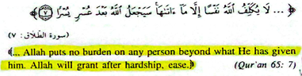

SLIDE 3 — The Nature of Happiness in Islam (approx. 2 minutes)
Now we move from what harms us to what heals us.
The chapter tells us that happiness is not a destination — it is an inner feeling. It is the contentment and satisfaction of one's soul. And it is a decision you can make at any time. Not when you get the job. Not when you pass the exam. Not when things get easier. Right now. Today.
Ibn al-Qayyim — one of the great Islamic scholars — classified happiness into three types, arranged in order from lowest to highest.
Type 1 — External Happiness. This comes from wealth, power, prestige, and material goods. It is the lowest form of happiness — a momentary pleasure that can vanish in an instant. The Quran (57:20) describes this world as 'play and amusement' — it grows like vegetation after rain, then dries up and turns to straw. And yet this is what most of the modern world is chasing. People are working 80-hour weeks to buy things that will not make them happy. And science agrees — study after study shows that beyond a certain income level, more money does not increase happiness.
Type 2 — Physical Happiness. This comes from good health, strength, and energy. It is more lasting than external happiness — when we are healthy, we genuinely feel better. But it is still impermanent. Illness, aging, injury — all of these take it away eventually.
Type 3 — Moral Happiness. This is true happiness. It originates from the heart and soul. It results from useful knowledge, good manners, content of character, and most importantly — faith. Allah says in the Quran (10:58): 'Say, In the Bounty of Allah and in His Mercy — therein let them rejoice. That is better than what they amass.' Ibn al-Qayyim interpreted Allah's Bounty as faith itself, and His Mercy as the Glorious Quran. True happiness is to possess these two things.
Al-Ghazali the Younger taught that the real reasons for happiness reside in the soul. The soul is served first by physical health, and then by external things like wealth and relationships — but only in that order. Whoever understands this hierarchy and adjusts their priorities accordingly will attain real bliss.
And there is something important I want to add about the word 'if.' The Prophet ﷺ warned us: do not say 'if I had done this, so and so would have happened.' Because 'if' opens the door for evil — for regret, self-blame, and despair. Instead, say: Allah decreed, and what Allah wills, He does. This is not passivity. This is the highest form of psychological strength.

SLIDE 4 — Islamic Prescriptions for Happiness, Part I (approx. 2 minutes)
The chapter then gives us something extraordinary — twenty practical tips for happiness, derived entirely from the Quran and Sunnah. Think of these as prescriptions — tried and tested for 1400 years. I will cover the first five on this slide.

Tip 1: Be Grateful
Gratitude is the foundation of emotional wellbeing. The Prophet ﷺ said: 'One who is not grateful to people is not grateful to Allah.' The believer's affair is amazing — if good times come, they are thankful, and it is good for them. If bad times come, they are patient, and it is also good for them.
There is a beautiful story in the book. Imam Malik was once walking when he saw an old, blind, handicapped man sitting on the side of the road — thanking Allah and praising Him. Imam Malik was moved and asked him, 'What are you giving thanks for?' The old man replied: 'Didn't Allah bless me with a healthy heart to glorify Him with?' SubhanAllah — this is the power of gratitude.

Tip 2: Give Without Expecting Return
Hasten toward good. Do not wait for thanks, praise, or reward. Your reward is with Allah. And psychological research actually confirms this — altruistic acts significantly increase gratification and support social wellbeing. Here is a profound truth from the chapter: the first beneficiary of your act of helping others is yourself. It feeds your soul, boosts your self-worth, and brings you closer to Allah.

Tip 3: Be a Believer
You experience what you believe in. This is not just spirituality — this is neuroscience. Our thoughts generate our sentiments; our beliefs generate tremendous power. Allah says in a hadith qudsi: 'I am as My servant thinks I am, and I am with him if he calls for Me.' If you anticipate goodness and abundance, goodness follows. If you are gloomy and pessimistic, evil follows.
Dr. Albert Ellis outlined an ABC system: A is the Action or event. B is your Belief about it. C is the Consequential feeling. Most people think A directly causes C — but it doesn't. B is the deciding factor. Change your belief, and you change your emotional experience completely. Do not accept failure permanently. Learn from your experience and try again.

Tip 4: Live in the Moment
The Prophet ﷺ taught Abdullah ibn Umar: 'When you wake up, do not talk to yourself about the evening. And if you enter the evening, do not talk to yourself about the morning. Take from your life for your death, and from your health for your sickness — as you never know what your fate will be tomorrow.'
Fretting over the past and worrying about the future deny us the joy of the present moment. The Prophet also told us: 'He who wakes up in the morning, healthy in his body, safe in his residence, and having his day's sustenance — is as if the entire world was granted to him.' When you read that, pause for a moment. If you ticked those three boxes this morning — healthy, safe, fed — you have been given the whole world.

Tip 5: Apply Detachment
Detachment means enjoying your blessings and belongings, appreciating all the gifts in your life — but not becoming enslaved by them. It is not indifference or carelessness. It is the recognition that our true centre of attachment must be Allah, not the material world. The Caliph Haroon Rasheed once asked a wise man a question: 'If you were denied a sip of water, would you give away your entire kingdom to have it?' The Caliph nodded. The wise man then asked: 'And if after drinking it, it was withheld inside your body, would you give your entire kingdom to release it?' Again the Caliph agreed. The wise man concluded: 'So what is the value of a kingdom that is not worth a sip of water — or even a drop of urine?' The simplest gifts we have are worth more than empires.

SLIDE 5 — Islamic Prescriptions Part II & Conclusion (approx. 2 minutes)
We now come to the final five prescriptions — and then our conclusion.

Tip 6: Love
The chapter describes love as the only true feeling that can bring peace back into our lives and unite our divided hearts. Ibn al-Qayyim identified two kinds of love: metaphorical love — the love of family, beauty, nature, the world — and Divine love — the love of Allah, which is real, eternal, and infinite. Rumi, the great Muslim philosopher and poet, taught that both kinds of love should ultimately lead the heart back to Allah.
The Prophet ﷺ said: 'By the One who holds my soul in His Hand, you will not believe until you love each other. Spread peace — say Salam — among you.' And there is a breathtaking hadith qudsi in which Allah announces His love for a person to Gabriel, and Gabriel spreads that love through the heavens until the people of earth love that person too. Imagine having the love of Allah — and through it, the love of all creation.

Tip 7: Keep Hope and Be Optimistic
The degree of hope you carry is directly proportional to the strength of your faith. When disasters strike, the believer is not destroyed — their faith is deepened. They feel inner peace, they see tests as opportunities to exercise patience, and they supplicate through hardship. The unbeliever, on the other hand, is completely devastated — because the only meaning in their life was worldly possessions, and those are gone.
Studies show that people who constantly complain, worry, and make a fuss about small things are more prone to encountering difficult situations. Pessimism programmes the mind and the body for trouble. The chapter teaches us: every morning, remind yourself that you have the choice to be happy or to be in a bad mood. Choose happiness. Look for the positive side of every situation you encounter.

Tip 8: Be Responsible
Do not blame others for your own mistakes. Look within yourself. Allah says: 'Verily, Allah will never change the condition of a people until they change what is in themselves' (13:11). Life is a series of choices — your attitude, your perception, your awareness. Each time something goes wrong, you can choose to be the miserable, afflicted sufferer, or the strong, unbeatable student of life who extracts a lesson and keeps going. Being responsible also means commitment — sticking to your plan and trying again after failure.

Tip 9: Define Your Objectives
Every person must have a purpose — an objective that prevents life from being barren and meaningless. A study of college students found that the unhappy ones did not envision a clear goal to live for. The ultimate goal for every Muslim is Allah's pleasure. The Prophet ﷺ said: Allah likes when one of you does a job, that he perfects it. Everything you do — your studies right now, your assignments, your exams — can be an act of worship when done with sincerity and with the right intention.
And keep yourself challenged constantly. Easy goals breed boredom and loss of interest. Goals that stretch you — that are matched to your abilities and slightly beyond your comfort zone — produce self-fulfilment, stamina, and the motivation to pursue bigger and higher ambitions.

Tip 10: Be Powerful
True power is not dominance or control over others. Our power lies deep within our souls. It radiates love, compassion, and understanding. It is reflected in every action, every movement, every decision. Being powerful means illuminating your surroundings, overcoming your fears and self-doubts, and fulfilling your duties.
The practical tool for building this inner power is Dhikr-Allah — the remembrance of Allah. It rectifies your mental image. It replaces negative thoughts and self-doubt with confidence and strength. It increases your faith in Allah and your belief in your own abilities. There is a hadith that says: 'In the Name of Allah, in Whose Name nothing can cause harm in the earth or the heavens.' Dhikr is your armour — and when you wear it daily, you become genuinely powerful.

Conclusion
So, to conclude — what does this chapter teach us?
Islam is not just a religion of rituals. It is a complete, sophisticated, and compassionate system of psychological wellbeing. Every teaching of the Quran and Sunnah has a measurable impact on our mental and physical health. The research in this book — Healing Body and Soul — shows us that modern psychology and Islamic wisdom are not opposites. They are parallel paths arriving at the same truth.
A Muslim who applies these ten principles — gratitude, generosity, belief, living in the moment, detachment, love, hope, responsibility, purpose, and inner power — does not merely survive life. They flourish in it.
And I want to leave you with the words that open and close this chapter — a hadith of the Prophet ﷺ:
"The strong believer is more loved by Allah than the weak one, and there is benefaction in both."
May Allah make us strong believers — strong in faith, strong in body, strong in soul — and may He grant us the happiness that no wealth in this world can ever buy.
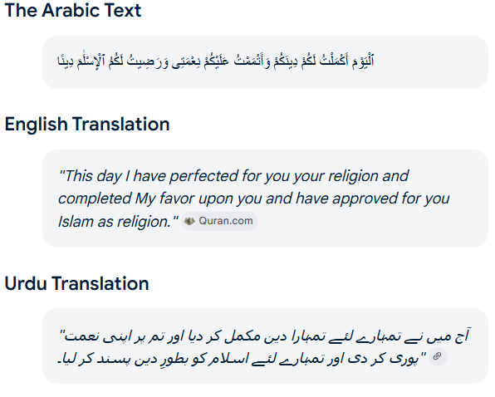
So which of the favors of your Lord would you deny?

Jazakumullahu Khayran. Thank you for listening. I am happy to take any questions.

