DOCUMENTATION

ASSIGNMENT *1*

STUDENT NAME: ZIMAN RARES-LUCIAN

GROUP: 30421

# CONTENTS

DOCUMENTATION 1

ASSIGNMENT *1* 1

CONTENTS 2

1. Assignment Objective 3

Main objective: 3

Sub-objectives 3

2. Problem Analysis, Modeling, Scenarios, Use Cases 3

3. Design 6

4. Implementation 7

5. Results 10

6. Conclusions 10

7. Bibliography 10

# Assignment Objective

## Main objective:

Design and implement a polynomial calculator with a dedicated graphical interface through which the user can insert polynomials, select the mathematical operation to be performed and view the result.

## Other objectives:

Analyze the problem and identify requirements 🗸

Design the polynomial calculator 🗸

Implement the polynomial calculator CORRECTLY 🗸

Test the polynomial calculator 🗸

# Problem Analysis, Modeling, Scenarios, Use Cases

In order to analyze the problem, we will start with a possible use case

It is one’s job to calculate different operations on polynoms on a daily basis and it is getting annoying to do so. He comes up with the genius plan to implement a polynom calculator in java.

**Use case:** add polynomials

**Primary actor:** user

**Main success scenario:**

1. User inserts 2 correct polynomials
2. The user clicks the “+” button
3. The calculator displays the result of the operation 🗸

According to the above use-case, we can define some requirements:

**Functional requirements:**

* Users should be allowed to insert polynomials
* Users should have a selection of mathematical operations
* The polynomial calculator should be able to:
  + add two polynomials
  + subtract two polynomials
  + multiply two polynomials
  + divide two polynomials
  + compute the derivative of a polynomial
  + compute the integral of a polynomial

**Non-functional requirements:**

* The polynomial calculator should be intuitive and easy to use
* The calculation should be fast enough for everyday use

# Design

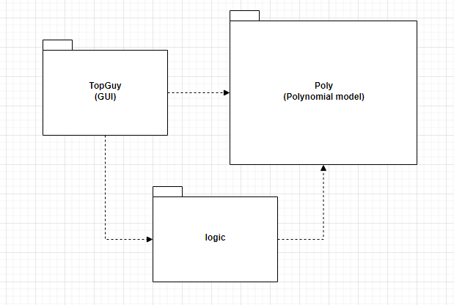

In order to have an easy to maintain project, I chose to split the needed classes in three packages: Business Logic, Data Models and GUI.

* logic:
  + Full set of available operations
* Poly:
  + Polynomial model
* TopGuy:
  + Full GUI and functionality behind it

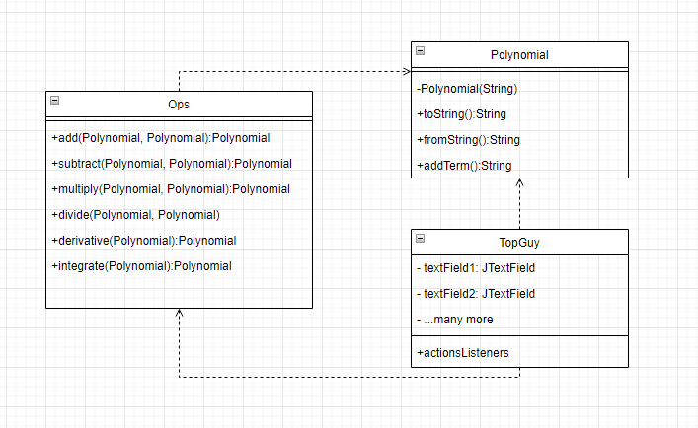

# Implementation

The **Ops** class only contains the mathematical operations that need to be done on the polynomials. They all return a polynomial as a result. Addition, subtraction, multiplication, derivation and integration are all done by simply iterating through a hashmap. Division unfortunately does not work at the time.

* Addition, subtraction, multiplication and division are all sent the two polynomials as parameters and return the result, while integation and derivative were only using the first polynomial.
* The polynomial was split using RegEx and mapped using the power as index and coefficient as value.

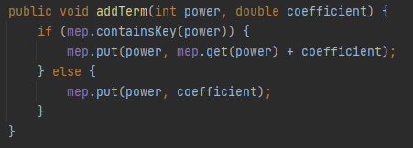

* The GUI was done using JavaSwing .

# Results

Due to time constraints, I only tested the operations manually. Problems I observed are:

* the coefficient 1.0 is still printed instead of just writing x
* if the highest degree monomial is positive, there is a ‘+’ sign which could be omitted
* division does not work ☹

# Conclusions

While working on this project I learned:

* how to work with regex
* the importance of not exceeding the deadline by 2 weeks
* the importance of planning, designing and structuring a project before starting to code

# Bibliography

1. *regex101.com*
2. [*https://dsrl.eu/courses/pt/*](https://dsrl.eu/courses/pt/)
3. *What are Java classes? -* [*www.tutorialspoint.com*](http://www.tutorialspoint.com)