DOCUMENTATIE

TEMA 2

NUME STUDENT: Ziman Rares Lucian
GRUPA: 30421

Objective
The objective of this project is to create an application that simulates the functioning of checkout queues in a store by distributing customers to the queues with the minimum waiting time. It aims to utilize the concepts of Object-Oriented Programming and the features and functionalities of the Java programming language.
2.1 Problem Analysis
The goal is to efficiently implement the simulation of customer queues in a store based on a hypothetical scenario. The input parameters include the number of customers waiting to be allocated to queues, the number of queues, the simulation time in seconds, the arrival time interval for customers, and the processing time interval for each customer. These data are randomly generated for each customer within the specified intervals.
2.2 Modeling
In this implementation, we utilize the concept of threads in Java to create a system where each queue functions as an independent "server." These servers receive "tasks" and execute them in the order they were received, adhering to the First-Come-First-Serve principle. Thus, each queue represents a distinct entity that operates autonomously, serving as a waiting area for customers who join the queue at specific times, using a defined optimization logic. These details will be further explained in the following sections.

To implement this system, we will require three main classes: Client, Queue, and Simulation. The Client class will model the customer entity, the Queue class will contain objects of the Client class, and the Simulation class will coordinate the overall operations. This includes creating threads associated with each queue, generating customers, and managing them based on their arrival time.

Additionally, a separate class responsible for the user interface will be needed. It will initiate the simulation as a distinct thread once the user provides the required input.
2.3 Scenarios and use cases

In this application, the use cases largely depend on the input data provided by the user. We can identify two scenarios:
a) Realistic Scenario: In this scenario, the customer arrival interval is smaller than the processing time, implying that queues will become overloaded at some point (in reality, there is a limit on the number of customers per queue). Thus, a customer whose arrival time does not allow them to be assigned to any queue, as all queues are full, will never be allocated. This case can be implemented in more detail in future developments of the application.
b) Less Realistic Scenario: In this scenario, the customer arrival interval is larger than the average processing time. As a result, queues will mostly be empty, which is further from reality. One method of optimizing this scenario would be to track when a queue (a thread) becomes empty and close it (wait()) until a customer arrives and it needs to be reopened (notify()). In my implementation, I assumed that queues in the store remain open at all times to avoid excessive complexity.
Various other scenarios can arise based on the input data. Additionally, this concept is highly abstract and applicable in various real-world situations, ranging from checkout operations and customer allocation to more complex problems like scheduling systems within operating systems.
Different scenarios can arise based on the input data, and the concept of queues has broad applications in reality. It can be applied to various situations, such as managing checkout queues in stores (which is the specific case implemented in this project) or tackling more complex problems like scheduling systems in operating systems.

For the design of this project, I have chosen to use a class called QueueT to represent the queue. This class implements the Runnable interface and provides an implementation for the run() method. It contains an instance variable of type List<Client> to process the clients. To ensure synchronization and concurrent access to the data, I have used a BlockingQueue<Client> list, which inherently supports these features.

The Simulation class extends the Thread class, and all the queue insertion and deletion operations are performed within the context of this execution thread. This allows for control over the way and order in which these operations are executed.

3.Design
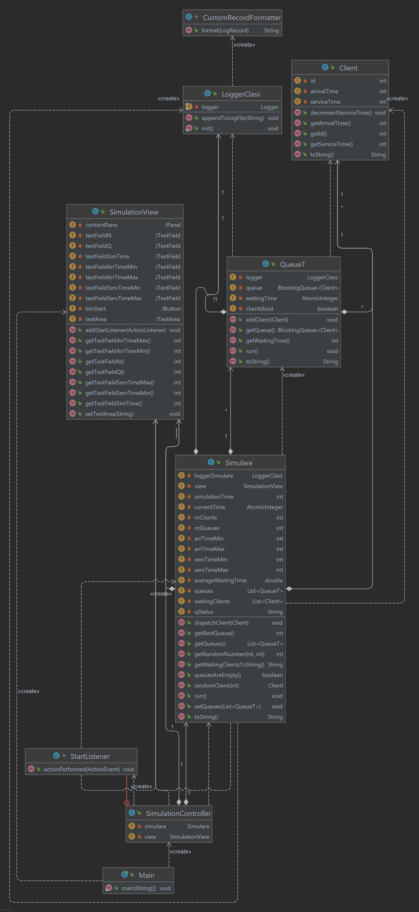

4.Implementation
- SimulationView class This class is where I implemented the user interface. My main goal was to translate the requirements of the proposed problem into a format that is easy to understand and use for all categories of users, without requiring any previous training. The main JPanel is divided into two sub-panels: the left panel and the right panel. The left panel contains 7 JTextFields through which the application retrieves user input and generates the corresponding data. The explicit input requirements include the number of clients (N), the number of queues (Q), the simulation time, the arrival time interval for clients, and the processing time interval for each client. When the Start button is pressed, the data is retrieved from the interface and the simulation is started.
The right panel contains a JTextArea where the detailed state of the queues at each moment in time can be observed and analyzed, along with details about the operations performed within each queue (deleting or adding clients), as well as the arrival of clients and their allocation to the queues with the minimum waiting time. The same content can also be found in the log file generated during the simulation. I used a JScrollPane associated with the JTextArea to allow the user to track the queue evolution in real-time or to review it. Additionally, the content displayed on the screen is updated every second to simulate the passage of time.
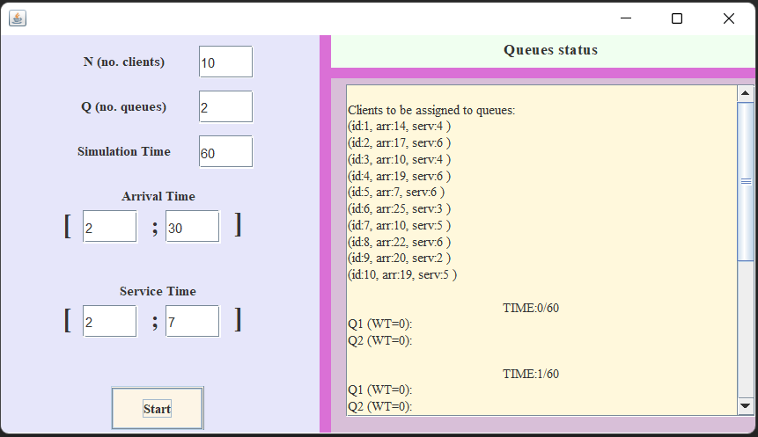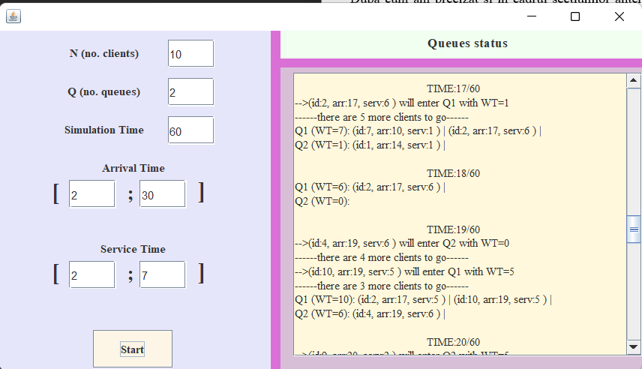
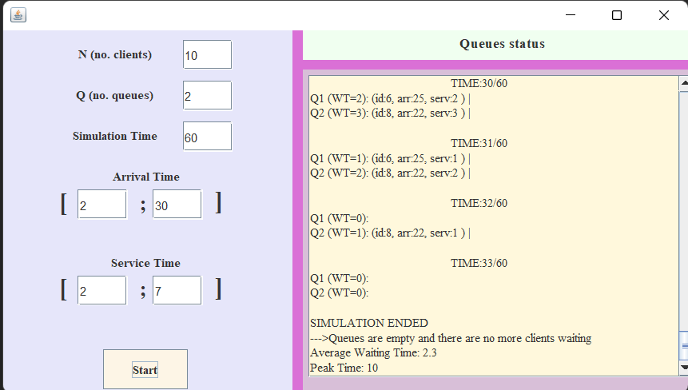
The SimulationController class is responsible for implementing the functionality of the Start button and controlling the GUI. It has instance variables of type SimulationView and Simulation. When the button is pressed, a new instance of the Simulation class is created, starting a new simulation. Immediately after its creation, following the Thread inheritance, we call the start() method to explicitly start the simulation and execute the run() method in a new execution thread.
The Client class is perhaps the simplest class in the project, modeling the attributes of a client. It has an id, arrivalTime, and serviceTime, which are randomly generated using a method from the Simulation class.
The QueueT class models the queue that processes its own clients. This class has an instance variable of type BlockingQueue list, which can only be accessed by a single thread at a time, ensuring data integrity in a concurrent environment. It also has an AtomicInteger attribute (implicitly synchronized) named waitingTime, which stores the total waiting time within a queue, calculated as the sum of the processing time for each client in the queue at that moment. The run() method implements the functionality of this class. In an infinite while loop (as the queue is always "running"), it first checks if there are clients in the queue, and if so, it decrements the processing time of the first client and removes it from the queue if its processing time becomes 0. After these operations, the sleep(1000) method is called to pause the execution of the method for one second, during which the simulation controls all the queues.
The Simulation class performs the majority of the internal logic in the application and has the most complex implementation. It contains several int instance variables, such as nrClients, nrQueues, simulationTime, arrTimeMin, arrTimeMax, servTimeMin, servTimeMax. These variables store the data entered by the user in the graphical interface and are used for generating random clients. Among the other attributes of this class, there is an object of type SimulationView, which is passed as a parameter to the constructor. It is used to display the state of the queues at each moment in the run() method. AtomicInteger currentTime is used to keep track of the current simulation time, which increases until it reaches the maximum simulation time or until there are no more clients waiting to be processed in any of the queues and the waitingClients list is empty. Another attribute of this class is a list that stores objects of type QueueT, which helps us keep track of the created and running queues. In the constructor of this class, the received parameter values are assigned to the corresponding variables, and at the same time, Q queues of type QueueT are created and stored in the queues list, and each of them is started by calling the start() method. Next, the N clients are randomly generated and stored in the waitingClients list by calling the randomClient(int id) method. The generation of random numbers is handled by the getRandomNumber(int min, int max) method, which returns a random integer within the [min; max] interval. Two other important methods are getBestQueue(), which returns the index of the queue with the shortest processing time, and dispatchClient(), which handles the dispatching of the client to the queue with the minimum processing time at that moment. Finally, the run() method implements the actual functionality of this class, using the utility methods described earlier. The simulation thread runs as long as the current time does not exceed the simulation time or, in the case of empty queues and exhausted simulation time, it waits for clients who have "reserved a spot" to be served. Additionally, I chose for the simulation to stop when the queues are empty and there are no more clients in the waitingClients list. Every second, the clients with arrival time equal to the current time are searched for, and if found, the dispatchClient(Client client) method is called to handle their allocation to the appropriate queue. This action is followed by incrementing the current time and calling the sleep(1000) method to simulate a one-second pause in the application. Additionally, the right panel of the GUI displays the evolution of the queues at each step, and the display is updated in each iteration of the while loop.
The Main class contains the static main() method, where an instance object of the SimulationView class is created and later passed as a parameter to the constructor of an object of the SimulationController class.

5. Results

To test the program, I used the inputs specified in the lab paper, as I couldn't use JUnit testing in this case since the client data is generated randomly. The implementation proves to be functional for both small input values (first case: N=4, Q=2, simulation time = 60, arrival time interval = [2,30], processing time interval for each client = [2,4]) and large input values (1000 clients, 20 queues, simulation time = 200, arrival time = [10,100], processing time = [3,9]). I created a LoggerClass that has a logger instance variable for the program, through which operations performed within the application are counted, such as adding a client to a queue, removing the client after the processing time, clients' arrival at a specific time, and efficiently sending them to the queue with the minimum waiting time at that moment.

6. Conclusions

I believe one of the most important things I learned from implementing this project is the utility of threads and the need to use them in most applications that interact with various types of user-input data in order to optimize processing speed. At the same time, I learned that although threads contribute significantly to the productivity and functionality of an application, they come with many considerations for the programmer, such as synchronization issues, concurrent access to data, and modification by other threads. Working with threads is not easy, but it represents an indispensable tool in building a complex application that meets real market demands.

Some further developments could include using the Executor class to maintain a limited number of active threads at any given time to avoid overloading the processor when working with a large number of such execution threads.

Additionally, another potential development would be handling the case where we consider a queue to have a limited number of slots, and if a client arrives when all slots are full, they would be placed in a higher priority queue, so they are selected first when a slot becomes available in any of the queues.

7. Bibliography
- materiale de la disciplina Programare Orientata pe Obiecte(semestrul 1)
- https://www.w3schools.com/java/java_threads.asp
- https://www.baeldung.com/java-concurrency
- http://tutorials.jenkov.com/java-concurrency/index.html
-https://stackoverflow.com/questions/2950704/java-util-logging-how-to-suppress-date-line

