<http://ekhordmining.com/public/new_employee_createview>

1. Add layout must be similar as “employee edit view”
2. Birthdate selector is 1990-2021; Must be at least 1950-2021
3. Following fields are not required.

* The middle name field is required.
* The registration num field is required.
* The phone field is required.
* The email field is required.
* The insurance book num field is required.
* The mechanism license num field is required.
* The pro driver license num field is required.
* The additional info field is required.
* The barcode field is required.

<http://ekhordmining.com/public/setting/position/create>

Add available_position” field

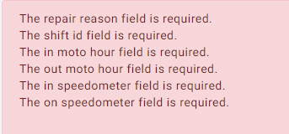

1. If user fills any form and “required’ fields not filled: system clears all previously filled fields. And have to start over again. It is very annoying.
2. Doc_category – Where can add to this table? (Documents category)
3. Body text color: #191919
4. Roles Settings menu: Where to add, edit user roles
5. Settings menu: change language
6. Checkbox on all list view and Batch actions (Batch edit, Batch time off, Batch stop time off, Batch delete, Excel, Print selected)
7. Transportation design fix, add features
8. Manufacturing, Time sheet, Fuel
9. Preloader on all pages.
10. All “add view” with only 1-4 fields must load in popup.