
ZIMGEO TRAINING
Introduction to GIS using QGIS
Practical 1: What is GIS? Exploring Vector Data in QGIS
The Zimgeo Team
info@zimgeo.co.zw | kudzai@zimgeo.co.zw | www.zimgeo.co.zw
Course materials: https://www.zimgeo.co.zw/training-tutorials/

Introduction
This is the first practical of the Introduction to GIS using QGIS course. It introduces the ideas behind a Geographic Information System (GIS), the main types of spatial data and how coordinates tie data to places on the Earth. You will then put these ideas into practice in QGIS, a free and open-source GIS used by government departments, consultancies, universities and NGOs around the world, using real datasets for Zimbabwe.
This practical concentrates on vector data: points, lines and polygons. Later sessions build on it: Session 2 covers raster data, Session 3 georeferencing, Session 4 coordinate systems and Session 5 data collection, followed by sessions on advanced data processing in QGIS. Raster data, coordinate systems and georeferencing are introduced briefly here so that you can see how the topics fit together.
What is GIS?
A Geographic Information System (GIS) is a computer-based system for capturing, storing, checking, analysing and displaying data that is linked to locations on the Earth's surface. What makes GIS different from a spreadsheet or a drawing program is that every piece of information is tied to where it is. This allows us to ask questions such as:
- Where are the health facilities in Manicaland Province?
- How many clinics are there in each district, and which districts have the fewest?
- Which villages are more than 10 km from the nearest clinic?
- What is the total length of the rail network, and which towns does it connect?
- What if a new district hospital were built at a given site: how many people would live within 20 km of it?
GIS is more than software. It is usually described as five components working together (Table 1.1).
Table 1.1: The five components of a GIS
Component | Description | Example
Hardware | The computers, GPS receivers, drones and mobile phones used to collect, store and process data. | A laptop, a handheld GPS, a smartphone running a data collection app
Software | Programs that store, analyse and display spatial data. | QGIS, ArcGIS Pro, Google Earth Engine
Data | Information about features and where they are. The most important and often the most expensive component. | Province boundaries, health facility locations, satellite images
People | The users who design projects, collect and check data, carry out analysis and make decisions. | GIS analysts, planners, field data collectors, managers
Methods | The procedures and rules followed to produce reliable results. | Data collection standards, analysis steps, map design rules

How a GIS sees the world: layers
A GIS stores the world as a set of layers (also called themes). Each layer holds one kind of feature, for example districts, the rail network or health facilities. Layers are drawn one on top of the other, and because they share the same coordinate system they line up exactly (Figure 1.1). This is what allows a GIS to combine information, for example to count the health facilities that fall inside each district.
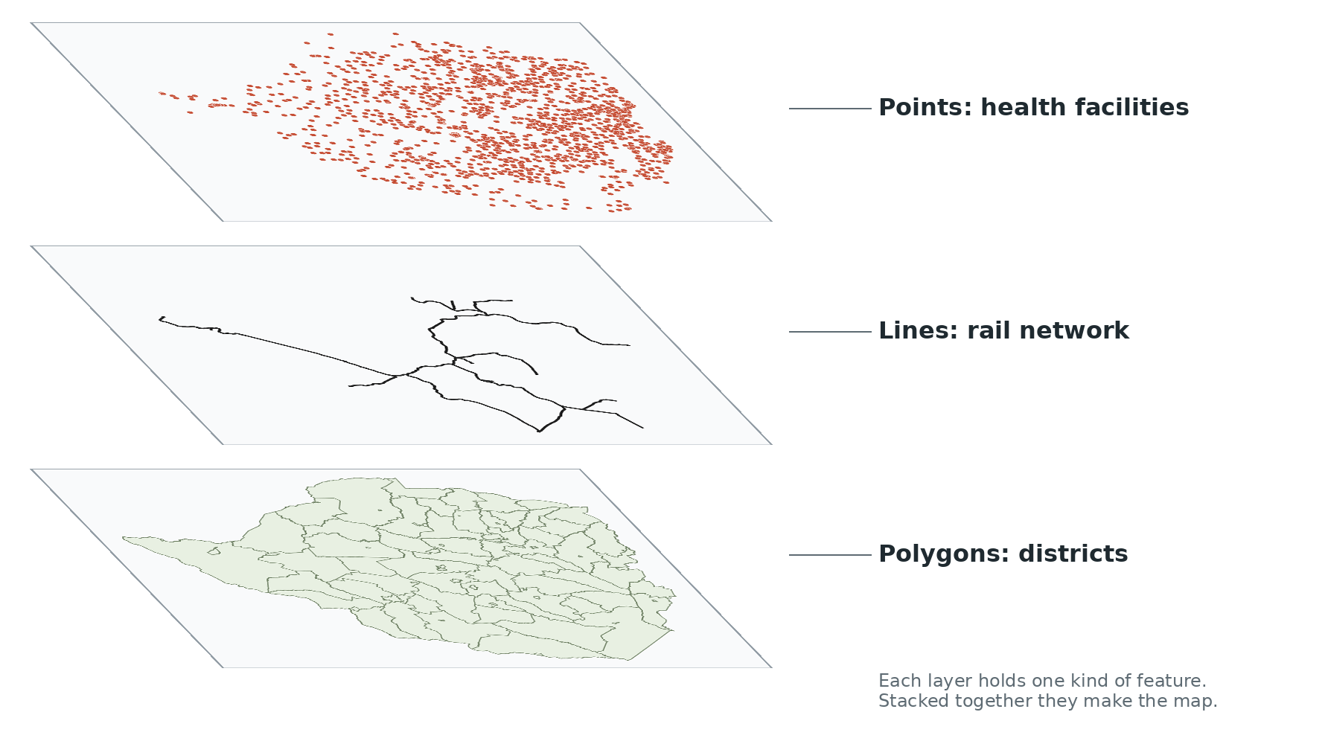
Figure 1.1: A GIS stores the world as layers that line up because they share the same coordinates
Spatial data: geometry and attributes
Every feature in a GIS layer has two parts:
- Geometry: where the feature is and what shape it has, stored as coordinates.
- Attributes: what the feature is, stored in a table with one row per feature and one column (field) per property.
For example, one health facility in this practical has the geometry longitude 31.03853, latitude -18.35294 and the attributes name = Acton Ronolds, fac_type = Rural Health Centre, district = Seke. You will see both parts in QGIS in Tasks 4 and 5.
Types of spatial data
There are two main ways of representing geographic features in a GIS: vector and raster (Figure 1.3).
Vector data represents features as points, lines and polygons built from x, y coordinates (Figure 1.2). Vector data is best for features with clear boundaries or exact locations, such as boreholes, roads or district boundaries.
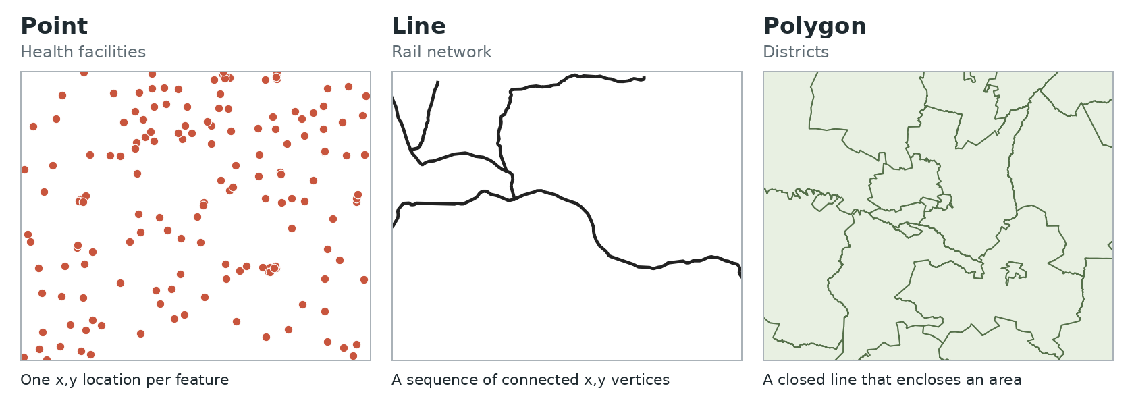
Figure 1.2: The three vector geometry types, shown with the practical data around Harare
Table 1.2: Vector geometry types
Geometry | What it stores | Examples in Zimbabwe | What you can measure
Point | A single x, y location | Health facilities, schools, boreholes, border posts, airports | Counts, distances between points
Line | A sequence of connected points (vertices) | Rail network, roads, rivers, power lines | Length
Polygon | A closed line that encloses an area | Provinces, districts, wards, dams, national parks | Area and perimeter

Raster data represents the world as a grid of equal-sized cells (pixels). Each cell holds one value, for example a colour in an aerial photograph, the elevation in a digital elevation model or the rainfall in a climate surface. The size of each cell on the ground is called the resolution: a 10 m Sentinel-2 image has cells of 10 m by 10 m. Raster data is best for things that change continuously across the landscape. Session 2 covers raster data in detail.
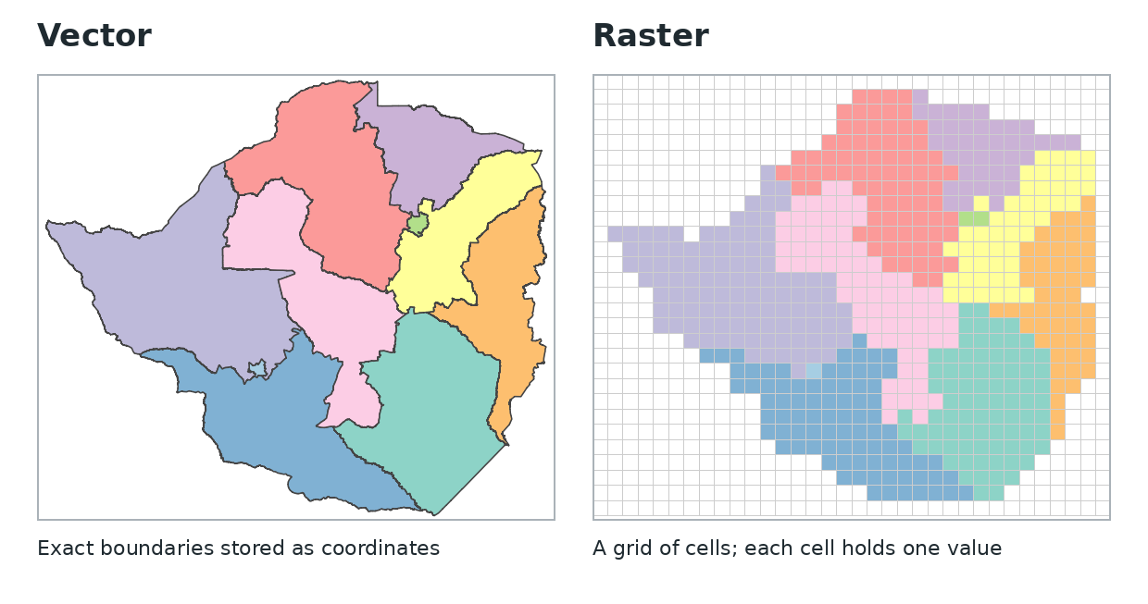
Figure 1.3: The same provinces stored as vector polygons (left) and as a coarse raster grid (right)
Common GIS file formats
Spatial data is stored in several file formats. The ones you will meet most often are listed in Table 1.3. This practical uses shapefiles and a CSV file.
Table 1.3: Common GIS file formats
Format | Type | Notes
Shapefile (.shp) | Vector | The most widely used format. One shapefile is made of several files with the same name: .shp (geometry), .shx (index), .dbf (attribute table), .prj (coordinate system) and often .cpg (text encoding). Field names are limited to 10 characters.
GeoPackage (.gpkg) | Vector and raster | A modern single-file format that can hold many layers. No 10-character limit on field names.
CSV (.csv) | Table | A plain text table. If it has coordinate columns (for example longitude and latitude), QGIS can turn it into a point layer (Task 8).
KML / KMZ | Vector | Used by Google Earth.
GeoTIFF (.tif) | Raster | An image with coordinates built in. Used in Session 2.

Note:
Always keep all the files of a shapefile together in the same folder. If you copy only the .shp file, QGIS cannot read the attributes (.dbf) or know where the data is on the Earth (.prj).
Coordinate reference systems
Coordinates only make sense if we know what they are measured in. A coordinate reference system (CRS) defines how the coordinates of a layer relate to real places on the Earth. Every CRS has a code, called an EPSG code. There are two main kinds (Table 1.4).
Table 1.4: CRSs commonly used in Zimbabwe
CRS | EPSG code | Kind | Units | Use
WGS 84 | 4326 | Geographic | Degrees of longitude and latitude | GPS, web maps, sharing data. All the data in this practical uses WGS 84.
WGS 84 / UTM zone 35S | 32735 | Projected | Metres | Measuring distances and areas in western Zimbabwe (west of 30°E).
WGS 84 / UTM zone 36S | 32736 | Projected | Metres | Measuring distances and areas in central and eastern Zimbabwe (30°E to 36°E).

A geographic CRS stores positions as angles (degrees) on a model of the Earth. A projected CRS flattens the Earth onto a plane so that positions can be given in metres. Because one degree of longitude is about 105 km in Zimbabwe but one degree of latitude is about 111 km, areas and distances calculated directly in degrees are meaningless. You will check the CRS of the practical data in Task 5. Session 4 covers coordinate systems in depth, including UTM zones, datums and reprojecting data from one CRS to another.
Georeferencing in brief
Many useful maps exist only on paper: old topographic sheets, farm plans, mining claims or hand-drawn sketches. When such a map is scanned, the result is just a picture. Its positions are pixel numbers (column, row) and it has no connection to real places, so it will not line up with other GIS layers. Georeferencing is the process of giving the scanned image real-world coordinates (Figure 1.4).
To georeference an image you identify ground control points (GCPs): places you can recognise both on the scanned map and on a map with known coordinates, such as road junctions, bridges or grid intersections. QGIS then uses the GCPs to calculate a transformation that stretches and rotates the image into the correct position, and saves the result as a GeoTIFF. Georeferencing is covered step by step in Session 3.
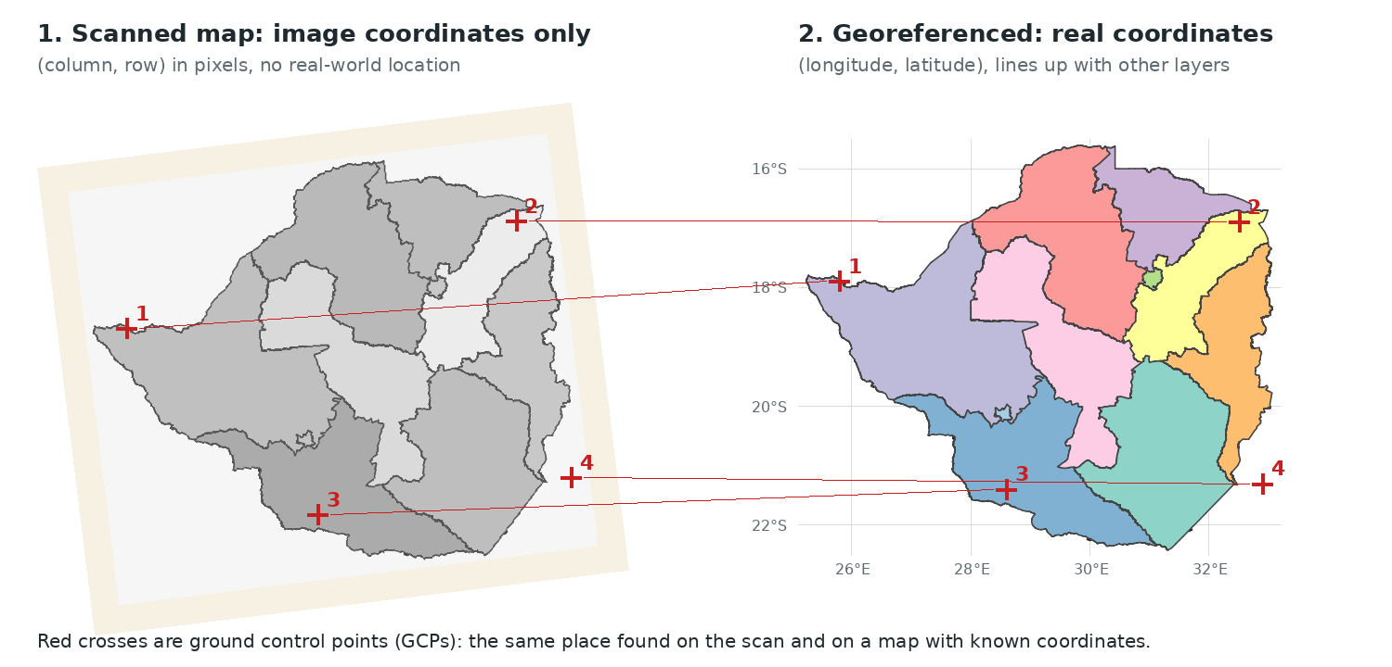
Figure 1.4: Georeferencing: matching ground control points on a scanned map (left) with known coordinates (right)

Learning Outcomes
By the end of this practical you should be able to:
- Explain what a GIS is, its five components and the kinds of questions it can answer.
- Describe the difference between vector and raster data, and between point, line and polygon features.
- Identify the main parts of the QGIS interface.
- Add vector layers to QGIS, explore their attribute tables and check their coordinate reference system.
- Style layers by category, add labels and select features using an expression.
- Create a point layer from a CSV file of coordinates.
- Produce a simple map with a title, legend, scale bar, north arrow and data source.
- Install a QGIS plugin from a ZIP file and use the Zimgeo Zimbabwe Boundaries plugin to get provinces, districts and wards.

Materials
Software
- QGIS 3.34 LTR or newer (free). Download it from qgis.org. The screenshots in this practical are from QGIS 3.34.
- The Zimgeo Zimbabwe Boundaries plugin for QGIS (free), used in Task 11.
Datasets
All the data for this course is on the course page on GitHub: https://github.com/zimgeozw/intro-gis-qgis-zimbabwe. For this practical, download intro_gis_session1_data.zip (6.8 MB): https://github.com/zimgeozw/intro-gis-qgis-zimbabwe/raw/main/data/intro_gis_session1_data.zip. When extracted it gives a folder called Session1_Data containing:
The practicals and data are also published on the Zimgeo training page: https://www.zimgeo.co.zw/training-tutorials/.
- zwe_level0_country.shp: the national boundary of Zimbabwe (1 polygon).
- zwe_level1_provinces.shp: the 10 provinces (polygons).
- zwe_level2_districts.shp: the 91 districts (polygons).
- zwe_rail_network.shp: the rail network, about 2 780 km in 59 sections (lines).
- zwe_health_facilities.shp: 1 470 health facilities (points), and the same data as a table, zwe_health_facilities.csv.
All layers are in WGS 84 (EPSG:4326). Each layer is in its own sub-folder with a README.txt file that describes its source, fields and limitations. The boundaries come from ZIMSTAT and OCHA (2018), the rail network from the Department of the Surveyor General (1:250 000) and the health facilities from the Ministry of Health and Child Welfare (recorded up to about 2007).
Note: Extract the zip file before you start and work from the extracted Session1_Data folder. QGIS can read some zipped data, but working from extracted files avoids many problems.

Instructions and Tasks

Task 1: Getting the data
- Open the course page in a web browser and download intro_gis_session1_data.zip (see Datasets above).
- Move the zip file to a working folder, for example C:\GIS_Course\Practical 1. Avoid folders whose path is very long.
- Right-click the zip file and choose Extract All... (Windows) or double-click it (Mac). Open the extracted Session1_Data folder and look inside zwe_admin1_provinces.
- How many files make up the provinces shapefile? List their extensions.
- Open the README.txt file. Who produced the boundary data and under what licence can it be used?
- Which file of a shapefile holds the attribute table, and which holds the coordinate reference system?

Task 2: Getting to know the QGIS interface
Open QGIS. Click New Empty Project if the welcome page is shown. Figure 1.5 shows QGIS with the practical data loaded; your window will be empty until you add data in Task 3. Table 1.5 describes the numbered parts.
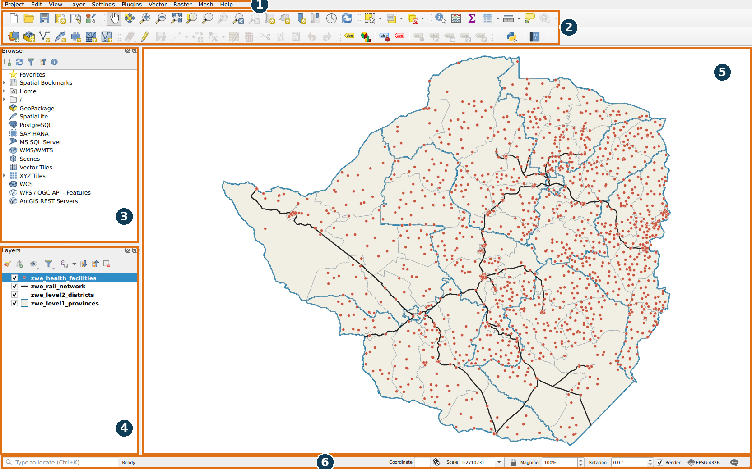
Figure 1.5: The QGIS 3.34 interface with the practical data loaded (numbers refer to Table 1.5)
Table 1.5: Main parts of the QGIS interface
No. | Part | What it does
1 | Menu bar | Access to every QGIS tool: Project (open and save), Layer (add data), Vector and Raster (analysis), Plugins and more.
2 | Toolbars | Buttons for common tools: zoom and pan, identify, select, measure, open the attribute table and add layers.
3 | Browser panel | Browse folders on your computer and drag data straight into the map.
4 | Layers panel | Lists the layers in the map. Tick a box to show or hide a layer, drag layers to change the drawing order and right-click a layer for more options.
5 | Map canvas | Where the layers are drawn. Layers at the top of the Layers panel are drawn on top.
6 | Status bar | Shows the coordinates of the mouse pointer, the map scale and, at the bottom right, the CRS of the project (here EPSG:4326).

- Hover the mouse over each toolbar button. Find the buttons for Zoom In, Zoom Out, Pan Map, Zoom Full and Identify Features.
- If a panel is missing, how can you show it again? (Hint: View → Panels.)

Task 3: Adding vector layers
- Click Layer → Add Layer → Add Vector Layer.... The Data Source Manager opens on the Vector page (Figure 1.6).
- Make sure Source Type is set to File. Click the ... button next to Vector Dataset(s), go to Session1_Data/zwe_admin1_provinces, select zwe_level1_provinces.shp and click Open.
- Click Add. The provinces appear in the map and in the Layers panel.
- Repeat steps 2 and 3 to add zwe_level2_districts.shp, zwe_rail_network.shp and zwe_health_facilities.shp. Click Close when you have finished.
- In the Layers panel, drag the layers so that the order from top to bottom is: health facilities, rail network, districts, provinces.
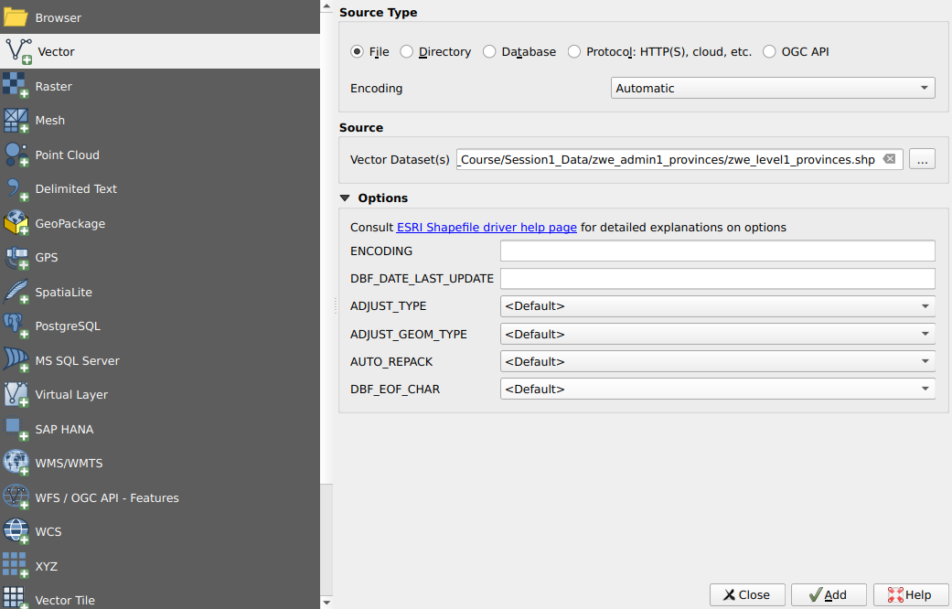
Figure 1.6: The Data Source Manager, Vector page, with the provinces shapefile selected
Tip:
You can also add data by dragging a .shp file from the Browser panel (or from Windows File Explorer) onto the map canvas.

QGIS gives each new layer a random colour. Look at the small symbol next to each layer name in the Layers panel: it shows whether the layer is made of points, lines or polygons.
- Which of the four layers are point, line and polygon layers? How can you tell from the Layers panel?
- Drag the provinces layer to the top of the Layers panel. What happens to the other layers? Why does layer order matter? Put the provinces back at the bottom.
- Use Zoom In to zoom to Harare. Then click Zoom Full to see the whole country again.

Task 4: Exploring the attribute table
- In the Layers panel, right-click zwe_health_facilities and click Open Attribute Table (Figure 1.7).
- The title bar shows Features Total: 1470: there is one row for each of the 1 470 health facilities, and one column (field) for each attribute.
- Click the fac_type column heading to sort the facilities by type. Click it again to sort in the opposite direction.
- Scroll right to see the beds, catchm_pop, longitude and latitude fields. Many cells show NULL: the value was not recorded.
- Close the attribute table. On the toolbar click Identify Features (the i button) and then click any health facility on the map. The Identify Results panel shows the attributes of that one facility.
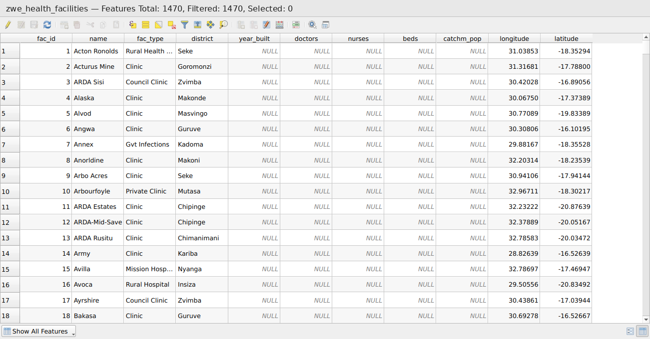
Figure 1.7: The attribute table of the health facilities layer, one row per facility
- List the fields of the health facilities layer. Which field holds the facility name and which holds the type of facility?
- Open the attribute table of the districts layer. How many districts are there, and in which field is the province of each district stored?
- Use the Identify tool on the rail network. What does the field length_km tell you?
- Why do you think so many facilities have NULL values for beds and nurses? What does this tell you about checking data before you use it?

Task 5: Checking the coordinate reference system
- Right-click zwe_health_facilities and click Properties.... Click the Information tab on the left (Figure 1.8).
- Read the section Coordinate Reference System (CRS). It gives the name, EPSG code and units of the CRS of the layer.
- Also note the Geometry, Feature count and Extent in the section Information from provider. The extent gives the minimum and maximum longitude and latitude of the layer.
- Close the Properties window. Look at the bottom right of the status bar: it shows the CRS of the whole project.
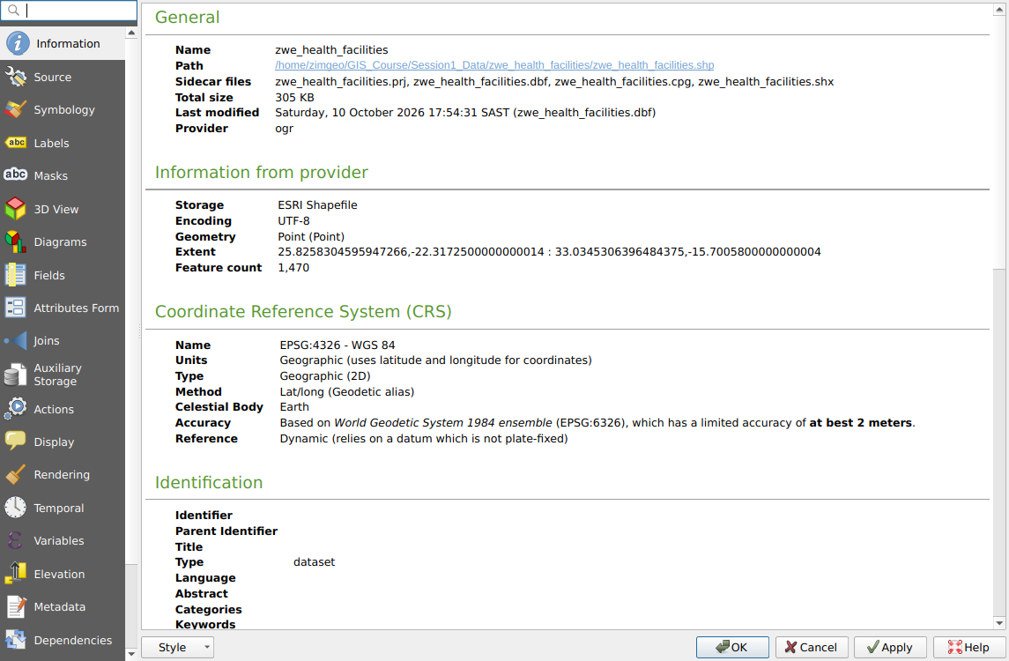
Figure 1.8: Layer Properties, Information tab, showing that the layer is in WGS 84 (EPSG:4326)
- What is the CRS and EPSG code of the health facilities layer? What are its units?
- Move the mouse over the map and watch the Coordinate box in the status bar. Roughly what are the coordinates of Harare? Of Bulawayo?
- The districts layer has an area_km2 field. Why could we not calculate the area of a district in km² directly from coordinates in degrees? Which CRS from Table 1.4 would you use for Mutare District?

Task 6: Styling the layers
Good symbols make a map easy to read. We will colour each province differently, show district boundaries as outlines only and label the provinces.
Provinces: one colour per province
- Open the Properties of zwe_level1_provinces and click the Symbology tab.
- At the top, change Single Symbol to Categorized. Set Value to province.
- Click Classify. QGIS gives each of the 10 provinces its own colour (Figure 1.9). Click Apply.
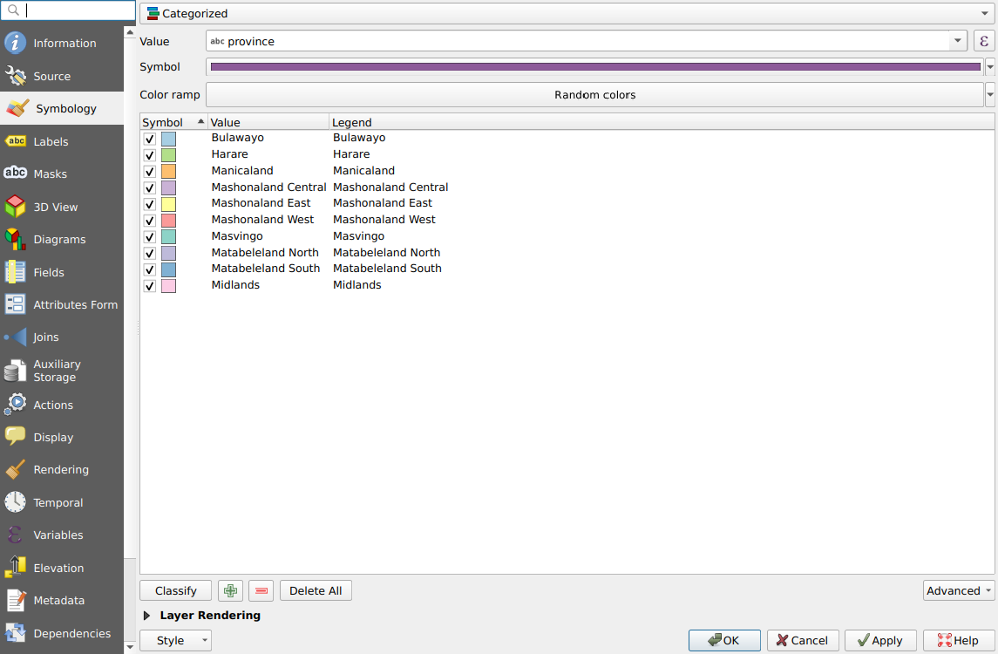
Figure 1.9: Categorized symbology: one colour for each value of the province field
Province labels
- Still in Properties, click the Labels tab. Change No Labels to Single Labels and set Value to province (Figure 1.10).
- In Text, set the size to 9 and the style to Bold. Click Buffer and tick Draw text buffer so the labels stay readable on top of the colours.
- Click OK.
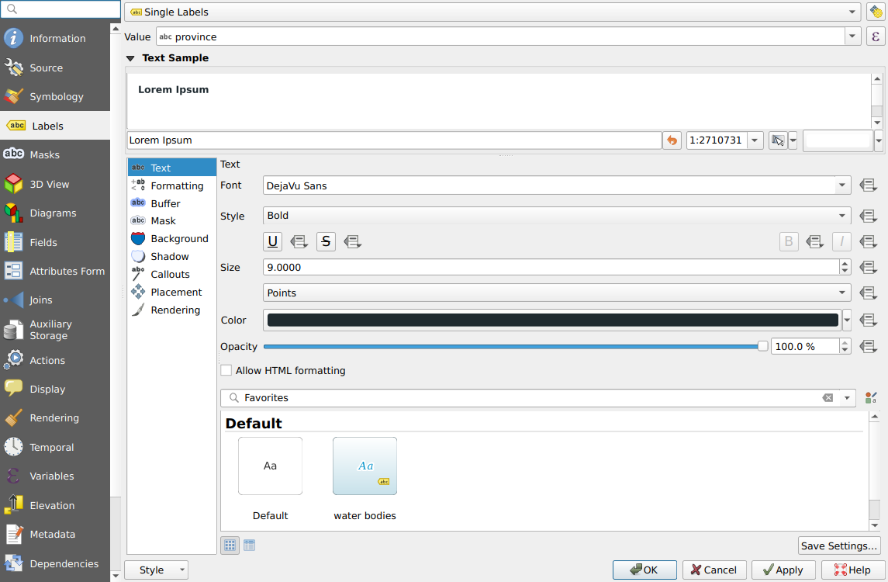
Figure 1.10: The Labels tab, labelling each province with the value of the province field
Districts, rail and health facilities
- Open the Symbology of zwe_level2_districts. Click Simple Fill and set Fill style to No Brush and the Stroke color to grey. Only the district boundaries now show.
- Give zwe_rail_network a black line 0.6 mm wide.
- Give zwe_health_facilities a small red circle (size 1.6) with a white outline.
- Why is a categorized style suitable for provinces, but not for a field such as beds?
- Style the health facilities as Categorized by fac_type. How many facility types are there? Is this style easy to read? Change it back to a single symbol.

Task 7: Selecting features by attribute
One of the most common GIS tasks is to find features that meet a condition. We will find all the District Hospitals.
- Click zwe_health_facilities in the Layers panel to make it the active layer.
- Click Edit → Select → Select Features by Expression... (or the toolbar button with a yellow square and ε). The expression dialog opens (Figure 1.11).
- In the middle list, expand Fields and Values and double-click fac_type. Click =, then click All Unique on the right and double-click District Hospital. The expression is now: "fac_type" = 'District Hospital'
- Click Select Features, then Close. The selected facilities are shown in yellow on the map (Figure 1.12) and the number selected appears in the status bar.
- Open the attribute table and click Show All Features at the bottom left, then choose Show Selected Features to see only the selected rows.
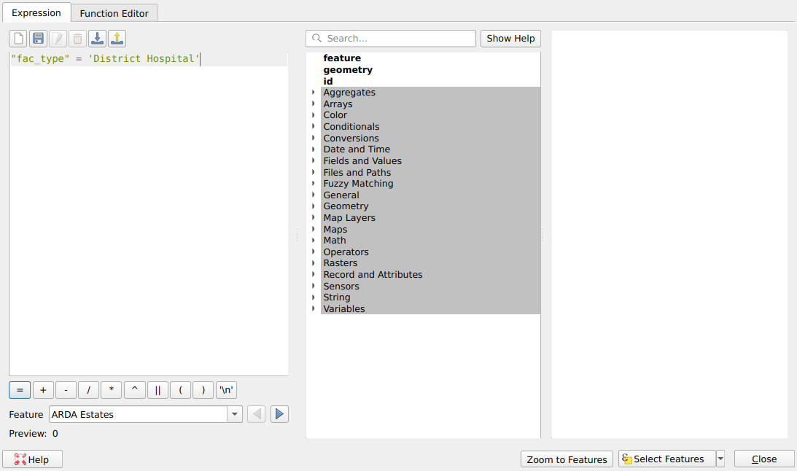
Figure 1.11: Select by Expression with the expression "fac_type" = 'District Hospital'
Quotes matter.
In an expression the field name is in double quotes ("fac_type") and the text value is in single quotes ('District Hospital'). Values are case-sensitive: 'district hospital' will not match 'District Hospital'.

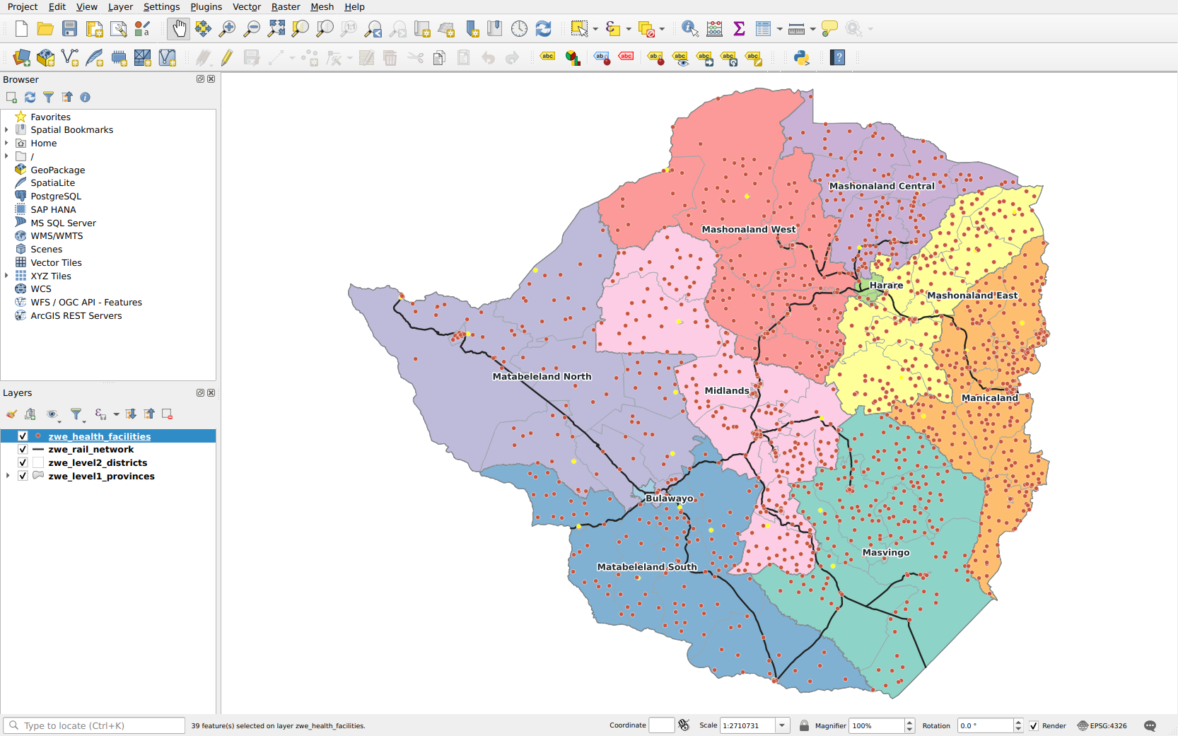
Figure 1.12: The 39 District Hospitals selected (yellow) on the map
To keep the selected features as a new layer, right-click the layer and choose Export → Save Selected Features As.... To clear the selection, click Deselect Features from All Layers on the toolbar.
- How many District Hospitals are there? Which provinces have the most?
- Change the expression to find all facilities of type Clinic. How many are there?
- Write an expression that selects all facilities in Mutare district. (Hint: use the district field.)

Task 8: Adding points from a CSV file
Field teams often record locations with a GPS or a phone and give the GIS analyst a spreadsheet with coordinate columns. QGIS can turn such a table into a point layer.
- Click Layer → Add Layer → Add Delimited Text Layer... (Figure 1.13).
- Next to File name click ... and choose zwe_health_facilities.csv in the zwe_health_facilities folder.
- Under File Format, select CSV (comma separated values).
- Expand Geometry Definition. Select Point coordinates, set X field to longitude and Y field to latitude.
- Set Geometry CRS to EPSG:4326 - WGS 84. Check the Sample Data at the bottom, then click Add and Close.
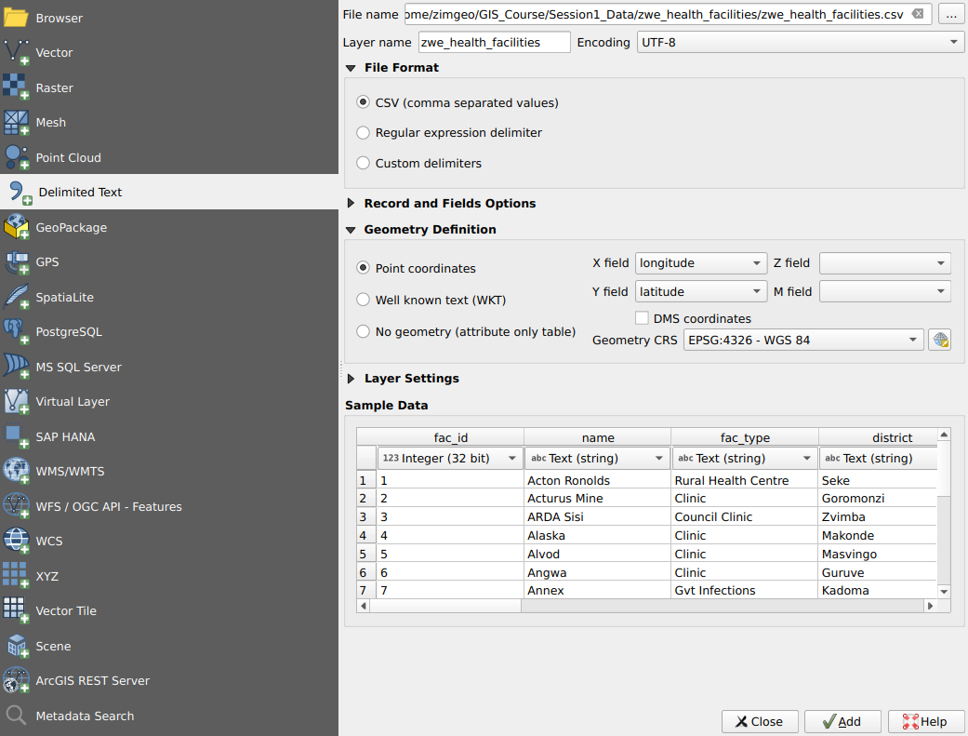
Figure 1.13: Adding the CSV file as a point layer using its longitude and latitude columns
Remember:
X is longitude (east-west) and Y is latitude (north-south). If you swap them, your points will appear in the wrong place, often in the ocean or not at all.

- Does the new layer have the same number of features as the shapefile? Do the points sit exactly on top of the shapefile points?
- What would happen if you set the Geometry CRS to UTM zone 36S instead of WGS 84? Try it, then remove that layer.
- Why must a CSV file with coordinates always come with information about its CRS?

Task 9: Making a map
A map for a report needs more than the data. It needs a title, a legend, a scale bar, a north arrow and the data source. In QGIS these are added in a print layout.
- Rename the layers so that the legend is readable: right-click each layer, choose Rename Layer and use the names Provinces, District boundaries, Rail network and Health facilities. Remove the CSV layer from Task 8.
- Click Project → New Print Layout..., type the name Zimbabwe health facilities and click OK. The layout window opens with a blank page (Figure 1.14).
- Right-click the page, choose Page Properties... and set the orientation to Landscape.
- Click Add Item → Add Map and drag a rectangle over the left two-thirds of the page.
- Click Add Item → Add Label, drag a box at the top of the page and type the title in Item Properties on the right, for example Health facilities and rail network in Zimbabwe. Increase the font size.
- Add a legend (Add Item → Add Legend), a scale bar (Add Item → Add Scale Bar) and a north arrow (Add Item → Add North Arrow).
- Add a second label with the data source and your name: Data: ZIMSTAT/OCHA (boundaries), Surveyor General (rail), MoHCW (health facilities). Map: your name, date.
- Click Layout → Export as Image..., save the map as Practical1_map.png and open it to check it (Figure 1.15).
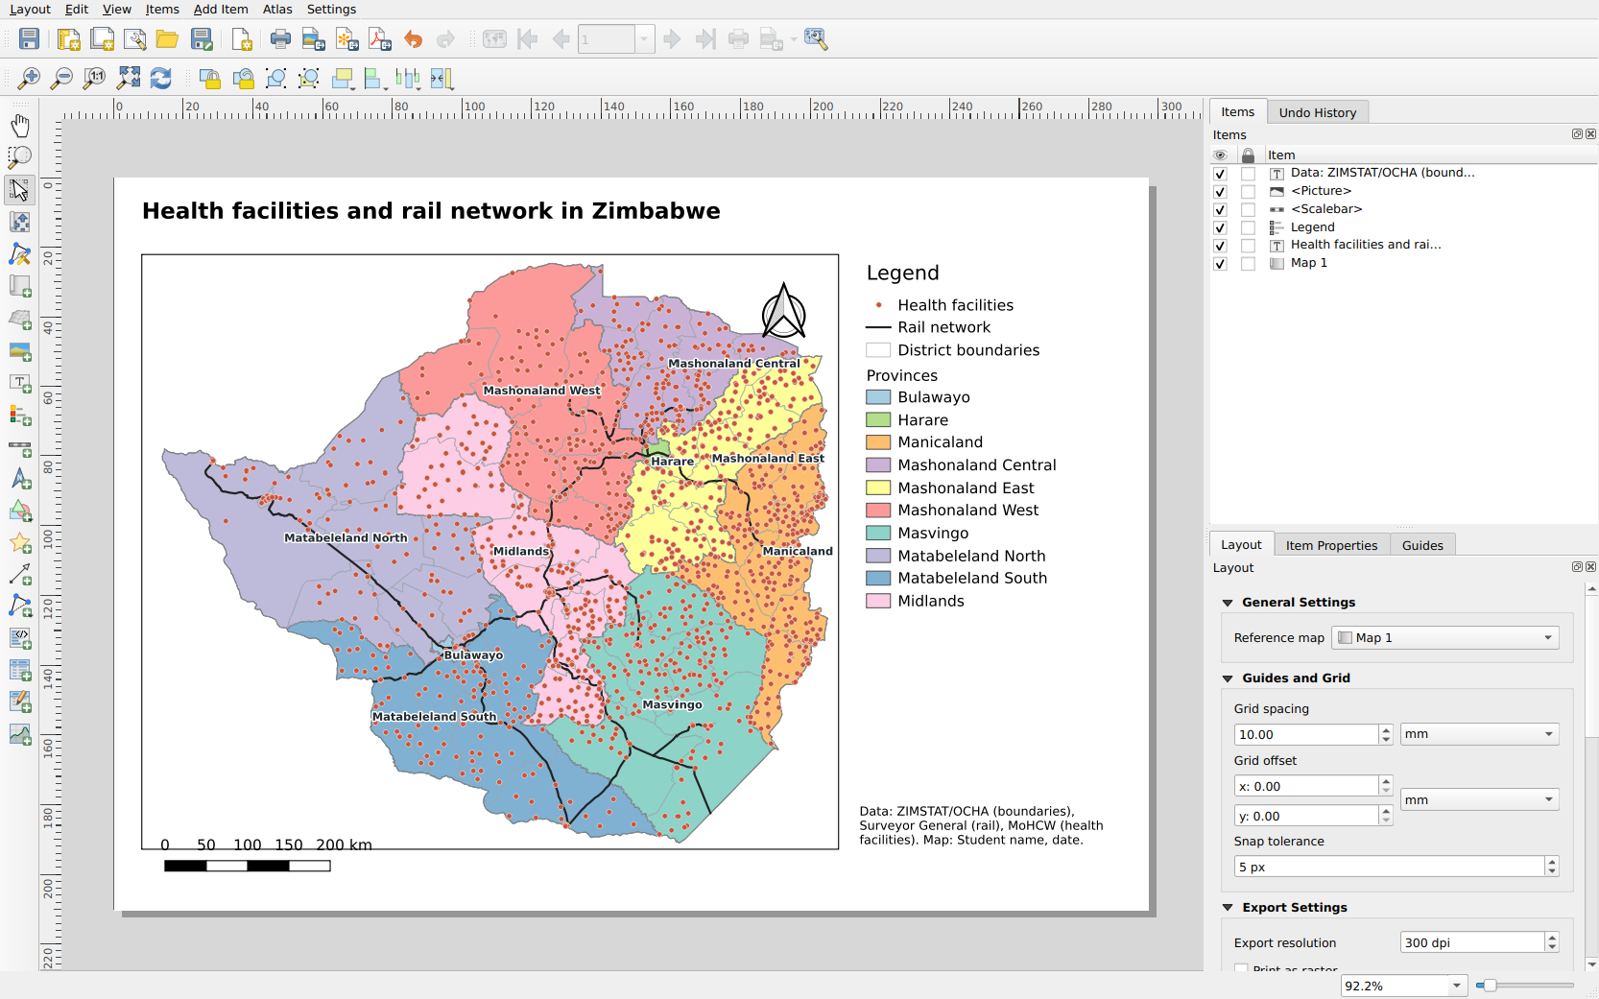
Figure 1.14: The print layout with the map, title, legend, scale bar, north arrow and source
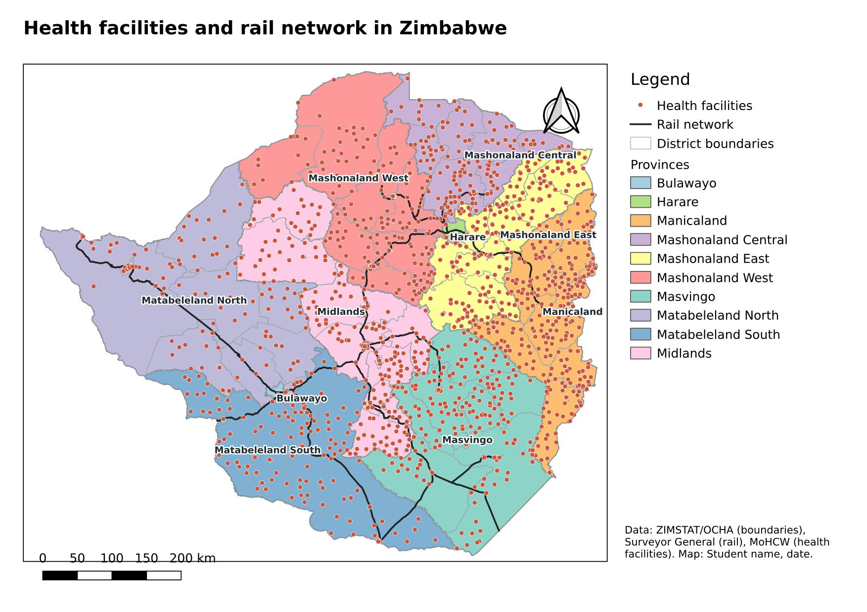
Figure 1.15: The finished map exported as an image
- Why does every map need a data source and a date?
- Select the scale bar and look at Item Properties. In what units is it shown? Change it to show 0, 50, 100, 150 and 200 km.
- Save your project with Project → Save As... as Practical1.qgz. What does the project file store, and what does it not store?

Common problems
Problem | Likely cause and solution
The layer is added but nothing appears on the map | Right-click the layer and choose Zoom to Layer(s). The layer may also be hidden under a polygon layer: drag it to the top.
QGIS asks for a CRS, or a layer appears in the wrong place | The .prj file is missing. Keep all shapefile files together, or set the CRS in Layer Properties → Source.
The attribute table shows only some fields | Scroll right, or widen the window.
The expression gives 0 features | Check the quotes and spelling. Text values are case-sensitive and must match the data exactly.
CSV points are in the ocean or missing | The X and Y fields have been swapped, or the wrong Geometry CRS was chosen.
Labels overlap and are hard to read | Reduce the font size, add a buffer or use labels on fewer features.

Task 10: Exercises
Save your project before you start. Write your answers in full sentences and support them with numbers from the data.
- Make a map of your home province showing its districts, the rail network and the health facilities. (Hint: right-click the provinces layer, choose Filter... and use an expression such as "province" = 'Masvingo'.)
- Use Select by Location (Vector → Research Tools → Select by Location) to select the health facilities that lie inside Harare province. How many are there?
- Click View → Statistical Summary (or the Σ button on the toolbar). In the panel that opens, choose the zwe_rail_network layer and the length_km field. What is the total length (Sum) of the rail network?
- Save the District Hospitals as a new shapefile called district_hospitals.shp (Task 7) and add it to your map with a larger red symbol.
- In about half a page, describe the pattern of health facilities in Zimbabwe. Where are they dense and where are they sparse? Give two possible reasons for the pattern and one limitation of this data.

Task 11: Extending QGIS with plugins
Plugins are add-ons that give QGIS new tools. Most are written in Python by the QGIS community, and over 2 000 are available free of charge. Some examples you may find useful later in this course are:
- QuickMapServices: adds background maps such as OpenStreetMap and satellite imagery.
- qgis2web: turns a QGIS map into an interactive web map.
- Zimbabwe Boundaries (by Zimgeo): Zimbabwe's country, province, district and ward boundaries in one click, without an internet connection.
Plugins from the official QGIS repository are installed from Plugins → Manage and Install Plugins..., which needs an internet connection. A plugin can also be supplied as a ZIP file and installed from that file, which is how you will install the Zimbabwe Boundaries plugin.
Installing the Zimbabwe Boundaries plugin
The plugin is on its own page on GitHub: https://github.com/zimgeozw/qgis-zimbabwe-boundaries.
- Download zimbabwe_boundaries.zip (25 MB) using the Download the plugin link on the plugin page. Do not extract it: QGIS installs the ZIP file as it is.
- In QGIS, click Plugins → Manage and Install Plugins... and click Install from ZIP on the left (Figure 1.16).
- Click the ... button, choose the downloaded zimbabwe_boundaries.zip and click Install Plugin.
- QGIS shows a security warning because the plugin does not come from the official repository. Click Yes to continue. When QGIS reports that the plugin was installed successfully, click Close.
- A new button with a small map of Zimbabwe appears on the toolbar, and a new menu item appears under Vector → Zimbabwe boundaries.
Direct download link: https://github.com/zimgeozw/qgis-zimbabwe-boundaries/raw/main/download/zimbabwe_boundaries.zip
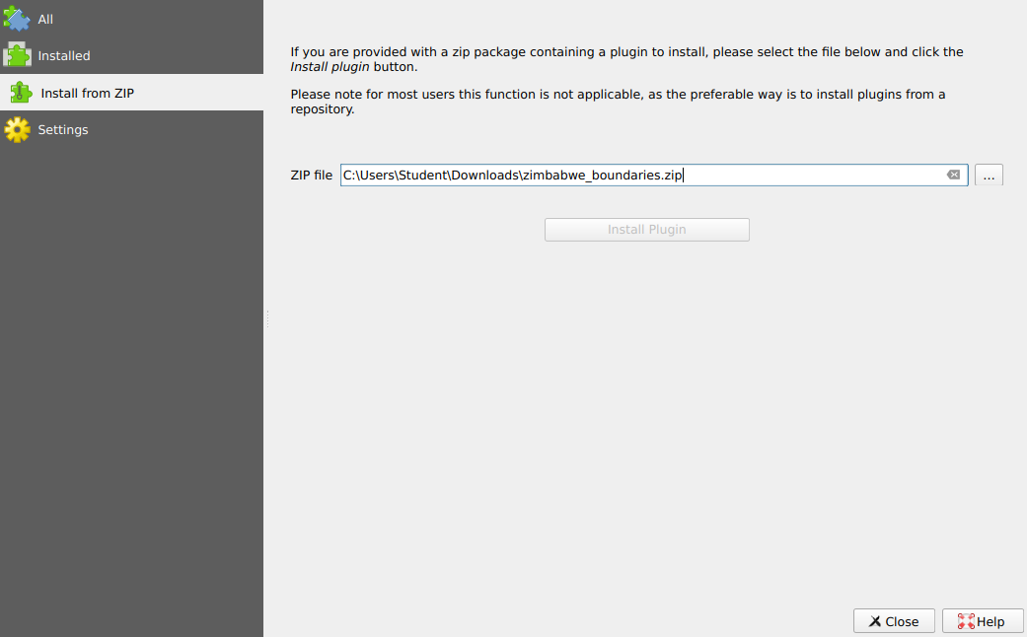
Figure 1.16: Plugins dialog, Install from ZIP page, with the downloaded plugin file selected
Using the plugin
We will use the plugin to get the wards of Mutare district in Manicaland, a level of detail that is not in the Session 1 data.
- Click the Zimbabwe boundaries button on the toolbar (or Vector → Zimbabwe boundaries → Zimbabwe boundaries (levels 0 to 3)). The plugin window opens (Figure 1.17).
- Under Levels, tick Level 2: districts and Level 3: wards, 2018 (old), and untick the others. Read the orange note about the ward boundaries.
- Under Provinces, click Clear and tick Manicaland only. The Districts list now shows only the districts of Manicaland.
- Under Districts, click Clear and tick Mutare only.
- Leave the Coordinate system as EPSG:4326 - WGS 84. Under Output, tick Add to the map and Show labels. Untick Save files to a folder for now.
- Click Get boundaries. The district and its wards are added to the map in a group called Zimbabwe boundaries (Figure 1.18). Zoom in to see the ward numbers.
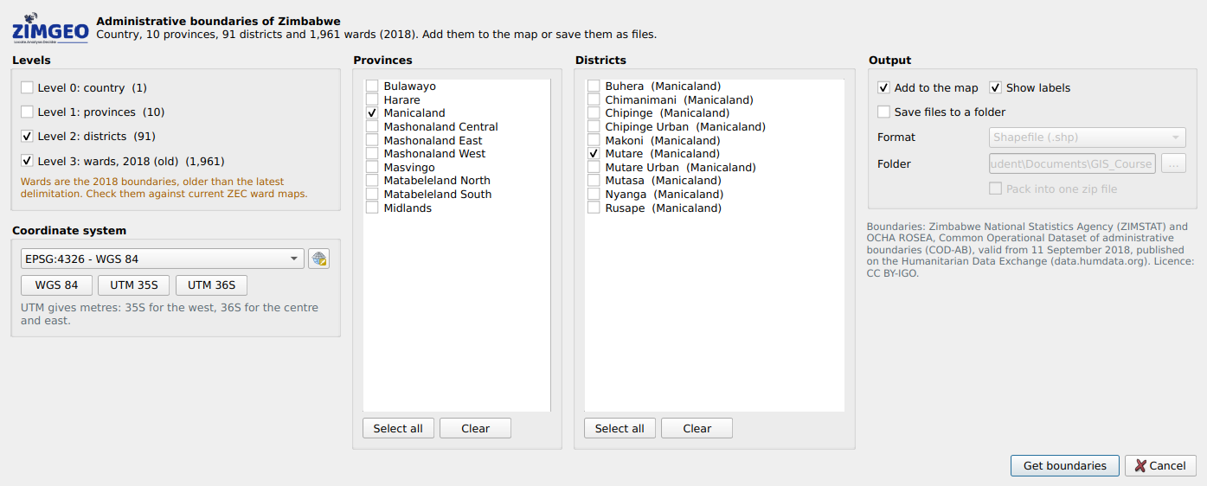
Figure 1.17: The Zimbabwe Boundaries plugin set to add Mutare district and its wards
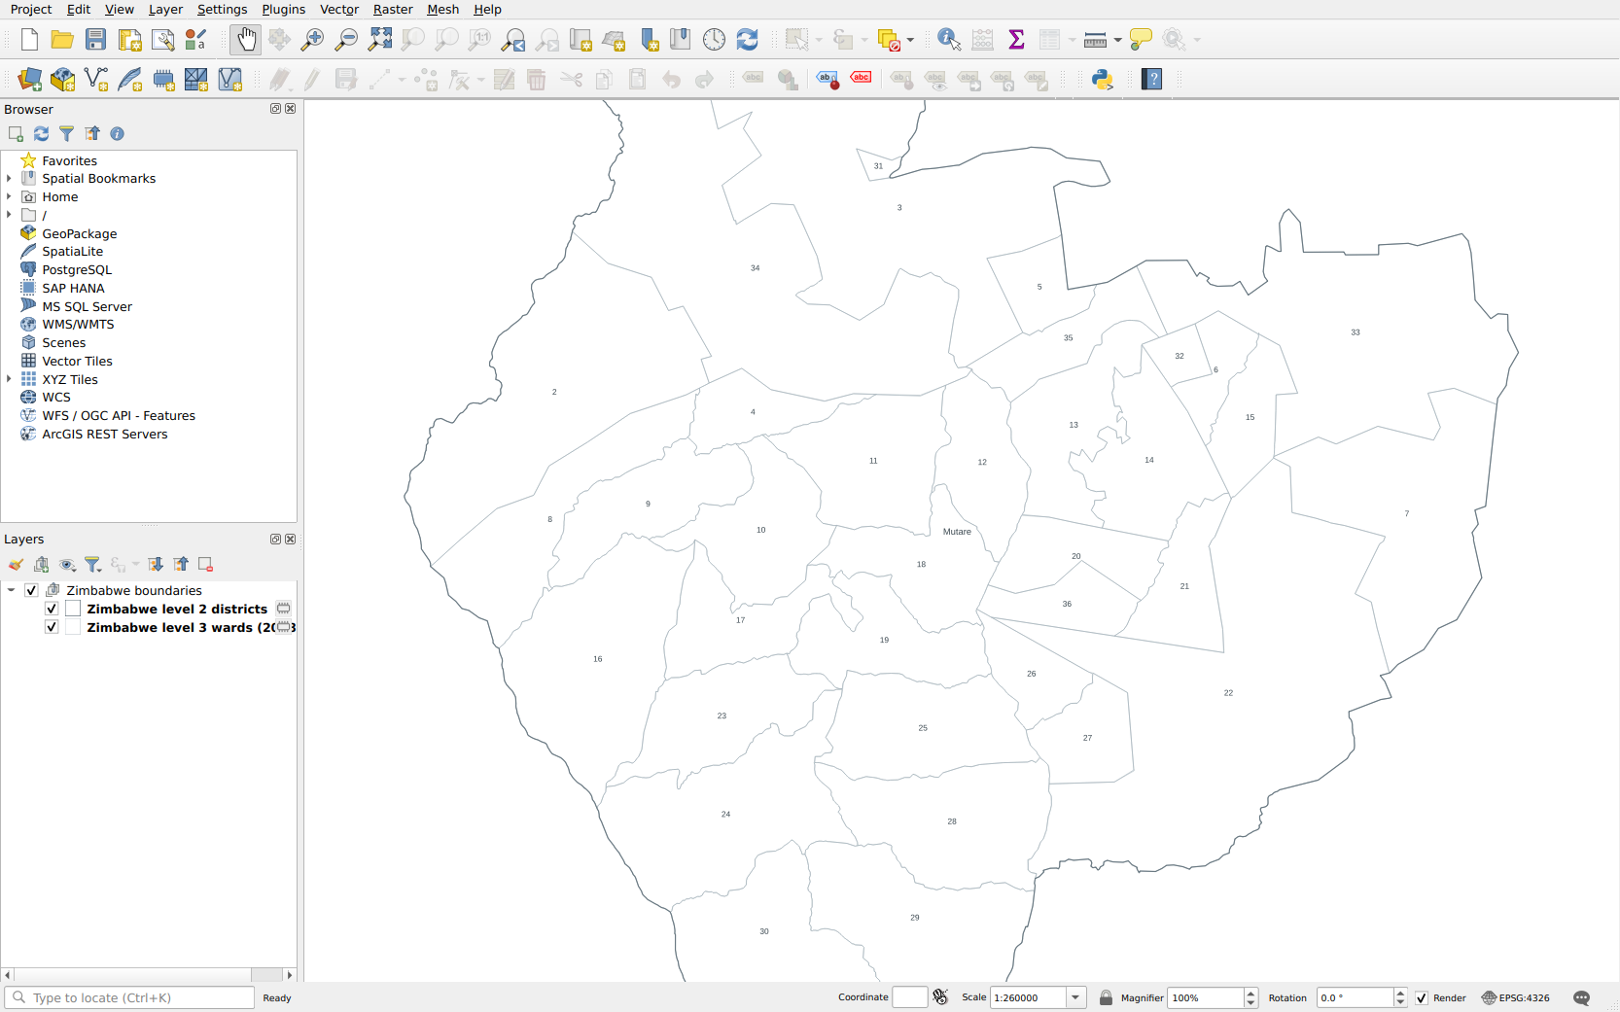
Figure 1.18: The wards of Mutare district added by the plugin, labelled with their ward numbers
Saving the boundaries as shapefiles:
Tick Save files to a folder, choose Shapefile (.shp) as the Format and choose a Folder. The plugin saves one shapefile per level, plus a text file with the data source. Tick Pack into one zip file to share them easily.
Choose UTM 35S or UTM 36S under Coordinate system if you need the boundaries in metres.

Note:
The ward boundaries in the plugin are the 2018 wards from ZIMSTAT and OCHA. They are older than the latest ward delimitation, so check them against current Zimbabwe Electoral Commission ward maps before using them for electoral or ward-level planning work. Always credit the data source on your maps.

- How many wards does Mutare district have? (Hint: open the attribute table of the wards layer.) Which fields does the ward layer have that the Session 1 districts layer does not?
- Use the plugin to save the districts of Masvingo province as a shapefile in UTM 36S. Add the saved file to QGIS and check its CRS in Layer Properties → Information.
- Use the identify tool on one ward. What is its ward_pcode? Why are codes like these more reliable than names when joining tables from different sources?
- Go to Plugins → Manage and Install Plugins... → Installed. Where can you switch the Zimbabwe Boundaries plugin off, and where can you uninstall it?

Looking Ahead
Practical 1 is free and open to everyone. The remaining practicals, with their data, will be available to students enrolled on the course. To enrol, contact the Zimgeo team (details below) or visit the Zimgeo training page.
Session 2: Raster data. You will work with satellite images and elevation data, learn about cell size and bands, and style and analyse raster layers in QGIS.
Session 3: Georeferencing. You will take a scanned map, add ground control points and turn it into a GeoTIFF that lines up with the data you used today.
Session 4: Coordinate systems. You will look more closely at geographic and projected coordinate systems, UTM zones 35S and 36S, datums, and how to reproject layers so that distances and areas are correct.
Session 5: Data collection. You will collect your own data in the field with GPS and a mobile data collection app, and bring it into QGIS.
Sessions 6 onwards: Advanced data processing in QGIS. Geoprocessing and spatial analysis tools, joins and summaries, raster analysis and automating your work.
Course information, updates and the Practical 1 data are on the Zimgeo training page, https://www.zimgeo.co.zw/training-tutorials/, and on the course page on GitHub, https://github.com/zimgeozw/intro-gis-qgis-zimbabwe. For questions, contact the Zimgeo team at info@zimgeo.co.zw or kudzai@zimgeo.co.zw.
End of Practical

